

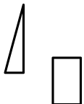
D D
0
a
□

Divisions
1, 2 & 3

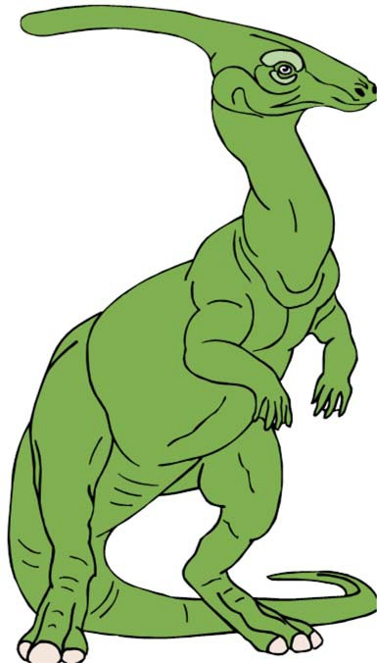
Developed by
Purdue University Cooperative Extension Service
Area 7 Youth Educators
(Blackford, Delaware, Fayette, Franklin, Henry, Jay, Madison,
Randolph, Rush, Union, & Wayne )

PURDUE UNIVERSITY,INDIANA COUNTIES AND U.S. DEPARTMENT OF AGRICULTURE COOPERATING AN
AFFIRMATIVE ACTION/EQUAL OPPORTUNITY INSTITUTION

Compiled 


Leanne M. Educator, 4-H/Youth
Henry
Purdue  Service -


Reviewed and Edited Area 7






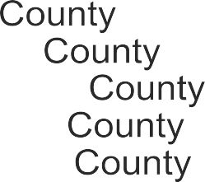





RaeAnn O’Neill, 4-H/Youth Blackford Rich 4-H/Youth Delaware Carolyn Miner, 4-H/Youth
Caldwell, 4-H/Youth Fayette County  4-H/Youth County
Sewell, 4-H/Youth Jay John Farris, 4-H/Youth Madison
Findley, 4-H/Youth Madison Jill Schneider, 4-H/Youth Randolph Brian Gauck, 4-H/Youth
John 4-H/Youth Union Debra 4-H/Youth Wayne

and
Exploring 4-H, Purdue University  
Mini 4-H Dinosaur Decatur County,
Dinosaurs, Paso California (access through 


Dinosaurs were very large animals that lived on Earth 200 years ago. We do not know for sure what they like. We guess from their bones and fossils what shape and they might have been. Most  say that they looked like giant lizards.

The word dinosaur means "terrible lizard". are part of reptile family. Can you name four types of lizards or 

Dinosaurs were not like the lizards or reptiles that we know on Earth  They were very big. How big? Here is an activity that will help you see how big dinosaurs

 Activity -- Measure a Dinosaur
You will to find these things around the
1 inch
- 50 feet of string  or 
- ruler - scissors
- scrap

Here what you
- Cut the scrap paper i n rectangles, 5 long and about inch wide. (See  1)


- Make a chain. To do this bend the of into a circle and tape (or glue) the


Take another piece of put it through of the first circle, the paper to make circle and tape the ends. You will
two circles and it will look like a
ex. 1

- Keep going until your chain is 50 feet long. You can use your piece of  to measure your chain. finished, this will be your dinosaur
- Make a second paper chain. This time, make it as long as you are
- you have time make another chain or two. Make as long as your mom and dad are

- When you are finished with your chains, take outside. You will need a lot of room. Put the chains to each
Here are some questions:

was  your dinosaur

If you put together your chain and your mom and chain(s), which one is bigger? Your family's or the dinosaur's?

What things do you see around you that are as tall as

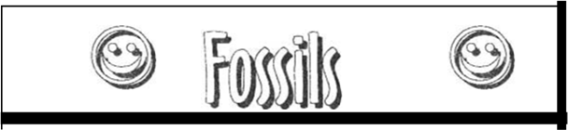

None of us have ever seen a dinosaur. But there are parts dinosaurs that have been found all over the world. Most of the parts called fossils.
Fossils are bones, eggs, or dirt that has turned into stone or a picture in stone. The special thing about fossils is that they  their shape. They look like they did millions of years

People are able to make casts from fossils. A cast is made of  special material. The clay is put around a fossil. The fossil makes prints or spaces in the clay. After the clay is hard,  can study the helps keep the fossil from 

Sometimes we find fossils that didn’t turn into stone, like a leaf or  The leaf may have fallen in mud millions of years ago. This mud then turns to stone with the print of the leaf on it. The leaf but left a picture for us to see 

 Activity 2 -- 
You will need to find these things around the house or 
- small bones, leaves, shells, buttons or
- a big  of 

Here what you
- Take the clay and split it in half. Press both pieces of the  flat and

- Take one of clay and put a bone, leaf or other  on the

- Put the second  of clay over the items. Press the pieces together gently. Make sure that the clay molds things inside.

- Let the clay dry for a little while. Carefully pull apart pieces of clay. The prints can be seen in your clay

Here are some questions:

What places can we visit and see fossils?

are some things that are in your house or out in the yard might be a fossil 200 million years in the future?



Types of Dinosaurs

There were a lot of dinosaurs. They were different Some were as small as a and some were taller than 50
People have found bones and of different shapes and sizes. shape and of tell people many things. If a bone was
large, then the dinosaur was large. dino-saur was small.
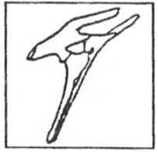
were two groups of dinosaurs. One is called  and the oth-er is called "reptile-hipped".  of the hip bone puts a
dinosaur in a
 dinosaur ate mostly dino-saurs stood on two feet. front feet were very small and looked like hands. They had very long tails which helped them They also had big heads with large mouths and sharp
bird-hipped dinosaur
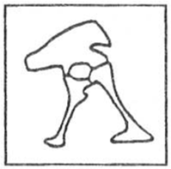
The reptile-hipped dinosaur ate plants. These dinosaurs stood on four feet.  had long necks helped them reach the tops of trees. Because they plants, they had week

reptile-hipped dinosaur

Activity 3 --Types of Dinosaurs
You will need to find these things around the house:
colored pencils or markers

Here what you
Match the dinosaur with the description and then color

Match the type of to the picture.
Brachiosaurus (means "great  – This dinosaur was the heaviest them all. It may have  80 tons. It was a plant

Stegosaurus (means "covered lizard) -  was about 20 long with short legs. It was a plant eater. It is known for the 20 plates sticking out of its back and the 2-foot long spikes at the end of its

(means "thunder lizard") - The was one of greatest giant dinosaurs. It had legs that were like pillars and round feet. It  about 30 tons and spent a lot of time in the feeding on soft green plants.
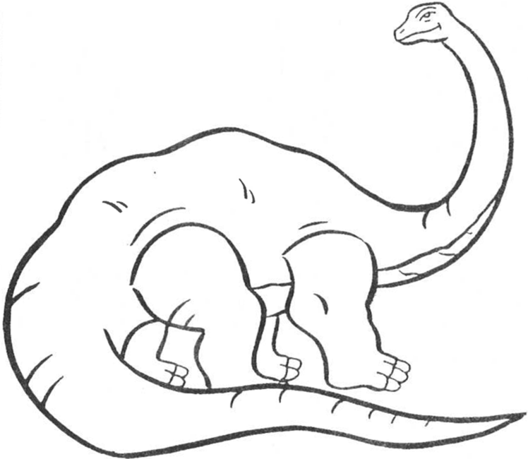



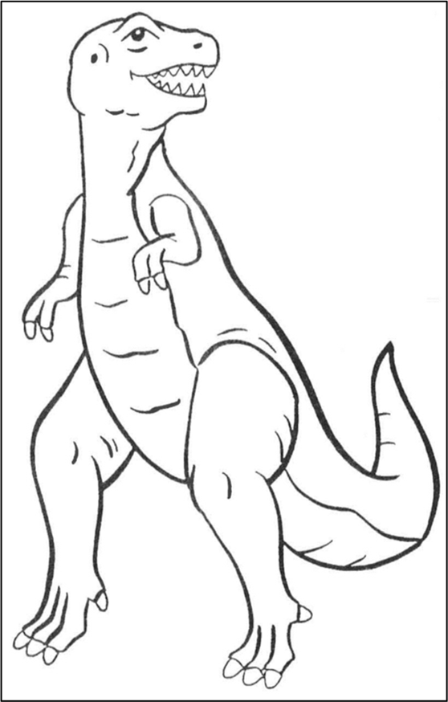
Diploducus
- This plant eating was the


longest. It 87 ½ feet
is
that they


Ankylosaurus  "curved lizard") - The Ankylosaurus was plant

was 15 long. It was too slow run away from the

dinosaur, so used its special as
was with
 plates that stronger that a shell. It had a bone at the end of its tail that crack enemies leg with

Triceratops (means "three-horn face") - Each horn on this dinosaur 2-feet long. This was a part of the heavy shield that was on skull. This 10-ton animal in herds and was very  They were  plant

Rex (means "king of the tyrant  - The was biggest of the meat eating dinosaurs. It was 50 feet long and
20 feet high. It would kill other dinosaurs for food. People that the ruled the land for million years.

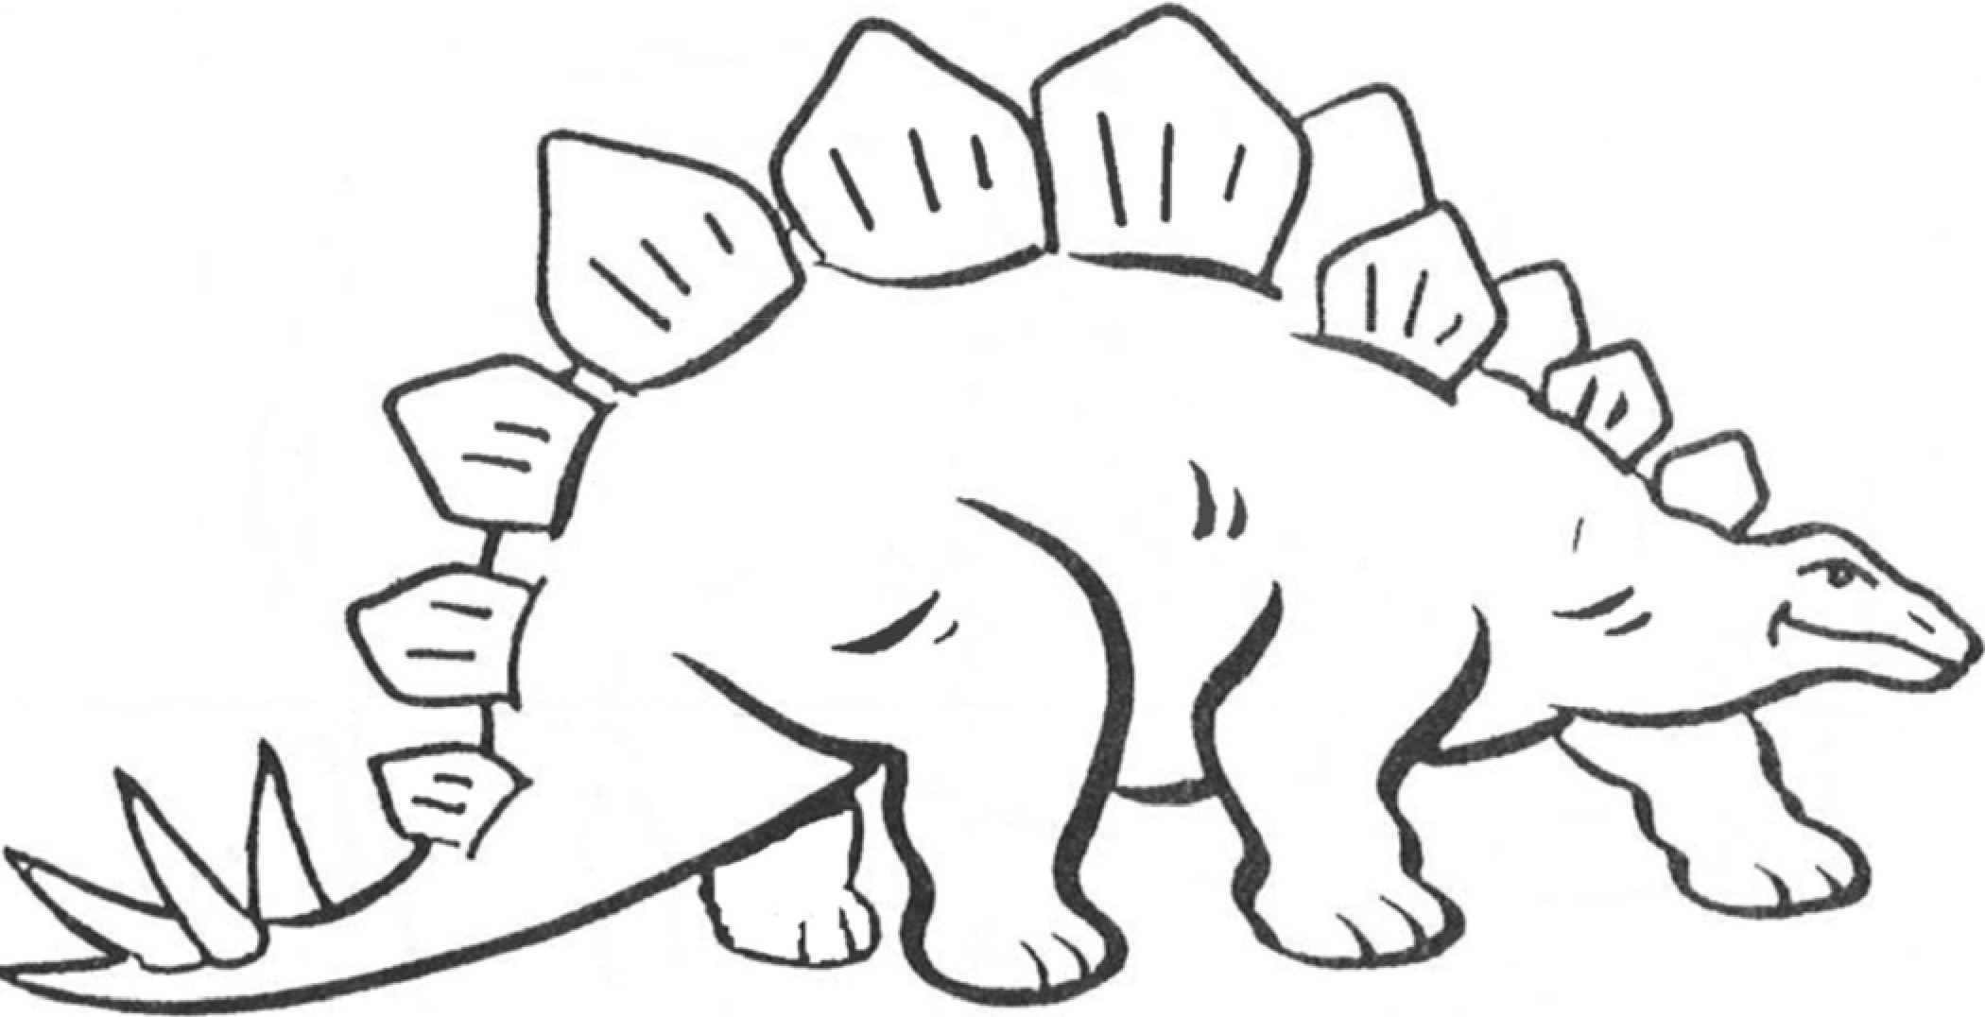
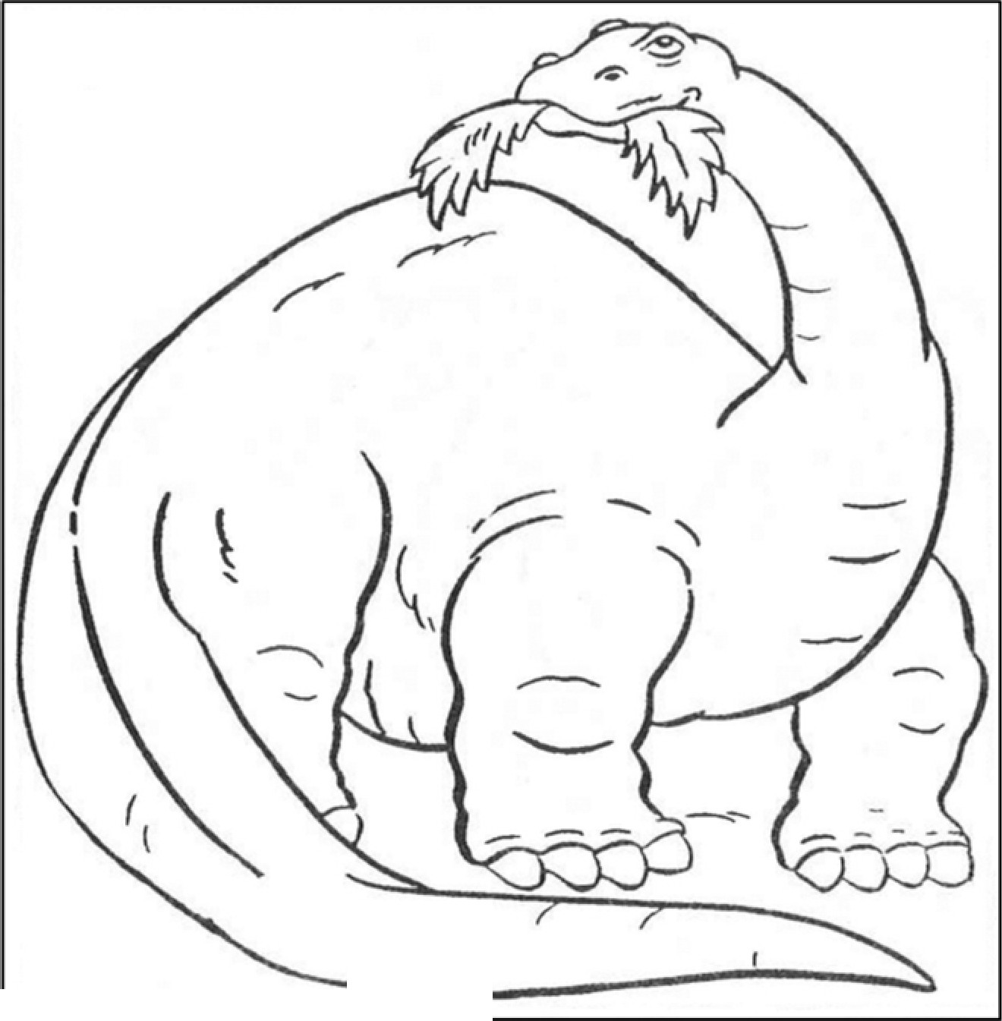
(

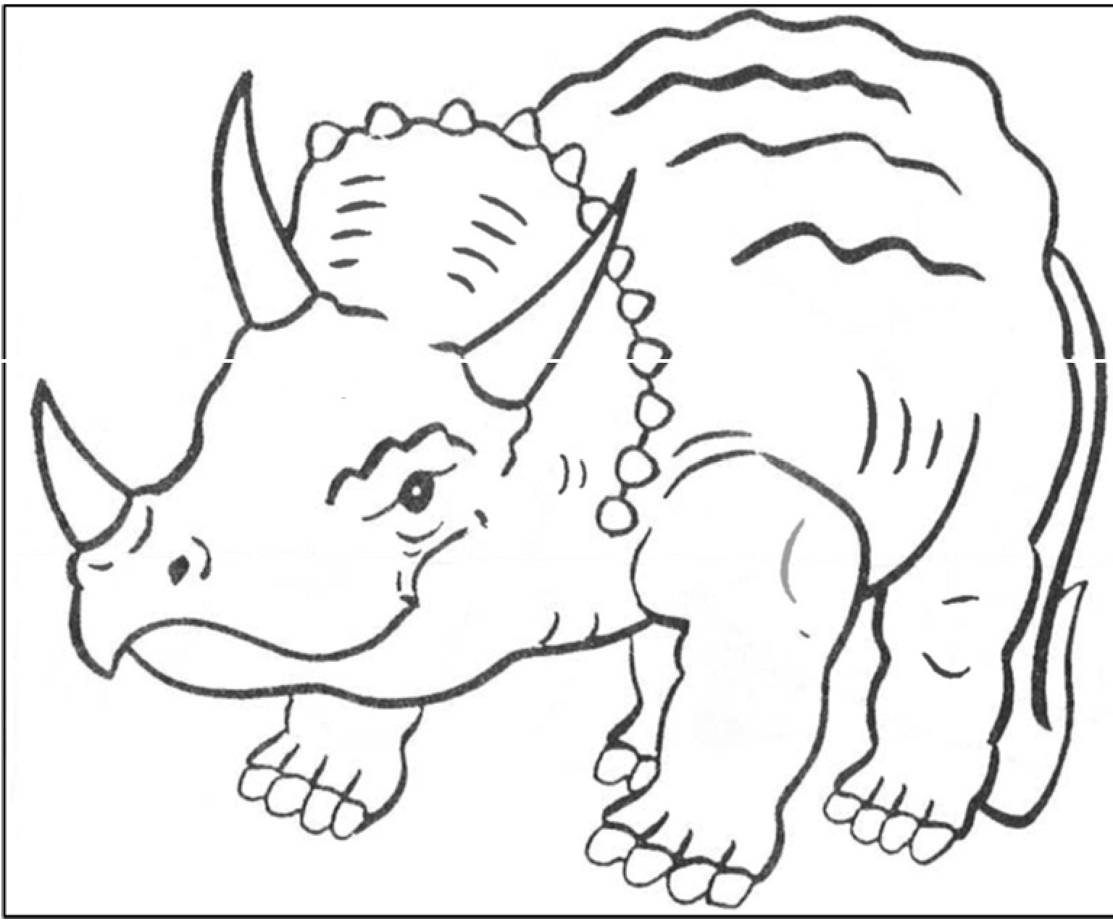
--.

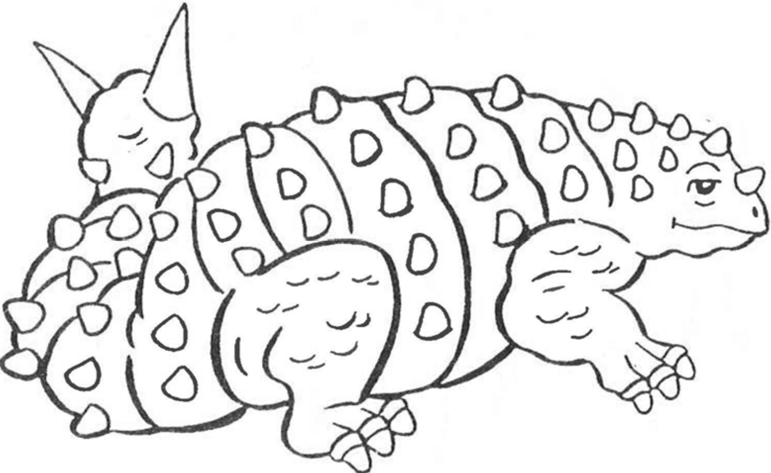

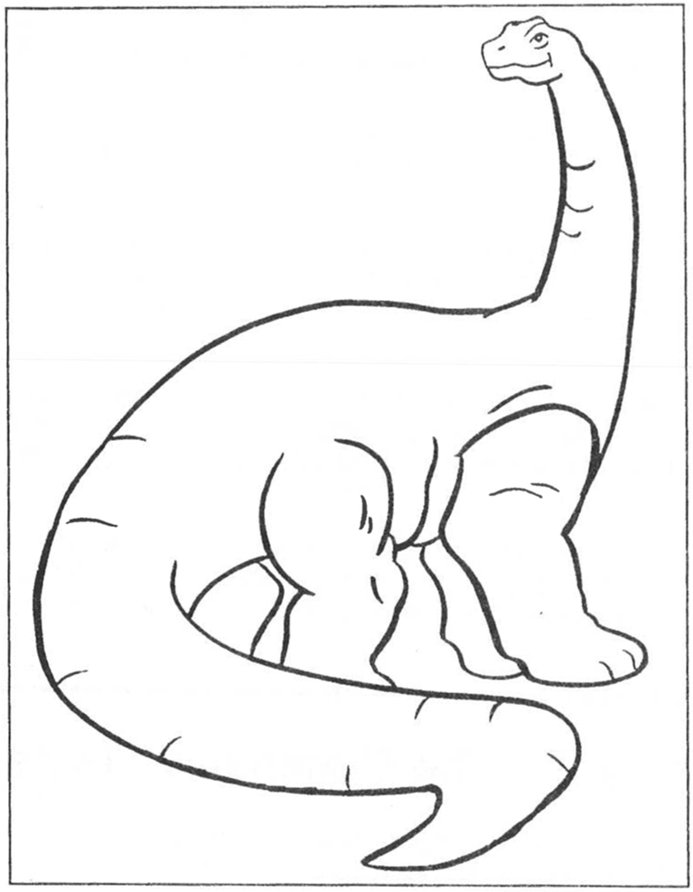

Here are some questions:
your
Which dinosaur is the tallest? If a floor is 8 feet tall, how many floors Which dinosaur is the most famous? Why?

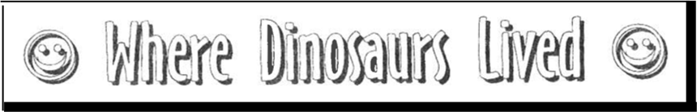

Some people believe that maybe lived in the same as we do now, of years ago.  could have lived you are sitting right
plant fossils, many people think that the Earth was very and humid. There were many and swamps. It rained most of year. weather would have been very close to the swamps in Central and South Americas.


Most of the plants that lived then were and smaller plants. plants were very simple. were no flowers, fruits or seeds. All plants liked the warm, wet climate. Plants gave a lot tender, green leaves to feed the large dinosaurs.

People also think that maybe at one time the continents were close together. could walk from North America to Europe! But the Earth was changing. were a lot of volcanoes. The  to

 Activity 4 -- The Continents 

You will need to find these things around the house:
- crayons, colored pencils or markers Here what you
- Draw lines that show how dinosaurs could have moved one continent to another on the "Pangaea" map.
- Color the continents.  to make them the same color each map. For example, color the continent of America green on both maps.

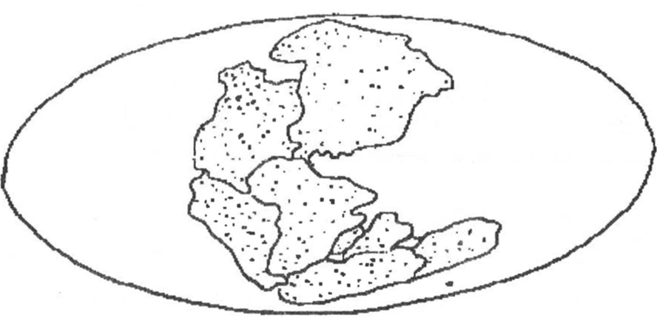
PANGAEA
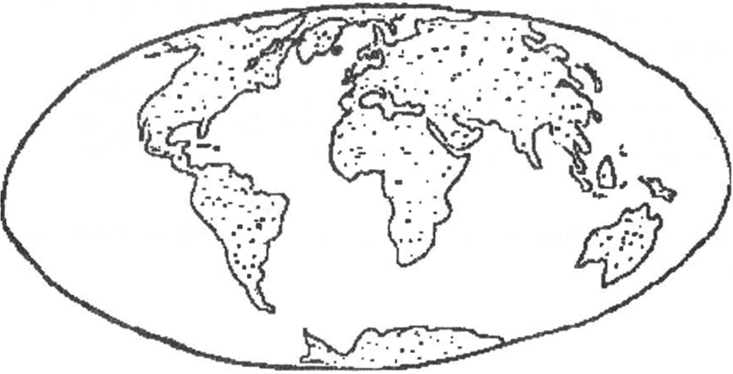

TODAY

Here are some questions:

What would have·to happen for
dinosaurs to come back
today?

Where would they live?

What would they eat?


About 65 millions years ago, something  to the dinosaur. Many people have many ideas about dinosaur extinction. means that a special kind of plant or animal no longer or is living.
One idea is that the weather on Earth  It

Another idea is that dinosaurs could not find enough food survive.
Other types of animals were able to live on small amounts food and survived.
A popular idea is that a large meteorite (a rock from space) hit Earth and made a big dust cloud. This cloud out the sun.
Because there was not any the plants died and the climate

are many other ideas. People are looking for the answer.
What do you

Answers to of Reptiles: (There are many

Answers to Types of Dinosaurs:
1. 2. T-Rex, 3. Stegosaurus, 4. Brontosaurus,
5. Triceratops, 6. Ankylosourus, 7. Brachiosaurus



"DINOSAURS"
RECORD SHEET
MINI 4-H PROGRAM

Name Grade Address

Please answer the following questions. Attach this completed

record sheet to your project. See you at
fair!!!

- Why did you choose this project?

- What is your favorite dinosaur?

- Which activity did you enjoy the most?

- Did you enjoy this project?

Parent's signature: Date:

WHAT TO

Choose
- Find 3 pictures of dinosaurs. Write the name of the dinosaur next to it. You can use the dinosaurs in this book. Put the pictures in a self-made notebook.

- Find 4 pictures of dinosaurs. Answer these questions for each picture. You can use the dinosaurs in the book. Put the pictures and information in a self-made notebook.
  - Name of dinosaur - Size of dinosaur
  - Weight of dinosaur - Type of dinosaur

- Exhibit an 11" x 14" poster (mounted horizontally with hard backing and covered in plastic) that how big dinosaurs were. Draw pictures of yourself, your house, your school, and your favorite dinosaur. Answer these questions for each thing.
  - Name of thing - Size of thing

PROJECT EXHIBIT
Mini 4-H

