ount
<J
�


MINI 4-H
PROGRAM

FLOWERS PROJECT MANUAL

Clay County Cooperative Extension Service
Mini 4-H Program
6656 N State Road 59
Brazil, IN 47834

(812) 448-9041

PROJECT EXHIBIT TAG
Mini 4-H Flowers
Name: Age:

Welcome to If you are 

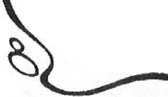


up for the Flowers project. We're glad to have

to the world us. Their scent makes air
sweet. They also have many uses. Bees, moths, and other insects feed on their nectar. So do some birds. Many flowers are used in cooking, in per in medicines

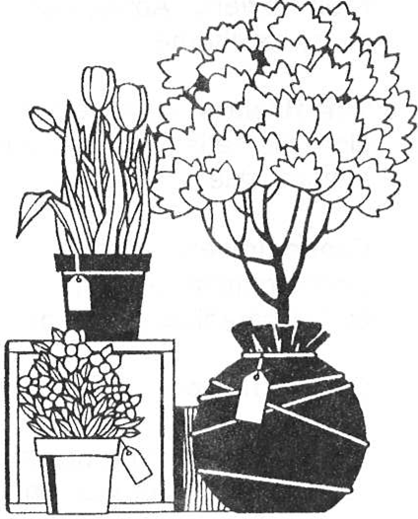
WHAT YOU WILL

You will exhibit a folder notebook with pictures  identification of 10


You may use flowers from  list on the following pages choose your

Pictures can be  magazines or you can  pictures 

TYPES OF
Wildflowers - daylilly, columbine, dandelion,  poppy, violet are a few.

Garden  that flower - carrots, peas, artichoke, squash cauliflower.

Grasses with wheat, rice, rye, bluegrass, and

Milkweed goldenrod, Lady's Thumb, Cudweek,  Milkweed.

flowers - yellow  dogwood, mimosa, Royal Poinciana, Horse

Shrub rhododendron,  swamp azalea, hibiscus and forsythia.

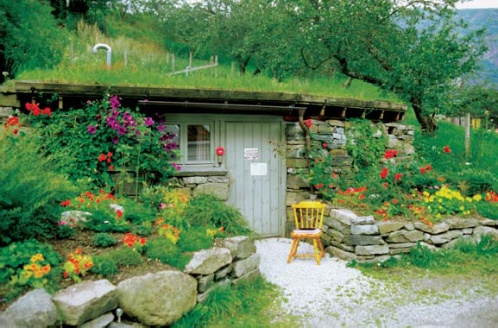
Fruit Apple, black cherry, plum,

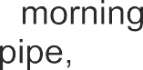
Vine flowers  vine, glory, clematis, dutchman's

Exotic flowers 
night-blooming
bird-of-paradise, yucca,
Garden flowers – iris, lilly, tulip, pansy, hollyhock, zinnia, tulip, daffodil, rose, peony, cornflower, snapdragon, and sunflower are just a few.

FLOWER FACTS

Pansies are grown from seeds and can be planted in the early spring or in
August.

Petunias, Snapdragons and Zinnias are grown from seeds and should be

planted in the
spring.

Marigolds are grown from seeds and should be planted in the early spring.

Daisies are grown from seeds and bloom in the spring. They must be planted in July or August the year before.

Tulips,
Daffodils,

and Hyacinth
are grown from
bulbs planted in the fall for

blooming the next spring.

Violets are grown from seeds
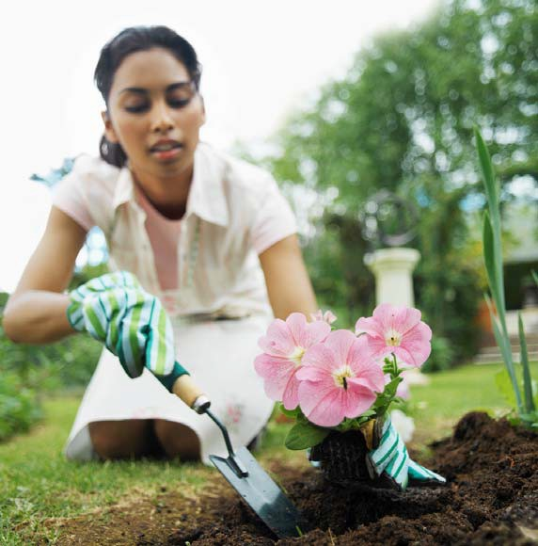
or cuttings and can be planted either in the spring or fall.

GARDEN PLAN

Although it is not required that you plant a "flower garden" for this project, you may want to practice so that when join 4-H at the age of 9, you will already be ahead of yourself with the

Here is a simple garden that is planned so that there will be flowers in bloom from the early spring through autumn. Start in the fall. In a sunny spot, dig the soil until it is fine. Plant daffodil bulbs, first, tulips later. Daffodils - shorter and first to bloom - should be in front. Dig 5 to inches deep. Put fertilizer in each hole. Put in the bulbs - flat side down - and cover with

On a warm spring day, plant the zinnias and marigolds. Follow the directions on the seed packages.

Put chrysanthemum plants in May. Put fertilizer and some water into each As the branches start  pinch off their tips to keep plants bushy.

Water and regularly and you will have a garden.

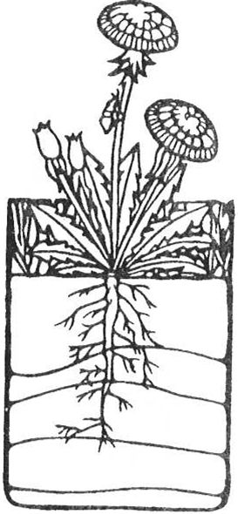
GOOD









CHECK SHEET



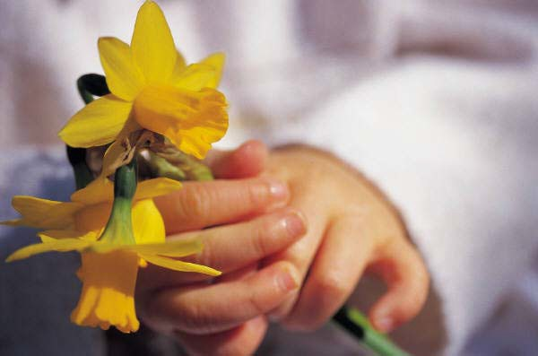

Is your exhibit tag on 
(Place on the front of your notebook in the lower right hand corner

Are your records 

(Include your “record sheet” in your notebook

Is your work neat, clean, and your 


Are you pleased with what you 



FLOWERS
RECORD SHEET
MINI 4-H PROGRAM

Name Age

Address

Please answer the following questions. Attach this completed record sheet to your project. See you at the fair!!!
- List five different plants that are grown from seeds.

- List three different plants that are grown from bulbs.

- Did you plant a garden? If so what kinds of flowers did you plant?

- What is your favorite kind of flower?

Parent's signature: Date:

