

Mini 4-H Program
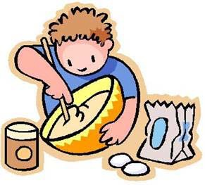

Foods Project Manual
Purdue Cooperative Extension Service-Clay County 6656 North State Road 59
Brazil, Indiana 47834
(812) 448-9041
Project Exhibit Tag
Mini 4-H Foods
Name:

Age:

Updated 2/2013

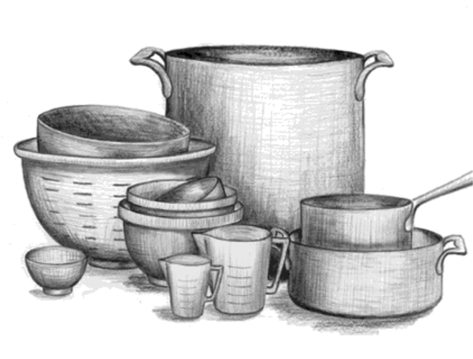
Hi there! Welcome to the Mini 4-H Program. In the Mini 4-H Foods project you will discover how much fun it is to cook and bake.
Some of the things you will learn in this book are:
- How to set the table
- My Plate and Food groups
  - How to Measure
- Following a recipe to make cookies
Cooking is a lot of fun, as you will find out as you work on your Mini 4-H project. Be sure to follow directions carefully and ask an adult before using the kitchen and the stove. Have fun and enjoy!
What You Will Exhibit
You will exhibit Four (4) no bake cookies from one of the cookie recipes in this manual on a plain white 6” paper plate at the Clay County 4-H Fair.
Attach the exhibit tag (located on the front of this manual) to the front of the plate. Attach the completed RECORD SHEET and a 5” x 8” recipe card with your exhibit recipe on it to the back of the plate.

Kitchen Safety Rules
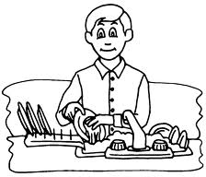
Before you start in the kitchen, you should know some Safety Rules so you don’t get hurt.
- Use pot holders when touching hot pans.
- Stir hot mixtures with a wooden spoon.
- Turn saucepan handles toward the back of the stove, so they won’t get knocked oﬀ.
- Turn oﬀ all burners when you are finished cooking.
- Ask an adult if it is okay to use the kitchen and the stove.

Helpful Hints
- Wash your hands.
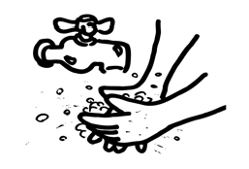
- Before you begin, read through the recipe.
- Get out the ingredients that you will need.
- Get out the utensils that you will need.
- Always follow the instructions carefully.
- Clean up your dishes and work area, put everything away.

Terms and Definitions
Boil - Heat a liquid hot enough so that it bubbles hard and steams. Melt-Changing a solid ingredient (like butter or chocolate) into a liquid by heat. Simmer-Cook in a liquid over very low heat. Bubbles are lazy, not rolling.
Mix-Stir ingredients together thoroughly.
3 teaspoons (t) = 1 tablespoon (T)
4 tablespoons (T) = 1/4 cup (c) 1 cup (c) = 1/2 pint (pt.)
8 tablespoons (T) = 1/2 cup (c) 2 cups (c) = 1 pint (pt.)
1 cup (c) = 8 ounces (oz.) 4 cups (c) = 1 quart (qt.)
16 tablespoons (T) = 1 cup (c) 4 quarts (qt.) = 1 gallon (gal.)

How To Measure

What To Use:
Standard measuring cups and spoons are the secret of accurate measuring.

Measuring Dry Ingredients– Take a heaping measure in a spoon or cup, then level it oﬀ with the flat edge of a table knife or spatula.

Measuring Liquids-A liquid measuring cup has a rim above the 1 cup line to prevent spills. Place the cup on a level surface and read it from the side. You’ll probably have to bend down to do this.

Measuring Brown Sugar– Since brown sugar is sticky, you can measure it more accurately by packing it. Fill a dry measuring cup and press down with the back of a spoon to pack firmly.

Measuring Fats or Shortening-Fat at room temperature is easier to pack without air pockets. Fat is leveled the same way you level dry ingredients.

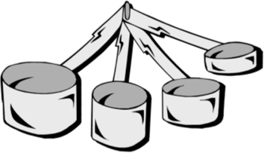
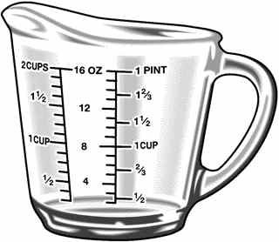

What’s on your plate?

Vegetables
Vary your veggies, eat more red , orange & green.

Eat 2 1/2 cups every day.
Fruits
Focus on whole fruits but any fruit counts.

Eat 2 cups every day.
Grains
Make at least half of your grains whole grain.
Choose products whose labels name a whole
grain first on the
Protein
Go lean with protein.
Eat a variety of foods from the protein group, beans, nuts, sea-
food, lean meat,
Dairy
Choose skim or 1% milk. They have the same amount of Calcium but less fat and calories.

Low-fat yogurt is a

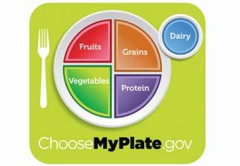
Make half of your plate fruits and vegetables.
ingredients list.
Eat 6 ounces every day. One slice of bread is an ounce.
eggs and poultry.

Eat 5 1/2 ounces every day.
good choice.

Get 3 cups every day.

Setting the Table for Everyday Meal
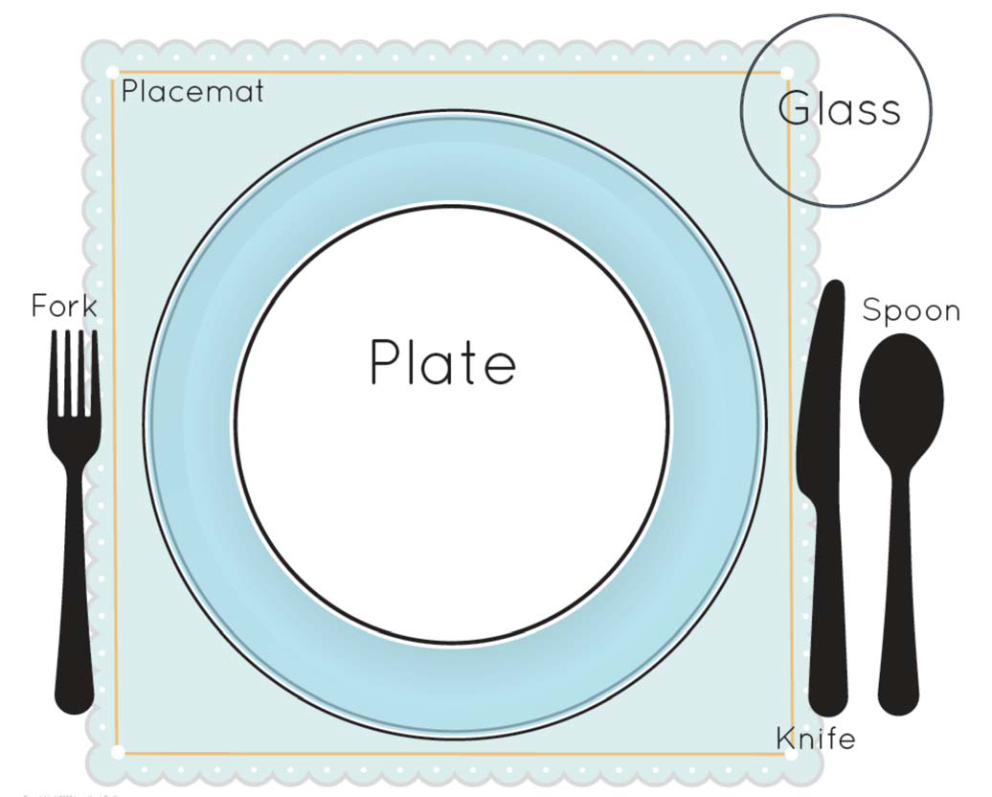
For pleasant family meals, set the table as shown in the picture above. To make the meal even more pleasant , add a centerpiece such as flowers, fruits or a candle. Place the fork and napkins on the left. Knife, spoon and glass goes on the right. The blade of the knife should always be pointed toward the plate.

You can practice by setting the table for some of your family meals.

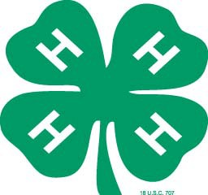

Scrambled Disks

Ingredients Equipment
2 cups semi-sweet chocolate bits Saucepan
2 T. vegetable shortening Mixing spoon
3 cups miniature marshmallows Dry measuring cups
2 cups broken pretzels Wax paper

Directions
- Melt chocolate bits and shortening over low heat in the saucepan. Stir until completely melted.
- Remove from heat, add marshmallows and pretzels. Stir until covered with chocolate.
- Drop by spoonful's on wax paper.
- Let cool until firm.

Rice Krispy Treats

Ingredients Equipment
1/4 cup margarine Saucepan
5 cups Rice Krispies Dry Measuring Cups
4 cups miniature marshmallows or Table Knife or Spatula 10 oz. regular marshmallows Mixing Spoon
Buttered 13’” x 9” pan

Directions
- Measure all ingredients before you start and prepare your pan (butter it).
- Place butter in saucepan and melt over low heat.
- Add marshmallows, stirring constantly until marshmallows are melted and mixture is blended.
- Remove from heat and stir in Rice Krispies. Mix well. Press warm mixture into buttered pan.
- When cool, cut into 2 inch squares. (makes 24 squares)

Noodle Clusters

Ingredients Equipment
12 oz. package semi-sweet chocolate bits Double Boiler Pan
1 cup Spanish peanuts Mixing spoon
2 cups chow mein noodles Dry measuring cups Wax paper

Directions
- Melt chocolate bits in the top section of a double boiler pan over hot water.
- Remove chocolate from heat, mix in Spanish peanuts and chow mein noodles.
- Drop by spoonful's on wax paper.
- Let cool until firm. Makes 2 to 3 dozen clusters.

Butterscotch Crunchies

Ingredients Equipment
6 oz. package butterscotch bits Saucepan
1/2 cup peanut butter Mixing spoon
3 cups Rice Krispies or Corn Flakes Dry measuring cups Wax paper or 9” x 9” pan

Directions
- Melt butterscotch bits and peanut butter over low heat in the saucepan.
- Stir until completely melted and well mixed.
- Remove from heat, add Rice Krispies or Corn Flakes. Stir until well coated.
- Drop by spoonful's on wax paper or press into 9” x 9” pan.
- Let cool until firm.
- Makes 16 squares.

Unbaked Peanut Butter Cookies

Ingredients Equipment
1/2 cup sugar Saucepan
1/2 cup corn syrup Mixing spoon & rubber spatula
1 cup peanut butter Dry measuring cups
2 cups corn flakes Wax paper

Directions
- Simmer sugar and corn syrup for 3 minutes .
- Add peanut butter and stir well.
- Remove from heat and stir in corn flakes. Stir until well coated.
- Drop by spoonful’s onto wax paper and cool.

Chocolate Oatmeal “No-Bake” Cookies

Ingredients Equipment
3 cups rolled oats Saucepan
1/4 cup cocoa Mixing Bowl
1 stick margarine Mixing spoon & rubber spatula
2 cups sugar Liquid & Dry Measuring Cups
1/2 cup peanut butter Table knife or spatula
1/2 cup milk Wax paper

Directions
- Place margarine, sugar, cocoa, peanut butter and milk into saucepan. Place saucepan over medium heat and bring to boil.
- Boil for one minute while stirring constantly, then remove from heat.
- Add rolled oats and mix.
- Drop by spoonful's on wax paper.
- Let cool until firm.



Mini 4-H Foods
Record Sheet

Name Age

Please answer the following questions. Attached this completed record sheet to your project. See you at the fair!

- Name the Five Food Groups from My Plate

- List the name of the cookies that you have made and how many times you made them. Example: No-Bake Peanut Butter 3

- What did you learn from this project?

Parent’s Signature Date

