-

All Divisions

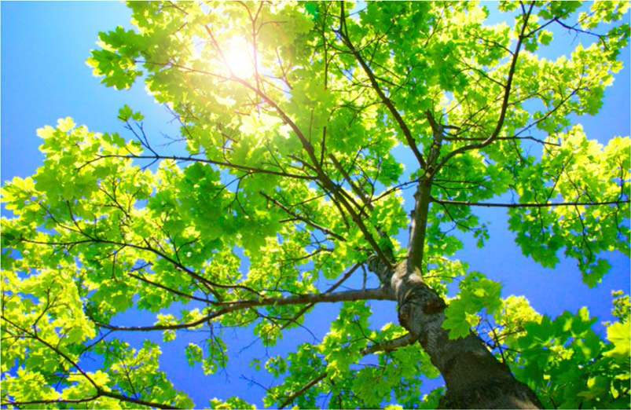

Draft
Developed by
Purdue University Cooperative Extension Service Area 7 4-H Youth Development Educators

(Blackford, Delaware, Fayette,
Franklin, Henry, Jay,
Madison,

Randolph, Rush, Union, & Wayne
Counties)

PURDUE UNIVERSITY, INDIANA COUNTIES AND U.S. DEPARTMENT OF AGRICULTURE COOPERATING
AN AFFIRMATIVE ACTION/EQUAL OPPORTUNITY INSTITUTION




Richard
Educator,
Purdue University Service - Delaware


Reviewed and Edited Area 7














RaeAnn O’Neil,  4-H Youth Blackford Carolyn Miner, 4-H Youth Delaware
Caldwell 4-H Youth Fayette County   4-H Youth County
4-H Youth Jay
Leanne  4-H Youth Henry Jeanette Findley, 4-H Youth Madison
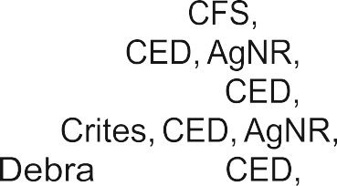
Scott Ripberger, 4-H Youth Madison Sue Provost 4-H Youth
Dan Kirtley, 4-H Youth
Brian Gauck, 4-H Youth County
4-H Youth Union
Searcy, 4-H Youth Wayne Natalie Carroll, Extension Specialist, State 4-H
Anita Krug, Program Coordinator, State 4-H




Please Note: As a professional courtesy, the Area VII Extension request that these materials be or
any means. Copies of the materials may be for

Resources and

Mini 4-H Manual, Madison County, Indiana
4-H Discovery Manual, Henry County, Indiana
4-H Manual, Delaware County,

January
 January


4-H

Welcome to the Mini Program! Mini designed for youth explore a variety of project areas.


child received this project manual when enrolling in Mini 4-H. This manual will provide fun, learning activities throughout their  in Mini and their in


As a Mini parent, your job be to guide and your through the activity. It is highly suggested that you do not
activities for them. Instead, help them, guide them, them, and them do all that they  can. motto is by doing” ... And is the best tool that we can provide for 

Additionally, the Mini program set up to allow your child to exhibit project at the Fair. This project is based upon information within this

The 4-H Fair is an exciting time for 4-H members and families. It is a week that allows community youth to showcase their talents, interests, and enthusiasm for learning.


Mini 4-H is fun! Your child will certainly enjoy it. can have fun too, guiding and helping as your child participates in the program. Encourage praise your child as he/she has fun learning and sharing with

If you have any questions regarding Mini or other please feel free to your local

Developed by Area VII Extension Youth Educators - Draft Purdue University Cooperative Extension Service


Mini 4-Her's Page

to Mini 4-H! are now a of the 4-H family. You a special

Mini have lots of fun! are lots of activities for you to  You can try new things. You can share it with your friends and 



Mom, Dad or another adult can help you with your project. project to the 4-H Fair and lots of be able to see what done. also get a ribbon for Mini 4-Her’s.
you


Here are some things to know about 4-H.


Symbol: A four-leaf clover with
an in

Colors: Green and White

Motto: make the best,

Pledge: I my Head to
clearer
my Heart to greater

my Hands to larger service, my to better
for my club, my
my country, and my



Do you to take a walk in the park or under a tree in the summer? you a real tree instead of an artificial one? Have you animals or birds that make their home in trees? Can you find things wood around your home? If you can answer  to any of these questions, Mini 4-H forestry is for you!
Forestry is the study of trees. leaves in many sizes and shapes. are many trees that have colorful leaves. Trees are cut down in forests and are into wood. Trees help us in many ways.  project will help you learn many things about trees.




main parts of a tree are the leaves and branches, the trunk, roots. sun shines on the leaves which helps make food for the tree. The leaves provide shade. leaves are to the branches. Birds in the branches. We get such things as lumber and paper products the trunk. roots feed the tree and keep the wind from blowing it

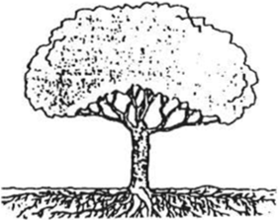
Can you the parts of the tree to it is on the picture? Draw a line the part to where it on the
Roots Branches Trunk Leaves
Developed by Area VII Extension Youth Educators - Draft
Purdue University Cooperative Extension Service


Activity --Draw a Tree

you might
Crayons markers

On a piece of paper, draw and color a tree. Make you draw all parts of the tree. may want to include birds or animals in the 



on

are many things that we use every day that are of wood. Our homes,  pencils and even the paper in manual are of around your home and neighborhood. Can you 4 things


2 --
of Wood

you might



Make a poster with pictures cut from a magazine or pictures taken with camera of items that are of wood. A title of your poster could be “Uses of Wood.” Use 5 to 7 pictures on your poster.

Developed by Area VII Extension Youth Educators - Draft Purdue University Cooperative Extension Service


Home Sweet

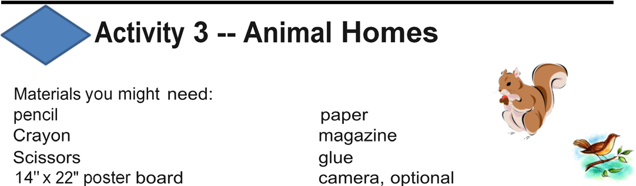
Many small animals make home in branches of trees or live in a in the of a tree. Have you seen a nest or a hole in the a walk park, woods,  or school yard and look for animals that use trees for home. Can you look for a bird nest or a hole where a  or hive of bees might live?


Make a poster pictures cut from a magazine or pictures taken camera of animals that make their homes in trees. A title for your poster be in Trees.” Use 5 to 7 pictures on your poster. Draw and color a pic-ture of an animal and home in a tree such as a bird In a nest in a tree, or a 
3 --
Homes
you might
pencil
14" x
poster
or in a hole in a tree.



Shapes of
leaves have many shapes. Some leaves may look a fan while may look a  the palm of your hand, or a needle. in a park, woods,  or yard and collect leaves that have different shapes.

Developed by Area VII Extension Youth Educators - Draft Purdue University Cooperative Extension Service


4 --
of Leaves

you might

container for

glue or scotch 


or tape 5 to 7 leaves on a piece of paper, 8 1/2 x 11 (one leaf page). notebook or plain white paper. a piece of colored paper for the front and back cover and staple together. now have a "leaf book." a title and your name on the front.

are many types of trees. are trees that grow very tall lots of branches to provide shade. We get apples, pears, and other fruit from trees. Walnuts, pecans, and other nuts are  on many kinds nut trees. In  many families go to a tree farm to select ev-ergreen tree to for Christmas. bloom in the  or sum-mer and provide color in our yards. Each tree has a special

5
Materials you might
of

14" x 22" poster
Make a poster pictures cut out of a magazine of the different types trees. the use of each tree by its picture. A title for your poster could  5 to 7 pictures in your poster. Draw a picture of your house and yard. what types of trees you have or would to have your 

Developed by Area VII Extension Youth Educators - Draft Purdue University Cooperative Extension Service


Fall Colors
can be many different colors. In the summer many leaves green but some can be yellow, purple, or other colors. In the fall, the change to bright colors of red, gold, orange, and yellow. Some trees like ever-greens have green leaves all year.

 6 --  Leaves
you might


 crayons
glue or
x
poster
ma
rkers

a walk in your yard, the woods, park,  or yard. 5 to 7 different colored leaves. If you cannot find leaves of different colors, out pic-tures of trees colored leaves from a magazine. Tape or glue colored leaves or pictures of trees colored leaves on the poster board. The title of your poster could be “Colored Leaves.” Make a colored leaf your own leaves crayons or of the shapes and colors that saw. Glue or paste leaves (one per page) on white paper. Use colored construction paper for the front and back and staple together. your title and name on the front.
Collect leaves this fall for your Mini  exhibit next



Developed by Area VII Extension Youth Educators - Draft Purdue University Cooperative Extension Service


Textures
bark protects the tree from   and injury. the bark of a tree. Does it feel rough or smooth? Does the bark feel the same at bottom of the tree as at the top? Feel the leaves. Do they feel rough on side  to the other? bottom side has or ridges. veins help the leaves to get water so that they can grow.

7 -- Rubbings
you might  crayons

notebook or plain white paper. Make bark rubbings by holding paper against the bark and coloring back and forth over it crayons. The ridges on the bark will show up darker than the depressed area leaving pattern on the paper. A leaf rubbing can be by placing the on the table vein side up. Place the paper over it and use the side of a to color over the leaf. different leaves and colors. Make 5-7 different bark and leaf rubbings. a  of construction paper for the front and cover and staple together. now have a “ rubbing a title your name on the front.


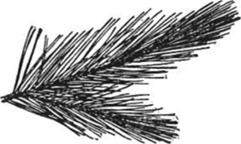
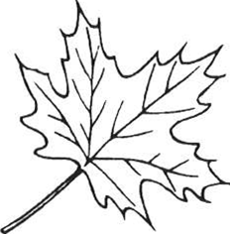

Developed by Area VII Extension Youth Educators - Draft Purdue University Cooperative Extension Service


Forestry Senses

or yard. Quiet--what you hear? Look--what do you see? What do you smell? What do you feel? Use your to see, hear, smell and
 Activity 8   Senses

Materials you might
clip
container for collecting glue or 

a walk in the woods, park, or  in the chart what you saw, smelled, heard or touched. Collect 5 to 7 things listed in your chart. Use one white  of paper for each smelled, heard touched. Write or draw what you saw, smelled, heard or touched. If any items,  or glue them to the  of paper. construction paper for the front and back and staple together. Put a title your name on your “
My  Senses

What I Saw | What I Smelled | What I Heard | What I Touched

Developed by Area VII Extension Youth Educators - Draft Purdue University Cooperative Extension Service


Exhibit Tips

Choose

- Make an 11" x 14" poster (mounted horizontally with hard and covered in plastic) of a tree that you have drawn. Label the parts of the tree that you have

- Make an 11” x poster (mounted horizontally with hard and covered in plastic) with pictures cut from magazines pictures taken with a camera of items that are made of wood. Use 5 to 7 pictures on your poster.

- Exhibit a collection of leaves. They can be displayed in notebook or a poster (11" x 14" mounted horizontally with backing and covered in plastic). Use 5 to 7 leaves. Label each leaf with their

- Make an 11" x 14" poster (mounted horizontally with hard and covered in plastic) with pictures cut out of a magazine the different types of trees. Write the use of each tree by its picture. Use 5 to 7 pictures on your

Good 

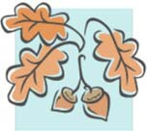
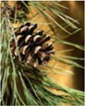
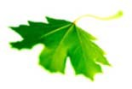

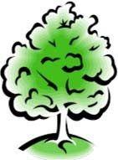

PROJECT EXHIBIT
Mini 4-H



“FORESTRY” RECORD SHEET MINI 4-H PROGRAM
Name

Please answer the following questions. Attach completed record sheet to your project. See you at the
choose this project?

the

learned

