
ount


MINI 4-H

PROGRAM

GARDENING PROJECT MANUAL

CLAY COUNTY COOPERATIVE EXTENSION SERVICE
MINI 4-H PROGRAM
6656 N. STATE RD. 59
BRAZIL, INDIANA 47834

812-448-9041

PROJECT EXHIBIT TAG
Mini 4-H Gardening
Name: Age:



Hi there! Good to have you enrolled in the  4-H" program. In this project you will discover how much  it is to grow 

   In order to complete  project you will need to decide what you are going to  You may grow 

- A small vegetable 

- A sweet potato 

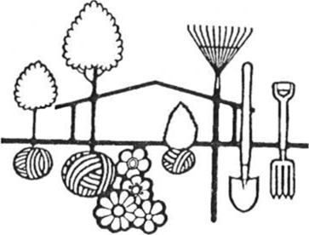
The following pages will give  more good ideas on how to grow 


WHAT YOU WILL EXHIBIT


- Select one vegetable variety from your garden and bring 3 products the same vegetable on a paper plate to the county 4-H fair. Be sure to fill out the "Exhibit Tag" and tape it to the front edge of your your complet-ed record sheet to the bottom of the paper



- You may exhibit your sweet potato 

OR
- Exhibit 3 to 5 pictures of your

plant or garden. If you decide to exhibit pictures of your plant or  you should put them on an 11" x 14" inch horizontal piece of  board or heavy cardboard. This must be covered with plastic mounted on a hard surface. Include a sentence under each picture. Be sure to fill out the exhibit tag and place it on the front lower right corner of your poster or on your plant container. Attach your record sheet to the bottom of the container or to the back of your and cover your poster with clear 

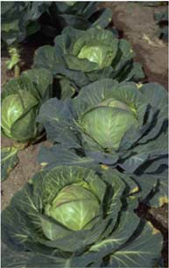
NOTE: If you select #1 above to exhibit, should exhibit only one product for larger vegetables such as watermelon,  or 

SWEET POTATO VINE

Here's a fast-growing vine for you to try, buy a sweet potato or two the next time you and your family go to grocery store.

Sweet Potato Vines are easy to grow. can grow it in water, and you can train it to climb up around a window. You must begin with a healthy sweet potato. Select a  potato that is free of rot, mold, or black spots. If a few  buds are showing, that's fine:  potato has   to sprout and probably will grow quickly. Make sure there are some "Eyes" (buds) on the potato you

Cut off half of the sweet potato so it will stand in a filled with one inch of water. Put the dish near a window. Soon you will notice green sprouts coming from the "eyes". If you keep it watered you will have a healthy and attractive green vine. Be sure there are some "EYES" on the piece of sweet potato you have chosen to grow.




PLANT YOUR VEGETABLE
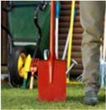
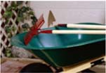
Find a place which has at least six hours of sunshine each day. Your garden should be no bigger than 10 by 10 feet or you could use a space  a garage or
Is the soil ready? Take a ball of soil (dirt) from your garden and squeeze If it falls apart you can go ahead and plant your garden. If the ball together, it's too wet so you will need to wait until the soil gets dry. Before plant your garden, you will need to do the following 

- Put fertilizer on your garden
- Turn the soil under about 6 to 8

- Smooth the area with a

When to plant? If you are using seeds, follow the directions on package. The package will tell you how long it takes the vegetables to grow. Make sure you plant it soon enough so that it will be ready by fair time. Ask your mother or father to help you decide when to plant each vegetable. You should plant at least 3 different kinds of vegetables. Why add some color to your garden by planting some



IDEAS TO HELP YOU

Planting

Now decide what you want to grow. Some easy vegetables beets, lettuce, carrots and
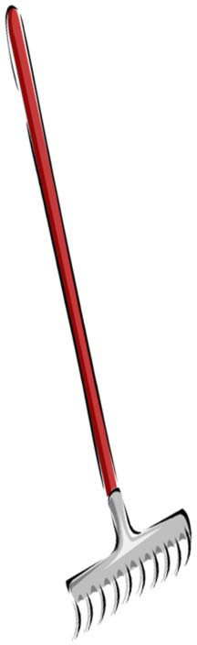
You may want to get a head start on some vegetables by plants. Some of these could be tomatoes, peppers, and

Be sure to ask your mother and father to help you with and reading the directions on the seed

Don't plant your seeds too deeply. Barely cover the little (like carrots and lettuce) and have only 1 inch of soil over seeds (like

Garden
You will need some tools to use in your garden. Maybe mother and father will let you use their tools. You will need spade or shovel, rake, hoe, garden hose or sprinkling string and


Other things you need are:
seeds and

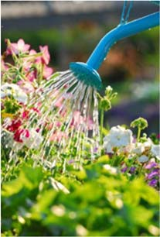
Weeding
Vegetable plants need plenty of water in the summer. Put 1 to 1 1/2 inches of water on your garden week, unless the rain does it for Light sprinklings may do more than good. Weeds are like They steal water, food an

from your plants. Pull all weeds
d
they
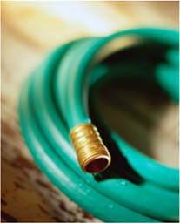



CHECK



 Is your exhibit tag on 

 Are your records 

 Is your work neat, clean, and your 

 Are you pleased with what you 


 Did you help anyone else learn  fun projects from this project 

 Did you do more than one activity  this 



"GREEN  RECORD  MINI 4-H 

Name Age Address

Please answer the following questions. Attach this completed record sheet your project. See you at the

- Which of the choices did you choose for your "Exploring

- How many plants did you have for your project?

- What date did you start your project?

- List the people that helped you with your project?

- How much did it cost you to grow your garden or sweet 
plants?

- List some of the things you did to make sure your plants

Parent's signature: Date:

