




Project Exhibit Tag
I’m a Hoosier
Name: Age:

In the Mini 4-H project, "I'm a Hoosier!" you will learn about some of the from Indiana and many interesting facts about the state where you


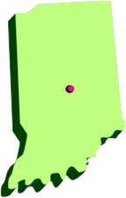
The town where you live is part of a larger area called a county. The county where you live is part of a larger called a state. In the state of Indiana there are 92

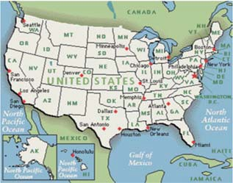
What is the name of the where you

That town is in Clay
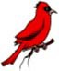
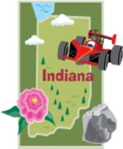
Clay County is in the state of Indiana is in the United States of
You will have fun learning about the state of Indiana while an exhibit for the fair. What do you need to exhibit? choose an activity to do. Read over the exhibit ideas with helper (mom, dad, grandparent, brother, sister...) and
what you would like to complete and bring to the

Come on! Let's learn about the great state of


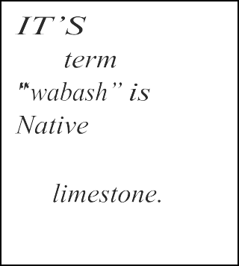
A FACT/
Holiday World,
once Santa
the world's
as
was
park!
IT’S A FACTI
Indiana farmers produce more popcorn than in any other
in the United
A FACT!
The
a

American word for





John Chapman, more commonly known as Johnny Appleseed, traveled Midwest planting apple seeds that would grow into beautiful apple
He died in March, 1845 near Fort Wayne. gravesite is located in Johnny Appleseed Park located in Fort Wayne, Indiana.

1: STATE SYMBOLS


In 4-H, there is one basic symbol: the 4-leaf clover with an “H” in each leaf. The state of Indiana has many symbols. State symbols are special and abundant in that particular state. In this activity you will learn about some common and uncommon state symbols.
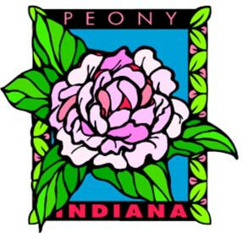
STATE FLOWER: PEONY
Peonies bloom in late May or early June. They tend to be plants that have blossoms
of red, pink, and white. You may notice ants on peony blossoms. When peonies grow buds, the sweet nectar attracts the ants.
The ants actually separate the flower petals to get more nectar. These ants are actually helping the peonies bloom! The peony became the state flower in

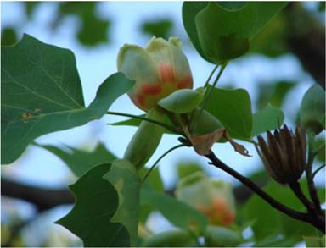
STATE TREE: TUL I P
Trees are a daily reminder that our roots should run deep if we want to grow straight and tall! The tulip tree is sometimes called the yellow poplar. It can sometimes grow to be 200 feet tall! How tall are you? Tulip trees are the tallest broadleaf trees in the eastern region of North The Tulip Tree became the state tree in . Here is what the leaf of the tulip tree like.

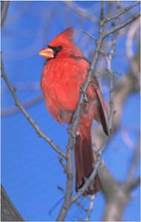
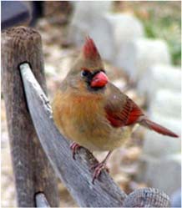
STATE BIRD:
The cardinal is a beautiful bird that lives Indiana year-round. The male (boy) cardinal a bright red color while the female (girl) is color with a reddish brown crest. The cardinal’s crest is the feathers that point out from the top of its head. Have you seen in your yard? Have you ever seen a pair (boy and girl) of cardinals? The cardinal was the bird in

A FACT!
The Indy 500 race track
built in 1909
bricks! WOW!!! The first race in 1911

STATE SONG: "ON THE BANKS OF THE WABASH FAR AWAY"
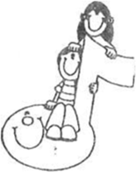
The state song was written, words and music, by Paul Dresser. Mr. Dresser was born in 1858 in Terre Haute, Indiana. His childhood home is located in Fairbanks Park along 1st Street and just south of the Vigo County Courthouse. Most people will recognize the chorus of this famous

"Oh, the moonlight's fair tonight along the ,

From the fields there comes the breath of new-mown Through the sycamores the candlelight is gleaming,
On the banks of the Wabash far away."


STATE ROCK:
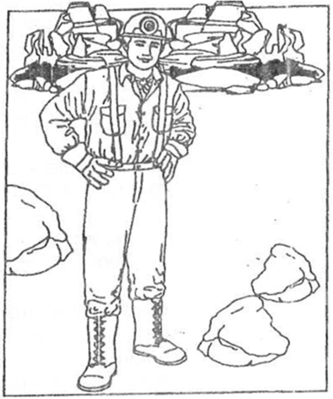
Limestone is found in and southern Indiana. It is mined from quarries and used in construction of buildings all across the United States. The Vermillion County Courthouse in Newport is made of Indiana limestone from Bedford, a city in Lawrence County. The state capito building Indianapolis is made from Indiana limestone. Indiana limestone is used all over the world! Buildings that you may have heard of visited that are made from limestone include: the Empire State Building and Rockefeller Center in New York City as well as the Pentagon, Washington National
Cathedral and the U.S. Treasury in Washington
  - Many government buildings in Indiana all over the United States are made from Indiana limestone.


WHAT DO YOU THINK?
Did you know that a
for a
from Indiana is a "Hoosier? "Hoosier" a
Indiana. Nobody
for sure where
this started. Here are a few Ideas.....
"Whe Indiana pioneers had a visitor knock on their
they would “Who's Through wooden cabin door it may have sounded like “Hoosier?”
legend is that Indiana rivermen very good
beating or “hushing” their enemies in fight that they became known "hushers.'' Over time, this turned in to “Hoosiers.”
building crew,
''Hoosier's men."
idea is that
hired
Hoosier,
boss for
from Indiana. These
were

EXHIBIT OPTIONS: CHOOSE ONE OF THE
    - Make a poster about Indiana's symbols and include at least 3 of the symbols that you learned about. Mini 4-H posters should be 14" x Make sure it's horizontal (sideways). Title your poster: “ Symbols”. You can find larger pictures of the symbols in this Color and cut these out to include on your

    - Have your helper help you find the following Indiana symbols: tree, rock, bird. Take pictures of them. lnclude these pictures on a poster. sure to tell where you took the picture and label each of the symbols. 4-H posters should be 14" x 22". Make sure it's horizontal Title your poster: "Indiana's Symbols”.

    - Find the page with the large-print version of the state song. Make a about the state song. You may use this printed version or recopy it in own handwriting. Around the lyrics (words to the song) draw and pictures about Indiana. The words in the song may help give you ideas. Mini 4-H posters should be 14" x 22". Make sure it's (sideways). Title your poster: "Indiana's State

    - Locate a piece of Indiana limestone. Display it nicely in a small and label it: "Limestone: Indiana's

    - Locate some peonies. With permission, cut at least one and display it in container of water. Label it: "Peony: Indiana's
    - Locate a tulip tree. If possible, find some nice leaves on the ground; pinch a few leaves from the tree. Press these leaves putting each one between two paper towels and closing tightly in a book. Leave them this way for at least one week. When pressed, on a poster and label it: 'Tulip Tree: Indiana's

    - Locate a tulip tree. If possible, find some nice leaves on the ground;

pinch a few leaves from the tree. You'll need some paper pa-per .may be too thick) and some crayons. Put a upside down (vein side up) on a table. Put the piece of paper on Color over the top of the leaf being very careful not to move the paper leaf while coloring. Before long you'll see the shape of the leaf and vein through your crayon rubbing. these cray-on rubbings in frame or on a poster. Label it: "Tulip Tree: Indiana's
    - Ask your school music teacher, a pianist at church, or someone you who could share the tune to "On the Banks of the Wabash Far Away" you. Make a cassette tape, CD, or video recording (whatever you available) of you singing this

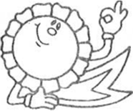

means of the Indians.”


Indiana State 

ON THE BANKS OF THE WABASH, 

Round my Indiana homestead wave the cornfield, distance loom the woodlands clear and cool.
times my thoughts revert to scenes of  I first received my lessons, nature's
But one thing there is missing in the  Without her face it seems so  I long to see my mother in the 
As she stood there years ago, her boy to 
Oh, the moonlight's fair tonight along the Wabash, the fields there comes the breath of new mown hay.
the sycamores the candle lights are 
On the banks of the Wabash, far
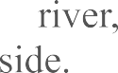
Many years have passed since I strolled by the Arm in arm with sweetheart Mary by my
It was there I tried to tell her that I loved her, It was there I begged of her to be my
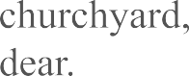
Long years have passed since I strolled thro' the
She's sleeping there my angel Mary,
I loved her but she thought I didn't mean Still I'd give my future were she only
-Paul



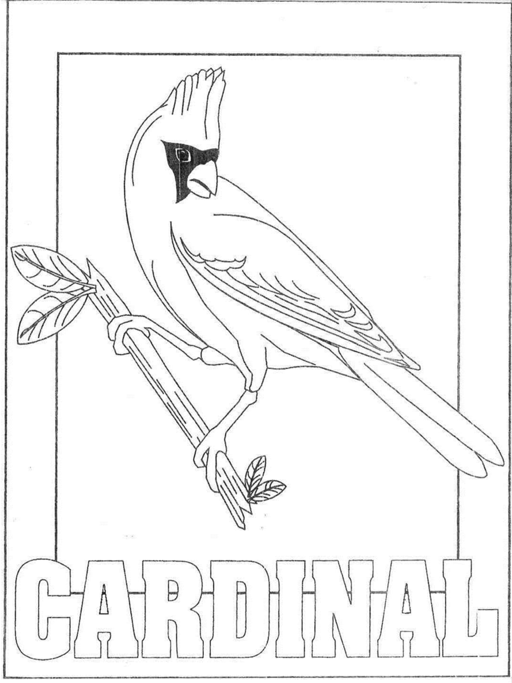

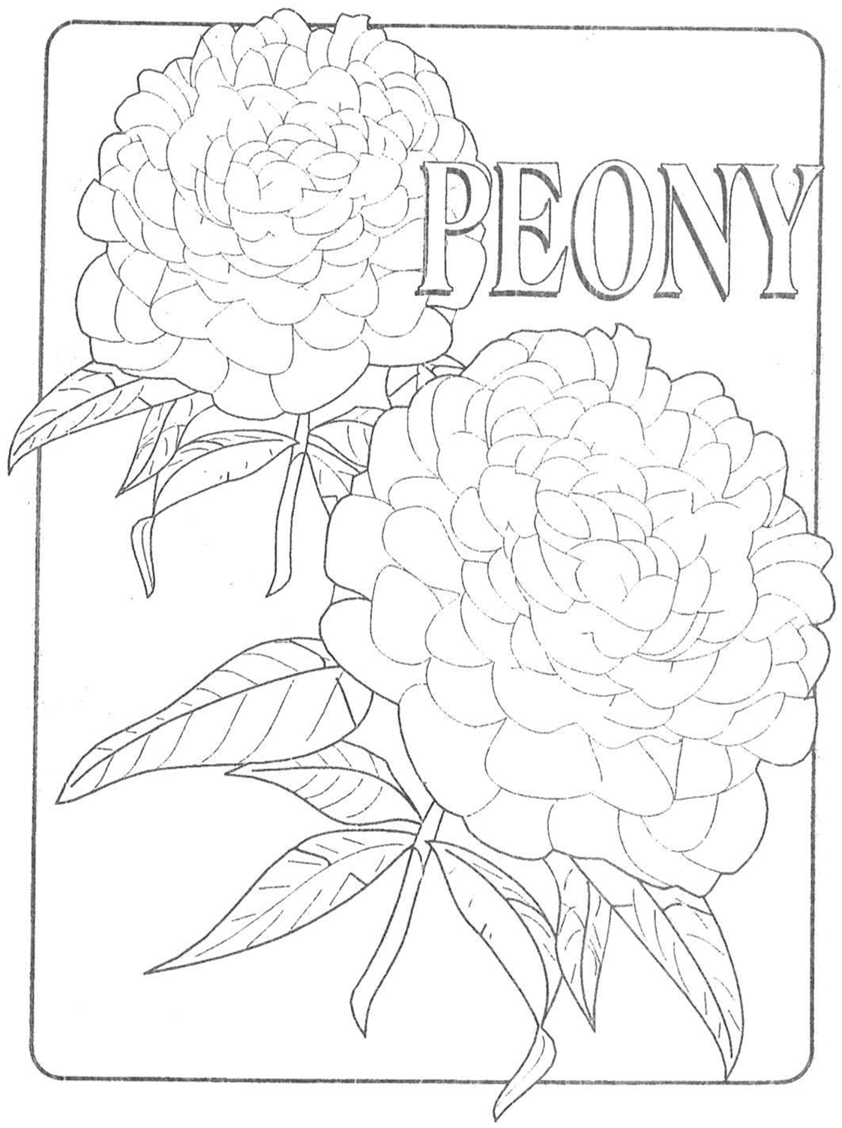

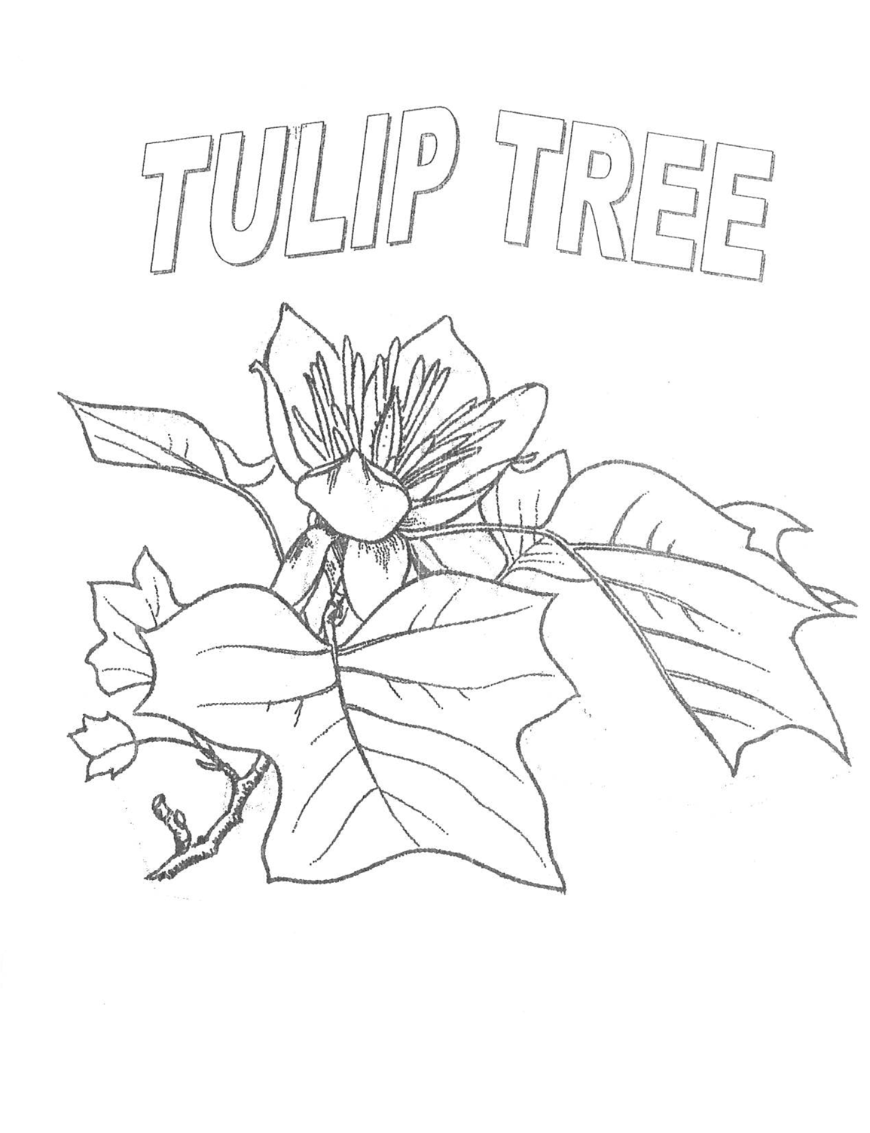

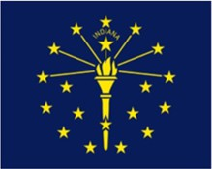
ACTIVITY 2: INDIANA'S
Did you know that each state has its own flag? It's true! Everybody recognizes the flag. Have you ever seen Indiana's flag?
Here is a picture of the

Indiana's flag was adopted in 1917. The colors of the flag are blue and a golden yellow. It shows a
golden torch and golden stars centered on a background. The torch symbolizes liberty and wisdom. (Have you ever seen a picture of the Statue of Liberty in New York City? She is holding a torch, too!
The rays coming out from the torch symbolize lib-erty and wisdom affect many


The one star flame represents Indiana and even has the word "Indiana" written above it. Indiana was the state to enter the Union. Indiana
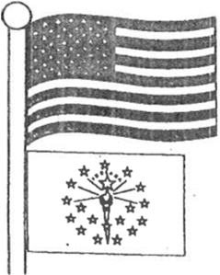
the 19 state on December 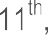
The 13 stars that make a circle around the torch stand for

13 states. The 5 stars to be smiling the next five states to enter the


You will always find the Indiana flag flying below or lower than the American flag. The flag should always be the highest flag

EXHIBIT IDEA: Find the full size picture of the Indiana flag. Color and cut it out. Around the sides of the flag, write on your poster what the stars, torch, and rays symbolize. Mini 4-H posters should be 14" x 22". Make sure it's (sideways). Title your poster: Indiana's
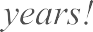
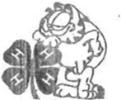
FACT
Jim Davis, the creator of Garfield comic strip, from Indiana! He was also a 4-H member in younger

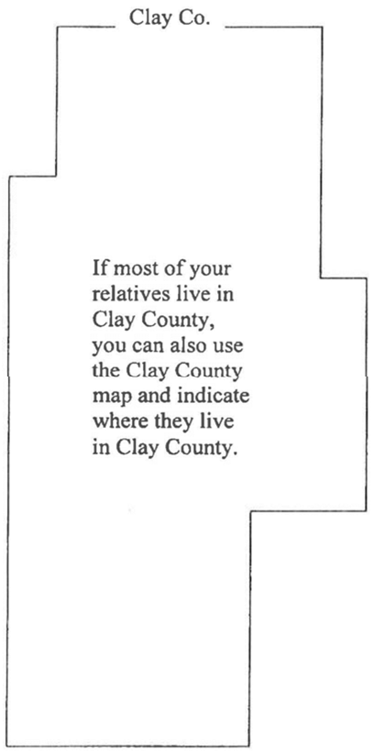
ACTIVITY 3: WHERE IN INDIANA ARE 

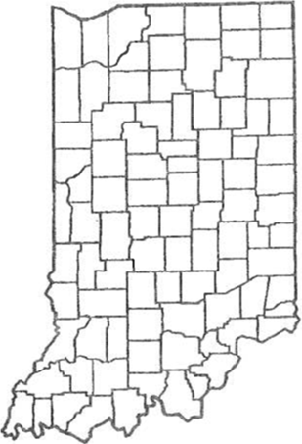
If you live in Indiana, chances are that you relatives (cousins, aunts, uncles, grandparents, etc.) or family friends who also live in
Do you know the name of the town or city where they live? you know the name of the county where they live? Ask helper to help you identify the counties in Indiana where some your family friends and/or relatives


EXHIBIT IDEAS: Find the enclosed map that has the counties outlined. Color the county where you live. Color the county or counties where your relatives or friends live. Attach your map of Indiana to a 4-H posters should be 14" x 22". Make sure it's horizontal (sideways). Title your poster: Home Sweet Home". In the space on the poster around your map, indicate who lives in the counties that
Example: Uncle John and Aunt Sue- Howard Co. (Co. is the abbreviation for county). If you'd like identify the town or city where they live, that is up to

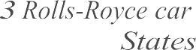
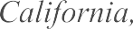
If you have several people to identify within Clay County, indicate which town they live in or closest Example: Grandma Helen- Cory; Grandma Lois- Poland; Uncle Bob and Aunt Betty-
Wabash, Indiana was first electrically
in the United
city

There are only
dealerships in the United in New York City, one in Beverly Hills,
and one in Zionsville, Indiana!


* � *

* ��TR�X/*
**o/i� *
* * * *
* * **

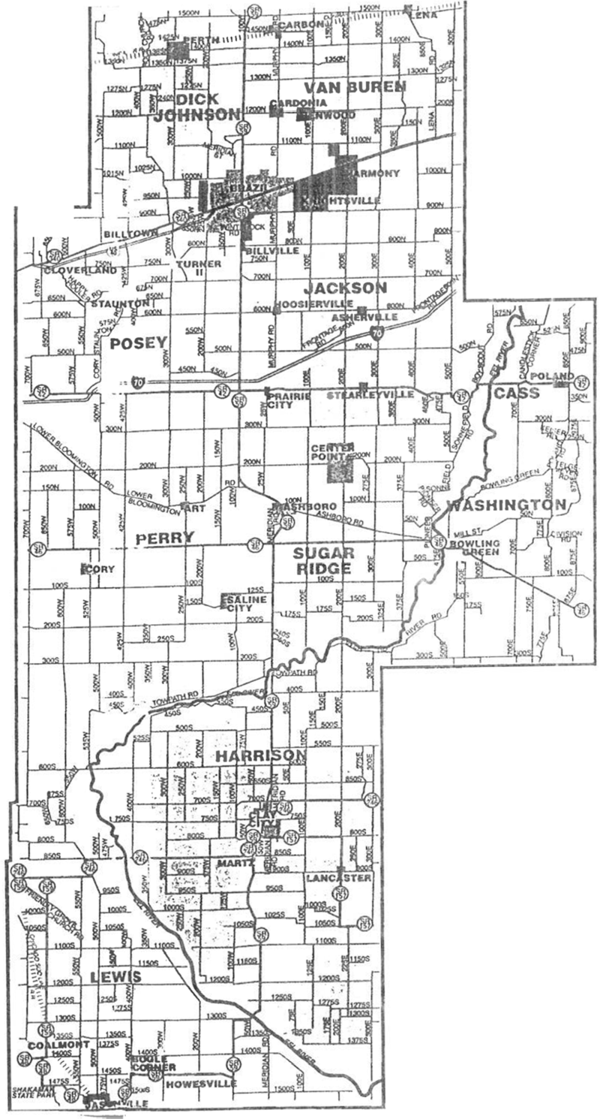
C L A Y
C O U N T Y,
I N D I A N A

LePorle St. Joseph
I

Elkhart

LaGrange

Steuben

Lake
Porter

Marshall

Kosciusko

Noble

DeKalb

Newlon

Jasper
Pulaski
.=unon Whitley
Allen

White Cass
Miami
Wabash

Huntington

Wells

A-jams

Benton

Warren Tippecanoe

Clinton

Howard

Tipton

Grant

Blackford Jay

Madison Delaware Randoph

Montgomery
Boone
Hamilton

V,go
Parke

Clay

Putnam
Hendricks

Morgan
Marion

Johnson

Shelby

Rush
-··
Fayette Union

Franklin

Owen

Momoe Brown

Bartholomew

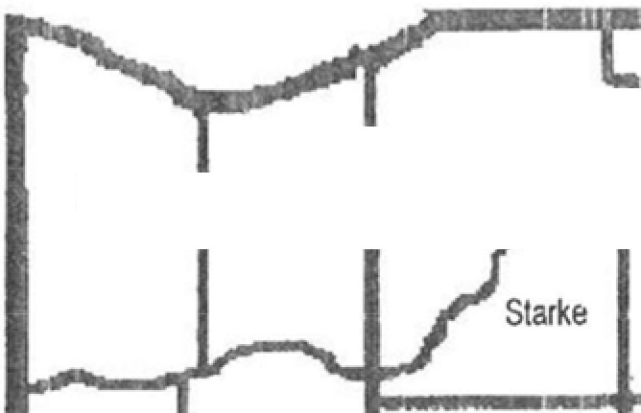

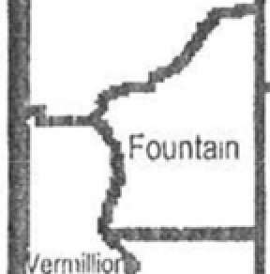

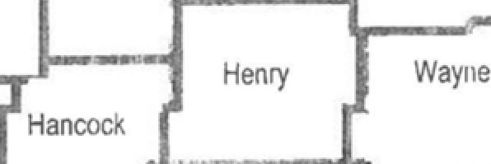
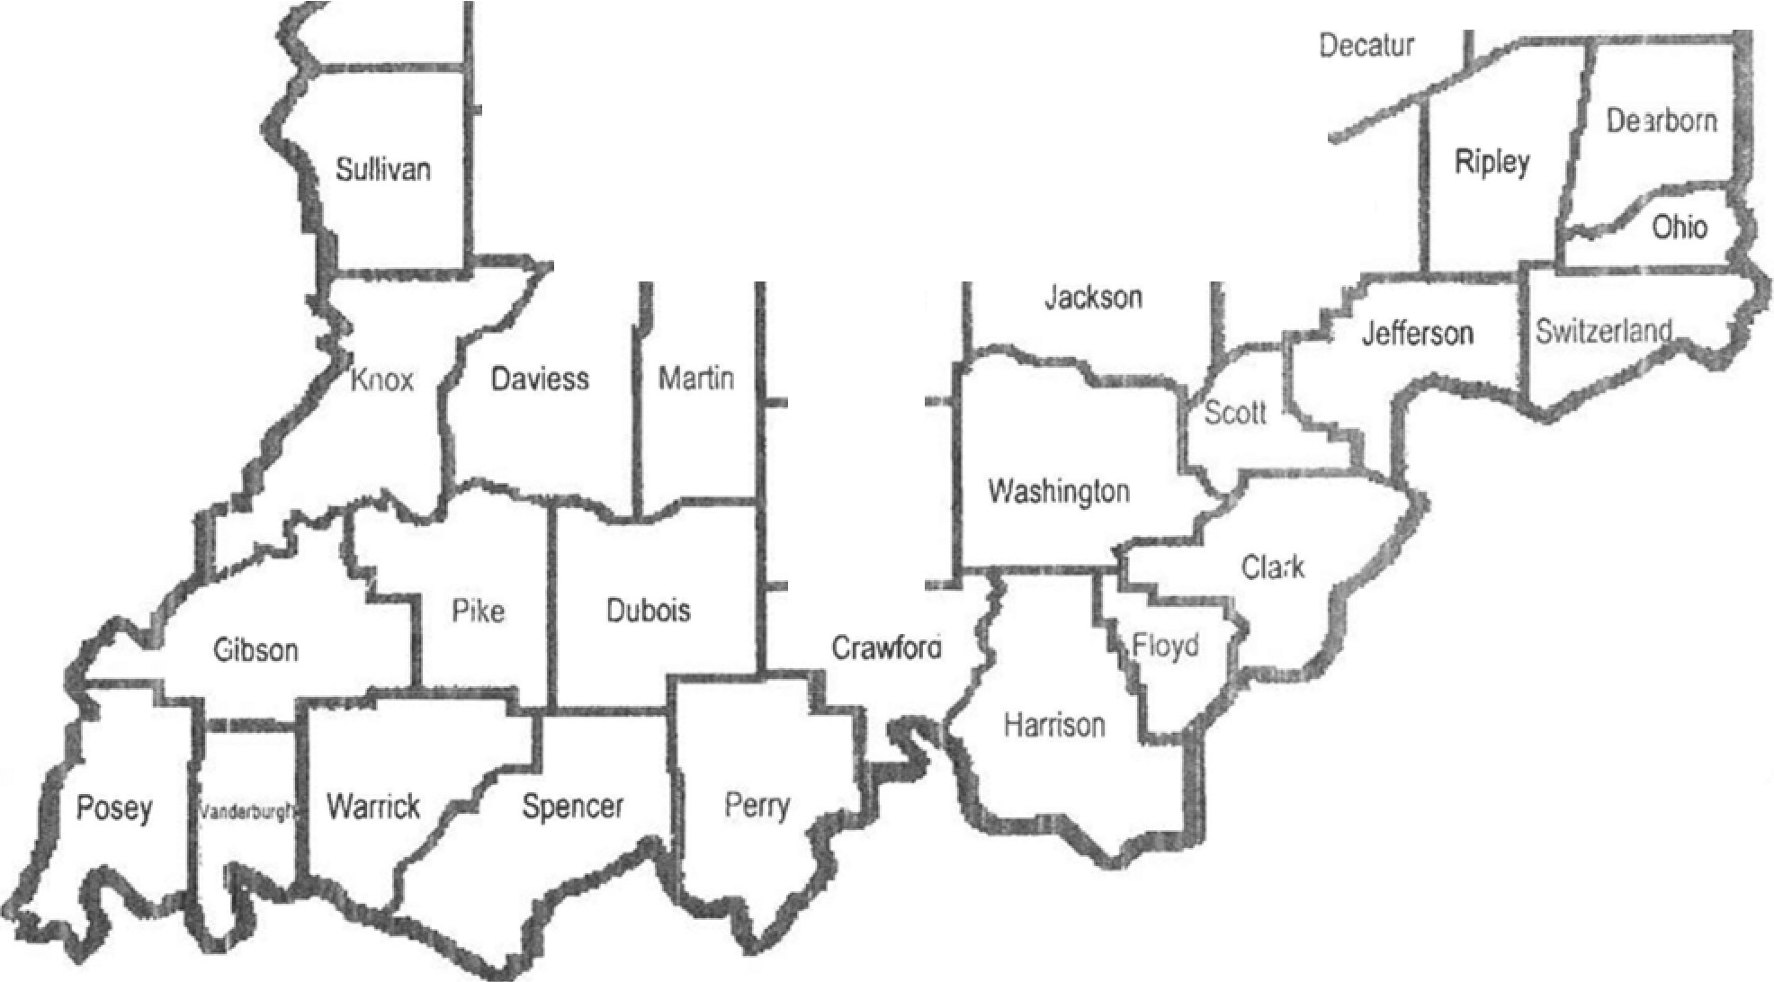
Greene Jennings

Lawrence

Orange

