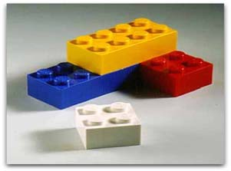

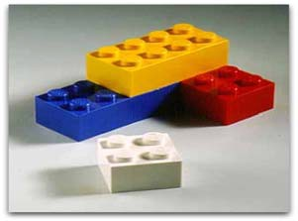
LEGOS
Clay County Mini 4-H Program

EXHIBIT

- Exhibit a Lego built model that is an original or a Lego set.

Exhibit shall not exceed 8” long X 8” wide X 12” high,
including fully extended parts.
- Exhibit needs to be on a sturdy, solid base and have project exhibit tag attached.
- Not responsible for lost or stolen models and blocks.

Project Exhibit Tag
Mini 4-H Legos

Name: Age:

