
ount


MINI 4-H
PROGRAM

LIVESTOCK PROJECT MANUAL

Clay County Cooperative Extension
Mini 4-H Program
6656 N State Road 59
Service

Brazil, IN 47834-8329
Audrey Evinger
8
(812) 448-9041

PROJECT EXHIBIT TAG
Mini 4-H Livestock
Name:
Age:

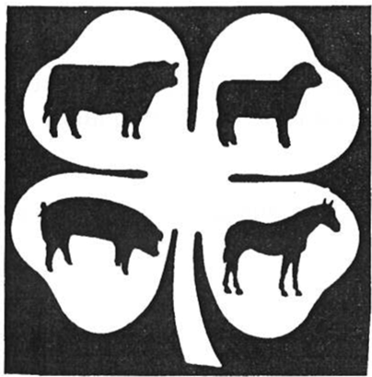
Welcome to "MINI 4-H". If you're  this, you've probably signed up for Livestock project. We're glad to have Mini 4-H Livestock is for small farmers yourself who are just starting out and want learn more about caring for their

What we hope you will learn while Livestock is outlined below. They are "Project 

PROJECT

- I will learn how to identify different parts of my animal.
- I will learn how to keep accurate records on my animal.
- I will have the responsibility of caring for my animal.

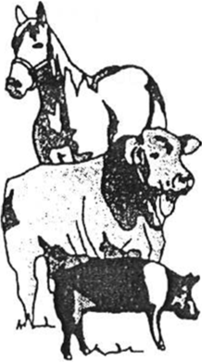
START

- Choose one (1) of your favorite animals to with (Beef, goat, dairy, horse & pony,  rabbit, sheep or swine). Complete your  animal's diagram by labeling the parts  (Try labeling some of the other animal  to learn about other animals also.) If you help identifying the parts, ask your parents, Leader or a Junior

- Take a look at your daily check sheet. Keep handy so you can mark it every day. A place your barn would be 

Page

Animals are like you. They like good clean food and they like to be fed on time. Give your animal a balanced diet. Make sure it provides adequate nourishment for a healthy animal.

Keep fresh water available at all times. Do not use same pan for water that you use for

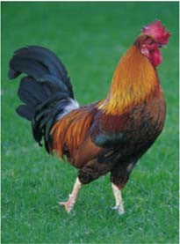
  - Do you always remember to feed your
  - Do you feed your animal at the same time each 

  - Does your animal always have a clean food 

  - Do you always have clean, fresh water for your

Animals like to run and play. They also need exercise. Spend some time with your animal each day. Help it grow strong and healthy.

- Do you take time to work with your animal each 
- Do you enjoy working with your

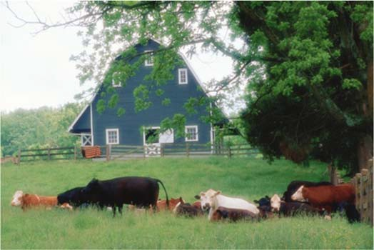
Page

Animals are like you, they need proper care too. They like to be kept clean and healthy. They enjoy nice, clean, dry beds to sleep in too.

  - Do you brush or groom your animal at least once a week?

  - Have you washed your animal on a warm sunny 

  - Do you make sure your animal has a nice, clean, dry

  - Do you care for your animal when it is sick?
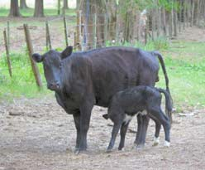
If your animal was sick or had an accident, did you know the name num-ber of your local veterinarian? Write his/her name and phone number here.

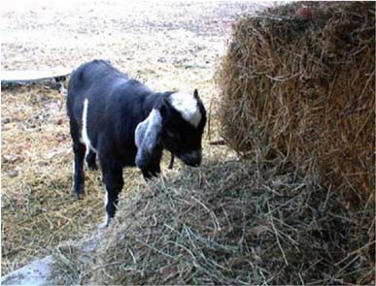
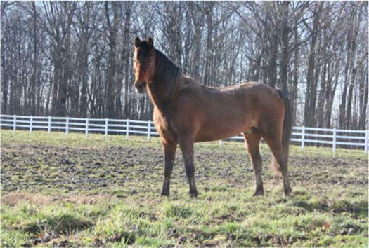
VETERINARIAN'S VETERINARIAN'S

Page

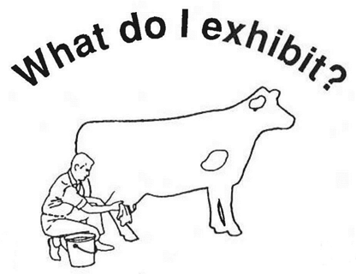
You will exhibit a poster 11" x 14" which includes your labeled animal diagram (may be colored), a picture of yourself with your animal, and a short story (which can be attached to the back of your poster) about your animal. In your story include such things as your animal's name, breed, age, bought or raised, what you like best about your animal, and a funny experience that happened to you and/or your animal.
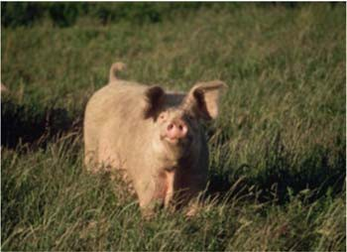
REMEMBER TO PUT  EXHIBIT TAG ON THE  COVER IN THE LOWER  HAND CORNER OF
 EXHIBIT! ALSO, attach  Record Sheet and "My  Check Sheet" to the back of your 

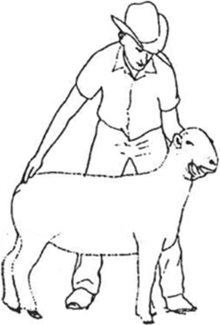
Also, BE SURE TO COVER 
EXHIBIT WITH CLEAR PLASTIC AND 
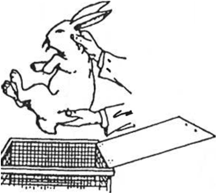
YOUR POSTER MOUNTED ON HARD 

Page 4

MINI
4-H CHECK SHEET

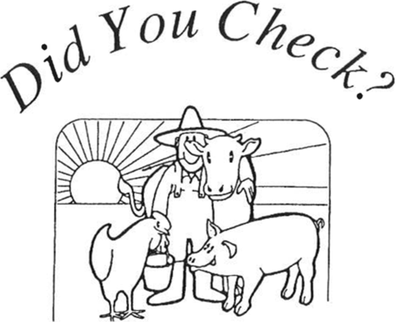

- _ Is
your exhibit
tag on

correctly?

(lower right hand corner of your poster)

- _ Are your records

complete?

(Attach "My Daily Check Sheet" and "Record Sheet" to the back of your poster)

Is
your work

neat,
clean, and your

very

best?

  - Are you pleased with what you

completed?

Page 5
have

BEEF
9
I
I
I 1o

I 12
:
: �-;
-1. J --.\
8

Brisket •
Hind Quarter (Round)
Stifle Muscle Poll
Muzzle
\

11
3 Neck
13

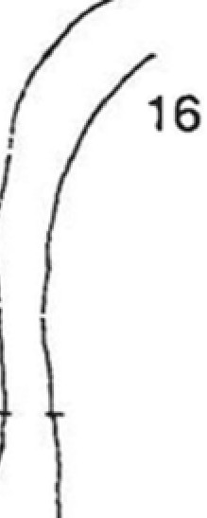
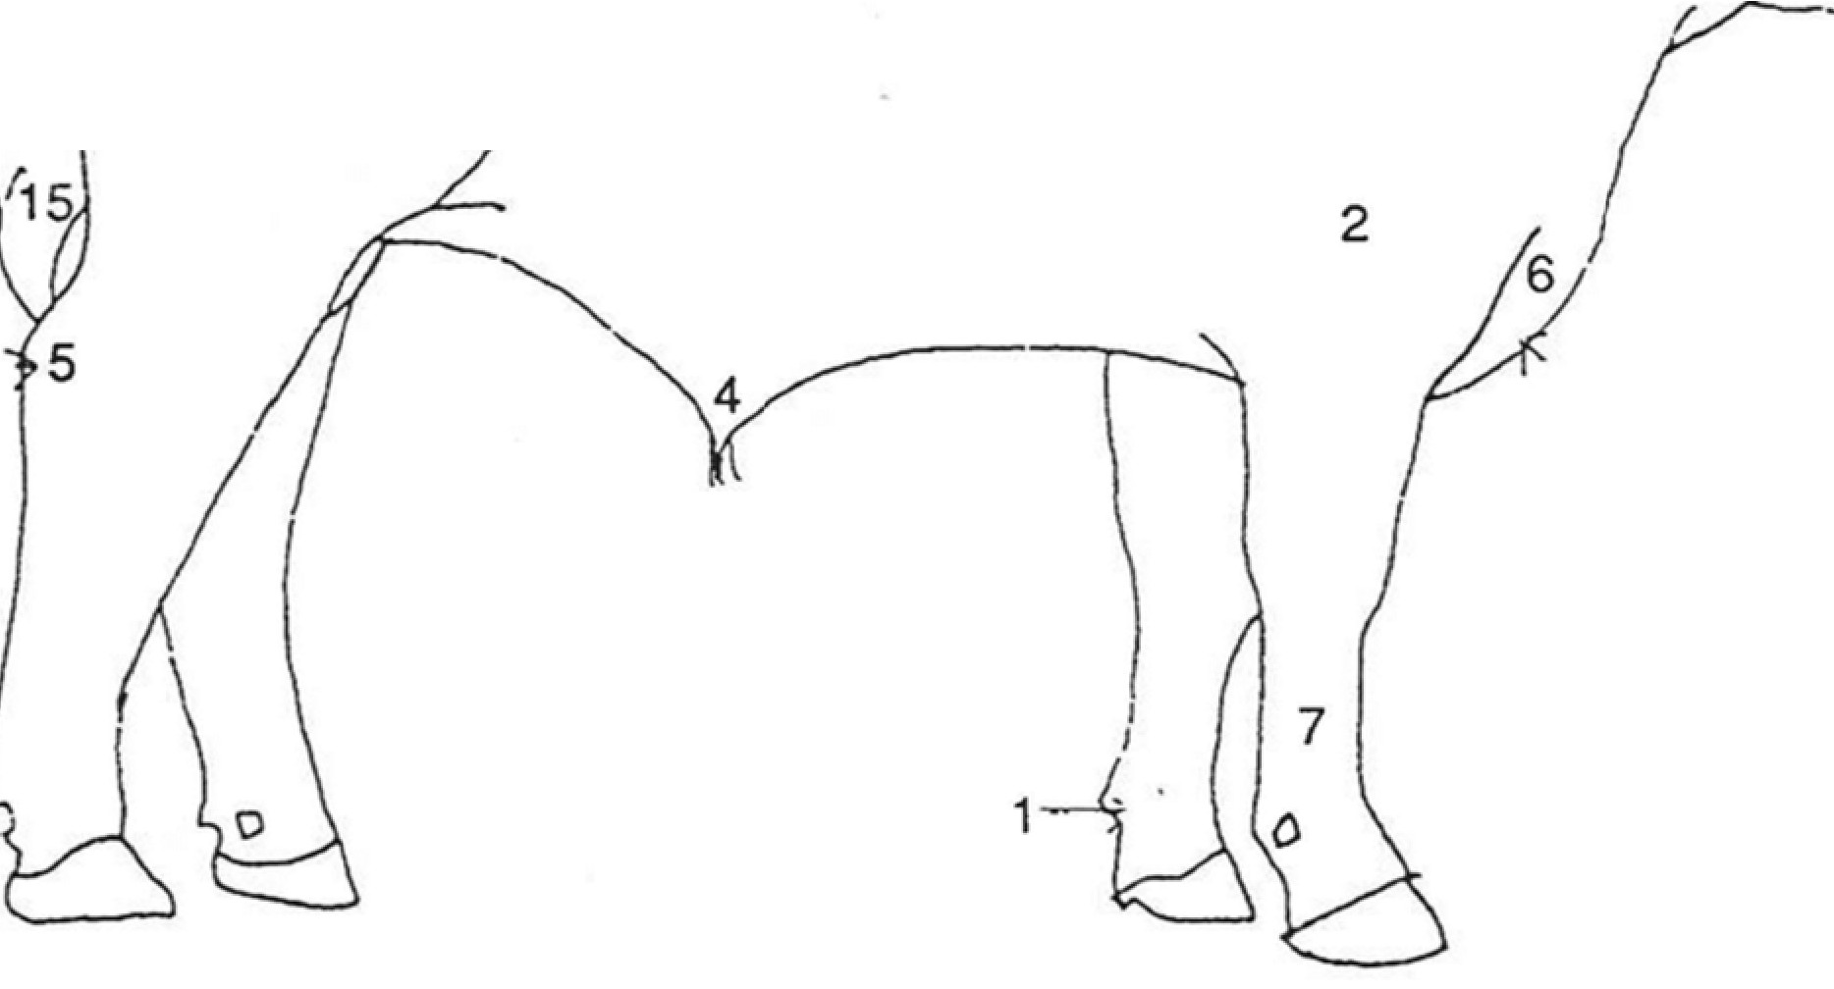
I
141
-:f
Shoulder Loin
Hooks (Hip Bones) Rump
Pins (Pin Bones) Hock
Sheath Dew Claw
Shank (Cannon Bone) Switch

DAIRY

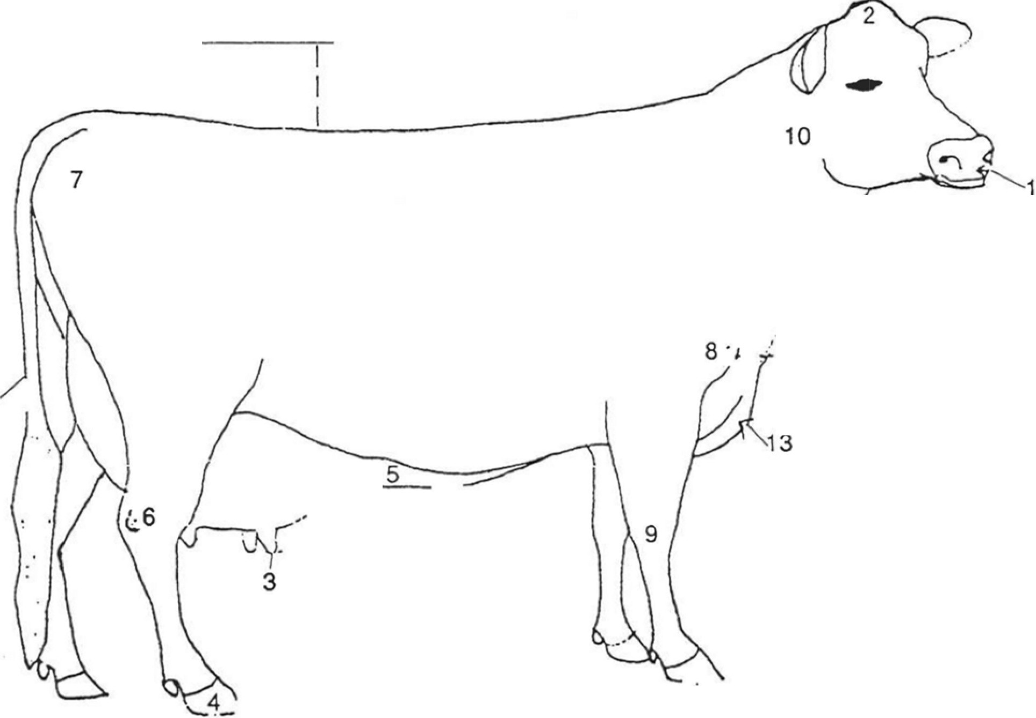
Mammary Veins Shoulder Blade
11
/
,,
/
I
I
,I
//"'"
Pin Bone
Teats Tail
Knee

Brisket
12 Neck
Poll Muzzle
Hoof Hock Rump

GOAT

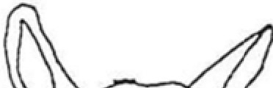
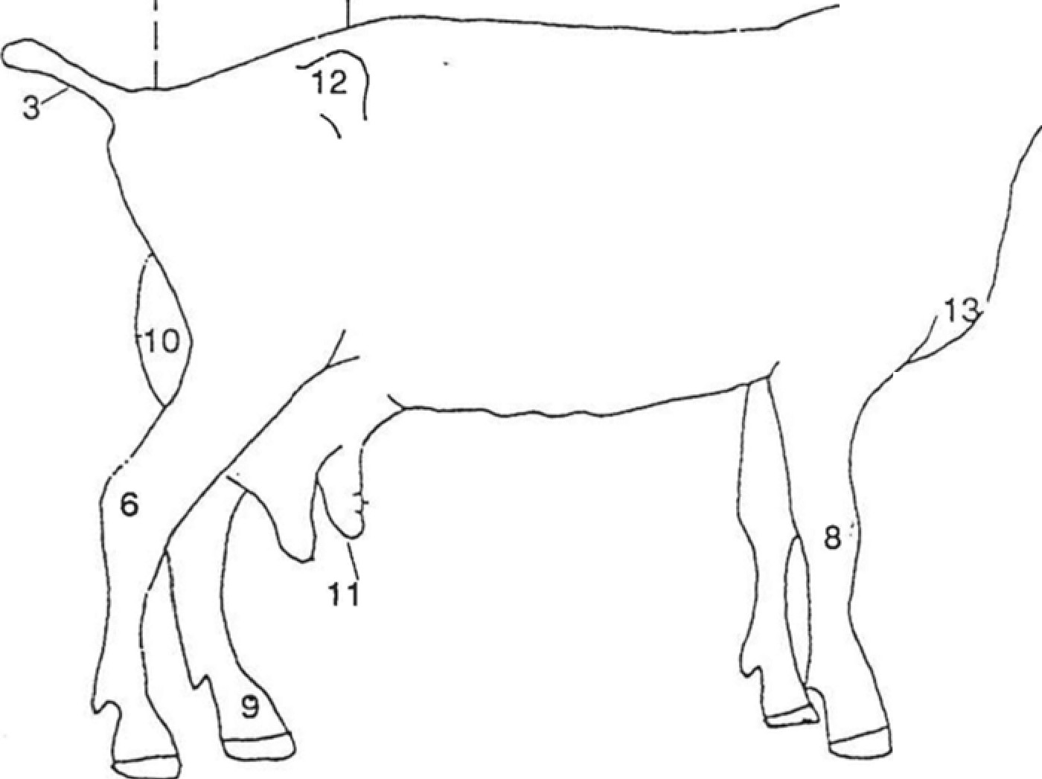
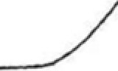
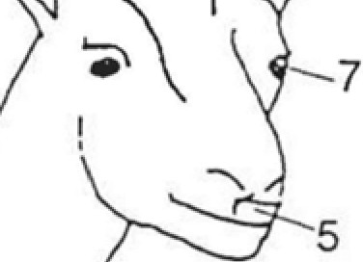
2
"'' .-_
1 -- J /
4
I
Hip Bone --
Udder

Pasten --
Withers Eye
Horn

Teats Muzzle Knee Hock
Rump
Tail
Brisket --

SWINE

Tail
Sheath 11
I
Back-Loin (Pork Chops)

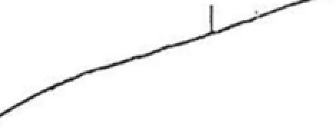
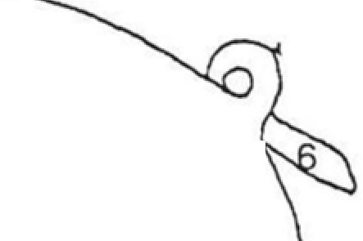
Snout
Jowl --
10
Side 12
4
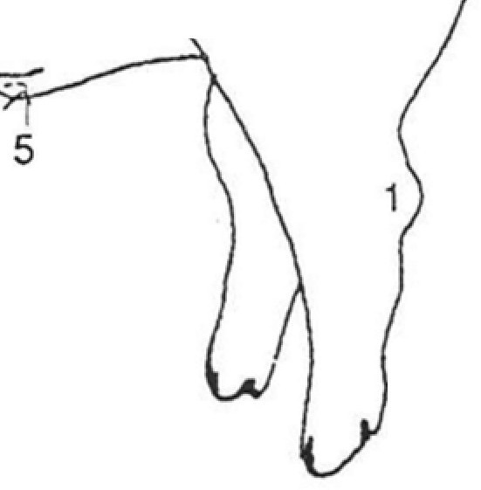
Ham
3
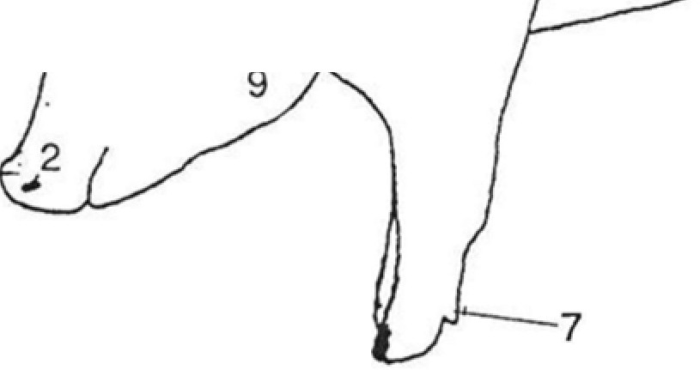
Belly �
13--1.o\_
--
Ear

Dew Claw Hock
Eye
Shoulder

SHEEP
8 7
Dock Rack Saddle Ear
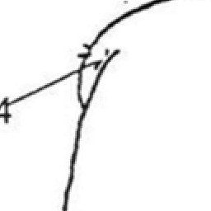
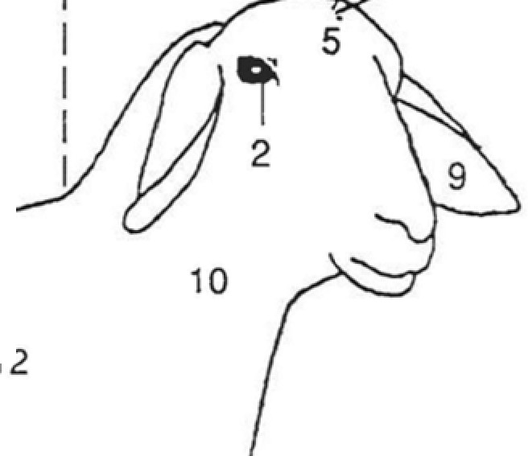
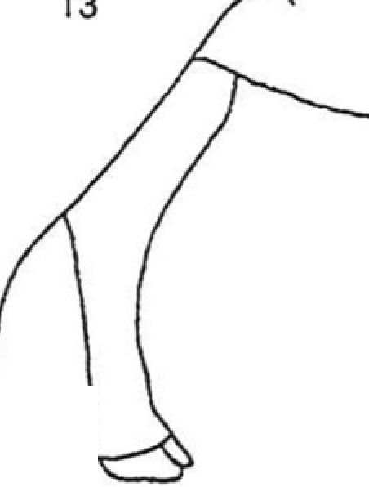
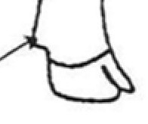
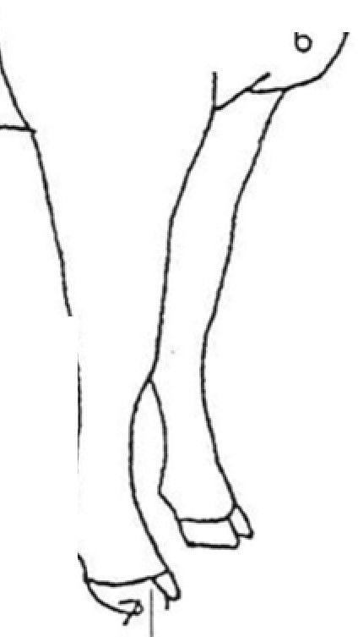
Leg of Lamb or Mutton
11
1

Dew Claw

Poll Hoof Hock Neck Breast
Eye Shoulder
3

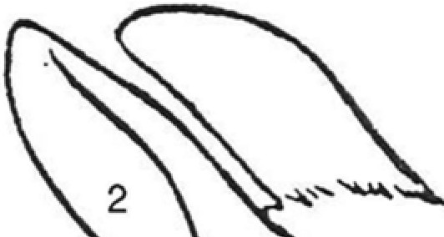
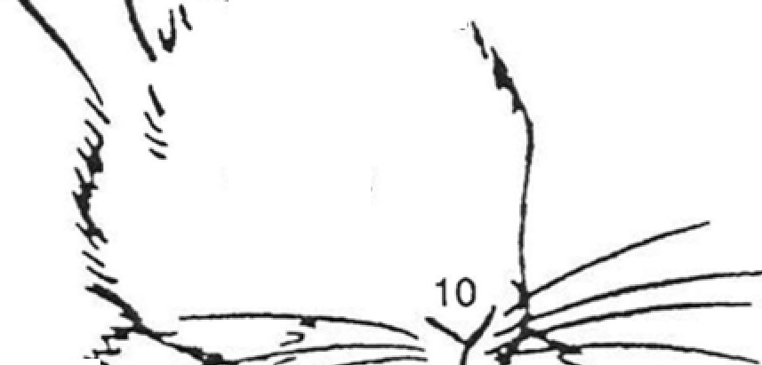
RABBIT
\ \
--8
i
� ,,.,,
�/
----
�::�
�
�

Eye Tail
Hind Leg Ears Belly
Front Leg

Muzzle Flank
Rump Shoulder

�.
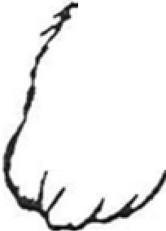
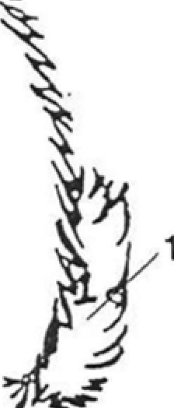
7 i
y
/
�
3

;,J,/J) ..,)"
/A _.?
� 9 -
� �
�1'1_ '�- ....%,'\4�-- .5 .:' J�
tc� v< �

HORSE-PONY

Face --
Crest
//<�\2\ � 6

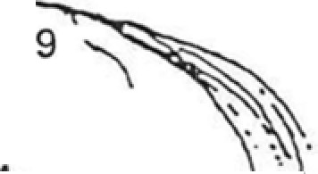
::?'" (
\
�;�\
: .\
�-C

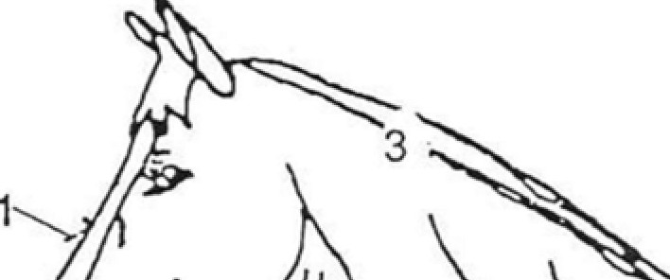
Flank -� \ \ t. /'
1/(
4 5
Chest --
J-..
f . \


Cannon -- \ I 12
!.I '.\�,- .

Barrel --
\ "'\.._ .IA. �
/•�-!.(



Heart -- \ I f\ \ \. ��.-,_'.\.1-�

Hoof \ I I \


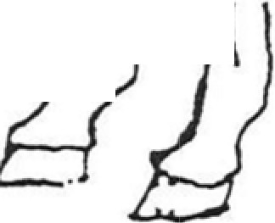
Neck -- I "1 nl
I I I
1/
':)1iN�,

Rump --
Withers --
\.�l tl

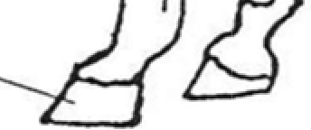
I • JI I l

Shoulder 11

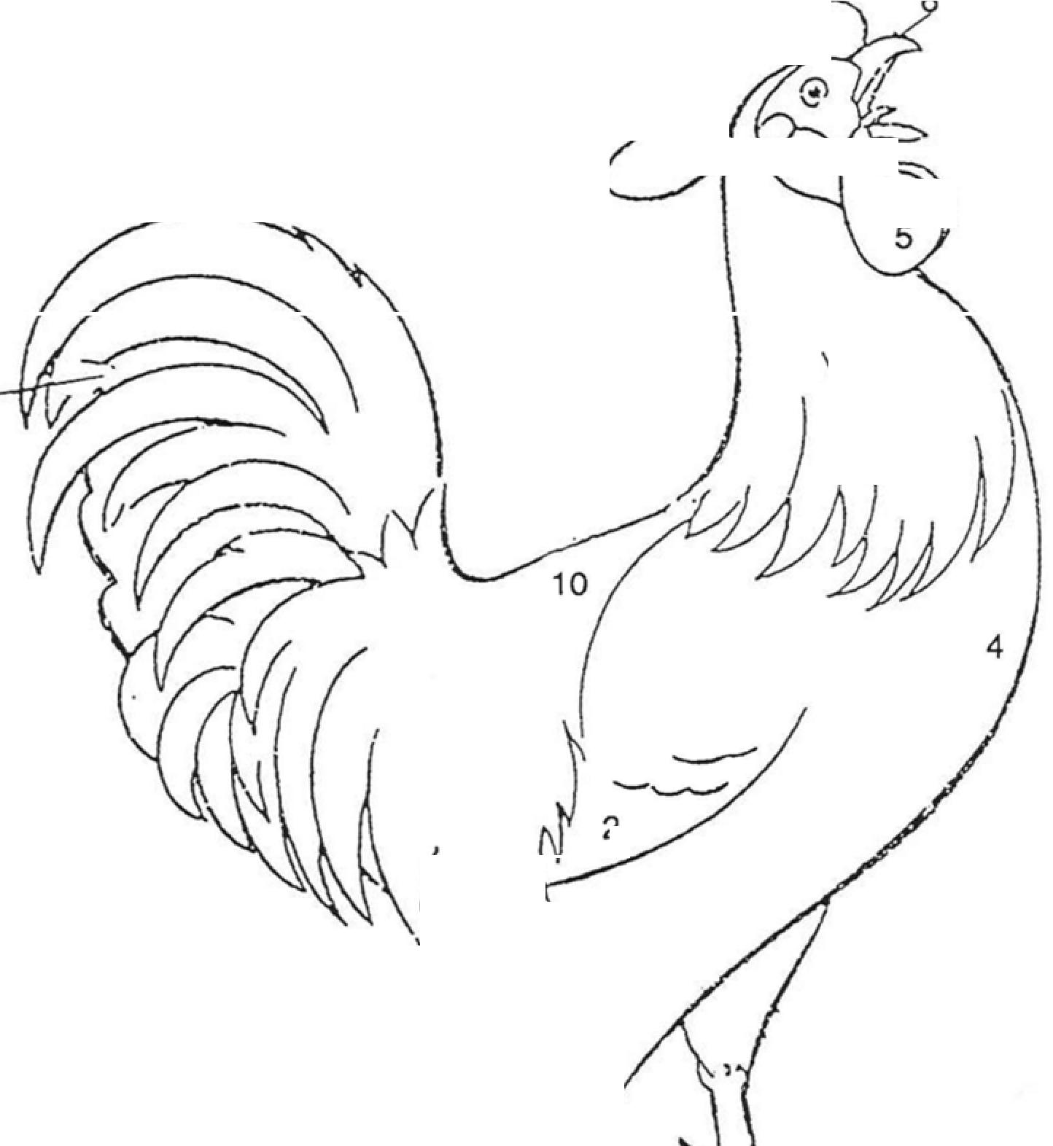
POULTRY
....:,; ·-·3
,· ._J '-
2
,
iVYt-:�
- :
).
7
2
1\"'\'
t/

9

Main Tail Feathers Breast
Wattles

8--�/


)_\:_
Wing Spur
Beak Toes Back Comb Hackle


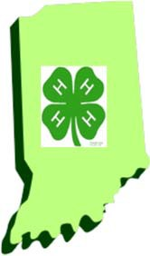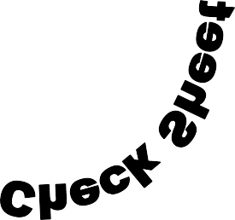

DATE | WATER | FEED | MEDICINE | OTHER | COST



“LIVESTOCK” RECORD SHEET MINI 4-H PROGRAM

Name Age

Address

Please answer the following questions. Attach this completed record sheet to your project. See you at the fair!!!

- How many times a day should you feed your animal?

- When should you bath your animal?

- List five parts of your animal.

Parent’s signature: Date:

