
ount


MINI 4-H
PROGRAM

PET ANIMAL PROJECT MANUAL

Clay County Cooperative Extension Service
Purdue Extension - Clay County
6656 N State Rd 59
Brazil, IN 47834-8329
(812) 448-9041

PROJECT EXHIBIT TAG
Mini 4-H Pet Animal
Name:
Age:

to 4-H". If    you've
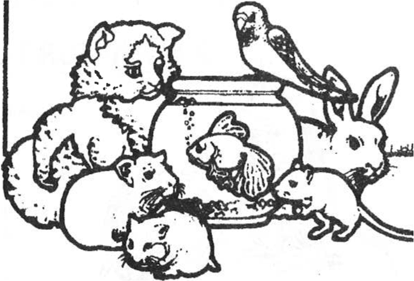
  up the Pet
 project.  glad to have you. Mini 4-H Pet is for small
 who are  starting
out and to more  caring for their animals.

we hope you will
learn taking Animals
is below.  are  Objectives”.


- Keep your pet’s cage/bedding clean.
- Keep food/water fresh.
- Play with your pet.
- Take care of a sick pet.



A gerbil is a small, furry rodent. He has a tuft of hair at the tip of his long tail.
His natural home is in the deserts of Asia, Africa, and eastern Europe. Gerbils will not bite unless you frighten or hurt

A HOME FOR YOUR

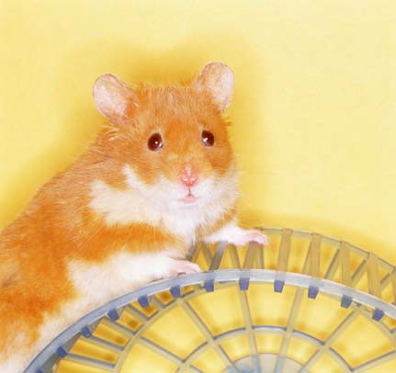
You will

10-gallon wire mesh food water bottle & holder
5 pound bag of wood
small juice can with both ends removed

  - You should have at least 4 inches of wood shavings in the bottom of your tank so that the gerbil can burrow
  - Remember that gerbils are very good jumpers so you should keep your wire mesh lid on
  - Do not put your tank in direct
  - Clean your tank once every three weeks washing your tank with soap and water and then putting in new wood
  - Never pick up a sleeping gerbil as this might frighten them and they may bite you
  - If you hold your gerbil every day, it will become

- A tablespoon of dry gerbil food each day is enough for a balanced
- Sunflower seeds contain a lot of fat so use these as a
- Twice a week you can give your gerbil a small piece of apple, fresh celery or carrot. Don't give them too much or they might get sick.


like a tiny, furry, teddy bear. a v ery short tail. His natural home is in of Syria. are at night.   or litter.


FOR
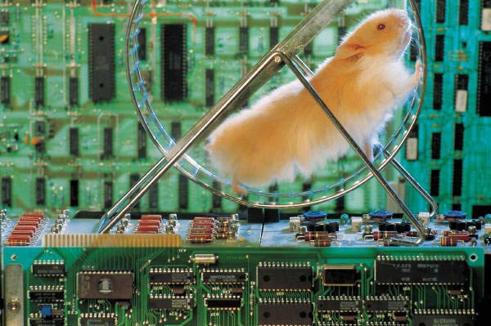
will

10" 20''

holder
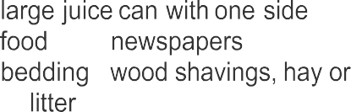
removed
dish
- hamster


or oil cloth
to
on

- Your hamster cage has a pan that can be removed for cleaning. Put 3 or 4 layers of newspapers on the bottom of the pan, allowing the newspapers to extend up around the sides. Then fill the pan with at least 2 inches of bedding. Clean your cage once a week by washing the pan and putting in new bedding and newspaper.
- Do not put your tank in direct sunlight.
- Once you get your hamster and put him in his new cage, don't pick him up tor at least a week. Let him get use to his new home. When you do pick him up use gloves if your hamster seems easily frightened because he might bite. Slowly place your hand in the cage and let the hamster sniff

- One-half cup of dry hamster food each day is enough for a balanced diet.
- Your hamster also likes carrots, lettuce, celery, potatoes, apples, dry dog food, milk, peanuts, corn, soybeans, wheat germ oil and cod liver oil. Don’t give him too much. They will hoard their food in their cheek pouches and could become very sick from overeating.

A guinea pig is not a pig at all. Perhaps, the got the “pig” part of his name because his funny whistle is like the squeal of a pig. A guinea pig is not as active as a gerbil or a hamster. They are very friendly and gentle. There are several different types of guinea pigs so shop around. The easiest kind to care for is an English Guinea Pig. They have short hair.

A HOME FOR YOUR GUINEA

a cage 2 feet long and 1 foot wide with a pan in the bottom
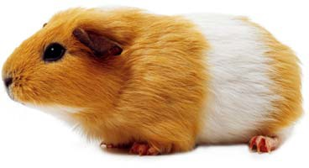
a little house to sleep water bottle and holder dispenser for dry food newspapers
bedding – wood shavings, hay, or kitty litter wood to gnaw on
large piece of plastic or oil cloth

- Your guinea pig cage has a pan that can be removed for cleaning. Put 4 or 6 layers of newspapers on the bottom of the pan. Then fill the pan with at least 2 inches of bedding. Your guinea pig will make a mess so you must clean the cage at least three times a week.
- It is very important that you find a good place for the cage. It must not get much cooler than 70 degrees and it shouldn't be drafty. If it gets too cool at night, put cover over the cage. Never put the cage in direct sunlight.
- Play with your pet every day. He will become very tame. Scratch him under his and on his head.

- Keep a supply of guinea pig pellets in the dispenser at all times. Your guinea will nibble at them often. Change his water
- Feed your guinea pig vegetables and fruit (lettuce, carrot tops, spinach, clover, dandelion leaves, carrots, celery, apples, tomatoes) once a day. At night remove any left over treats.


You cannot hold and pet goldfish, but you will enjoy watching graceful fish

A HOME FOR YOUR

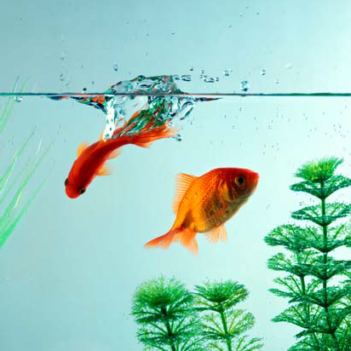
You will

10 gallon fish tank with feeding dip siphon
two 2-gallon
three 5-pound bags of six water goldfish

- Before you fill your tank with water, you should rinse the inside, even if it is new.
- Rinse the gravel, a bag at a
- A good place for your fish tank is on a table near a window. Goldfish need light but not too much sunlight.
- You should use your siphon and clean the bottom of your tank once a week.

- There are many different foods that you can buy for your goldfish. There are and frozen foods, pellets, pastes and live foods. them
- Feed your goldfish once a day by placing the food inside the feeding






can tame a easily. He  you can him to best to
to sit on
is at

A
finger. If you are night.

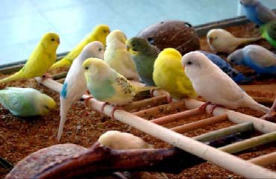
will

13
high

feeding cup and water cup
two or three perches that are different shapes swinging perch
plastic or glass bird bath
paper to fit the sliding tray at the bottom of the cage cover for your cage

- Put your bird’s cage in a room with no drafts. Do not put your parakeet in the kitchen as they are very sensitive to odors.
- Always cover your parakeet’s cage at night.
- You should change the paper at the bottom of your pet’s cage three times a week. Always put clean gravel on the clean paper.
- Rinse the water dish and fill it with fresh water each day.
- Clean out the seed dish every day even if it looks full.
- You should give the cage a thorough cleaning once a month.
- If your parakeet scratches a lot, he may have mites. You must take your parakeet to the veterinarian if necessary.

- Parakeet seed. It is important to have fresh seed, so do not buy too much at one time.
- A cuttlebone. This is the dried shell of a cuttle fish. It helps build a strong beak and good bones for your parakeet.
- Lettuce, carrot tops, spinach or dandelions should be fed to your parakeet 3 times a week. Be sure they are fresh. Do not put these in the bottom of the cage, tie them to the side with string.
- Gravel. A parakeet has not teeth so he must have gravel to help him digest his food. Put some gravel on the cage floor.
- Polyvisol (a vitamin in liquid form. Add one drop to the drinking water once a week.

A cat or kitten is a good pet for the city. He will not be unhappy in close quarters. He will get enough exercise by climbing onto high shelves, exploring all the dark closets, and playing with you! It is a big responsibility to raise cat because he is not kept in a cage it is up to you to keep him safe.

A HOME FOR YOUR CAT or



of or a
a
to
(a
a
re
moved)
&

- Fill your litter box with at least 4 inches of litter.
- As soon as you can take cat or kitten to the veterinarian for a checkup. Your veterinarian will give your pet shots to protect him from cat diseases.
- Clean the litter box frequently to avoid odors.
- A cat must have something to scratch. Pet stores sell scratching posts.
- Playing with your cat is good exercise.

- Your pet should be fed at least two times a day. Dry cat food contains the proper balance of protein, vitamins, and minerals for cats.
- Try giving your kitten 1/2 cup of dry food moisten with 1/4 cup of warm milk. If he eats every bit and looks for more, increase the amount you give him next time. A cat should have dry food kept out all the time.
- If your pet doesn't his place it in the so it spoil.
- Vary your pets meals by giving him cooked mackerel, chicken, liver, kidney or heart at one meal every few days. Also, cooked vegetables mixed in with the meat are good for your pet.
- Do not your pet any bones.
- Be sure that you cut your pet’s food into tiny pieces.

A dog is good pet as long as it has plenty of room to grow. Dogs love lot of attention.




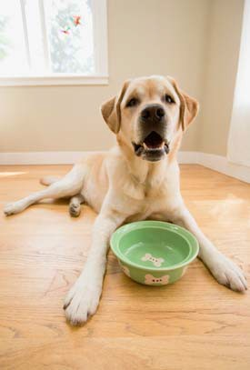
a place to sleep (a dog bed or box the one side
& bowls

- You will have to housebreak your pet if you are going to keep it inside. This

- Your pet likes to chew on things. A large round beef bone is good to chew on an old leather
- Teach your pet to obey
- It is important to play with your pet because it gives her exercise, it's a lot of fun and it's a good way to let her know that you love

- Dry food is cheaper than canned food and it is just as nutritious. On the outside of the bag there are directions for feeding a dog according to its weight.
- Learn how much to feed your dog. Dogs can get sick from eating too much.
- Your full grown dog needs 1 to 2 meals a day. A puppy should be fed 2 to 3 times
- Keep fresh water in your pet's bowl at all times.

MORE ABOUT YOUR PETS AND THEIR NEEDS
- that your pet lives all of his life in a small space. He cannot move to a new home when his cage becomes damp and dirty. It is good practice to clean your pets cage once a month with a  disinfectant. This will kill any germs that soap and water have not killed.
- Some advice about water bottles. Check to be sure that water is slowly dripping out of the bottle. Do not fill your water bottle all the way to the 
- Almost all animals bite when they are frightened. It is their way of protecting themselves. PICK A ANIMAL! If a pet bites you accidentally and you are bleeding, tell your mom or right away.
- Pets get sick just as people  sometimes for no apparent reason. You can tell when your pet is He will look and behave differently. You will know if something is he has runny eyes, sniffles, or lies quietly refusing to eat or
parents have not had a lot of experience caring for animals, it is good idea to take your sick pet to the veterinarian to be

How long will your pet

The average life of each of the animals described in this manual

Cat | 15 years
Dog | 12 years
Guinea Pig | 4 - 5 years
Gerbil | 4 years
Goldfish | 10 years
Hamster | 2 years
Parakeet | 10 years

Good luck with your 


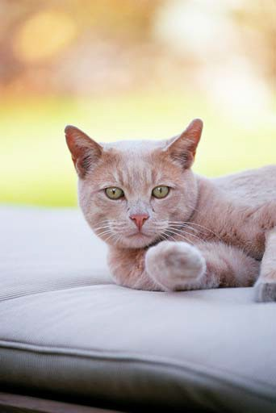



You will exhibit a notebook or folder with  short story about your pet. This  include at least 3 pictures of you and your pet. You should include your pet's name, age, and what you feed it. Don't forget   your story a 

MINl4-H

CHECK

SHEET

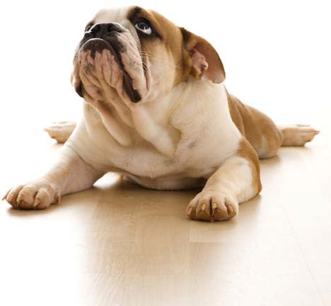

1 - Is your exhibit tag on

correctly?

(Place on the front cover of your notebook in the lower right hand corner)
2. Are your records complete?
(Include your “ record sheet” in your notebook )

3_ Is your work neat, clean, and your very

best?

4_ Are you pleased with what you

completed?
have


“PET ANIMAL RECORD SHEET MINI 4-H PROGRAM

Address

Please answer the following questions. Include this completed record sheet your project. See you at the
- What type of pet do you

- What is the name of your 

- How old is your 

- Where do you keep your pet at

- How often do you clean your pets cage/bed?

- What do you feed your 

Parent's

