CLAY COUNTY MINI 4-H


PHOTOGRAPHY PROJECT

CLAY COUNTY COOPERATIVE EXTENSION SERVICE MINI 4-H PROGRAM
6656 N. STATE RD 59
BRAZIL, INDIANA 47834 812-448-90
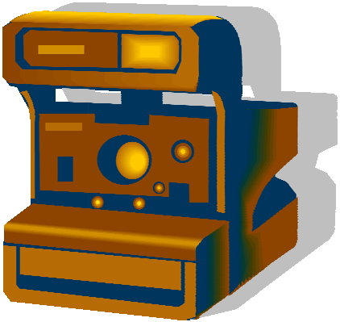
PROJECT EXHIBIT TAG
Mini 4-H Photography
Name:
Age:

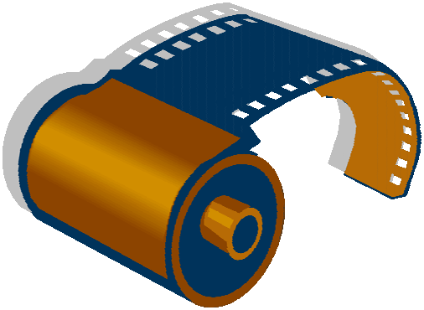
Welcome  4-H". If you're
 this,  probably  up for 

project. We're glad to have 

You will exhibit a 11" x 14" 
on a stiff backing and covered  plastic) with five color pictures you  taken. You must use the title "ME AND  FAMILY".

These pictures can be of you and your family at  during a holiday, or on 

Don't forget to cover your poster with clear plastic and mount it on a stiff backing. Also, don't forget to attach your record sheet to  back of your poster.

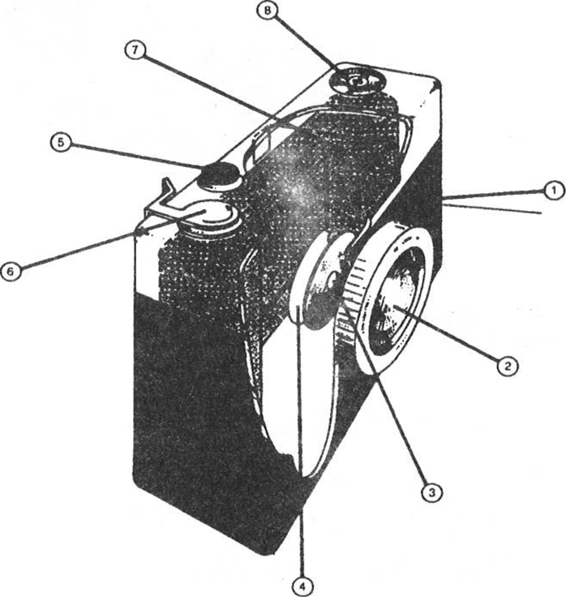




Here's what the basic camera looks
- Light-tight
- Lens
- Lens
- Shutter
- Shutter release
- Film-advance lever

- Viewfinder

- Socket

- LIGHT-TIGHT BOX - is to   out as a to parts.
- LENS - is to  a  to an  on the film.
- LENS OPENING - is to the of  the film.
- SHUTIER - is to the of the light the film.

- SHUTTER RELEASE - is to the shutter.
- LEVER KNOB - is to the picture.
- VIEWFINDER- is to  area.
- SOCKET - a for a  a or holder.



Light
Light is essential to photography. Without it you wouldn't be able to see anything, and neither could you camera.

Film
Film is the material that records the light which comes through your camera lens when the shutter is opened.

The Subject
Almost anything you see can be a subject for a picture.

Processing
When you take a picture, the film in your camera is exposed to light and an invisible image is formed on the film. The film must be processed before you can see this image by taking your roll of film to a “Photo” store
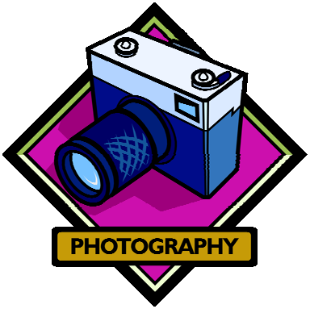
for developing.

Camera Care
Your camera is a precision instrument and very delicate. You should read the instruction manual before you begin taking pictures. It will tell you the best way to keep your camera clean and in good shape.



- MAKE IT SHARP
Hold the camera as still as possible
- EXPOSE CORRECTLY
Use the correct amount of lighting when taking a picture
- KEEP IT SIMPLE
Most pictures have only one main subject or center of interest. Don’t have too many objects (items) in your picture


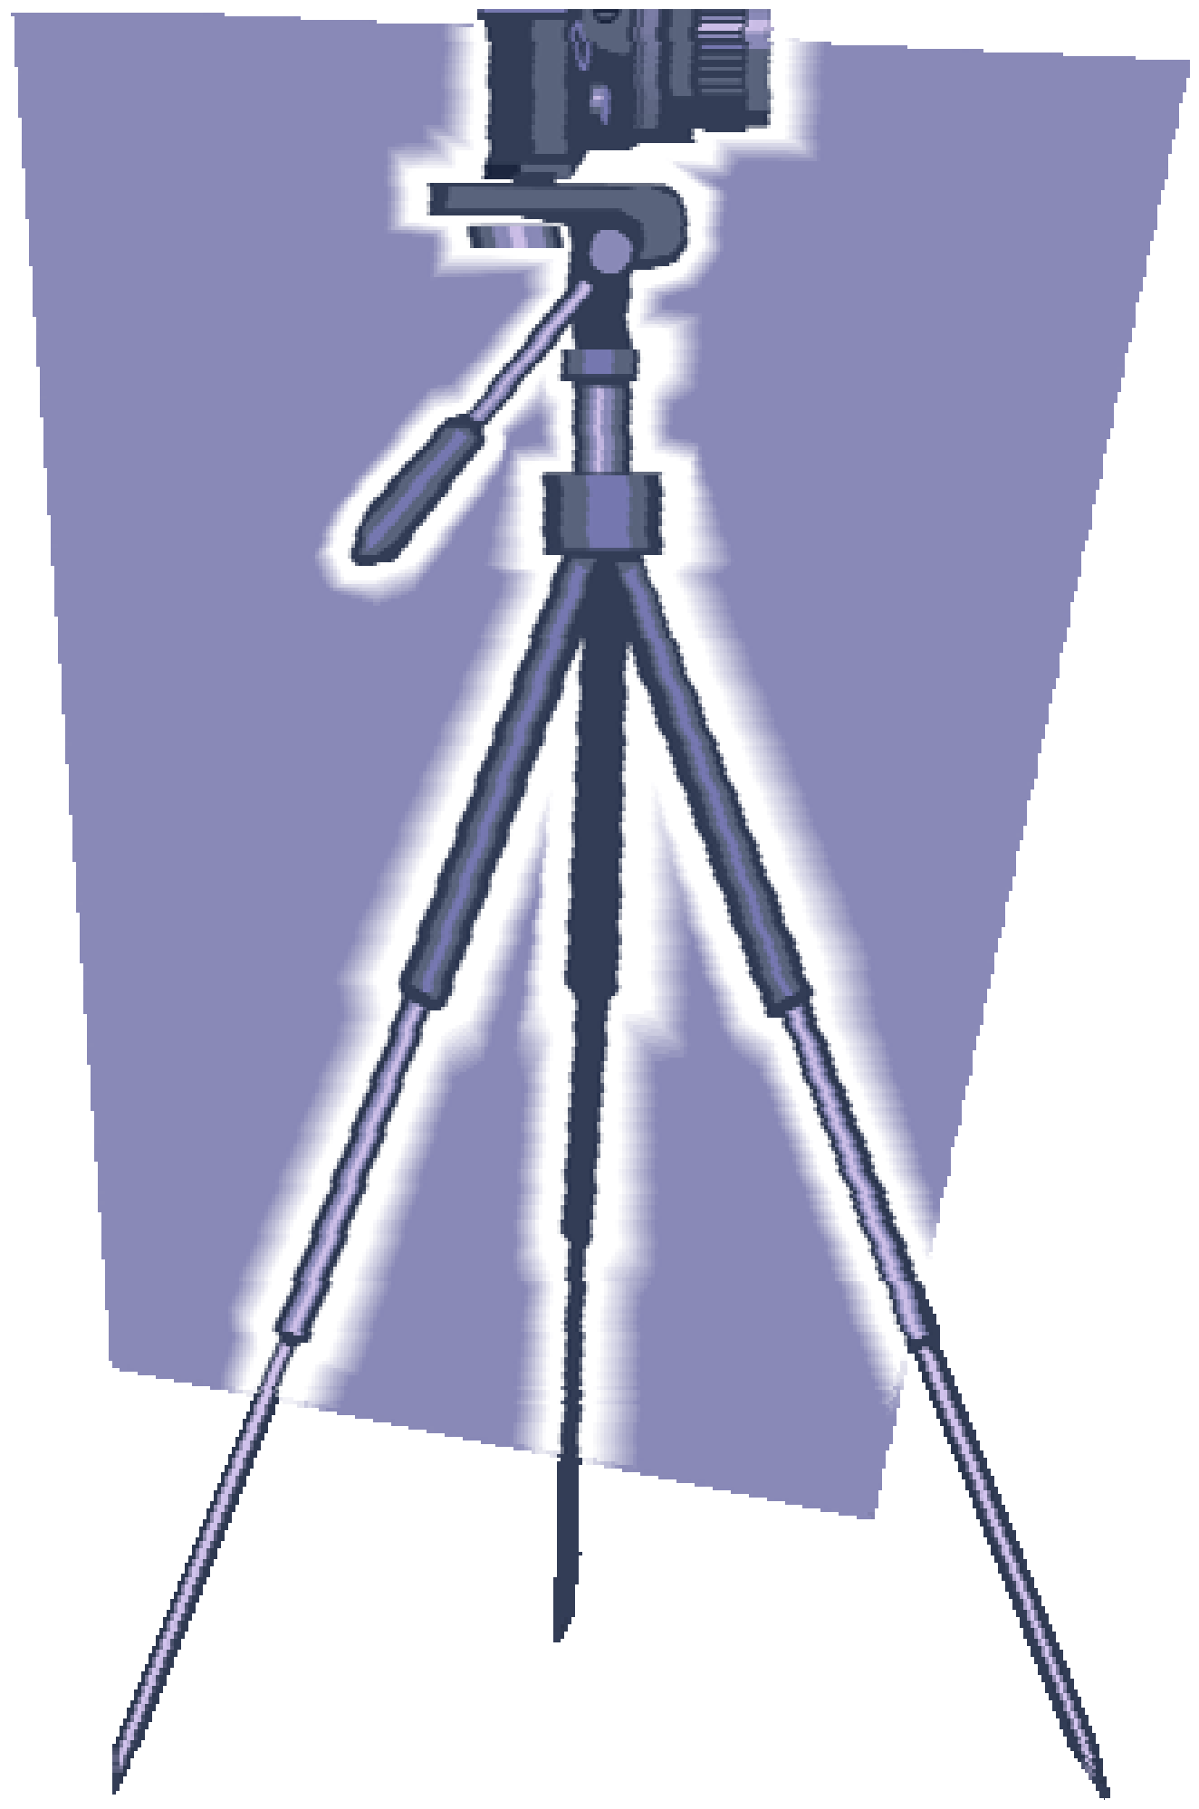
Telling a Story with Photographs

Photo stories are fun and easy to make, and they’ll teach you how to use your camera to take pictures to convey a message to someone. Photos can tell a whole story from beginning to end. It is now your chance to tell a story about you and your family. Good Luck!



 Is your exhibit tag on 
(Your "exhibit tag" is located on the front cover
 Are your records 
(Must be attached to the  of your )

Is your work neat, clean, and your very

Are you pleased with what you 








RECORD
 Mini4-H 

Name Age

Address School

Please answer the following questions. Attach this completed record sheet your project. See you at the
- Briefly describe each of the photographs you have exhibited.

- What is your favorite subject to take pictures of?

- What type of camera did you

- What type of film did you use?

- Why did you use the pictures in your

Parent's signature: Date:

