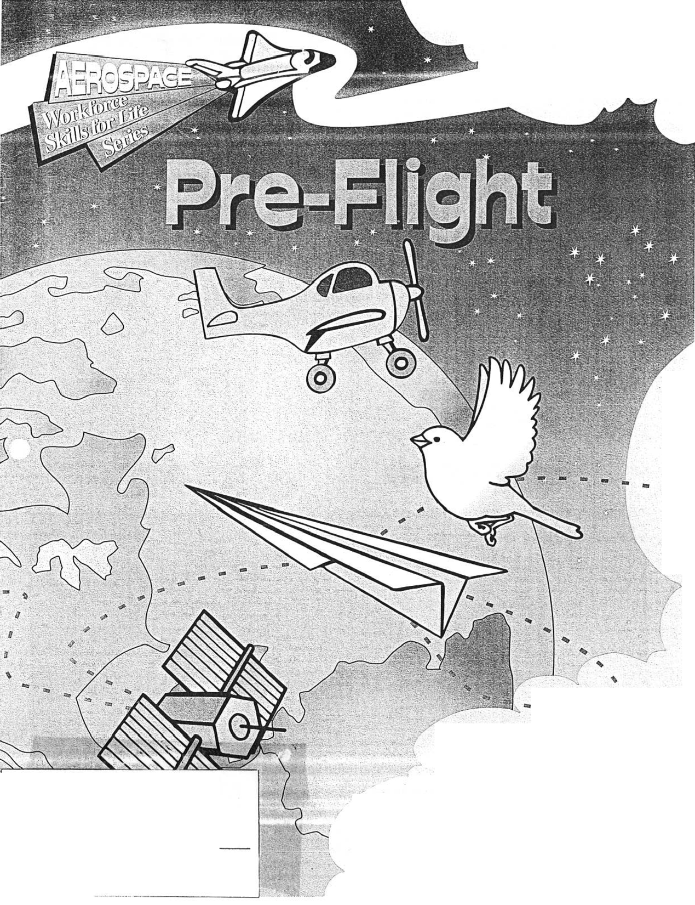

Project Activity Guide
PROJECT EXHIBIT TAG
Mini 4-H Rockets
Name:

Age:

'ha

Aerospace Supporters
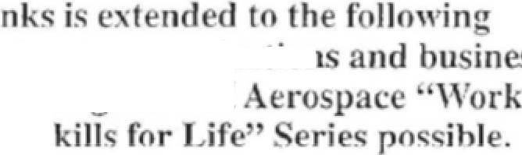
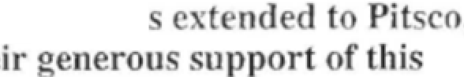
. p ial r
o0niti n i

indi ani 1
form k -II
r C
PITSCO
innovative edu a ti on
In . for th
curricula.



tan and Irene Meinen E DO T


MIDWEST
PRODUCl'S CO� INC.
EDUCATIONAL PRODUcrs DIVISION

::JEPPESEN
Sanderson Training Products




Orrtce of

Aeronautic:

O';, UJl'i8NEINMSl/troTf--,., 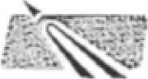
,.J(...,_ 4·H Cooperative
4'.,_��Curriculum System
"uo<ri<n<,o._OII ,.

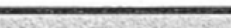
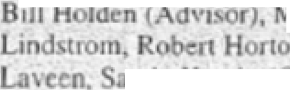
Acknowledgements
Prim urri ulum Dono .
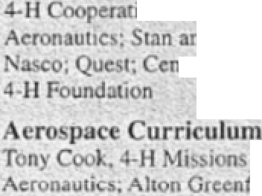
,c Curriculum ysIcm. PiL'-CO, In , M 'D T, Office of
d Irene \1emen Endowment, \hdwesI Produ
tcr t r 4•H • u1h Dc,clormcnt. and Mmne L'.I

t crin ommilt
in Spa c. Gordon Hoff, Qffj c or
,cld, Dcpanmcnt ofEJu.:oti n; 1,n
lemen. , Jeppe n ande=n, Ina kL:11n Jnd Carol
P menr son , and Tom Zuro her Educauonal
CO(IJdinJror
A ro pace urri ulum D . ign am
Judy Rice, Julre Loo . \\'ntcr: Jan Hnrpe, Ed, r,
onhem De Ign and Produ rron; l,Jritmg fcam • fll
on And rker, Oon Bemfield. �anne Bloom. Joel) .
Bptrom. 1 arolyn Clai:ue Ch ), R,
offcy, Ca bb1e urry. Im Ch )
nn Cirimm, Lind� Frey, Ed Fncl.c) (Chair, Aviauon). D,

YouU1 D�ign Team Iember;,
ur:i Brnltley, Ertn Duffy, 1a11 Fr:inl..hn, Heather Hardm . R)lan KJ\-1 ko. fed KmghL Kyra lani;c,ld, Ja: n . fell, RenJdmtn Race, T;)lor pp n, K thryn ha1 her. an\ cmc s rew Yeaser, .Ma ·c Zeb1II
ro p Pilot, Re,ic11 nnd rnluation '!"earn
til..e Ale1>1int, Noel AIIJrd,Todd nder,,on, H I.. • Carol Au tin. Andrc.i D�I , te, en Bcrrr, Lynn Bondrnnt, T,na Brc,tfcllcr, Viet r 6. Belardo. Jct') h.bna.n, Charlonc oflm�n. l,..olo O md , Linda Da,is. C I Doolntle, Bill E'" n , t,chcle Fl oder. t. l Chuc•
' m' Gcmar, Rt'>ben Gn , And} H lptr, 0. D 'Olhc' Kaldahl, Richard Khnc, Jo-eph H. J.;oncn. Chuck Lar n, Sh on LoH:11. B,11
.1addy, rank M1tche.JI, Pam Peterson, Jim Rice. 11.11 y tedman, Mcnin K Su, J.lcr, Jr,, R m ndcrwood, Hcl n nruh, \ 111 w ncn. Ru.,� \VJ!\ n, fan Wiede,1..chr. Bart\ ,Iii m . Ben \\' tephJnic W1i ht. Ted Wyrow ki

P:irticip Lin1: ni I.Idem of Aviat
iw1io at,on

- hl..e Kuul..e, D.m Jam Au">Cr•
E.-te:. lndu,111c ,
, 4-H
chcop u

o
Jrm L.id"'''i!:•
n, .\irk
111,
,om. D
ng , tc K:uie K h-
,m Krn Lc:ml..c,
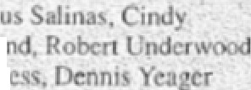
er, Juli
F11gl,L, Inc:, Honey
Edu.: tio A
Ccn1cnm o
Jeppc
' ·1
, ITn
pl f
i hi
e,

Lhncbu, D Morl T rchc:
h Sor
. pace)
hn tra
er We n
Tn· 1�1e 11, lei;
e�1on'
Par nd T·rrilori• :
Airline.�.

Al., KS, ID, M . Ml. 0. IT, 'C. 'D, Y,
.
() 

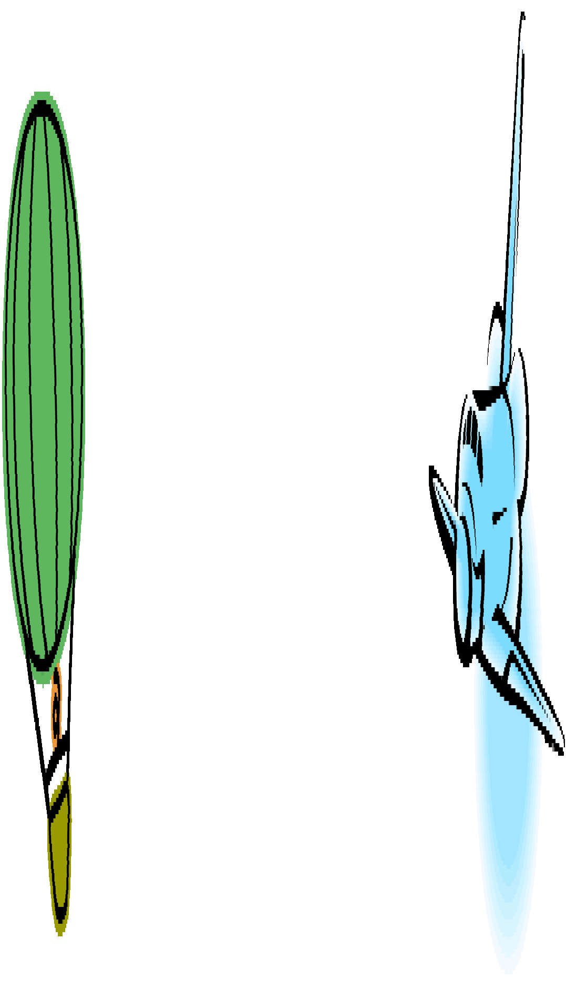
Launch Pad

Aerospace Supporters | Inside Front Cover
Launch Pad | 1
Helper’s Information | 2
Pre-Flight Aerospace Achievement Program | 3
5..4..3..2..1.. | 4
Wonderful Wings | 6
What Do You Do? | 10
Spacey Suit | 12
Hangar Talk | 14
Prop Shop | 16
4-H CCS Products | Inside Back Cover


There looks like a
lot of fun things to do here!
Stage 2 Lift-Off
Rockets Away! Gnome of Your Own I Want to Be… Family Flyers
From Here to There! Follow That Shadow Can I fly Today?
Which Way is Up? Angle of Attack! Up, Up and Away Round and Round
Charlie Oscar Delta Echo From Nose to Tail
Stage 4 Pre-Flight
The Yokes on You! High Flying Mission Future Pilot
Ace Instructor Cross Country Knowledgeable Navigator
Space Notes Brouhaha Box Kite Care in the Air Elevator Magic Airport Issues
My Personal Qualities
Flight Crew Aerospace Group Activity Guide
Afterburner Aerospace Quiz Bowl Aircraft Fire Rescue
Top Gun Far Out!
Community Airport Field Day Flight 747
Aerospace Proficiency Game Traffic Cop in the Sky Mission Aerospace Skillathon Aerospace Glossary Games Touring An Airport
Full of Hot Air
Stage 3 Reaching New Heights
Rippin’ Rockets Fly’n Show
Let’s Go Launching
Attitudes, Altitudes and Airspeed Flying Feathers
Follow That Shadow Flying My Way Shuttle on a String Powerful Payload Flying Fighters Mustangs to Zeros Copiers and Robbers Just Blowing Through
Stage 1 Pre-Flight
5...4...3...2...1…
Wonderful Wings What Do You Do? Spacey Suit
Aerospace Community Organizer Guide
You, The Community Aerospace Organizer Aerospace Resources Organizing Aerospace Youth
Groups
Sign-up Night Program Supporting Aerospace
Volunteers Orientation Workshop
Outline Scavenger Hunt Aerospace Program
Incentives Achievement Program
Certificate
Project Meeting Ideas

Helper’s Information





to of four
in Adventures
in
discusses what was most important; sees how this experience and the life skill practiced relates to his or own everyday experiences; and finally applies what was learned to a new situation. This model stresses the use of

Life'' Series.

·••
open-ended questions that build on what the youth and says. More information on this model and how to

You have an exciting and challenging role as the of a young person interested in exploring Your three key responsibilities include the

- Review this guide and Flight the Aerospace Group Helper's

- Support the youth in efforts to set goals and the Pre-Flight Aerospace Achievement

- Serve as a resource person to help connect youth the community, resource materials and knowledgeable about
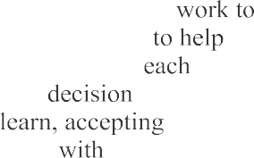
By encouraging the young person to set goals and complete them, there will be many opportunities
them develop important life skills they will use day. These skills include creative thinking, making, problem solving, learning how to
responsibility, managing time, teaming others and participating as a member of a team. How you are involved will often determine how successful youth is in developing these critical


The Experiential 
The experiential learning model is used throughout series to maximize the opportunities for strong development outcomes. The model emphasizes a centered rather than leader, teacher or helper approach. In other words the youth is encouraged to learn by doing before being told or shown how possible instead of being guided step by step through activity. Then the youth shares what
it are found in Flight Crew, the Aerospace Activity Guide and the Aerospace Organizer's Guide, the fifth and sixth pieces of aerospace

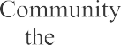
The Adventures In 


A total of six pieces are included in the Aerospace
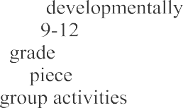
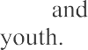

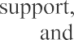
for Life Series." The first four activity guides, Flight, Lift-Off, Reaching New Heights and Pilot Command have been designed to be appropriate for grades K-2, 3-5, 6-8 and respectively but may be used by youth in any based on their project skills and expertise. The fifth Flight Crew has been designed to provide that can ·organized very quickly conducted with a group of usually three to forty The sixth piece is the Aerospace Community Guide. This piece has been designed to help a or staff member organize a youth aerospace program in a community. Included are hints on financial organizing a sign-up night, providing recognition much

Evaluating the Experience
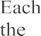
activity can be evaluated based on the understanding youth has about the aerospace content and the work
skill shared during the debriefing session.
of the Pre-Flight Achievement Program is final evaluation. As the project helper your initials on achievement program will indicate that the activity been successfully

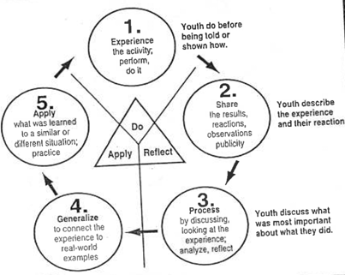
Good luck in your role as aerospace project

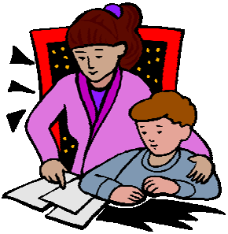

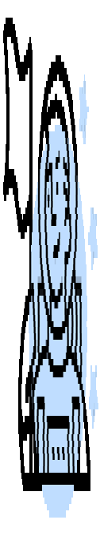
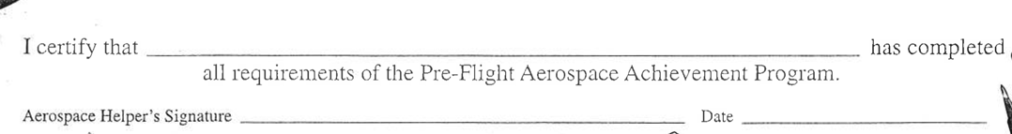

Pre-Flight Aerospace Achieve- ment Program









Aerospace Activity Log

To Complete:
- Do 4 required activities.
- Do at least 2 of the Solo Flight activities
- Do at least one of your own activities.
- Share each activity with your helper and have your helper initial.
Date and list exciting things you do and learn In the aerospace project














Pre-Flight Completion Certificate

- .4. .3. .2. .1. .
Have you ever looked closely at a rocket? In this activity you will do just that! You will make a rocket using marshmallows, candy, and six or more toothpicks. And here’s the best part: when you’re done, you can eat your rocket!

Blast Off
Begin by finding picture and information about real rocket and parts in a newspaper or a
Use the picture help you make
own
  - The marshmallows stand for the rocket stages or body tube.
  - The gum
the fins.
  - The candy cone the nose cone which people sometimes
What To Do: Build a rocket that can be eaten
Work Life Skill: Recognizes patterns/ relationships
Aerospace Skills: Building a rocket and
identifying rocket parts
Science Skills: Building models, inferring
Materials: 3 large marshmallows, 3 gumdrops, 1 cone-shaped chocolate drop, 6-8

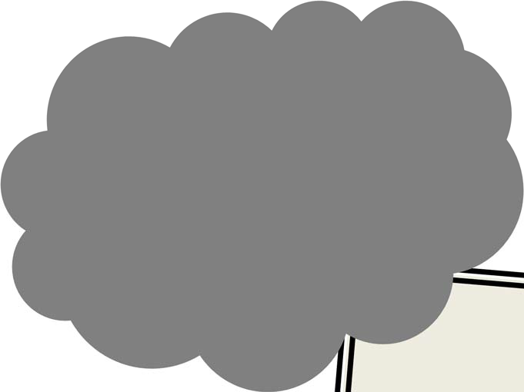


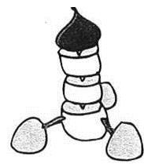
- Draw and color a picture of your
- Label the three main  fins, body tube and nose

Debriefing
Ground to Ground
Q. Tell a family member about your and its parts. What is each part
Q. How did you make your

Climb Out (Process)
Q. How is your rocket like real

Space capsules have special heat shields to protect the cabin during its journey and as it comes back to Earth

Level Off (Generalize)
Q. Where can you find more about

Cross Country

Q. How can building or looking at a of something help us learn more the real
- With your helper read a story about rockets or exploring space.
Date: Initial:
- Watch the next live shuttle launch on television or watch a video of a launch. Describe the launch to your helper.
Date: Initial:
- Make a model rocket.
Date: Initial:


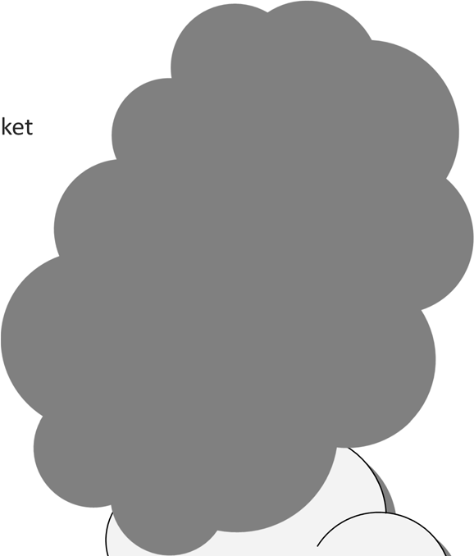


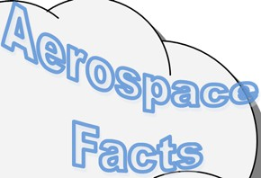




Resources
The Usborne Book of Space Facts is available from the 4-H Source Book as well as from many libraries and book stores.

by Dan James, 4-H Blue Skies Series, from Gateway to the Future by Jean
St. Louis, MO

Wonderful Wings
Hummingbirds, robins, eagles,
gliders, jets, helicopters, and airplanes. What do all of these have in common? In this activity you will discover how birds and airplanes are alike.
What To Do: Compare birds and airplanes
Work Life Skill: Transfers information between formats


Aerospace Skills: Comparing birds to airplanes
Science Skills: Inferring
Materials: Bird and airplane pictures, crayons, scissors

Blast Off

- Color the birds and the airplanes on pages 7 and 8.
- Cut out the 14 picture boxes
- Arrange the boxes in order with the birds facing up.
- Staple the boxes together on the top left corner. Helper note: Be sure edges are trimmed evenly.
- Flip through the pictures and watch the birds take-oﬀ, fly, and land.
- Turn your booklet over, flip through the airplane pictures and watch an airplane take-oﬀ, fly, and land.
- Then draw and color a picture of your favorite bird and airplane.

My Favorite Bird

My Favorite Airplane

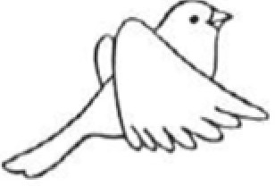
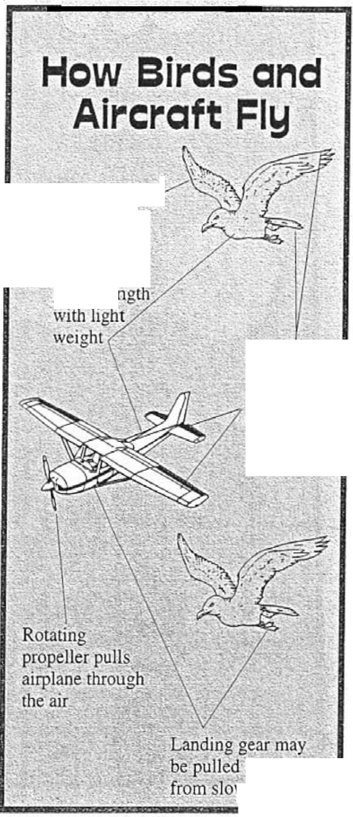
:I- - - - - - - - - A- ,- - - - _I 1---------------
'
Wings give lift

Inside parts:
gi�es�e
Movable wing and tail surfacis help _control and keep . steady -
I!) !O, keep _
�ing down·-
1
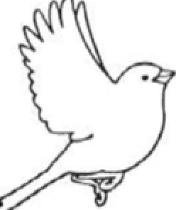
I I

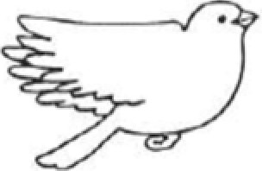
I
I
I' I
1 I
I II
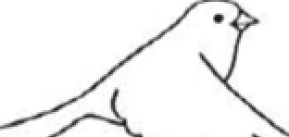
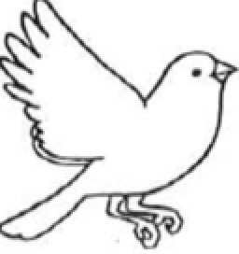
I
II I
II,---------------I',--------------
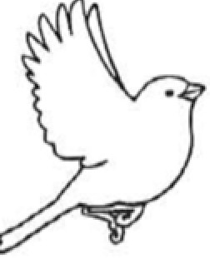
1

�
I I
, '
I ,--------------
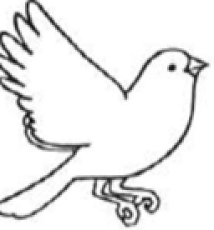
1

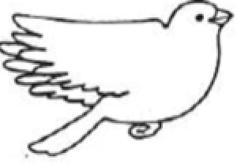
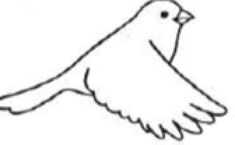
I I I
:-- - - - - - - - - - - - _,I
,--------------
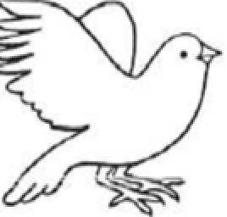
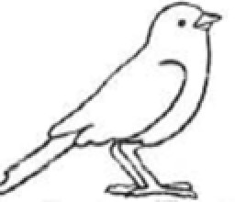
'


I �
I

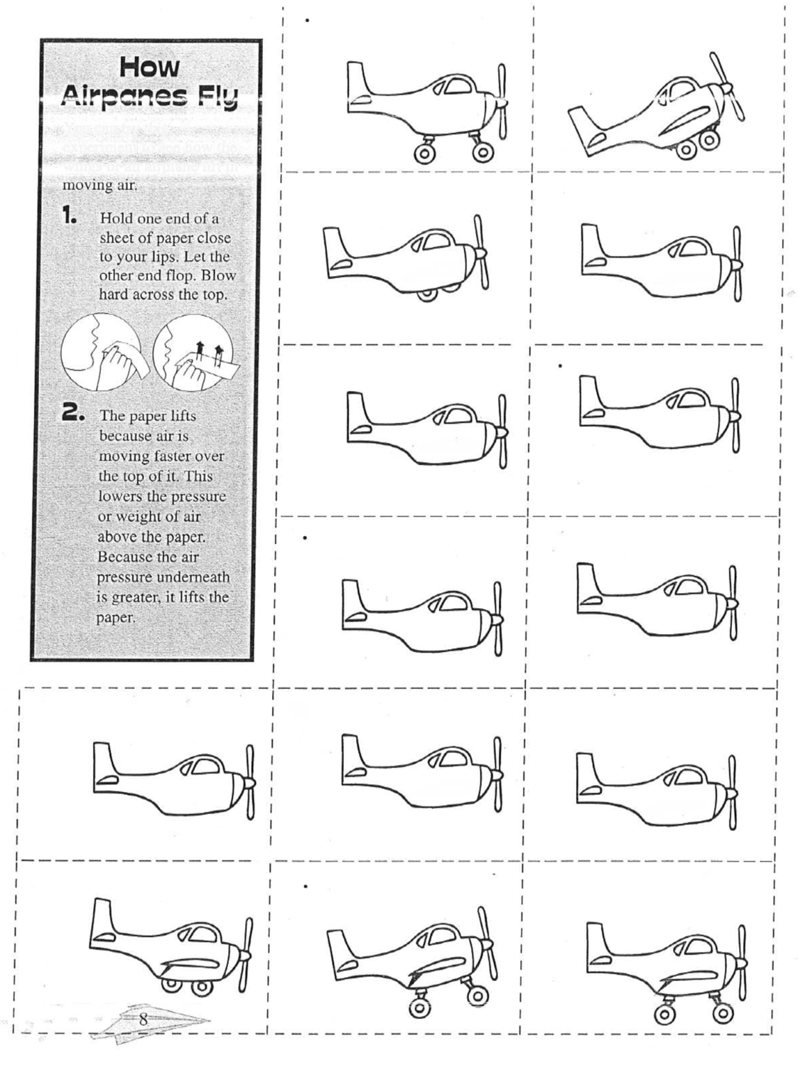



How Airplanes Fly

You can try this experiment to see how the wings of an airplane lift in moving air.
1. Hold one end of a paper close to your lips. Let the other end flop. Blow hard across the top.
1. The paper lifts because the air is moving faster over the top of it. This lowers the pressure or weight of air above the paper. Because the air underneath is greater, it lifts the paper.













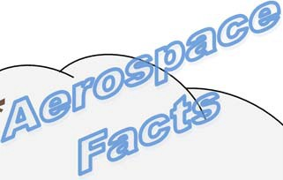


Ground to Ground
Q. What did you see when you through the
Q. Share with your helper how the bird took
flew and landed compared to the
Climb Out
Q. How do the feet, tail, wing and light body of a bird compare to the parts of


Level Oﬀ
Q. How can comparing two things you learn about them?

Cross
How can comparing things help you do something else in your life, like:
- decide which bike to
- choose a meal at a
- decide if you would rather have a  or a cat for a

- Pilots must have licenses to fly, just like drivers have licenses to drive. When people pass the tests to get their pilot’s licenses, we say the have earned their “wings.”
- A special department of the government called the Federal Aviation Administration sets the rules for pilots. It also works hard to make sure flying is safe for everyone.

- Visit an aviary. zoo, or your backyard feeder and watch how diﬀerent birds take-oﬀ, fly, and land.
Date Initial
- Take a discovery airplane flight through the Young Eagle’s Program. Ask your helper to contact :
Experimental Aircraft Association
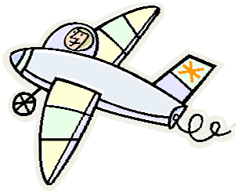
PO Box 3086, Oshkosh WI 54903-3086 For more information call—920-426-4800
Date Initial

What Do You Do?
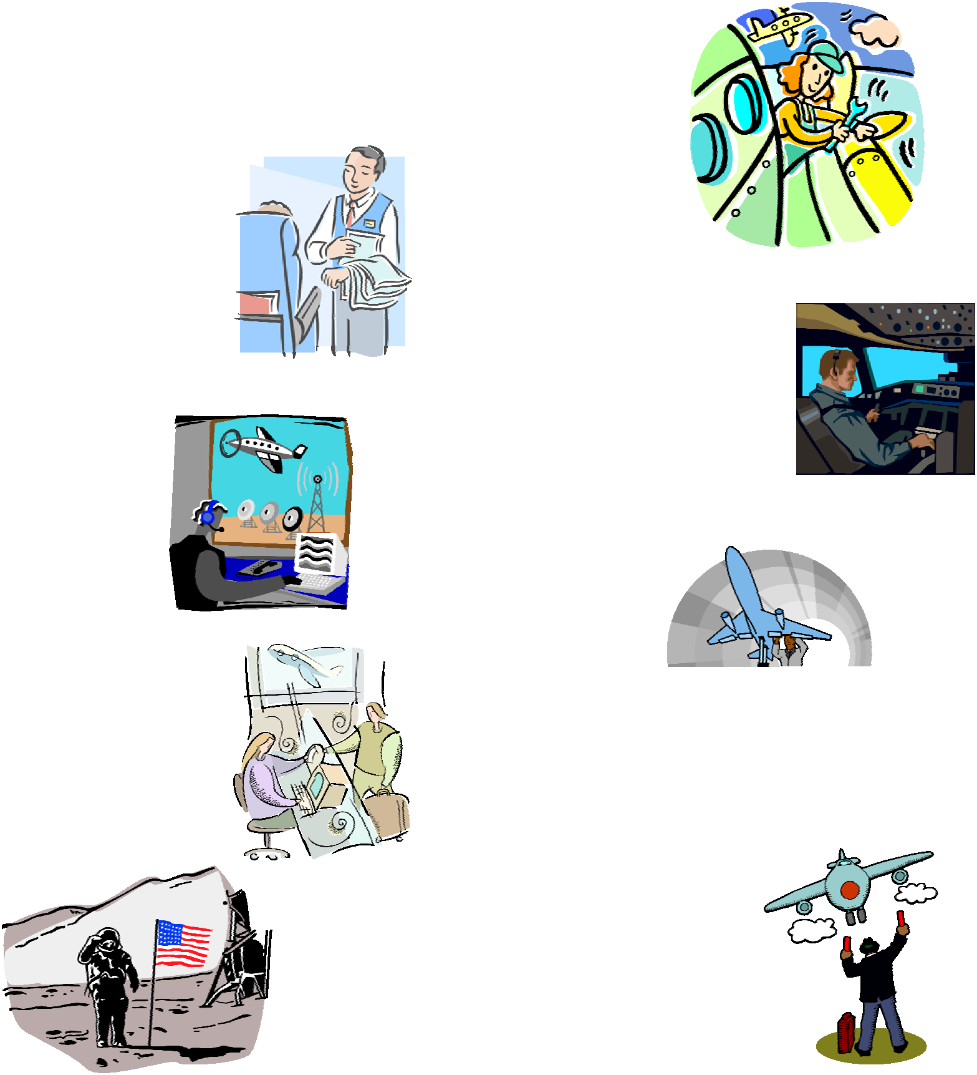

People have many diﬀerent jobs in aviation and space. Lie being an astronaut, pilot, aircraft mechanic, meteorologist, flight attendant, air traﬃc controller, and ground support crew.
Each job requires special skills and tools, and a special workplace. In this activity you will work with a helper to match the people with their special workplaces.
What To Do: Match people with their jobs
Work Life Skill: Interprets and communicates information
Aerospace Skills: Identifying aerospace careers
Science Skills: Classifying
Materials: “Who Works Where?” activity sheet, pencil or crayon

Blast Off
- With your helper, draw a line from the job to where the person might work.
- Tell your helper what the worker is doing in each picture.
- Draw a picture of you and the special workplace you might want to work in the box provided.
Aerospace Engineer Flight Attendant Ground Support Crew Pilot
Ticket Agent Aircraft Mechanic Air Traffic Controller
Astronaut

A picture of me where I want to work.

Ground to Ground 
Q. Tell your helper what each person is doing.
Q. What new jobs did you see?
Climb Out 
Q. What did you learn about aerospace jobs by doing this activity?
____
____

Level Oﬀ
Q. How can you find more about a job you like?

Cross

Q. Tell your helper about a job you would like to do when you are older.
In 1944, Cornelius “Neil” V. Loving was injured in a glider accident and both of his legs were amputated. He worked very hard and continued to be a pilot with artificial legs. He went to college to learn more about airplanes and flying, and even designed an airplane of his won. You can see it at the Experimental Aircraft Association Museum in Oshkosh, Wiscon-sin. The “Loving Love” had folded wings and can be driven on the highway.

- Visit the library with your helper and read about the Wright Brothers, Charles Lindbergh, Mary Ross, Amelia Earhart, Jeanna Yeager or any other aerospace hero/heroine.
Date Initial
- Visit your local airport. Tell your helper who works there and what they do.
Date Initial





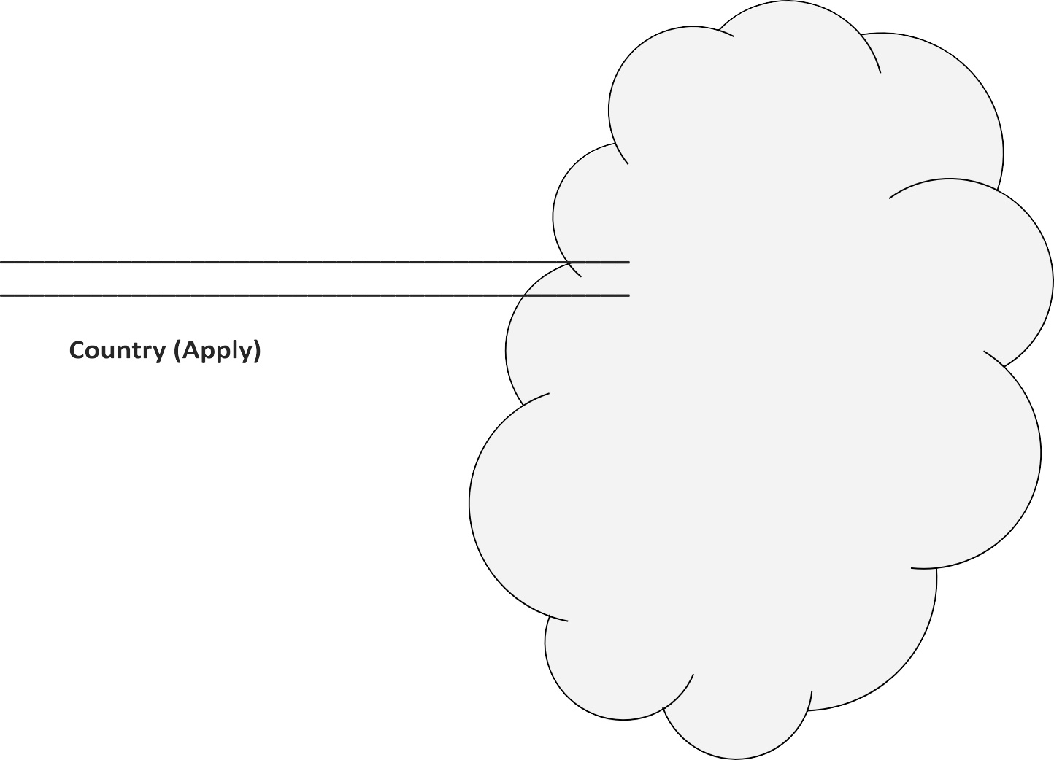


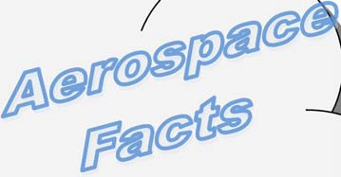


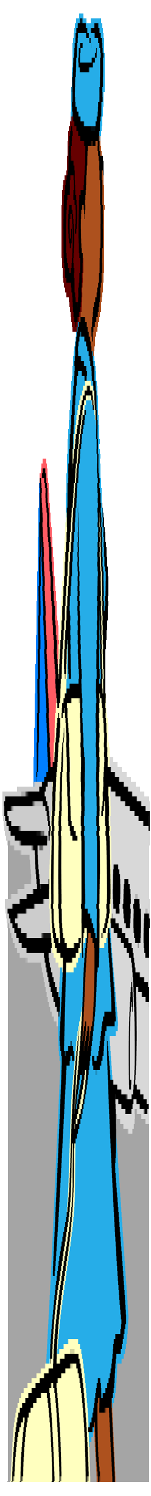


Activity adapted by Carol Comer, Gordon Hoff and Jason Mell from The Sky's the Limit: Volume Pilots Help Our Nation by Monica Sorenson, Minnesota Department Office of Aeronautics, Drawings by Office of Aeronautics, Minnesota of Transportation

Spacey Suit
Your space ship has just landed on the planet Nad. What kind of clothes do you need to leave the spaceship and discover what’s out there? Let’s get ready for a space walk by making a space helmet and wearing gloves.
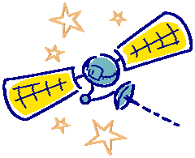
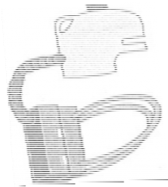










Blast Off
- With your helper, cut the gallon milk jug into a helmet shape and smooth and tape the edges
Activity
- Decorate with paints, markers, crayons, pipe cleaners, pop can tabs, straws, paper, fabric, or whatever you choose. You can use colored acetate or cellophane for the eye shield
Fold a paper
airplane
Write your
name
- Next, try the tasks in the chart to the right. Give yourself a star for each task you can do.
Touch your
nose with one finger tip

- Then, put on the pair of adult gloves. These gloves are like the stiﬀ, bulky gloves astronauts wear while on space walks. Wearing your space helmet and gloves, try to do the tasks again. Give yourself a star if you can finish the tasks while wearing your space helmet a
nd gloves….
Turn a door
knob
Tie your
shoes
Brush/comb
your hair
Or if you gave it your best try.
What To Do: Make a space helmet and practice us-ing space-suit-type gloves
Work Life Skill: Demonstrates creative thinking and problem solving
Aerospace Skills: Making a space helmet and using space-suit-type gloves
Science Skills: Building models, experimenting
Materials: Gallon plastic milk jug, orange juice bottle or paper bag, scissors, glue, crayons, miscellaneous decoration items, pencil, paper, hairbrush or comb, adult-size ski, welding or heavy rubber work gloves

Without
Gloves
Wearing
Space Gloves



Ground to Ground 
Q. Share with your helper how you made your helmet.
Q. How did you feel when you tried the tasks while wearing the space-suit-type gloves and helmet?
Climb Out 
Q. Why do astronauts need special clothing?

Level Oﬀ 
Q. When might you or someone you know wear special clothing for a certain job or event? Why is it needed?

Cross 
Q. If you were going to visit the planet Nad, what special equipment and supplies would you take with you?

- The word astronaut means “sailor among the stars.”
- The purpose of the space suit is to give the astronaut air to breathe and to keep air pressure and temperature steady. Space suits have about 15 layers of material. A space bubble helmet weighs about 40 pounds. That’s almost as much as many kindergarteners weigh!

  - Draw a picture of how you think the planet Nad looks. Share with a family member what a day in your life on planet Nad might be like.
Date Initial
  - With your helper , write to NASA for a color space suit poster.
Request Space Suit
WED-109
NASA Education Publications Code FEP







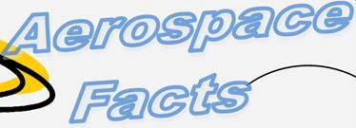




Written by Dan James, 4-H Blue Skies Series. Aero-Space Facts adapted from How Do You Go to the Bathroom ill Space? by William R.
Washington DC 20546
Date Initial
: Several books on space and space travel including “How Do You Go To the Bathroom in Space?” are available from the 4-H Source Book.

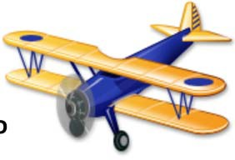
Hangar Talk

This is the first of four Hangar Talk glossaries for you t use to increase your aviation and space vocabulary.
o

Aerospace engineer -
a person who designs airplanes and space ships using computers.
Aircraft mechanic - a person who repairs and helps keep in good condition aircraft engines, power plants, and electrical wiring systems.
Air traﬃc controller -
person who helps
 safety to aircraft in the and on the .
Airfoil - The shape of wing that helps make possible for the aircraft fly.
Airplane -A machine wings, heavier than air is driven by an engine

Airport - place where aircraft can take oﬀ and land; usually equipped with a control tower, hangars, and places for passengers and cargo.
Astronaut - a person who operates a space vehicle, conducts experiments, and gathers information during a space flight.
Amphibian airplane - an airplane that can land on both land and water.
Aviation - related to aircraft.
Aviary - A place s kept.
A bag filled a gas that is lighter than air, moved by the
A light or signal showing
Biplane - An airplane two sets of wings, one above the other.
Capsule - a small, sealed pressurized cabin that a human or animal can live in while in space.
Commander - the crew member who is the leader of the flight and crew.
Crosswind - wind that blows across the path of a kite, aircraft, or other object.
Dirigible - a long cigar-shaped bag filled with a gas that is lighter-than-air, powered by an engine and is steerable.
Engine - the part of the aircraft that provides power to move the aircraft
through the air.
Fins - Act like feathers an arrow to guide the in 
Flight A
who helps passengers crew.
Flight deck - The part of the spacecraft where commander and pilot fly the shuttle.
Four forces of flight forces acting on  during

1. Lift - upward force created by airflow as it passes over a wing.
2. Weight/Gravity - causes an object to be pulled downward.
3. Thrust - force that moves an object through the air.
4. Drag - limits the speed of am object; opposite of thrust.
Fuel - the gasoline or kerosene used to run engines.

Galley - the area on the shuttles middeck where food is prepared.
Glider - an airplane without an engine.
Ground Support Crew - a person or group of people, who helps with the aircraft, crew, and passenger.
Hangar - a large building at the airport where airplanes are stored and repaired.
Hang Glider - A glider where the pilot hangs underneath the wing.
Headset - Headphones that fit over the pilot’s ears to help him or her hear better.
Helicopter - an aircraft that flies by using a rotating wing.
Jet Aircraft - an aircraft that travels very fast and is powered by a jet engine.
Jet Engine - an engine that turns air and fuel into a hot gas that shoots out the back of an engine and pushes the airplane through the air.
Launch - to take oﬀ
Lighter-than-air - aircraft that is lifted into the air by a gas that weighs less than air.
Meteorologist - a person who studies the weather forecasts changes and gives weather reports
Monoplane - an airplane with one set of wings.
Multi-Engine Aircraft - an aircraft with more than one engine.
Orbiter - the Space Shuttle.
Parachute - Fabric attached to objects or persons to give a slowed trip to Earth.
Pilot - a person who operates aircraft or is the assistant commander of aircraft or space flight.
Propeller - two or more twisted blades that pull an airplane forward as they turn. Blades have the same shape as a wing.
Ramp - an area at the airport where aircraft are parked to be serviced or to load/unload passengers and cargo.
Rocket Stages - two or more rockets stacked on top of each other in order to go up higher in the air, or to carry more weight.
Runway - a long, straight road for aircraft to take oﬀ and land on.
Seaplane - an airplane that takes oﬀ or lands on water.
Space - air, atmosphere, sky, universe.
Spacelab - the space shuttle’s
flying laboratory.
Star - a burning ball of gases.
Tail - the rear part of the airplane.
Takeoﬀ - the beginning of the flight, when the airplane gains speed and leaves the ground.
Taxi - to move an aircraft on the ground.
Taxiway - the roads used by aircraft when they move on the ground.
Temperature - the degree of hot and cold.
Terminal - a building on the airport where aircraft arrive and depart, people board, buy tickets, and have luggage handled.
Weather - the condition of the atmosphere at a given time: air motion, moisture, temperature, air pressure.
Windsock - a cone shaped, open-ended cloth that catches the wind and shows wind direction.
Wing - the part of a bird, animal, or machine shaped in a way that gives life when air flows over it.

Prop Shop (Aerospace Resources)

National
National Association of State Aviation Official
Metro Plaza One
8401 Colesville Road, Suite Silver Springs, MD 20910
Aviation education informationn each including career information.
Raytheon Aircraft Aviation Education Dept. 97 10511 East Central
Wichita, KS 67206 http://www.raytheon.com/rac/
Aviation education materials for all ages
NASCO
901 Janesville Ave.
PO Box 901
Fort Atkinson, WI 53538-0901 1-800-558-9595
Catalogue of aerospace s books,
,

posters,

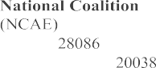

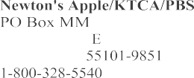
for Aviation
4-H
211 Duncan Auburn
AL

Skylights, periodical for the aerospace

172 4th Street St. Paul, MN

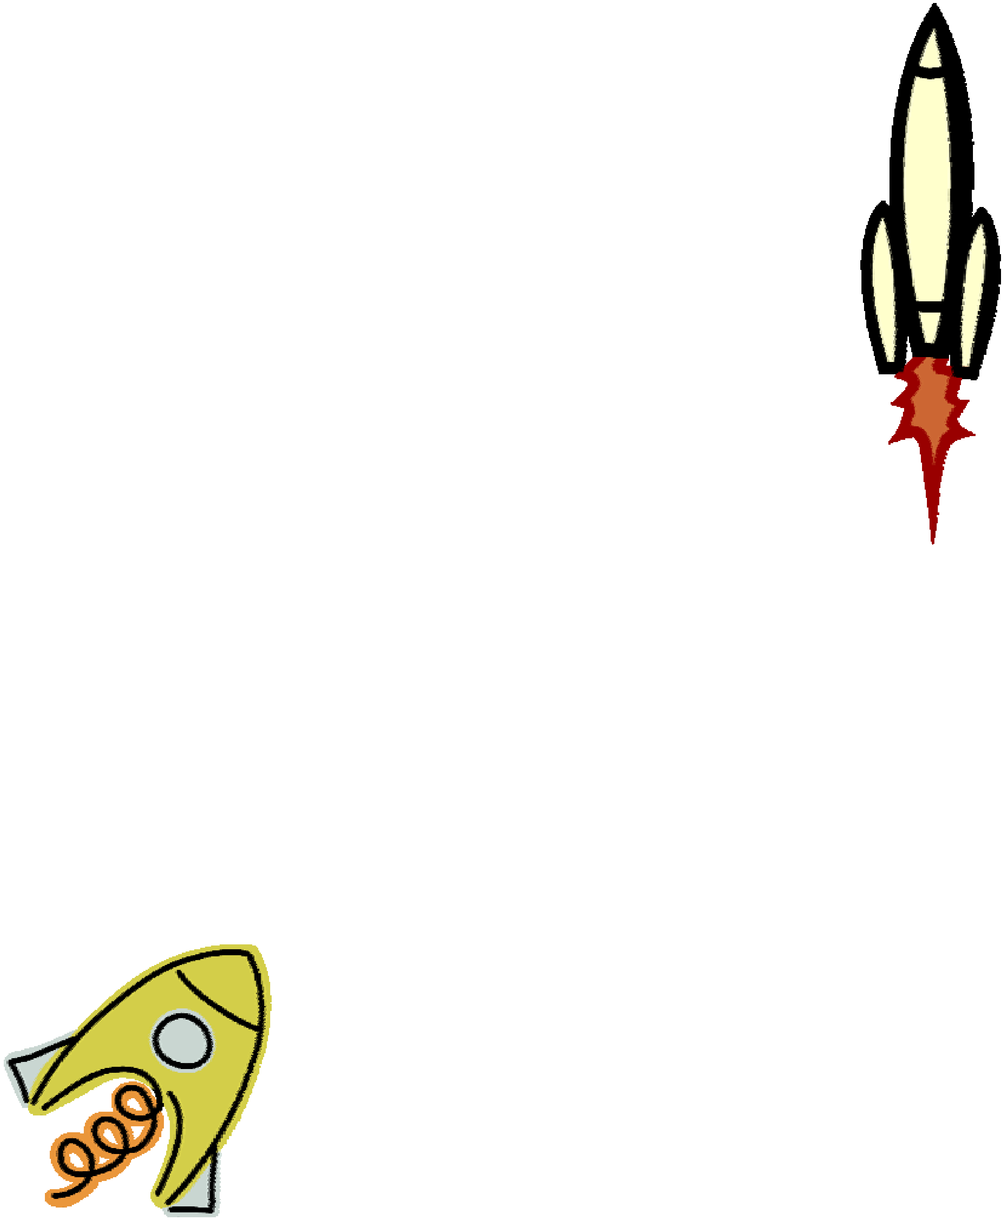
PO Box Washington, DC
Excellent directory representing the industry and

Videotapes of selected programs, CD-ROM


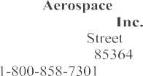
“"What's the Secret?," science
US Space
Space
US Space & Rocket
and
One Tranquility Huntsville, AL
1-800-63-Space or
Quest
A Div. of Toy Biz, 350 East 18th Yuma, Arizona

The Collegiate Aviation Directory

Your local Cooperative Extension Office

Aerospace Educational Organizations

of Model 5151 East Memorial Muncie, IN
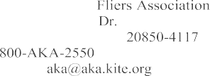
Model aviation information, teacher
Kite 352 Hungerford
Rockville, Maryland
E-mail:
Aerospace Materials in National 4-H Collection


Work Skills for Life
Aviation 3410 Skyway Auburn, AL
Distribution
20 Coffey Hall

of Minnesota
St.
See inside back cover for ordering
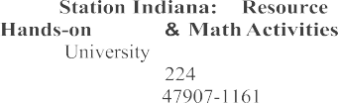
Space
A
Book
Science
Purdue
1161 AGAD Room
West Lafayette, IN
Aerospace and

Teacher/Youth Leader resources; model rockets, supplies, education
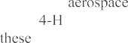
A portion of the sales price of the products services in the sales catalogs of these product suppliers will be used to promote educational programs. No endorsements, of products or services is implied or
Exploring Aerospace on the Web
Aviation Web/Student


Fleeting Glimpse:
EAA Youth & Education
http.

Local Kite

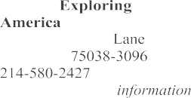
Aviation
Division
1325 Walnut Hill Irving, TX
Explorer program
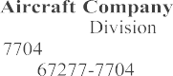
Cessna
Air Age Education PO Box
Wichita, KS

- Boy of


including this
4-H Source
7100 Connecticut Chevy Chase, MD
Fax:
Catalogue of 4-H and aerospace aerospace curriculum

For additional resources not available through 4-H Source Book see the


FAA Aviation Career
National Air and Space

Virtual Library Embry-Riddle Aeronautical University: http://macwww.db.erau/www_virtual_lib/aviation.html

Women in Aviation:
http://www.tc.faa.gav/ZDV/wia.html

Teacher resources, Air Age Educational Packet
for Space Science
1029 N. Royal St., Suite

Alexandria,


Teacher resources, information, education

http://www.eaa.org/youngeagles/cap.html
Teacher resources, information, aerospace education materials
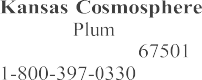
1100 N.
Hutchinson, KS
Aerospace summer camps, family
GA Team 2000: www.beapilot.com


Rockets

Paul Grary’s Model Rocketry : (Beginners): http://www.dimensional.com/~pmgray

Irving Family: Model & High Power Rocketry:
http://www.irving.org/rocketry//

Space


NASA—Home Page http://www.hq.nasa.gov/office/codef.education

Kites

http://www.latrobe.edu.au/Glenn/KiteSite/Kites.html

Helicopters

http://www.rotor.com

Hot Air Balloons
http://www.apci.net/~wag

Weather
http://www.crhnwscr.noaa.gov/mpx/mpx.html

