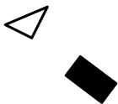
ount
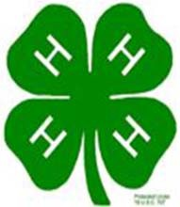

MINI 4-H

PROGRAM

SEWING PROJECT MANUAL

Clay County Cooperative Extension
Mini 4-H Program
6656 N State Road 59
Service

Brazil, IN 47834
(812) 448-9041

PROJECT EXHIBIT TAG
Mini 4-H Sewing
Name:
Age:



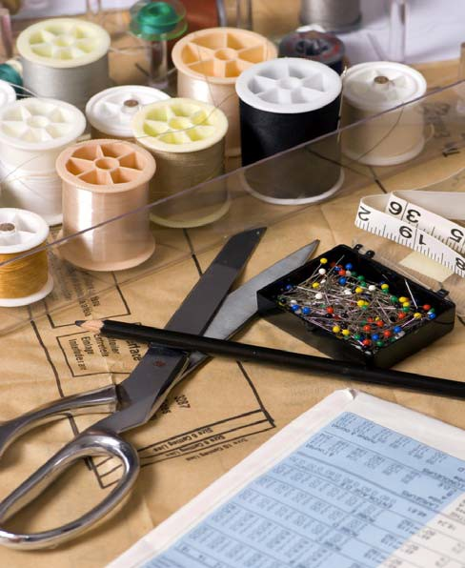
to fun
4-H".

to sew. learn put used in a a pin
or  and
to on a


WHAT YOU WILL

a lot of fun.
learn

will at the   4-H the  items:
Sewing Box that includes at  the

Pin  Needlebook 
and a button you have  on
a piece of 

REMEMBER TO PUT THE EXHIBIT TAG and  SHEET WITH YOUR 

LET'S LEARN 
MAKE A SEWING 

You will need a cigar box or shoe

You will probably want to cover or decorate your sewing box. To do you can use contact paper, scraps of fabric, gift wrapping paper or spray  Maybe you can think of some other ideas, try to be creative. Make it your personal sewing

LET'S LEARN  SEWING

1. KNIT
This is a certain type of fabric that stretches easily when pulled. A knit fabric has a lot of give to
2.
Simply refers to the edge of the fabric that is folded, when a piece of material is folded in

A like the one found in this manual) which is pinned to and cut

DOUBLE THREAD
A double thread is made by threading a needle and tying the two together.

BASTING STITCHES
Large, loose stitches that weave in and out of the fabric. Stitches all approximately the same

YOUR BASIC SEWING
Here are some basic sewing tools you include in your  box. It is  to know what your tools to be able to use  and to be able to call them by name. may  be with some of these tools.

SCISSORS: Use for clipping and trimming. Scissors are small and have straight handles.
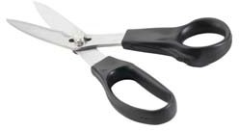
RULER: A 6-inch ruler or seam gauge is useful for measuring hems or seams.
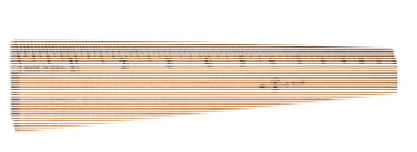

PIN CUSHION: Used to hold pins; A wrist pin is easy to find when you sew.
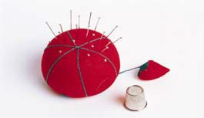
NEEDLES: Straight, sharp needles come in different sizes. The ones with long eyes are easier to thread.
MEASURING TAPE: A 60-inch
 tape is best because it won't stretch.
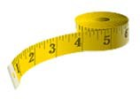
SHEARS: Used for cutting the fabric. Shears are 7 or more inches long and should be sharp. Shears with bent handles make it to cut on a flat surface.

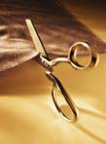
PINS: Used to hold pieces of fabric  for sewing. Dressmaker, silk and ballpoint pins are available. Do not use bent or rusty pins.

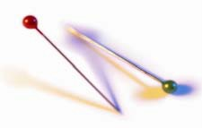
THREAD: It should match your fabric. You may want to ask your salesperson for help in selecting the best type and color.

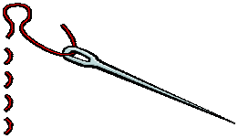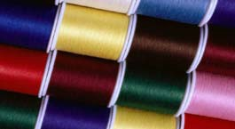


LET'S MAKE A PIN

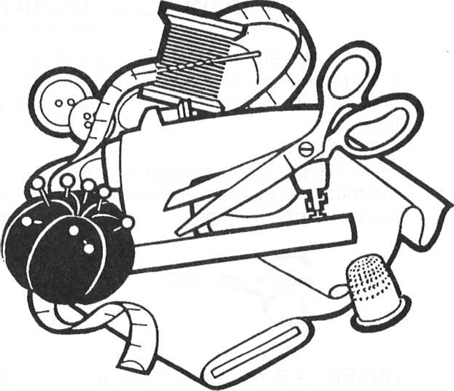
Items needed for  PIN 
one 3-inch styrofoam medium weight knit fabric {any
color)
large eyed needle or #14 Arts Crafts
 floss or straight
tailor's

NOTE: For this project, you can use either a solid colored knit fabric or knit fabric that has a design. Also, the yarn or embroidery floss can be any color you wish. The fabric should be at least 12 inches wide and 12 inches long, so the pattern piece will fit easily on your material.

INSTRUCTIONS {read all instructions before you begin).

- Cut out the half-circle which is in this manual, and place the pattern on the fold of your fabric.
- With straight pins, pin the pattern in place on the fabric.
- Very carefully, cut around the pattern, keeping the fabric flat on the cutting surface. Open up your fabric and you have a
- With tailor's chalk, mark the broken lines on your fabric circle, in the same they are found on your pattern, about 1 1/2 inches from the edge.
- Thread your needle. If you are using yarn, use an Arts & Crafts Needle #14. If you are sewing with embroidery floss, use a doubled thread and a crewel or large eyed needle. (Mom might have to help you get the yarn or floss through the eye of the needle.)
- Following the broken lines on the fabric, very carefully make your basting stitches. Try to keep them all about the same size, and be sure you stitch all the way around the circle.
- With your parent's help, take a knife and cut approximately 1/4 inch off the bottom of the Styrofoam ball. Make the edge even so the ball will sit
- Put the styrofoam ball in the center of your fabric circle and slowly draw the strings tightly. When the fabric is drawn snugly around the ball, make a tight
- To make sure your ties don't unravel, put a knot in each

CONGRATULATIONS....You've just completed your very own CUSHION!!!!

HERE'S ANOTHER PIN CUSHION TO TRY
or LADYBUG PIN CUSHION

What you will

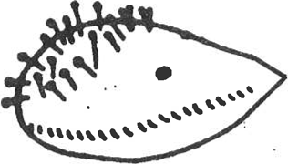
two pieces of different colored each 5 inches by 3 1/2
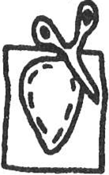
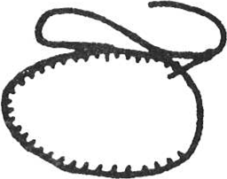
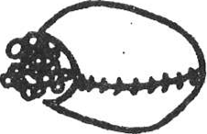
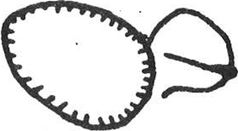
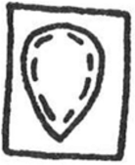

or for the ladybug polka dot material black and colored embroidery cotton stuffing (Kapok or polyester fiberfill)

large

- Pin pattern to felt, cut out shape Repeat with second

- Place both shapes together. Oversew edge, leaving opening for stuffing.

- Push stuffing through opening making Hedgehog/Ladybug as fat as possible.

- Press edge together and neatly oversew the opening.

- Embroider nose and eyes in satin stitch using black embroidery cotton.

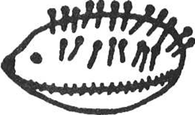
- Stick in pins for too or they may poke through underneath. If you didn't use polka dot material for ladybug, you may want to glue some black felt on ladybug for her spots.

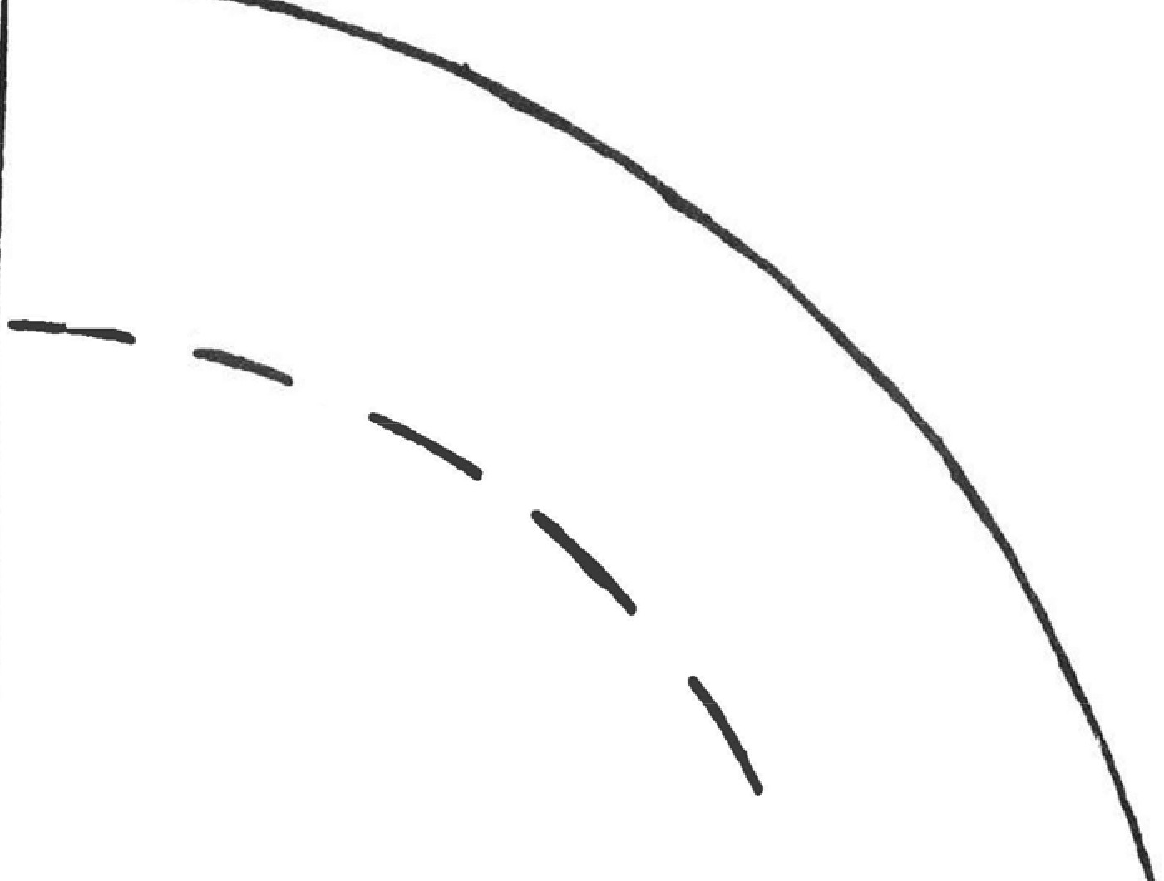
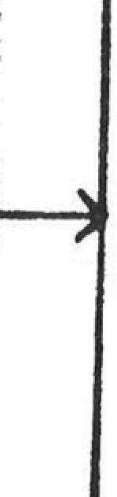
\ �
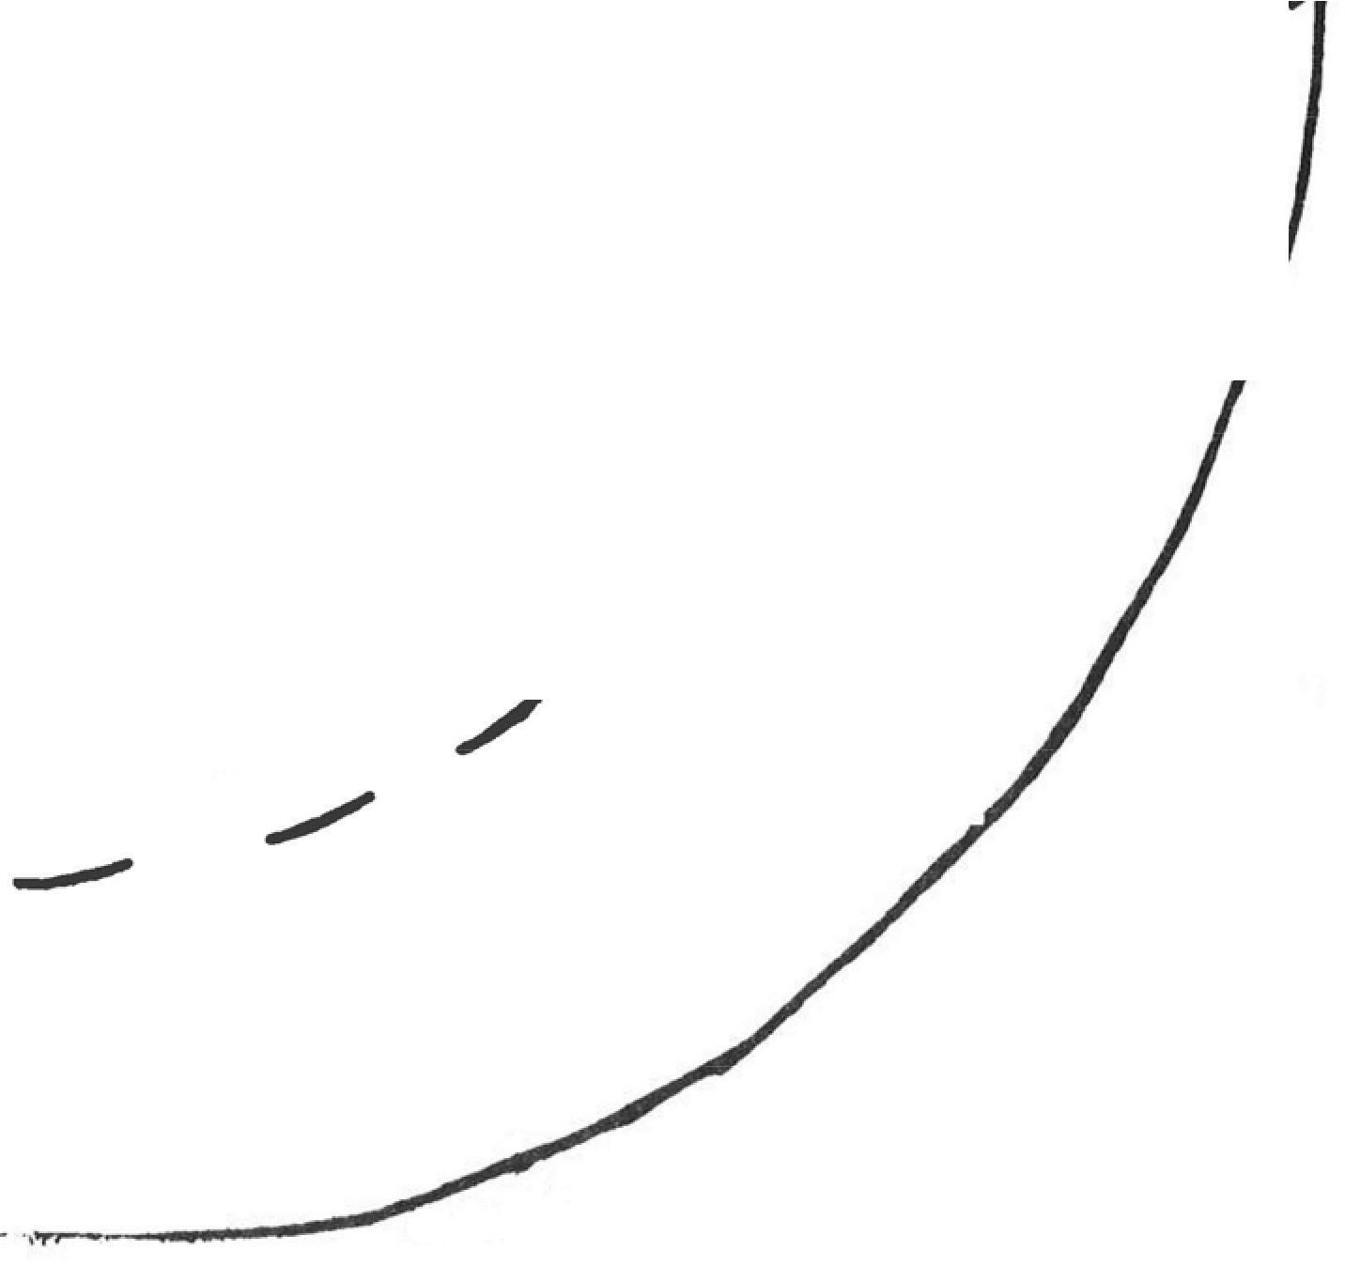
tliol'l pattern
pi11 cos
/
1i ii �
�I
I
/

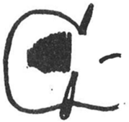
SATIN STITCH: Satin stitch is rather like 
the stitches go over and over, but are very close together.

YOUR HEDGEHOG or LADYBUG

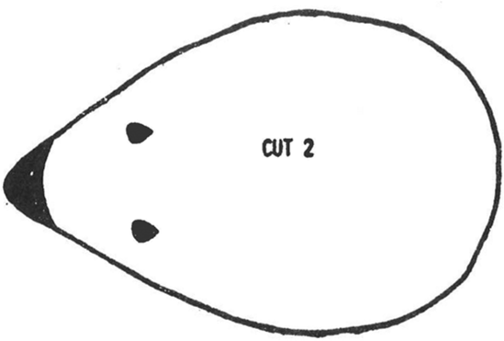

SHELL SHAPE NEEDLEHOLDER
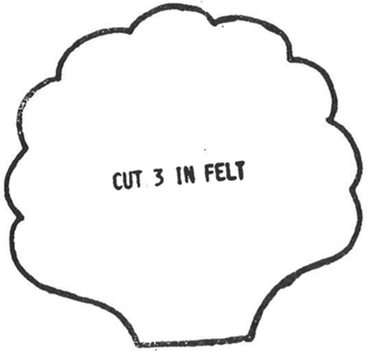

LET'S MAKE A SHELL SHAPED NEEDLE 

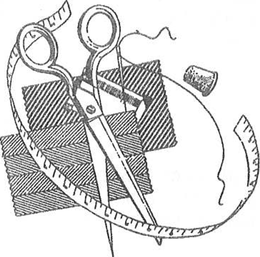
Here is a pretty shell shaped pattern you can cut from scraps of felt. It will give you practice in learning to cut out patterns and with only
a few stitches you will have a useful needlebook holder for your sewing box.

WHAT YOU WILL NEED

three 4 inch squares of different colored felt, or one 9-inch square of felt
embroidery cotton scissors
pins
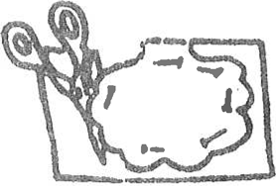
large needle

INSTRUCTIONS
- Cut out pattern.
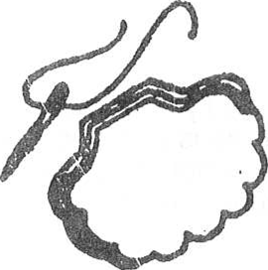
Cut out three pieces of felt.

- Lay 3 shapes on top of each other. Cut embroidery cotton, thread needle, know one end.

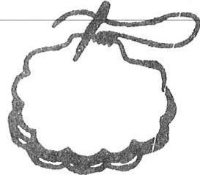
- Sew shapes together along straight base of shell. With stitches that are tak-en through all three shapes, over and over. Cut thread, leaving short end in-side.

SEWING ON A BUTTON

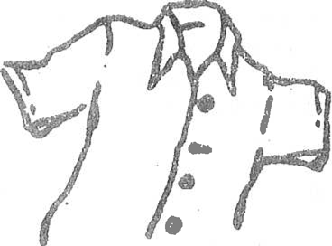
This is "How to Sew on a Button":

- Button up all the on the shirt. Lay it flat a

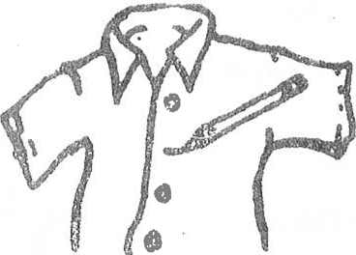
- Mark place where button goes. Use a pencil mark it. Open shirt.

- Cut a piece of thread. Cut it about as long your arm.

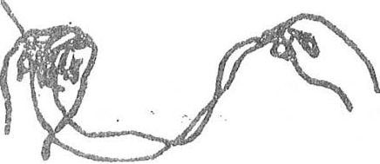
- Thread your Pull ends of thread together. a knot. This makes double

- Make a stitch on right side of shirt. Make it on pencil mark. Make 2

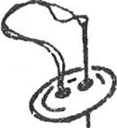
- Stick needle up through hole in the button. Stick needle down through the other hole. Stick needle through shirt.

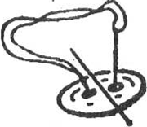
Lay a toothpick on top of button. Lay a toothpick in  of thread. Pull thread 

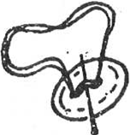
- Stick needle up through one hole. Stick needle down through other hole. Do this 4 or 5

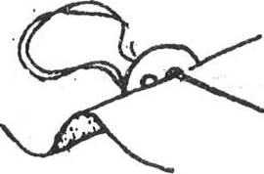
- Pull out the toothpick. Stick needle through hole in button. Do not stick it through the

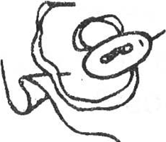
- Pull button away from shirt. Wrap thread around stitches under button. Wrap 4 or 5 times. Pull thread tight.

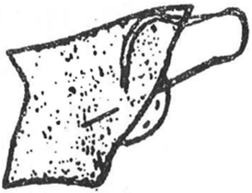
- Stick needle to wrong side of shirt. Make 3 or 4 small stitches. Make on top of the other. Cut the thread.

MINI 
CHECK 
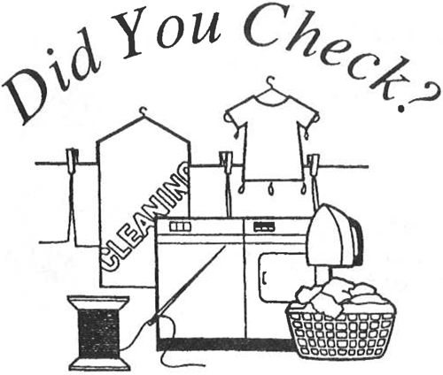


 Is your exhibit tag on
(Attach this to your sewing
 Are your records 
(Include your "record sheet" in your sewing 
Is your work neat, clean, and your very

Are you pleased with what you   Did you help anyone else learn  fun
projects from this project 

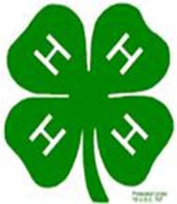
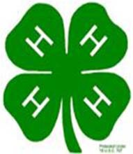
"SEWING" RECORD SHEET
MINI 4-H PROGRAM

Name Age

Please answer the following questions. Include this completed record sheet in your project. See you at the fair!!!

 include in  box?

2. Did you enjoy this project?

 like ?

Parent's signature: Date:

