Sun, Stars
-
& Space

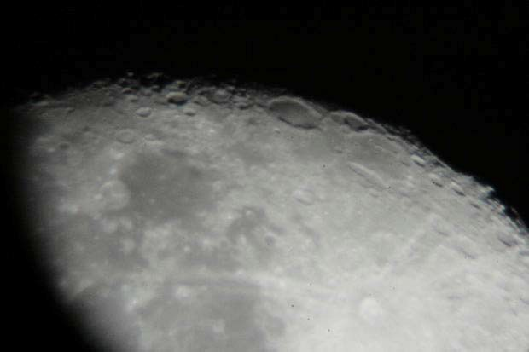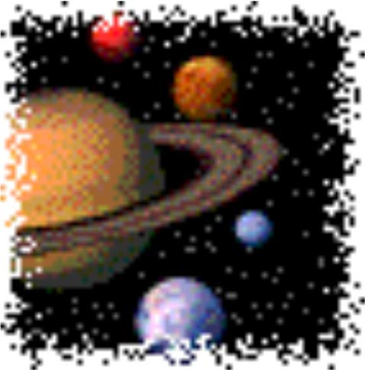

Draft Developed by
Purdue University Cooperative Extension Service

Area 7 Youth Educators
(Blackford, Delaware, Fayette, Franklin, Henry, Jay, Madison, Randolph, Rush, Union and Wayne Counties)
PURDUE UNIVERSITY, INDIANA COUNTIES AND U.S. DEPARTMENT OF AGRICULTURE COOPERATING AN AFFIRMATIVE ACTION/EQUAL OPPORTUNITY INSTITUTION

Mini 4-H 'Parent's Page

Welcome to the Mini 4-H Program! Mini 4-H is designed for you to explore a variety of project areas.

Your child received this project manual when enrolling in Mini 4-H. This manual will provide fun, age-appropriate learning activities throughout their year (s) in Mini 4-H and their interest in this project.

As a Mini 4-H parent, your job will be to guide and encourage your child through the activity. It is highly suggested that you do not complete the activities for them. Instead, help them, guide them, work with them, and let then do all that they possibly can. The 4-H motto is "learn by doing" ... and is the best educational tool that we can provide for youth.

Additionally, the Mini 4-h program is set up to allow your child to exhibit a project at the 4-h Fair. The project is based upon information within this manual.

The 4-H Fair is an exciting time for 4-H members an families. It is a week that allows community youth to showcase their talents, interests and enthusiasm for learning.

Mini 4-H is fun! Your child will certainly enjoy it. You can have fun too, by guiding and helping as your child participates in the program. Encourage and praise your child as he/ she has fun learning and sharing with you.

If you have any questions regarding Mini 4-H or other 4-H programs, please feel free to contact your local Extension Office.

Developed by Area VII Extension Youth Educators • Draft Purdue University Cooperative Extension Service


Mini 4-Her's Page
to Mini 4-H! are now a of the 4-H family. You a special

Mini have lots of fun! are lots of activities for you to  You can try new things. You can share it with your friends and 


Mom, Dad or another adult can help you with your project. project to the 4-H Fair and lots of be able to see what done. also get a ribbon for Mini 4-Her’s.
you


Here are some things to know about 4-H.


Symbol: A four-leaf clover with
an in

Colors: Green and White

Motto: make the best,

Pledge: I  my Head to clearer 
my Heart to greater 
my Hands to larger service, my to better 
for my club, my  my country, and my


by Area Extension Youth Educators
Cooperative Service


S
We live on the planet called Earth. The Earth is one of nine planets that orbit or go around the sun in a circle. Most planets, like Earth have a moon. Some planets have more than one moon. The sun, the planets and the moons make up the solar system.

The planets in our solar system are very different. The ones close to the sun are very hot. The ones that are far from the sun are very cold. Here is a list of plan-ets and their order from the sun.

- Mercury 6. Saturn
- Venus 7. Uranus
- Earth 8. Neptune
- Mars 9. Pluto
- Jupiter

Mercury is the planet that is very close to the sun.. Pluto is usually the planet that is the farthest. Sometimes Pluto is closer than Neptune … it all depends on their orbit.

From Earth, the other planets all look like stars. Venus shines very bright and is close to the ground or horizon. It is usually the first “star” that you can see. You can sometimes see Mars and Jupiter. Mars has a red glow to it and Jupiter has a yellow glow. These planets usually are high in the sky.

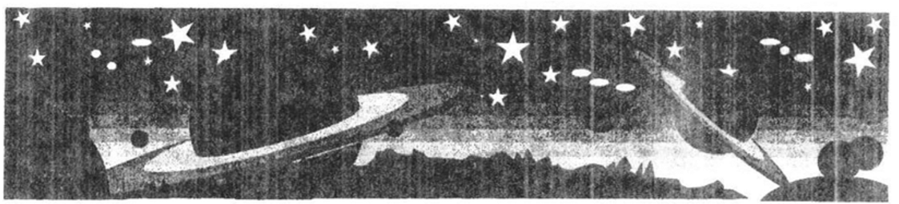

Developed by Area VII Extension Youth Educators • Draft Purdue University Cooperative Extension Service

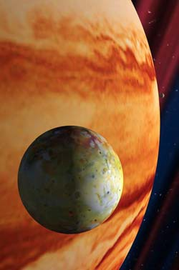
Activit 1   Planets!

You will need these things.

Here’s what you
- Read the about planets.
has
box about 1 planet.
- Match the a planet















Planet (a)

So small you can barely see it with a telescope
Know as the tilted planet - it looks like it is lying on its side
Has 15 moons and a ring
Looks like the planet is covered by a blue-green fog.
Is 1.8 billion miles from the sun Third largest planet
Takes 84 years to orbit the sun Temperature is -350°F
Planet (b)

Half the size of Earth Does not have any moons
The surface is a rocky desert - hot that nothing can live on it
Is 36 million miles from the Earth
So close to the sun, that you cannot look at it. Even with a telescope, it will damage your eyes
The second smallest planet Takes 88 days to orbit the sun
Temperature is 666°F during the day
Planet (c)

11 times bigger than Earth Has 16 moons and thin ring
Covered with colorful storm clouds Is known for the Great Red Spot Was hit by a comet in 1996
Is 480 million miles from the sun The largest planet
Takes 11.9 years to obit the sun Temperature is –240°F
Planet (d)

The last planet to be discovered
The smallest of all planets, even smaller than Earth’s moon
Will be the furthest planet (again) in 1999
Has 1 moon
Is 3.6 billion miles from the sun Takes 248 years to obit the sun Temperature is –240°F

Developed by • Draft

Service













Planet (g) The second largest planet
Has a lot of wide rings and is know
as the most beautiful planet
Rings are made up of ice bits, rocks, and dust
Has 20 moons
Is 900 million miles from the sun
Takes 29.5 years to orbit the sun Average temperature is -300°F
Planet (e) Our home planet
Has 1 moon
Is 93 million miles from the sun
Takes 365 days, 6 hours to orbit the sun
The axis is tilted and gives different seasons
Average Temperature is 0°F
Planet (f)
This planet spins backwards Almost the same size as Earth The surface is mostly flat
Has yellow clouds and traps in heat
Does not have a moon
Is 67 million miles from the sun Takes 243 days to orbit the sun Average Temperature is 870°F
Planet (h)
The fourth largest planet Known as the blue planet Very difficult to see in th esky
Is the furthest planet from 1990 to 1999
Has 2 moons and a very small ring
Is 2.8 billion miles from the sun Takes 165 years to orbit the sun Average Temperature is -360°F






Developed by Area
- Draft
Purdue
Planet X
Some scientists think there is an-other planet. Special satellites show heat rays coming from tspce. These heat rays are like the ones coming from other planets. If a planet does exist, it would be fur-ther from the sun than Pluto
Planet (i)
About half the size as Earth Has a white ice cap on its North
Pole and gas freezes on its South Pole and looks like it is snowing.
Known as the red planet
Was explored by a small rover in 1997
Has 2 moons
Is 141 million miles from the sun Takes 687 days to orbit the sun Average temperature is –9°F
Extension

Activity 2 -- The Solar 

You will need these things:
- pencil

Here’s what you do:
- Now that you know more about each planet...let’s see if you can label them in their correct order!
- Match the planet with a planet name.
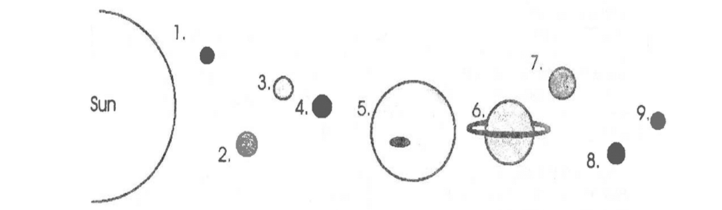

The Planets are….

1. |  | 2. |  | 3.
4. |  | 5. |  | 6.
7. |  | 8. |  | 9.

(If you need help, see page 3!)


by Area Extension Youth Educators • Purdue Service

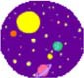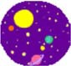
Mini Planets
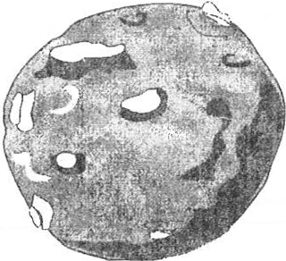
There are a lot of other “planets” that orbit with us in our solar system. These mini planets are called asteroids. What are asteroids? They are large rocks and metal.
These asteroids are as small as 1/4 mile across to as large as 685 miles across. Astronomers can keep track of about 3,000 asteroids.

Most asteroids are found in an asteroid belt. This belt is located between Mars and Jupiter. Like planets, asteroids travel in an orbit around the sun.

Asteroids hit each other. They also can leave their orbit. When this happens, asteroids can fly into planets or moons. If you look at pictures of our moon, you will see it has craters. Craters are “holes” in the ground. The Earth has also been hit by asteroids. Barringer Meteor Crater near Winslow, Arizona, is an example of a hit.
This crater is 1.2 kilometers (0.75 miles) across and 200 meters (650 feet deep.

Meteorites are a small type of asteroid. Meteorites can be as small as a grain of sand. Finding meteorites are difficult. When the rock crashes through our atmosphere, they burn up. Meteorites are our “falling stars”. You can see meteorites in museums.

Activity 3 - - Asteroids Hit the Moon
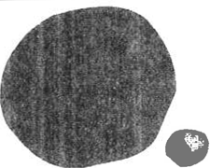
You will need these things:
- foam ball (any size) - paper
- brown paint - pencil
- paintbrush - pins
- scissors

Developed by Area VII Extension Youth Educators • Draft Purdue University Cooperative Extension Service

Here’s what you do:

- Take the foam ball and pinch craters into it with your finger. You can push in the foam for a little crater or remove part of the foam for a large crater.
- Paint the foam ball brown.
- Create your own name for the craters. The biggest crater on the moon is called “Ceres”.
- Make small labels of the name of your craters. Cut the label so that it is small. Pin the label in the crater.
- Now you have your own moon model complete with craters … just like the real moon!
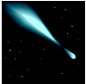
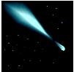
Comets

Comets have been popular these past few years. A comet is a ball of dust and ice. Like planets, it orbits the sun.

What makes a comet different than an asteroid or meteorite? As the comet travels close to the sun, the ice gets hot. The ice turns to water and then into a gas. This gas makes a long tail.
As the comet moves away from the sun, it gets cold. The tail gets small and goes away … until it travels close to the sun again.

The most famous comet is called Haley’s Comet. It went by the Earth in 1986.
Its orbit around the sun is 76 years. How old will you be when we can see it from Earth in 2061?

Developed by Area VII Extension Youth Educators • Draft Purdue University Cooperative Extension Service

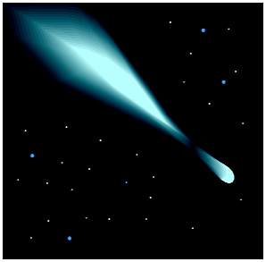
Activity 4 -- 

You will need these things:

- foam ball (any size) - paper
- cotton balls - pins
- glue
- scissors
Here’s what you do:

- Glue cotton balls to your foam ball. This will give your foam ball a snowy or icy look. This will be the head of your comet.
- Cut strip of paper. They can be long or short. Try to make them thin. About 1/2 inch or 1 inch.
- Pin these to one side of the foam ball. This will make your tail.
- If you want to make a longer tail, glue some of the pieces of paper together to make long strips.
- Don’t forget to name your comet!

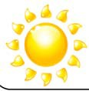
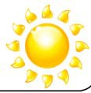
The Sun & Stars

A very important part of our solar system is the sun. The sun is a star. Stars are big balls of hot gas. Like the Earth, they also spin.

The sun is very large. You can put over 1 million Earths into our sun.

Developed by Area VII Extension Youth Educators • Draft Purdue University Cooperative Extension Service

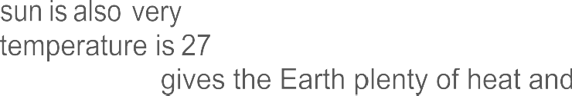
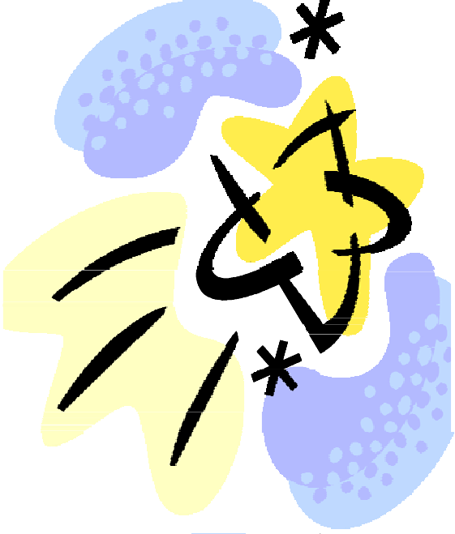
hot. Scientists think its
million°F. The sun is so big
hot that it light.
The sun gives so much light that you should NEVER look directly at it. It will hurt your eyes.
Stars, like the sun, shine all of the time. So why do we have a day and night? The Earth rotates or spins. During the day, the part of the Earth where we live faces the sun. During the night, we face away from the sun.


5  Shadow
need to find these things:

-
day - rocks

table - a helper
a

- tape measure chart
what you
- At about 10 a.m., go and in an open area. With a  mark you are standing.
- With a second  have helper mark the end of you shadow.
- the  of shadow You can do this by measuring between the rocks.
- At noon, go back outside. Stand in the same place as you did before. the end of the new shadow. Measure the new length.
- At 2 p.m., go back outside Stand in the same place as you did before. Mark the end of the new shadow. the new length.


aft
by
- Dr Service









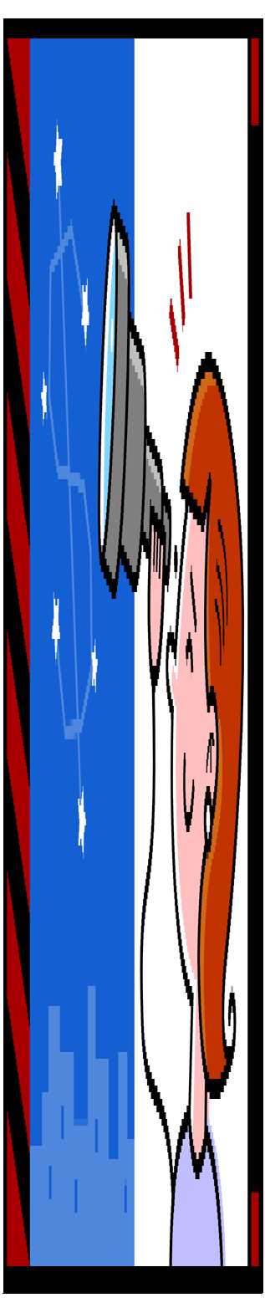
- At 4 p.m., go back outside. Stand In the same as you did Mark the end of the new shadow. Measure the new
- Keep track of your information in this shadow

Time of day Length of shadow Where was the sun in the
sky?
10 a.m.
12 p.m. (noon)
2 p.m.
4 p.m.

Question: What to your shadow during the day? Did it stay in same or did it move?

Question: your shadow length What was with the sun?

Question: did things

One fun thing you can do look for patterns the stars. patterns are constellations.
Hundreds of years ago, people from Greece looked at the stars and picked out constellations. They named them after animals and people. There are 88 constellations that are know to stargazers.
Some of the popular constellations are Leo,

by Area Extension Youth Educators Purdue Extension Service

the Lion and Orion, the Hunter. In the United States, many people look to the
sky for the Ursa Major, the Great Bear and Ursa Minor, the Little Bear. These are
easy to find because they use the Big Dipper and Little Dipper constellations
most people can find the Dippers In the night sky.


Activity

6 --
Constellations

You will need to find these
- a clear 
- constellation chart
things:

Here's what you do:
- Wait until you have a good, clear night. You will want to pick a night when the stars are bright.
- Use the constellation charts below.
- See if you can find the Big Dipper, the Little Dipper, and the Great Bear.
- If you are ready for a more difficult constellation, learn the Lion and Orion, the Hunter.
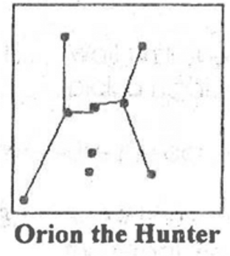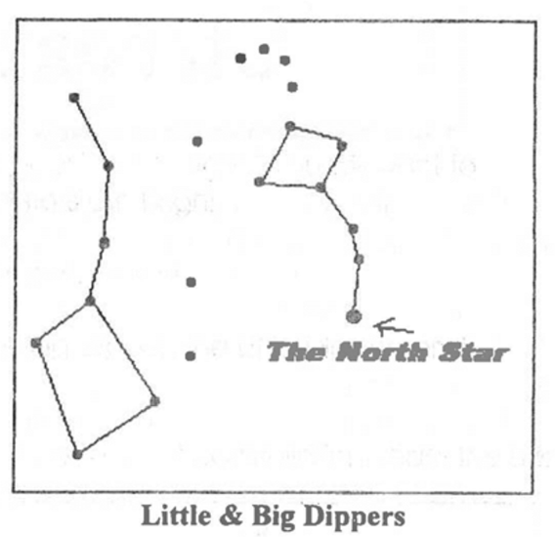

Developed by Area VII Extension Youth Educators • Draft
Purdue University Cooperative Extension 5ervice

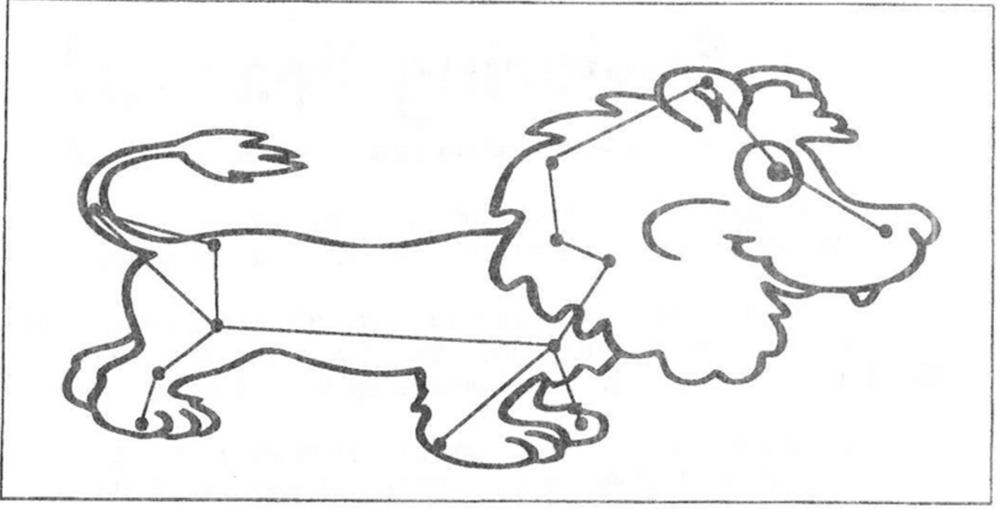

Leo The Lion
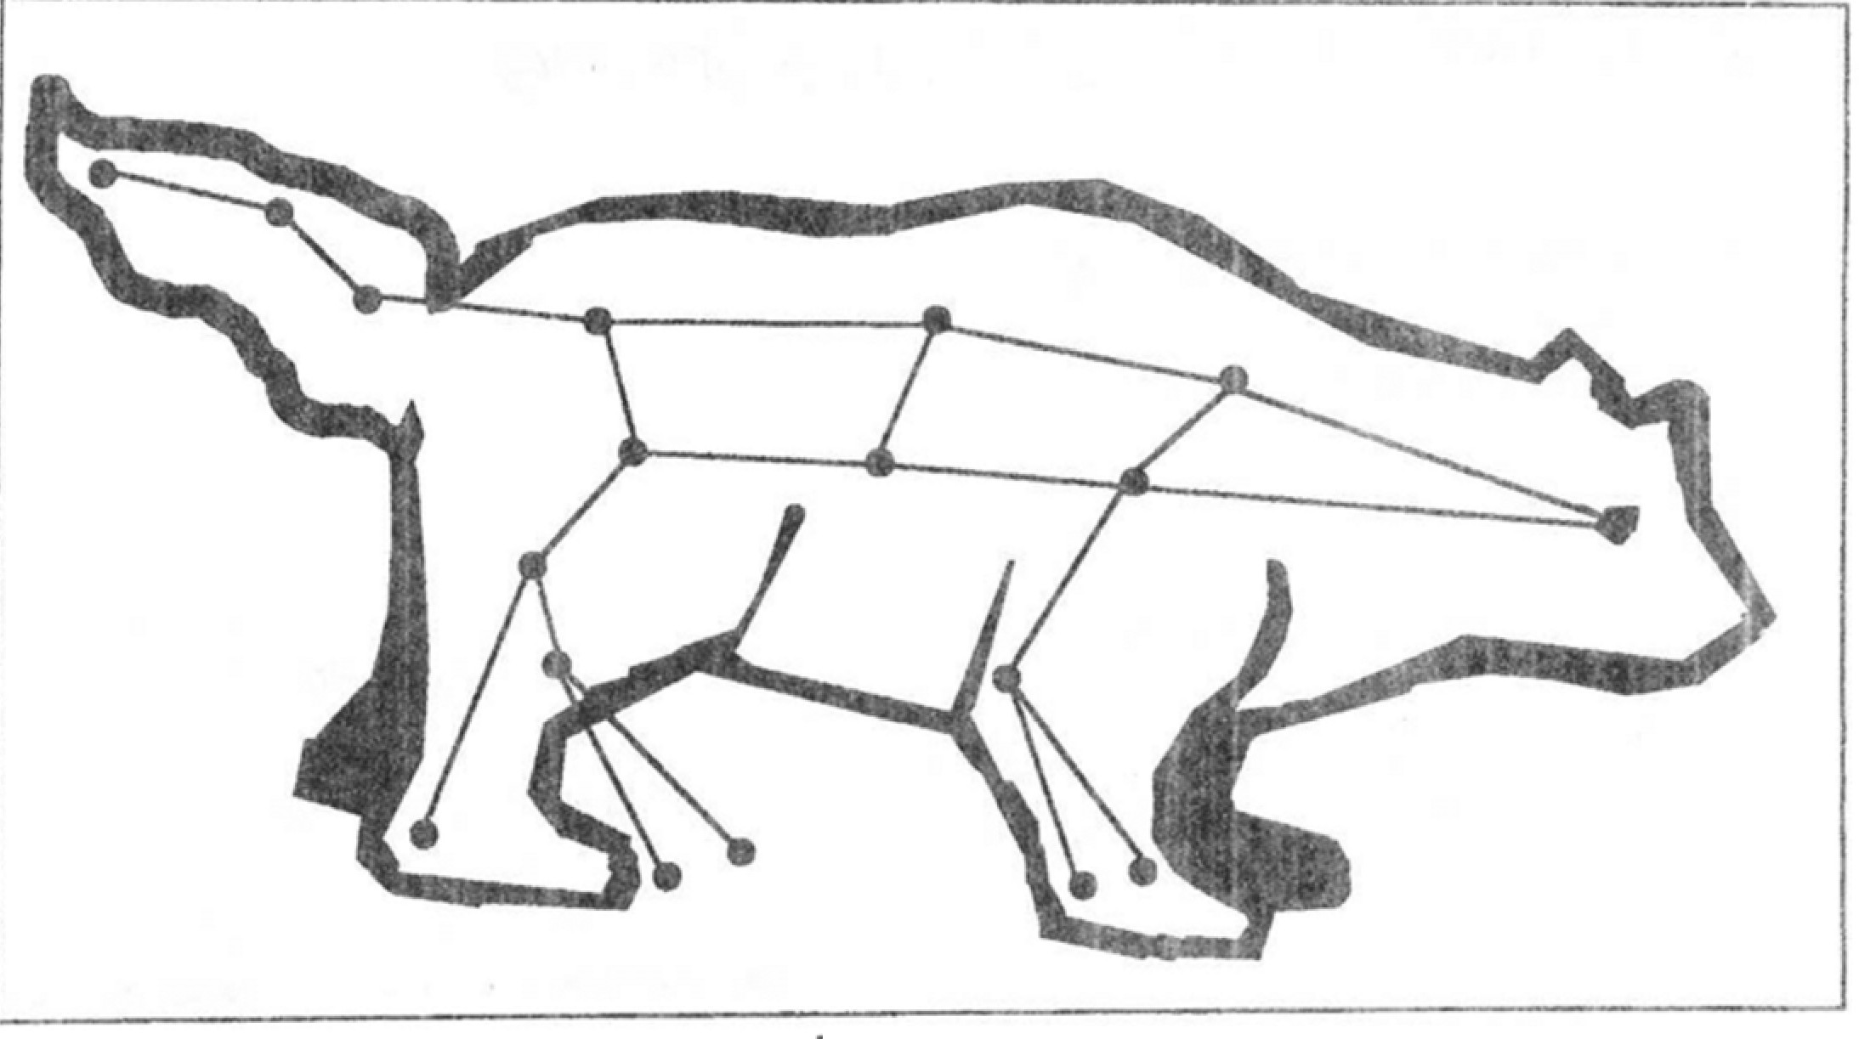

The Bear

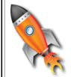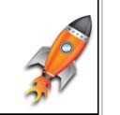
Space travel is new to people. We have only been leaving Earth for 30 years. We have explored the land and ocean for thousands of years!


Man could not leave ground he discovered a way to "fly". The  were the first to do this in the early 1900's. man
space almost every 8 weeks. Some people are in space for a



Activity 6 --  Space Shuttle

You will need to fin things:

- picture of the shuttle

what

Look at the 

Developed by • Draft
Service



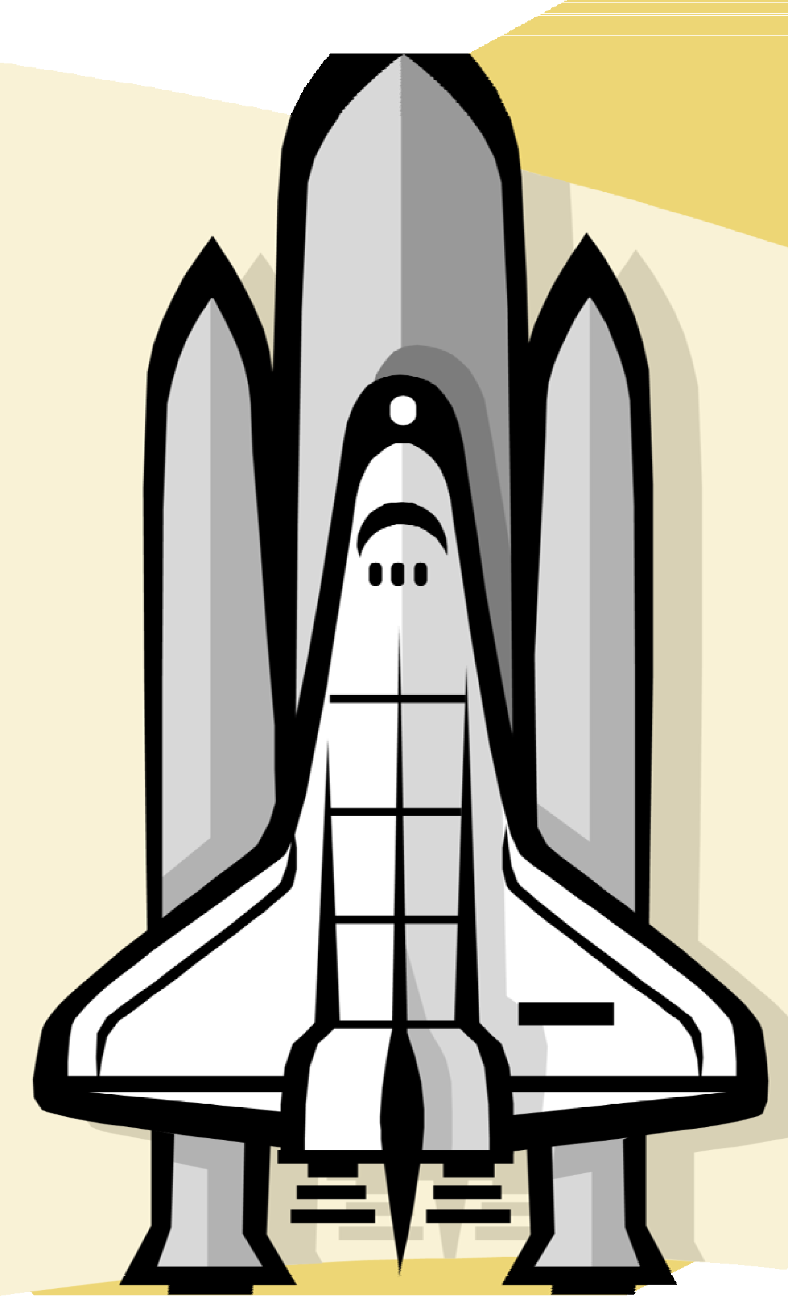



1.

2.

Hint -- The Shuttle Main Engine is made up of a group of 3 engines and Is on the back of the orbiter.

Hint -- The External Tank is the biggest or tallest part of the shuttle and contains liquid fuel.

Hint -- There are two solid Rocket Boosters which contains solid fuel and helps the shuttle leave Earth

3.

Developed by Area VII Extension Youth Educators • Draft
Purdue University Cooperative Extension Service



Here is a list of projects that can be shown 4-H fair. Pick one of the projects you would to exhibit at the fair. Use the label at the bottom the page on your
If you have any questions about your please call the Extension Office. There are there who can help
- Make a poster showing one or two constellations. You can use the ones in manual or find new

- Make a poster about one or two different Label the planets and tell something about
You can use the information in this manual find your
- Make a solar system mobile. You may use materials that you want. Make sure you each
Exhibit the asteroid that you made in Activity
For information on how to label your project, to enter it in the fair, and where the project needs go, please contact your Extension

PROJECT EXHIBIT TAG
Mini 4-H Sun, Stars & Space Name: Grade:


"SUN, STARS & SPACE" RECORD 
MINI 4-H PROGRAM

Name

Please answer the following questions. Attach this  record sheet to your project. See you at the fair!!!

- What was your favorite activity?

- What is something new that you learned?

- Did you enjoy this project?

 Date:

