
ount


MINI 4-H

PROGRAM

WEATHER PROJECT MANUAL

Clay County Cooperative Extension
Mini 4-H Program

6656 N State Road 59
Service

Brazil, IN 47834
(812) 448-9041

PROJECT EXHIBIT TAG
Mini 4-H Weather
Name: Age:

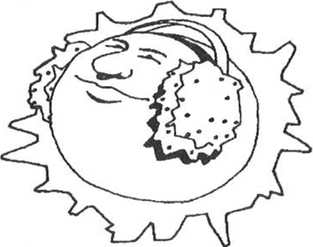
Welcome to "MINI 4-H". If you're reading this, you've probably signed up for the Weather project, We're glad to have you.
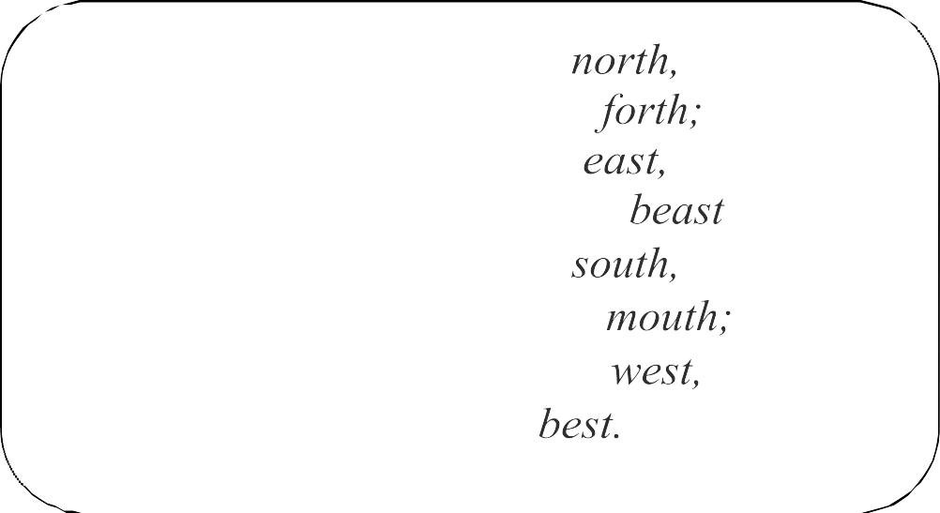
When the wind is in the The skillful fisher goes not When the wind is in the
Tis good for neither man nor When the wind is in the
It blows the flies in the fish's But when the wind is in the
There it is the very

WHAT YOU WILL EXHIBIT AT THE FAIR
 will exhibit a poster  on which you will draw or color a picture of the weather outside that you observe one day.

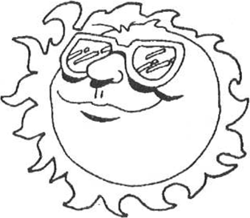
Don't forget to cover your poster  clear plastic and mount it on a stiff backing. Also, attach your record  to the back of your poster.

What is

The Earth is surrounded by a life-giving layer of air called the atmosphere. It from hour to hour and from day to day. Weather is what is happening in the

It may be hot and dry or cold and damp, calm and sunny or windy and raining. world would be cold and frozen without warmth from the

Weather is like a huge machine driven by the mighty furnace we call the
WEATHER TERMS

Here are a few weather terms, listed below, that might interest you. If you want you may (you do not have to) put any of these terms on your poster if they go with it. You may use any other terms in this manual or that are not in this

Temperature - how hot or cold it is
Rain - precipitation that falls from the sky in the form of

Snow - precipitation that falls from the sky in the form of

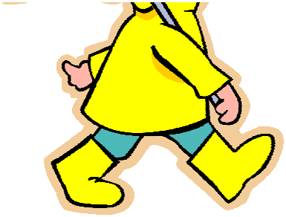
Sleet precipitation that falls from the sky in the mixture of and

Hail precipitation that falls from the sky in the form of balls or lumps that are layers of ice and compact

Hurricanes - tropical cyclone with high
Tornados - violent, destructive whirlwind, in a funnel-shaped cloud

Lightning - flash of light that is a discharge of electricity either one cloud to another or cloud to

Thunder - loud sound that follows a flash of
Drought - lack of precipitation for an extended amount of

OBSERVING THE WEATHER

For your poster here are a few hints to help you along your 

- Pick out the place that you are going to watch  weather and draw it on your 

- On the day that you pick to observe the weather,  what happens for the entire day.

- Then sketch a picture of what you saw that day on other piece of paper before you put it on your 

- Now, Draw your picture on your posterboard and color 

- Put on your exhibit tag and attach your record 

- Your project is now complete. Good 

WEATHER

Some people think that the weather can be foretold by certain animals, vegetables, minerals. So, here are a few things to look for to see if these "sayings" hold

If toads come out of their holes in great numbers, it will rain

CUCKOOS

When the cuckoos sing in the sunny sky, all the roads will soon be 


When a squirrel eats nuts in a tree, weather as warm as warm can

Ropes are more difficult to untwist before bad

Doors and windows are harder to open and shut in damp

The locust sings when it is to be hot and

When spiders work at their webs in the morning, expect a fair 

When fish hook well, and when they are hard to haul up, it is a sign of

Birds on a telephone wire indicate the coming of

When hens run about acting frightened, a windstorm is 

MINI  CHECK 












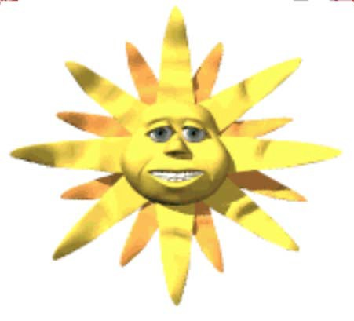

Is your exhibit tag on 
(lower right hand corner of your poster

 Are your records 

(must attach to the back of your poster

Is your work neat, clean, and your 

 Are you pleased with what you 



WEATHER RECORD  MINI 4-H PROGRAM

Name

Please answer the following questions. Attach this  record sheet to your project. See you at the fair!!!

And what changes did you notice

What new weather terms did you learn by doing this project?

Of the little “sayings” on how to foretell the weather, which of these did you find to be true?

Did you enjoy this project?

 Date:

