ount
<l
�


MINI 4-H
PROGRAM

WILDLIFE PROJECT MANUAL
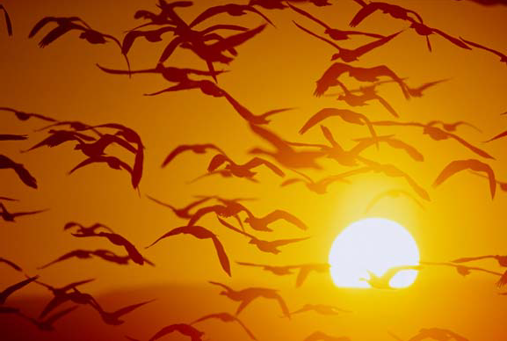
Draft Developed by
Purdue University Cooperative Extension Service
Area 7 4-HYouth DevelopmentEducators
(Blackford, Delaware, Fayette, Franklin, Henry, Jay, Madison, Randolph, Rush, Union and Wayne Counties)

PURDUE UNIVERSITY, INDIANA COUNTIES AND U.S. DEPARTMENT OF AGRICULTURE COOPERATING AN AFFIRMATIVE ACTION/EQUAL OPPORTUNITY INSTITUTION



Gauck, Educator,   Cooperative

Reviewed Edited  Area 7

RaeAnn 4 H/Youth  Blackford 
Richard   Delaware 
Carolyn Miner, 
Caldwell,  Fayette County
 County
Jonatha  Jay 
Leanne  Henry 
Jeanette Findley,  Madison 






Scott Ripberger,  Madison 
an John
AgNR,
Debra Searcy, CED,
Natalie Carroll,
Union Wayne
Specialist, State 4-H
Krug, Program Coordinator, State 4-H

D

for
any means. Copies of the materials may be
or
Please Note: As professional courtesy, the Area request that these materials
Resources and References



Wildlife Adventures Mini 4-H Manual, Rush county, Indiana Cloverbuds, Minnesota Extension Service, University of
 permission from The Kid’s Nature Book
by Susan Milord © 1989, 1996, Williamsburg Publishing company, Charlotte, VT 05445, 800-234-8791, $12.95.

December 1997
Updated December 1998


Mini 4-H 'Parent's Page

Welcome to the Mini 4-H Program! Mini 4-H is designed for you to explore a variety of project areas.

Your child received this project manual when enrolling in Mini 4-H. This manual will provide fun, age-appropriate learning activities throughout their year (s) in Mini 4-H and their interest in this project.

As a Mini 4-H parent, your job will be to guide and encourage your child through the activity. It is highly suggested that you do not complete the activities for them. Instead, help them, guide them, work with them, and let them do all that they possibly can. The 4-H motto is "learn by doing" ... and is the best educational tool that we can provide for youth.

Additionally, the Mini 4-h program is set up to allow your child to exhibit a project at the 4-H Fair. The project is based upon information within this manual.

The 4-H Fair is an exciting time for 4-H members and families. It is a week that allows community youth to showcase their talents, interests and enthusiasm for learning.

Mini 4-H is fun! Your child will certainly enjoy it. You can have fun too, by guiding and helping as your child participates in the program. Encourage and praise your child as he/ she has fun learning and sharing with you.

If you have any questions regarding Mini 4-H or other 4-H programs, please feel free to contact your local Extension Office.

Developed by Area VII Extension Youth Educators • Draft Purdue University Cooperative Extension Service


Mini 4-Her's Page
to Mini 4-H! are now a of the 4-H family. You a special

Mini have lots of fun! are lots of activities for you to  You can try new things. You can share it with your friends and 


Mom, Dad or another adult can help you with your project. project to the 4-H Fair and lots of be able to see what done. also get a ribbon for Mini 4-Her’s.
you


Here are some things to know about 4-H.


Symbol: A four-leaf clover with
an in

Colors: Green and White

Motto: make the best,

Pledge: I  my Head to clearer 
my Heart to greater 
my Hands to larger service, my to better 
for my club, my  my country, and my


Extension Youth Educators Cooperative Service
by Area


are

Do you ever wonder about the animals that live in the woods and areas around your home or city? Would you like to know how and they live? world of wildlife  are so fun things to do get to know wildlife, indoors and out, every month of the

Wildlife Adventures involves watching wild animals and birds that live our It also Involves building shelters, creating your own making nature mobile, and learning what type of tracks animals behind. you won't in the way of  to enjoy wildlife. have the most important tools - your eyes, ears, nose, and


are some to keep in mind when exploring. before you wander onto someone's property. Do not pick plants, tamper nature or fences in any way. wildlife habitats with great Don't  over or logs. Animals may in those   time to  wildlife. is so we all can

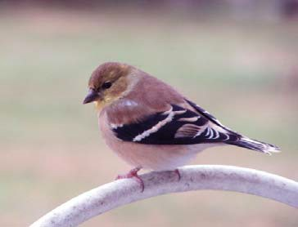
-  of Indiana
need the following things:
color pencils, markers or
- scissors
- poster (any color)
OR
- two or three twigs of
- string or heavy thread
- glue or 



by Area Extension Youth Educators • Purdue Extension

Here what you
- Find color pictures of the birds at the end of the manual in a at or in the library.
- Color the birds to the pictures in the

- Carefully cut out your
- Arrange the pictures on the poster Leave room for you in the lower right hand corner and a title across the top. If would like to  to step 6 .
- Carefully glue the pictures to the poster
- make bird follow steps 1, 2, and 3. Tape or glue string or thread of different lengths to the back of of the birds.
- Arrange the twigs so the longest is on top and the shortest is the twigs together leaving 4” t o 6 ”
- Carefully arrange the birds and tie their  to the twigs. the birds if you
- Carefully pick up the top twig in the center. Look at how the hangs.  of string to the point on the stick where you holding it.

You have a
your poster
- or to the fair.

It will take some time to find the color picture of the birds in book. Look carefully. If ask your librarian to help. activity helps you to
identify the types of birds that live near your home. closely. Some of birds live around your only during the summer months. Some birds seen only In the winter months. It shows how close we live to the wildlife us.

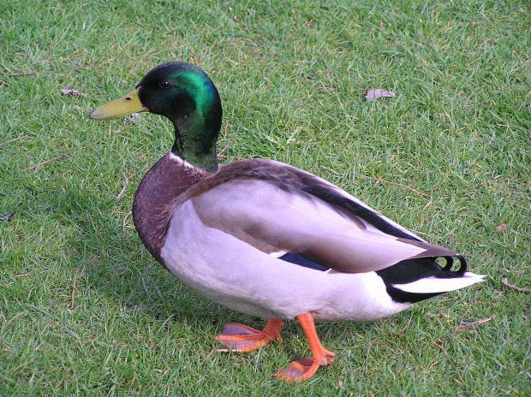

Developed by
•
Cooperative

Activity 2 - Make A 
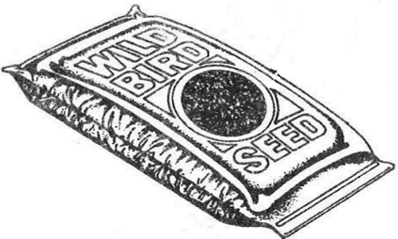
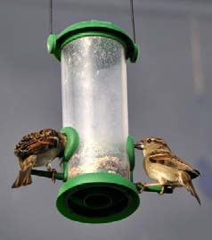
need the following things:

- an empty half gallon carton, coffee can, glass jar, shell or pine
- wire or string to feeder to a tree
- small block of scrap about 1”x2” that is 1/2” to 3/4”
- stapler, glue or 
- small nail or 


Here what you do to make feeder a milk

- Cut 2 opposite sides out of the milk Leave 1" all way around the cutout. top should be stapled,  or  shut Punch hole in the top to tie the wire or
-  3 or 4 holes in the the with small nail or pin. Punch from the inside out so water drain
- a hole in the center of the top. (Do not the 
- the to look like the tree. Or cover it with leaves  on with weatherproof 
- Loop  or wire through the in the top of the carton. This  or wire go the tree limb to support the Leave  string or wire to tie the feeder at height where can refill
- You may hang your feeder from post or clothesline 
-  your feeder to the fair.

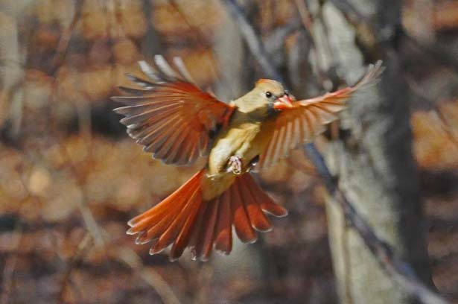
Developed by
•
Cooperative

Other bird feeder
For seed:
suggestions:
Coffee can with half

a plastic lid on

both ends.

Glass jar hung horizontally. Empty coconut shell cut in half.

For suet: Mesh
bag (like the kind onions come in).

Coconut shell filled with melted suet.

Drill holes in log and fill with
melted suet.

Other ideas:
Slather peanut butter on pine cones and roll them in birdseed.

Hang coconut half upside down (some birds love fresh coconut!)



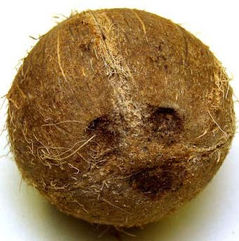

String peanuts on wire or heavy string.

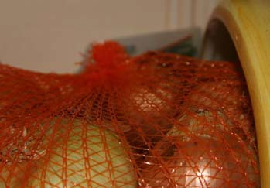
Some birds will nest in an old kettle or jug in the grass, or one placed securely

in the fork of a tree. Hang up a hollowed out
coconut that has
an entrance hole

up to 1 1/2" in diamter and see if anyone moves in.

Developed by Area VIIExtension Youth Educators • Draft Purdue University Cooperative Extension Service

Activity· 3 - 

You will need the following things:
- Binoculars (
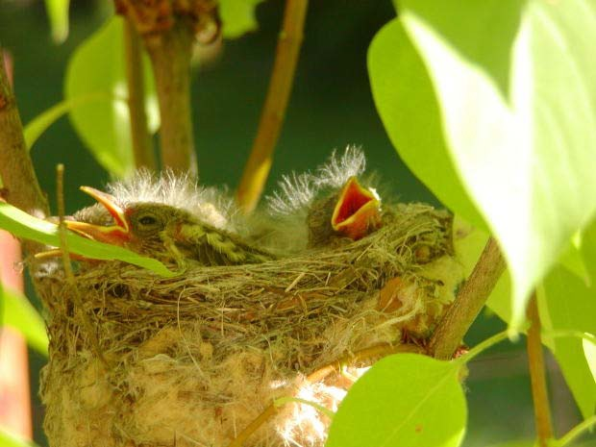
- A bird
- Pencil and
- A quiet  to sit

Here is what you

- Since birds like to eat in mornings,  the bird where you can see it while eat your breakfast.
you are doing this
activity in when you begin to the birds you must continue
feed them until their natural
- Find a quiet to sit. You will to be still for several before the birds around you. Perhaps you watch birds from inside your
- Watch the birds with your binoculars (or your own eyes) and what you see. Keep your chart by the window near the bird Draw pictures of the tracks you see. your family to help too! Use a book from the library to help identify the birds.
- Complete the chart. There is an activity sheet at the end

BIRD HOW MANY DATE TIME WHERE THEY LIVE


Developed by Draft

 4 - How Do Birds Fly?
You have  that birds fly in ways. Crows robins their wings times every  starlings their  4 to 5 times second. Chickadees are almost as fast as
their wings at least 27 times How they do it? They have really strong chest muscles and hollow bones. Try beating your arms as fast as a robin beats it’s wings. That’s three beats per second. How long can you keep up the flapping?

To build your own  for flight you will need the  
- quality
- Paper 
- Pencil, ruler and stapler with staples.
Here is what you

W i t h a sheet of  quality fold it in half  the short sides  Crease this
-  the

- Bring the lower corner up to the fold
triangle. There will sticking out the top. That is Crease this fold.  this step with the right

- With the into a triangle, bring the right up to the There is   sticking


of the This is OK. Crease this fold.  this for the left
- Fold  the using the very first folds you
- Lay the  on the
- Measure up from the fold  to at end. These are your  marks for  the wings. them lightly with a 
8 Carefully fold the wing on the side  you using the  marks as guide. Crease this
- Turn the  over.  this step for the other 
Fold the tip of the airplane's nose into the at the  Staple the  of the  the



by Area Extension Youth Educators Purdue Extension

  - Slide a paper clip onto the nose for weight.
  - Congratulations! You have paper 
  - Repeat these steps as often as necessary to get the airplane just the way you like it. Remember, it is OK if it doesn’t turn out right the first time. You can always make another airplane
  - Color or decorate your airplane. Bring it to the fair.

Follow the diagram as you make your airplane.
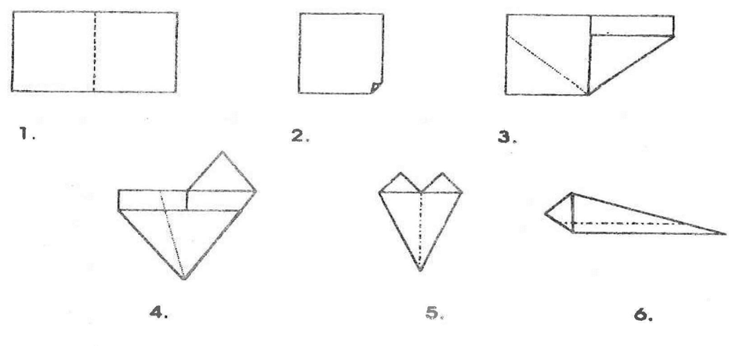
How do the airplanes fly? There are four forces that affect them and anything that flies. Even your paper airplane! Here they are:

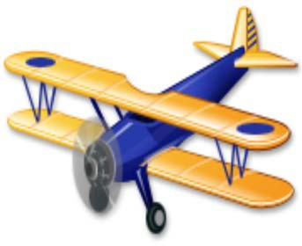
LIFT - Force exerted by air on the wing as it passes through the air.

DRAG - Force caused by the air as it strikes the surfaces of the airplane.

THRUST - Force that moves the
airplane through the air.

GRAVITY - Force of pull
the Earth has.



by Area Extension Youth Educators Purdue Extension

Lift and thrust must drag and gravity for bird or plane to fly. Once they are in the air, lift and thrust must equal drag and gravity for them remain in the air. When drag and gravity lift and thrust, the bird or airplane comes

What provides the thrust for your paper 

How do birds provide thrust for flight?

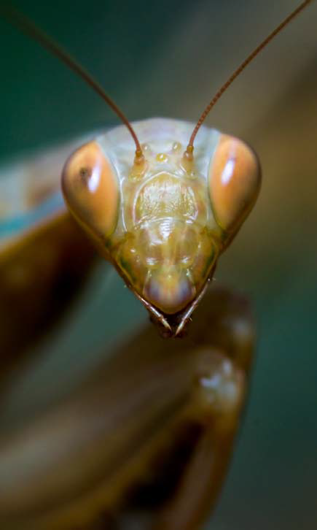
Watch several different birds fly. Talk what you see. Do the birds flap their wings all the time? Have you ever seen bird stay in the air without  Its wings? Hint: Look for big bird up in the
Activity 5 - Insects
the following things:
- Three glass or plastic jars with lids.
- Magnifying glass.
- Tape, and slips of

Here is what you
- Capture three different  one in each of the jars.
- Close the lids tightly.

- Use the pen to write this on a slip of name of the insect, the date, the insect was  and your
- Tape the slip of paper to the top or side of the jar.  the to the fair.
- Write down what you observe about the

How are they alike? List as many ways as you



by Area Extension Youth Educators Purdue Extension

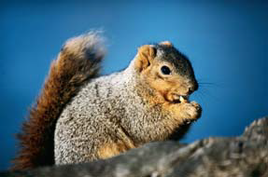
 5 - Local 
You will need the following things:
- Pencil

Here is what you do:
- Take a walk in a park or woods. Look for different kinds of wildlife. Fill out the chart of five different kinds of wildlife.

What wildlife did you see? | Where did you see it? | What does it eat? | What did you find that belongs to it?
Example:  Robin | In tree | Worms | Nest, feather

Where did you take a walk to find the wildlife?

How long did it take you to find the wildlife?

How many more kinds of wildlife did you find?



by Area Extension Youth Educators Purdue Extension

Activity 6 - Make a Chart of Animal Characteristics
You will need the following things:
- Some continuous length of paper or several 11”x14” sheets.
- Pen, pencil or marker.
- Ruler.
- Magazines, pictures or your own sketches of animals.

Here is what you do:
- Make a chart that outlines some of the basic animal characteristics.
- Make a heading for each section.
- List under the heading some of the characteristics the animals possess.
- Illustrate the chart with pictures or sketches.
- Place the chart on a 14”x22” posterboard.
- Bring it to the fair.
How many sections your chart has is up to you. It depends on how detailed you would like to get. Refer to the chart below to help you get started.

What similarities did you notice within each group?

What are some of the animals that aren’t like the others in their group?

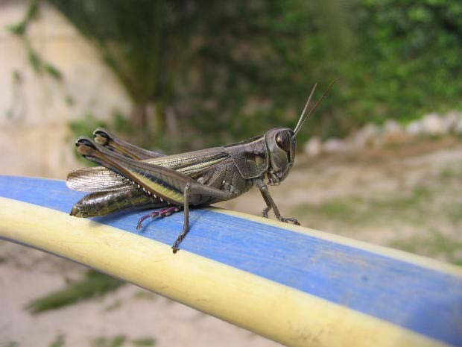
Here are some ideas for your chart.

Insects
  - Three pairs jointed legs
  - Three-part body
  - Hard outer skeleton
  - One or two pairs wings

Arachnids
  - Four pairs legs
  - Two-part body
  - Hard outer skeleton



by Area Extension Youth Educators Purdue Extension

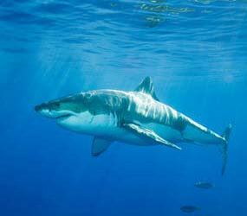
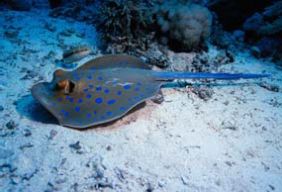
Sharks and Rays
  - Skeleton made of cartilage
  - Rough skin
  - Unequally divided tail

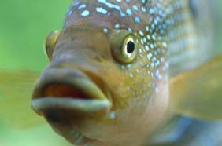
Bony Fish
  - Scales or bony plates
  - Equally divided tail

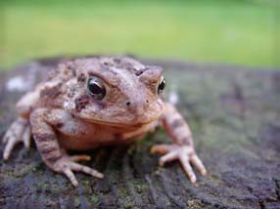
Amphibians
  - First part of life in water
  - Moist skin
  - Four limbs
  - Webbed feet

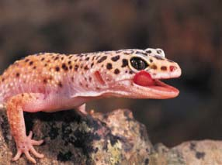
Reptiles
  - Dry skin covered with scales or bony plates
  - Four limbs
  - Lay leathery-shelled eggs

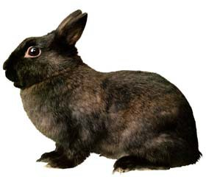
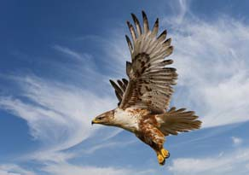
Birds
  - Warm-blooded
  - Covered with feathers
  - Front limbs are wings
  - Lay hard-shelled eggs

Mammals
  - Warm-blooded
  - Covered with fur or hair
  - Young drink mother’s milk



by Area Extension Youth Educators Purdue Extension

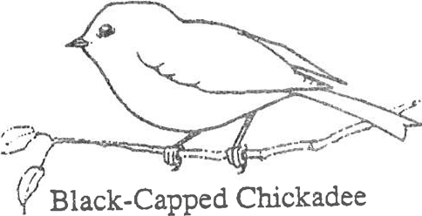
BIRDS

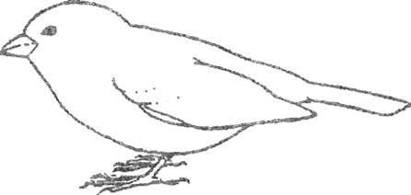
House Sparrow

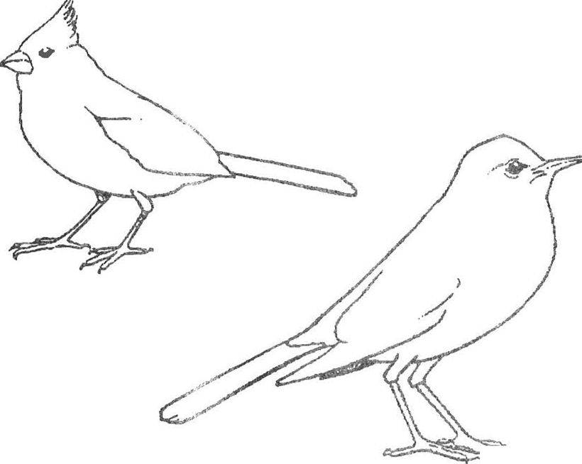
Northern Cardinal

American Robin



by Area Extension Youth Educators Purdue Extension

BIRDS

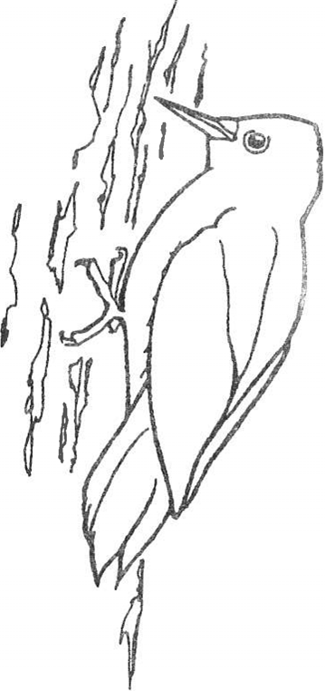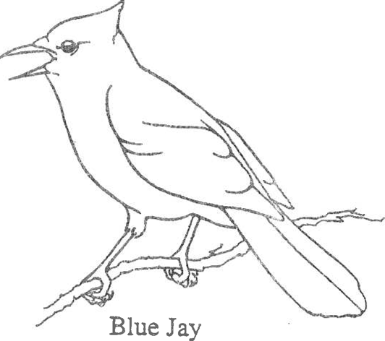

Downy Woodpecker

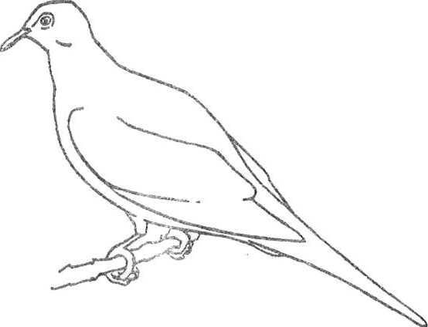
Mourning Dove

by Area Extension Youth Educators Purdue Extension

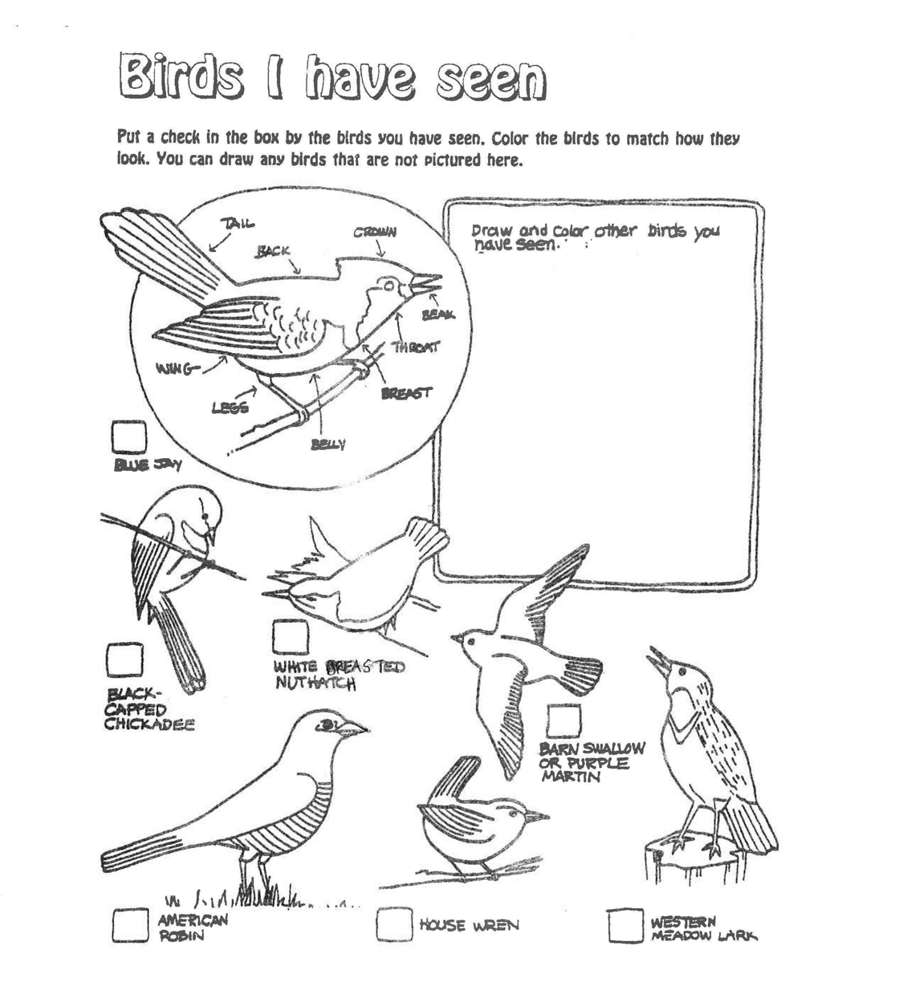

by Area Extension Youth Educators Purdue Extension


"WILDLIFE ADVENTURES" RECORD 
MINI 4-H PROGRAM

Name

Please answer the following questions. Attach this  record sheet to your project. See you at the fair!!!

- What types of birds did you see?

- What is your favorite bird?

- Did you enjoy this project?

 Date:



4-H Fair Exhibit

Listed here are the projects you can exhibit at the fair. Choose one project and bring it to the fair for judging. Use the label at the bottom of the page on your exhibit. Choose a different exhibit each year you take the project.

If you have any questions about your projects, please call the Extension office.
There are people there who can help you.

  - Make an 11” x 14” poster (mounted horizontally with hard backing and covered in plastic) showing different types of birds. You can color and cut out the birds in the manual or find your own pictures of birds.
  - Make an 11” x 14” poster (mounted horizontally with hard backing and covered in plastic) about animal characteristics from the information in Activity 6.
  - Exhibit the bird feeder that you made in Activity 2.

PROJECT EXHIBIT TAG
Mini 4-H Wildlife Adventures Name: Age:

