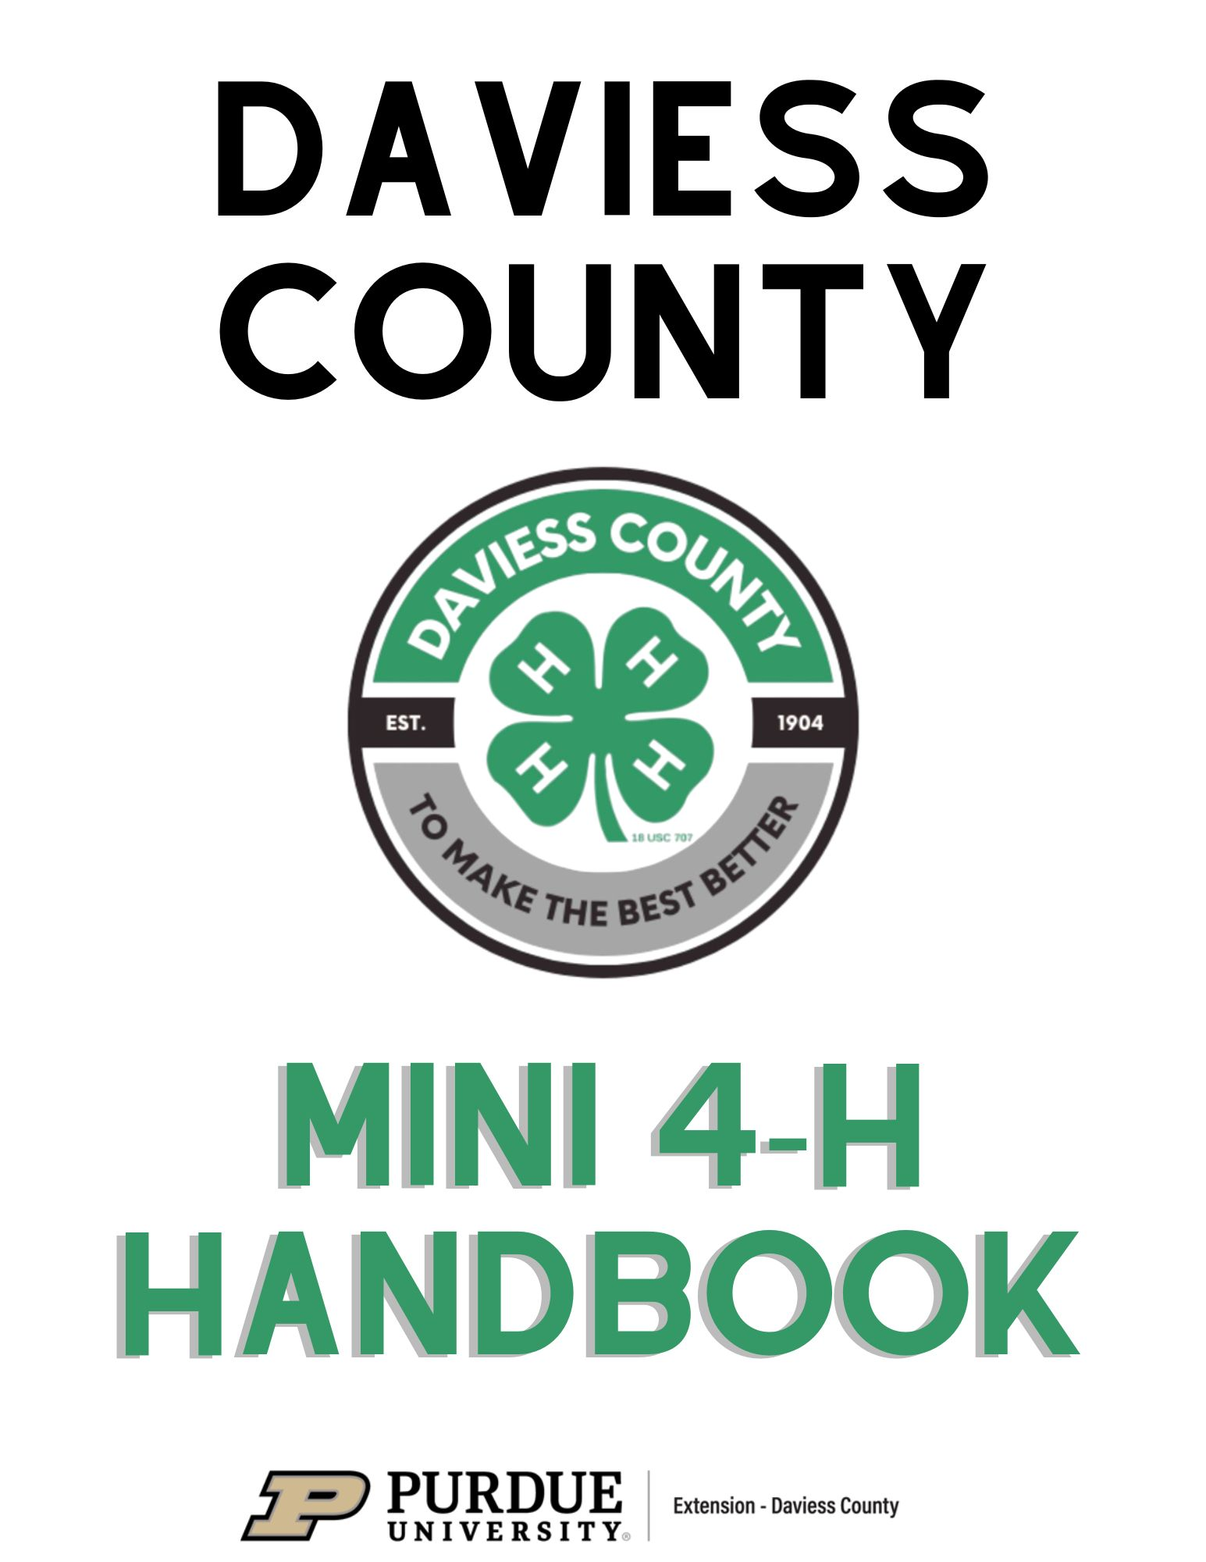

Daviess County Extension Staff

Wes Richardson
4-H Youth Development Educator
Cindy Barber
Community Development/County Extension Director
Sarah Brackney
Agriculture & Natural Resources
Chris Clark
Nutrition Education Program Advisor
Luis Santiago
Community Outreach and Engagement
Jennifer Stefancik
Health & Human Sciences
Teeny Davis
Office Manager
Amelia Ray
Secretary

Daviess County Extension Office
300 E Hefron St. Suite 119
Washington, IN 47501
812-254-8668

Office Hours:
Monday – Friday
8:00 am – 4:00 pm

Website:
Daviess County 4-H
www.extension.purdue.edu/county/daviess/4-h

Facebook:
Purdue Extension-Daviess County

Table of Contents
Parent’s Page………………………………………………..….……….4
Non-Competitive Policy……………………………………..…….……5
Mini 4-Her’s Page…………………………………………...…………..6
4-H Pledge, Slogan, Motto……………………………………..………..6
Project Guidelines and Poster Requirements……………………………7
Mini American Presidents……………………………………………….8
Mini Bicycle…………………………………………………………….8
Mini Bugs……………………………………………………………….8
Mini Collections…………………………………………………………9
Mini Crafts………………………………………………………………9
Mini Electric………………………………………………...…………10
Mini Farm Animals (not live animals)…………………………………10
Mini Foods…………………………..…………………………………10
Mini Forestry………………………..…………………………………11
Mini Garden………………………..………………………………..…11
Mini My Pet & Me………………..………………………………..…11
Mini Models………………..………………………………………..…12
Mini Photography………………..………………………………….…12
Mini Plants & Flowers………………....…………………………...…12
Mini Poultry………………..……………………………………….…13
Mini Rabbits………………..……………………………………….…13
Mini Reading………………..…………...…………………………….13
Mini Robotics.………………..……………………….……………….13
Mini Sewing………………..……………………….………………….14
Mini Whales & Dolphins………………..…………………………….14
Mini Wildlife Adventure………………..…………………………….14
Mini Livestock (live animals) ………………..……………………….15

Mini 4-H Parent’s Page

Welcome to the Mini 4-H Program!
Mini 4-H will introduce you and your child to the 4-H Program. It is an excellent way for children to learn by doing as they can exhibit projects at the fair. Projects are based on information within this manual.

How can families help?
The 4-H program encourages parents, grandparents, guardians and family members to help their 4-H’er with his/her projects.

This can be achieved by:
- Helping your child select projects that relate to their interests/hobbies.
- Attending club meetings with your child.
- Giving encouragement and supervision but allowing the 4-H’er to do their own work.
- Reading the 4-H newsletter/emails and helping them stay on top of dates, deadlines, etc.
- Being positive. Praising them when they succeed & being there to help them when they are struggling.
- Seeking help from Extension Staff, Club Leaders, fellow 4-H’ers, as well as people with specific expertise in project areas.

Mini 4-H Requirements
- Child is in Kindergarten-2nd grade and enrolls in 4-H starting October 1.
- Complete enrollment for 4-H on 4-H Online @ v2.4honline.com
- Pay enrollment fee of $5.00 to Daviess County
- Attend 4-H club meetings
- Complete and submit a project at the fair
- Enter projects to be exhibited at the Daviess County 4-H fair on Fair Entry @ fairentry.com

Mini 4-H Non-Competitive Policy

Mini 4-H is a program designed to encourage positive development of children, Kindergarten through second grade. The goal of Mini 4-H is to help young children explore friendships outside of their family, explore the way in which things work, practice both small and large muscle control and think about the way people work together on projects.

The NON-COMPETITIVE learning environment for Mini 4-H includes:
- Planned learning activities in which children are invited to be active and explore materials and ideas without the pressure of completing a specific product or exhibit.

- Low adult/leader to child ratio that allows time for adults/leaders to provide individual, positive encouragement and assistance.

- Simple, interesting activities that are fun.

- Encouragement of children to participate in a group activity by sharing and or displaying their activity projects.

- Rewards that are identical and/or ribbons of the same color for everyone.
Mini 4-Her’s Page
Welcome to Mini 4-H!! We are excited to have you as a member of the 4-H family.

Mini 4-H’ers have lots of fun. There are so many activities for you to explore and new things for you to try. You can share your activities with your friends and family.

Mom, Dad, or another adult can help you with your project. Bring your project to the Daviess County 4-H Fair and people from our community will be able to see what you have accomplished. You will get a ribbon for completing and submitting your project!

Here are a few things to practice as you get ready for 4-H!

The 4-H Pledge
4-H members should learn the national 4-H pledge. It is stated at each 4-H event.
“I pledge:
…My Head to clearer thinking
…My Heart to greater loyalty
…My Hands to larger service, and
…My Health to better living,
for my Club, my Community, my Country and my World.”

4-H Slogan:
“Learn by doing”
This slogan represents to 4-H member’s way of acquiring new skills and learning how to get along with others.

4-H Motto:
“To make the best better.”
Mini 4-H Projects

Guidelines:
- Mini 4-H Members may enroll in any number of projects
- Submit a project record sheet with your exhibit when entering your project at the fair
- Mini 4-H projects are exhibited at the county fair only
- Ribbons will be awarded to all mini projects
- All Mini 4-H project manuals can be found on the Daviess County Website or at the Daviess County Purdue Extension Office

Mini Poster Requirements
All poster exhibits must:
- Have a solid, stiff backing which is 22” high by 28” wide.
- Be positioned HORIZONTALLY.
- Include space in the bottom right corner for a card with your name, grade, and age.
- Be covered by a clear plastic sleeve.
  - Foam poster boards, white posters, and clear plastic sleeves may be purchased at the Extension Office.
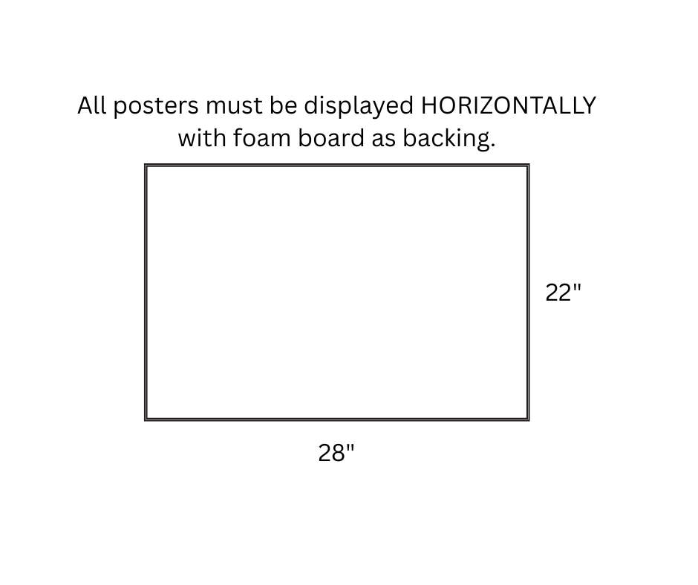
American Presidents – There are so many options for this project with over 40 American Presidents to learn about. Learn about the life and legacy of an American President and tell us all about it.

Exhibit an age-appropriate project from a president from American History
Examples:
* Create an educational poster, notebook or display about an American President: President’s Birthplace, Legacy of President, Fun Facts about the President

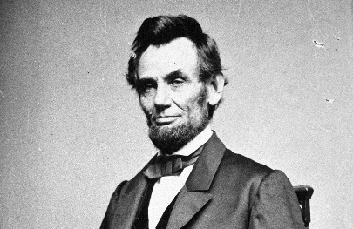
This Photo by Unknown Author is licensed under CC BY

Bicycle - Bicycle riding is the outdoor activity most popular with children. Learn about choosing a bike, bicycle maintenance, traffic rules, hazards of the road, safety and helmets.

Exhibit: a poster board on one of the activities covered in the manual.
Examples:
* Create an educational poster, notebook or display about a bicycle topic of choice.

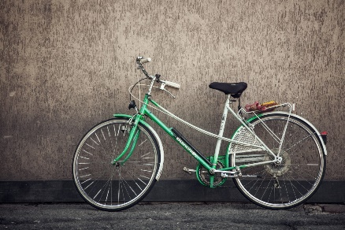

Bugs - Bugs are Everywhere!!! Are you interested in learning the different parts of Bugs? Do Bugs have 6 legs or 8? In the Mini Bug project, you’ll learn this information and more.

Exhibit one of the following: a poster of an insect or spider, a scrapbook of pictures of the different insects you took pictures of, make your own bugs and many more exciting activities that have to do with bugs.

Examples:
* Make a poster of an insect or a spider and label the body parts
* Draw a picture of a butterfly
* Make a poster or notebook showing some of the ways bugs protect themselves
* Make a scrapbook of different types of insects and spiders and label them
*Design and make your own bug using materials from around your house

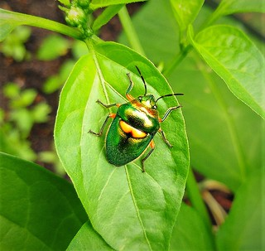
This Photo by Unknown Author is licensed under CC BY

Collections - Everyone loves to collect things. Collecting is as easy as finding a group of your favorite rocks to putting together a group of pencils. Learn more about collecting and why people collect things.

Exhibit one of the following: a sample of your collection, a report on a collection you saw at a museum or library, or a survey of friends and family to find out what they collect.

Examples: 
* Collection of bracelets
* Collection of keychains
* Collection of rocks

Crafts - Let’s be creative and make a neat craft. Use your imagination as you design your craft. Crafts can be used for decorations and they make great gifts too.

Exhibit one of the following: splatter painting, decoupage, hand print, drawing, gift bag, sculpting with modeling dough, sponge fun, craft kits or homemade paper.

Examples: 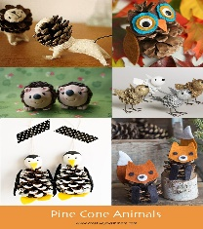
This Photo by Unknown Author is licensed under CC BY-NC
* Sun-catcher
* Homemade Ornament
* DIY Birdhouse

Electric – Learn about electricity. What is a circuit and how does it work?

Exhibit one of the following: Start simple and work your way towards something more complex like a circuit motor kit.

Examples:
* Poster with information about electricity
* Simple Circuit kit

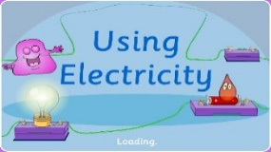
This Photo by Unknown Author is licensed under CC BY

Farm Animals - There are all kinds of farm animals. Explore the world of farm animals, from the little ones...like rabbits and poultry, to the big ones...like cows and sheep.

Exhibit one of the following: as story about your favorite farm animal or about a farmer, posters showing what farm animals make for us or the different kinds of farm animals, rewrite a fairy tale using farm animals, or make a model of your favorite animal, and more.

Examples:
* Show the different breeds of your favorite farm animal
*Overview of care for an animal: grooming, feeding, housing, etc.

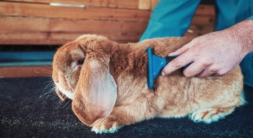
This Photo by Unknown Author is licensed under CC BY-NC-ND

Foods - Everyone can have fun in the kitchen. Learn about measuring, nutrition, making easy recipes and kitchen safety.

Exhibit one of the following: popcorn snack, two no-bake cookies, poster with kitchen safety rules, poster showing My Plate, two marshmallow bars, a poster showing how to measure ingredients, a 4-H cooking kit.

Examples: 
This Photo by Unknown Author is licensed under CC BY
* Display a small cup of your favorite popcorn snack
* Display two no-bake cookies in a Ziploc or plate
* Create a poster of measurements and tools used to measure.
Forestry - Trees are all around us. They grow big and strong for all to enjoy. Learn about trees, the wood they make and the animals that live in trees.

Exhibit one of the following: a poster of the parts of a tree, the uses of wood, animal homes, shapes of leaves types of trees, types of trees, along with collecting colored leaves and completing leaf rubbings.

Examples:
* Create a poster display of the different parts of a tree using items found outside
* Draw the shapes of different leaves for different types of trees
* Create a picture of what you find in your yard

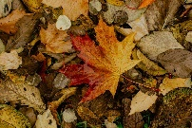

Garden - Learn how plants grow. Plant seeds or small plants in a garden or in a pot, inside or outside, and watch them grow and make vegetables or flowers.

Exhibit one of the following: a plate of three vegetables, a plant in a pot, a plant scrapbook, or a Chia Pet.

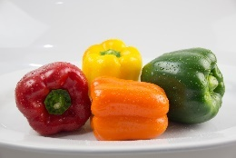

My Pet & Me - Do you enjoy animals? If an animal has four legs, crawls, flies, swims, or hops, you can bet someone has one for a pet. Caring for animals can be fun. In this project you get to share your pet with pictures, drawings, and stories in a notebook you put together. Let us read about your special pet.

Exhibit includes: a scrapbook or poster telling us about your pet.

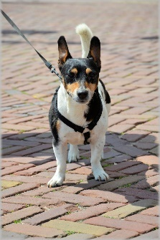

Models - Models is a great way to build things! Learn about models and different ways of making models.

Exhibit one of the following: a snap together model, a model made from clay or popsicle sticks, a model made out of different things (i.e. Legos and clay), a model with backgrounds or a report on models that you saw in a museum.
Examples:
* Lego kit
* Model Kit
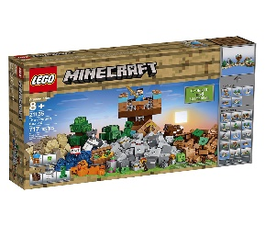
This Photo by Unknown Author is licensed under CC BY-NC

Photography - Bring things into focus!

Exhibit: a poster that contains 6 color pictures (see handout for specific pictures). Number each picture and add a creative title to your poster.

Examples:
* 6 color pictures (Animal, Flower, Person, Scenery, 2 of your Choice); Number each picture, and Title your poster
* 6 black & white pictures (Animal, Flower, Person, Scenery, 2 of your Choice); Number each picture, and Title your poster



Plants & Flowers - Learn about plants and their special needs. Do great experiments with plants. You will also learn about different kinds of flowers.

Exhibit one of the following: 3 cut flowers in a vase, a flowering plant, a house plant, a cacti, a colored flower, a poster of the different parts of a plant.
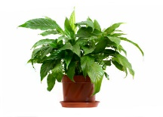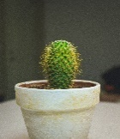
This Photo by Unknown Author is licensed under CC BY-NC-ND
Poultry - Learn all about Poultry.

Exhibit: Bring your own animal to the fair to show during the Mini 4-Her Poultry Class OR make a poster according to the guidelines in the Mini Poultry handout.
**If you bring your own animal, a Mini Liability Form will be required**

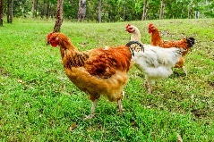

Rabbits - Learn all about Bunnies.

Exhibit: Bring your own animal to the fair to show during the Mini 4-H Rabbit Class or exhibit a poster on the subject of the care of your rabbit.
**If you bring your own animal, a Mini Liability Form will be required**

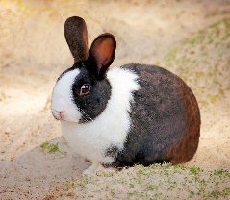

Reading - Learn the different parts of a book, the different types of books and where you can borrow books from.

Exhibit one of the following: a drawing of your favorite book character, design a new book cover, make a map of your favorite library and many other options from page 19 of your reading manual.
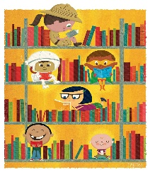
This Photo by Unknown Author is licensed under CC BY-SA

Robotics - Working with robotics can be fun. It lets you use your hands to create something useful, or something for pleasure.

Exhibit:
Kindergarten – Tin Can Robot
1st Grade – Solar Robot
2nd Grade – Motorized Robot
Robotics cont. 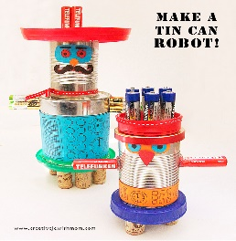
This Photo by Unknown Author is licensed under CC BY-NC

Sewing - Learn the basic skills needed for sewing. Begin putting together the Equipment needed for doing easy home sewing and repair work. A SEWING MACHINE IS NOT NEEDED FOR THIS PROJECT.

Exhibit one of the following: sewing kit, pin cushion, tissue cover, placemat, bbq apron.

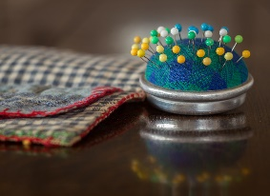
This Photo by Unknown Author is licensed under CC BY

Whales & Dolphins – What do you know about the animals that live in the ocean? Whales are actually mammals, not fish! Dolphins are part of the whale family. There are more than 40 different types of dolphins. Learn all about these animals in the Whales & Dolphins Manual.
Exhibit one of the following: any of the Activities in the manual

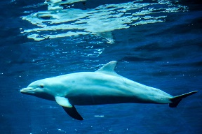

Wildlife Adventure - Do you ever wonder about the animals that live in the woods and open areas around your home or city? The world of wildlife beckons you. Learn about wild animals and birds that live around you.

Exhibit one of the following: any one of the Activities in the mini 4-H manual

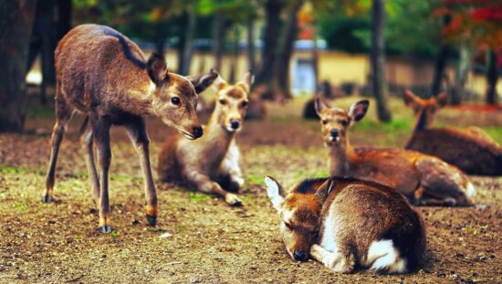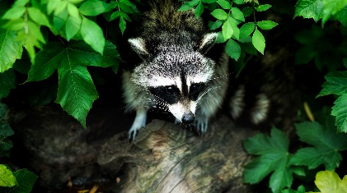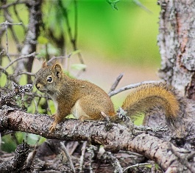
Mini 4-H Livestock

Mini 4-H Livestock – Beef, Sheep, Goat, Swine, Dairy, Cat, Dog, Poultry, Rabbit and Horse & Pony
- Rules for Daviess County Mini 4-H Livestock Shows
- Mini 4-H show class will be held for each of these species.
- A Mini 4-H participant may exhibit only ONE animal per species at the Daviess County 4-H Show. This animal may be their own animal or one that is owned by another 4-H member who is also exhibiting the animal at the Daviess County 4-H Show with the Exception of Horse & Pony. See page 44 (Horse & Pony), item #6. Verbal agreement between the parent or legal guardian of the Mini 4-H participant and the parent or legal guardian of the 4-H member will suffice, if the Mini 4-H participant is borrowing an animal to exhibit in a Mini 4-H Livestock Show.

- Mini 4-H animals must follow the same project guidelines and health requirements as all other 4-H animals. Refer to the Daviess County 4-H Handbook for these guidelines.

- If a Mini 4-H participant brings his or her own animal to exhibit, the animal(s) must stay at the fairgrounds for the same length of time as the 4-H animals of the same species.

- Registration and liability release forms MUST be completed and returned to the Extension Office before the deadline of May 15. If not returned, the Mini 4-H participant will not be allowed to exhibit an animal.

- The parent or legal guardian of a Mini 4-H participant MUST be present while the Mini 4-H participant is showing.

- NO Mini 4-H participants will be eligible to participate in the Daviess County 4-H Livestock Auction.

- Mini 4-H participants will NOT be judged competitively. Instead, constructive comments will be shared with them so that they may learn from the experience. All Mini 4-H participants will receive a blue ribbon.

- Mini 4-H participants exhibiting animals that weigh more than 300 pounds MUST have an adult assistant who is in charge of the animal AT ALL TIMES while exhibiting. This adult may be the parent of legal guardian of the Mini 4-H participant or an adult who is designated in writing by the parent of legal guardian.

- Must have Premise ID number if bring livestock to fair.

- Mini 4-H’ers who wish to participate in 4-H Dog Obedience project and show are encouraged to participate in the series of obedience training/classes that are held throughout the year. Each 4-H’er is encouraged to participate in these lessons/sessions to prepare for the 4-H Dog Show.

- Mini 4-H’ers who wish to participate in 4-H Horse & Pony project and show are encouraged to participate in the series of training/classes that will be held throughout the year. Each Mini 4-H’er is encouraged to participate in these lessons/sessions to prepare for the 4-H Show.
Safety Policy for Mini/Exploring 4-H Members:

The safety and well-being of our 4-H youth is of the utmost importance. Although Kindergarten is specified as the time when a child may begin participation in some 4-H events and activities, parents are encouraged to take into consideration their child’s physical and mental development before agreeing to let the child begin to show, work with, or care for animals. Each child matures at a different rate, and children in grades K-2 may still be too young to begin showing, working with, or caring for animals.

The Indiana 4-H Youth Program at Purdue University has agreed to allow Mini/Exploring 4-H members in grades K-2, to participate in NON-COMPETITIVE animal projects subject to certain conditions. These conditions are specified below.

“Mini/Exploring 4-H members, in K through 2, will be allowed to show, work with, or care for animal projects after their parent or legal guardian has signed a liability release. Mini/Exploring 4-H members may independently show, work with, or care for animals that weigh 300 pounds or less. Mini/Exploring 4-H members may only show, work with, or care for animals over 300 pounds when they are assisted by a parent, legal guardian, or another adult designated in writing by parent of legal guardian.” (The word assisted means that the adult has control of the animal at all times.)

Mini/Exploring 4-H members exhibiting horses must wear ASTM or SEI standard F1163 (or above) certified helmets whenever mounted. The parent/guardian is responsible to see that this specified headgear is properly fitted with the approved harness in place and fastened whenever a rider is mounted.

4-H Board of Directors voted in support of a “No Smoking”/ No Vaping, Tobacco Free policy at their 6/15/09 meeting for the Grounds & Buildings.

The Daviess County 4-H Directors and Trustees are dedicated to providing a clean, safe, and healthy environment for employees, exhibitors, and visitors. The Board recognizes that the use of tobacco presents a health hazard that can have serious consequences both for the user and the nonuser, and therefore it is a concern of the Board. In an effort to create a healthier environment for everyone at the fair and to set a good example for children and families attending the 4-H show, it is the intent of the Board to create a “smoke-free/tobacco-free” 4-H Show and 4-H grounds environment.
Smoking shall not be permitted anywhere on fair grounds at any time. This policy applies to all parents, members, exhibitors, visitors and renters of the facility.

“No Smoking/Tobacco Free” signs will be posted throughout the grounds.

The success of this policy will depend on the thoughtfulness, consideration, and cooperation of both smokers and nonsmokers. All employees, exhibitors, and visitors share in the responsibility for adhering to and supporting this policy.

Chairman, 4-H Directors

Thank you!

