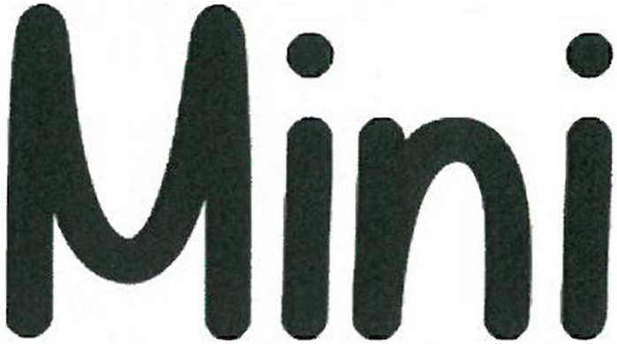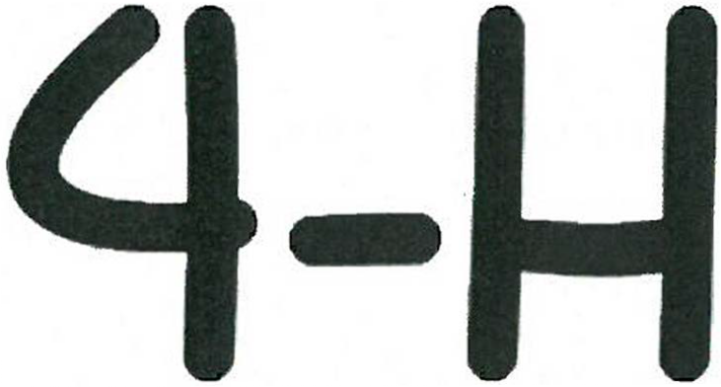

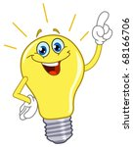

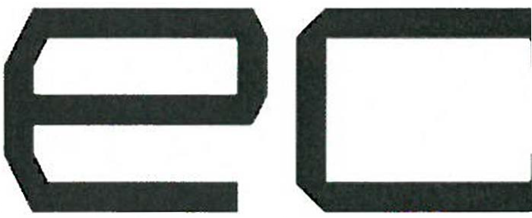
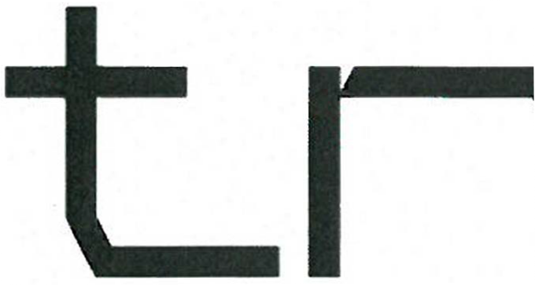
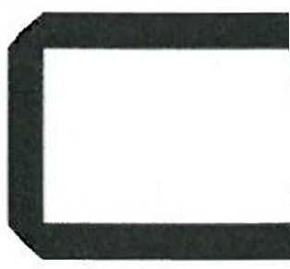
I I
•

It is the policy of the Purdue University Cooperative Extension Service that all persons have equal opportunity and access to its educational programs. services, activities. and facilities without regard to race. religion. color. sex. age. national origin or ancestry. marit.11 status. parental status. sexual orientation. disability or status as a ,•eteran.
Purdue University is an Aflirmative Action institution. This material may be available in alternative lormats.

MINI ELECTRIC

It's fun to learn about energy, especially renewable energy. In your electric project, you will learn about solar power as one source of renewable energy.

4-H Show Exhibit

In this project, you will need to purchase your own kit.

Exhibit - Start with a simple electric circuit kit and work your way to something more complex like a Circuit motor kit.

All projects are to have a name label on them.

See you at the 4-H Show!
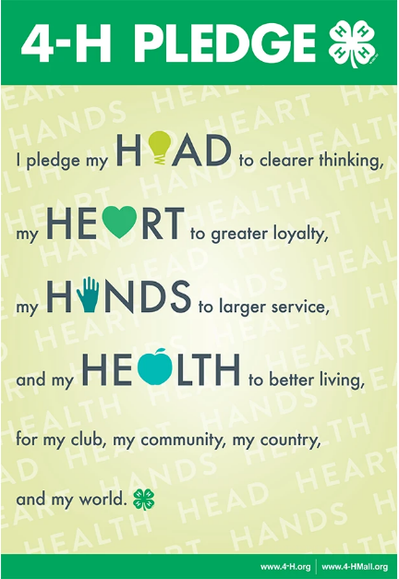

The 4-H motto is:

"To make the best better."

What is Solar Energy?

Solar energy comes from the sun. The sun is an important resource, as it helps sustain life. Without the sun, our planet would have no life. Through the use of technology, we are able to harness the energy from the sun to convert it
to electricity.

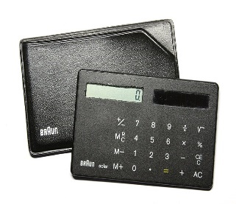
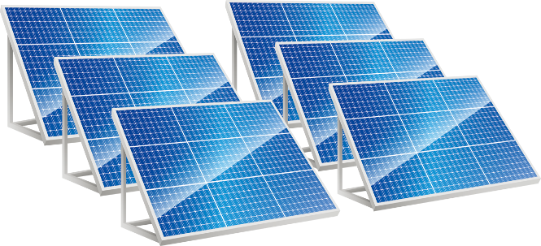
What do you think a car powered by the sun would look like? Draw a picture.
SOLAR CELLS are tools that change light energy from the sun and other light sources into electricity. Many calculators use solar cells to power them.
SOLAR PANELS are a group of solar cells connected to a large flat surface.
CONDUCTORS AND INSULATORS

A conductor is a material that allows electricity to flow through it. An insulator is a material that electricity cannot flow through.

Project Directions:
To find out if an object is a conductor or insulator, use your energy stick to see if it lights up!
Once you have determined if the item is a conductor or insulator, display the items you tested along with your findings.
Don't forget to bring your energy stick to be displayed at the Show!
Object | Conductor or Insulator?
Rubber Band
Penny
Paper Clip
Toothpick
(Your Choice)
(Your Choice)

Renewable Energy - Wind Turbines

Use the words at the bottom of the page to label the parts of the wind turbine.

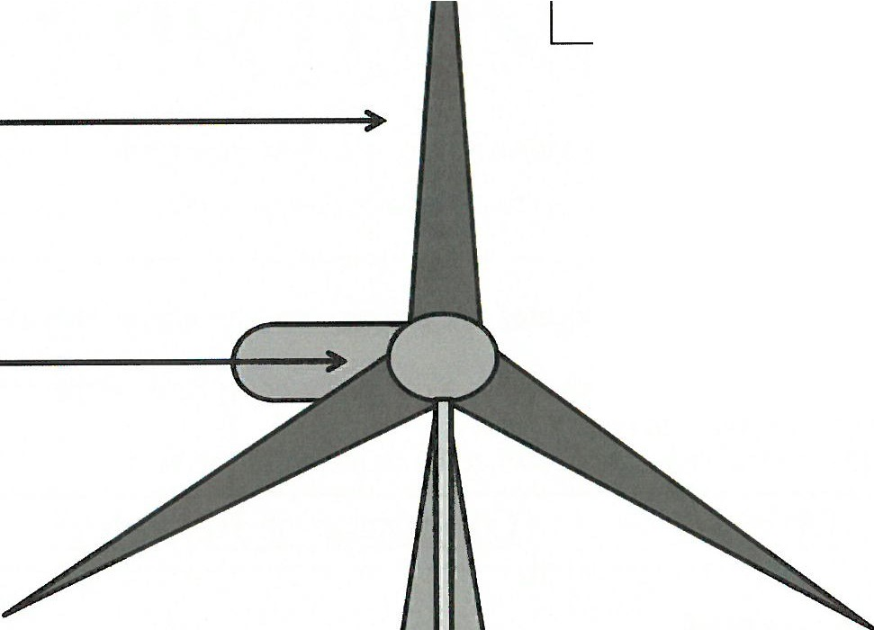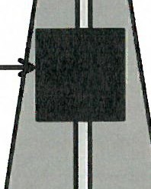

Computer System
Blades
Generator
Cable

Energy Types

Directions: Use the words below to answer the questions and fill in the crossword puzzle.
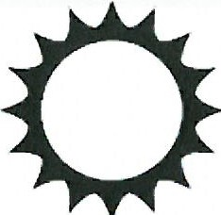

BATTERY ENERGY GASOLINE NONRENEWABLE
RENEWABLE SOLAR WIND

■ ■ ■ ■
ACROSS:

- What we need to work and play
4. An energy source that can run out
7. The energy source we use in a car

DOWN:

2. An energy source that will never run out
3. An energy source used in flashlights and cell phones
5. Energy that comes from the sun
6. Energy source that uses

