Hamilton County 4-H Llama Youth Scholarship
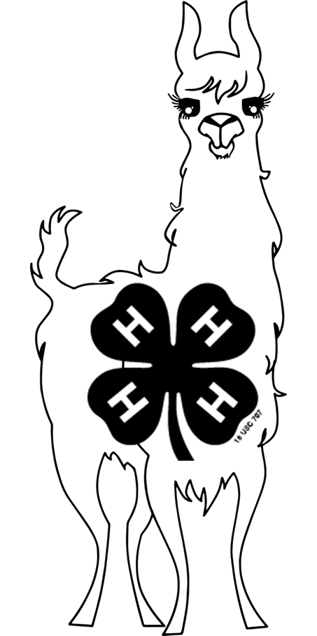

Goal
- To provide assistance to recipients who seek to further their education. Up to three scholarships in an amount up to $1,000 each may be awarded at the discretion of the Scholarship Steering Committee.
Eligibility
- Current 4-H Llama Project members in their senior year of high school meeting the criteria and planning to attend an accredited college or university as an undergrad student (course load to be at least 12 credit hours).
- Previous 4-H Llama project members who met the criteria and are now enrolled in an accredited college or university as an undergrad student with at least one term remaining in their course of study (course load to be at least 12 credit hours).
Criteria
- Applicant must be a current 4-H member who has been actively showing llamas at the Hamilton County 4-H Fair for a minimum of five years prior to graduation, OR a previous member of the Hamilton County 4-H Llama Project who has participated in the same
4-H Llama project actively showing llamas at the Hamilton County 4-H Fair for a minimum of five years.
- Applicants should NOT include letters of recommendation, statements regarding grades, GPA, or transcripts, or any financial need disclosures.
Due Date
- Applications are due no later than May 15
Purdue Extension Hamilton County
2003 Pleasant Street
Noblesville, IN 46060
Questions regarding the 4-H Llama Scholarship should be directed to Marilyn Nenni at llamas@shagbarkridge.com.

Scholarship Selection Committee
- The scholarship selection committee will be comprised of five members not affiliated with any applicant(s) or with the Hamilton County 4-H Llama Project.
- The scholarship selection committee will review all applications in a blind review. (No applicant or family names will be visible until after the review.)
- At the discretion of the committee, a personal interview may be required. If a personal interview is required, the applicant will be contacted by the committee.
- The committee will make the final selection of the recipient(s).
- The level of funding available each year will be determined by the Scholarship Steering Committee.
Additional Information
- The scholarship(s) will be presented at the Hamilton County 4-H Fair during the 4-H Queen Pageant. Scholarship recipients will be notified in advance. Therefore, recipients will be expected to attend the award presentation.
- Applicants not selected for the scholarship may re-apply for consideration (if eligible). Recipients of the award may only receive the award once and cannot re-apply for the scholarship.
- Applications are available at the Purdue Extension Hamilton County Office or online at www.extension.purdue.edu/county/hamilton. Applications are due May 15.

Hamilton County 4-H Llama Scholarship Application

Applicant Information
Name_____________________________________________________________________
(Last) (First)

Address___________________________________________________________________

Birthdate:_________________________ Phone Number:_________________________

Email:_____________________________________________

4-H Club:________________________________Years in 4-H (including current year):________

Years in the 4-H Llama Project (including current year):________________

Parent or Guardian:__________________________________________________________

Parent/Guardian Phone:__________________ Parent/Guardian Email:____________________

Education
Name of high school:__________________________________________________________
Year of graduation:__________________

University or College you plan to attend (or currently attend) next year:___________________

Major you are pursuing and why:

Activities
4-H Llama Project Involvement
Projects, offices held, leadership activities, committees, awards, achievements, other activities and involvement, etc.

Llama-related involvement (other than Hamilton County 4-H)
Activities, memberships, leadership activities, committees, awards, achievements, service, etc.

4-H Involvement (Other)
Projects, activities, offices held, committees, services, awards, achievements, etc.

Community Involvement
Organizations, activities, leadership, service, etc.

High School Involvement
Organizations, offices held, leadership, service, etc.

College Involvement (if applicable)
Organizations, offices held, leadership, service, etc.

Personal References
Please list three personal references (not family members or any person affiliated with the Hamilton County 4-H Program). The Scholarship Selection Committee may contact these references at their discretion during the application review process.

Name:___________________________________________________________________
Phone:_____________________________ Email:_______________________________
Relationship to applicant:___________________________________________________

Name:___________________________________________________________________
Phone:_____________________________ Email:_______________________________
Relationship to applicant:___________________________________________________

Name:___________________________________________________________________
Phone:_____________________________ Email:_______________________________
Relationship to applicant:___________________________________________________

Certification
I hereby affirm that the information provided on this application is accurate and complete to the best of my knowledge.

Applicant Signature:______________________________________ Date:_______________

Personal Narrative
How has the Hamilton County 4-H Llama project impacted your life and how do you see it impacting your future?

