April 19, 2024

Dear 4-H Poultry Member,

POULTRY ID DAYS will take place in the north end of the Small Animal Barn:
June 12, 2024 from 6:30 – 8:00 p.m. or June 22, 2024 from 9:00 – 11:00 a.m.

- All chickens and turkeys OVER one year of age must be blood tested at one of the dates listed above, even if they originate from a NPIP approved flock. If they originate from an approved flock and are under one year of age, they do not need to be tested but the NPIP certification must be turned in to the project leader at the blood testing dates.

- All other poultry (i.e. waterfowl & pigeons) are only required to return the Poultry Entry Form. They do not have to attend the Blood Testing.

- ALL POULTRY SPECIES must return the Poultry Entry Form included in this mailing by May 15, 2024 to the Extension Office. Be sure to list any and all poultry you wish to show at the 4-H Fair. Poultry not listed on the form will not be eligible to show at the 2024 Hamilton County 4-H Fair.

- All waterfowl (with the exception of Grand and Reserve Grand Champion) will be released upon completion of judging at the 4-H Fair.

INDIANA 4-H QUALITY LIVESTOCK CARE: 4-H’ers planning to exhibit beef cattle, dairy cattle, swine, sheep, meat goats, dairy goats, poultry or rabbits MUST BE CERTIFIED through Indiana 4-H Quality Livestock Care training (in-person option) OR Youth for the Quality Care of Animals Program (YQCA) (online option). 4-H’ers must be re-certified annually. See enclosed flyer for more information.

Please contact Project Leader Julie Hoffmeister at 317-529-2237 with any questions.
Animal Location Form

4-H members must turn in a 2024 Animal Location Form to the Extension Office by
May 15.

Sincerely,
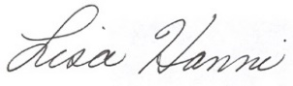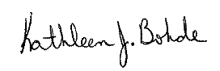
Lisa Hanni Kathleen J. Bohde
Program Assistant Extension Educator
Ag/Youth 4-H Youth Development

KJB:meh
cc:Julie Hoffmeister

