April 19, 2024

Dear 4-H Rabbit Member,

Enclosed you will find a 2024 4-H Rabbit Registration Form. Please complete this form and return it to the Purdue Extension Hamilton County Office, 2003 Pleasant Street, Noblesville, Indiana 46060 by MAY 15, 2024.

Remember, you may show a maximum of 12 entries plus one meat pen. You may not show more than three (3) breeds of rabbits. A meat pen is not considered a breed class. The rabbits you plan to show at the Hamilton County 4-H Fair MUST be enrolled on this form.

All rabbits to be sold in the 4-H Livestock Auction must be shown in a meat class. ALL sale animals are slaughtered immediately following the auction.

INDIANA 4-H QUALITY LIVESTOCK CARE: 4-H’ers planning to exhibit beef cattle, dairy cattle, swine, sheep, meat goats, dairy goats, poultry or rabbits MUST BE CERTIFIED through Indiana 4-H Quality Livestock Care training (in-person option) OR Youth for the Quality Care of Animals Program (YQCA) (online option). 4-H’ers must be re-certified annually. See enclosed flyer for more information.

Please check your 2024 4-H Handbook for a listing of the 2024 Rabbit Rules. Please do not hesitate to contact the Extension Office at 317-776-0854 or Project Superintendent Jerry Urbanus at 317-508-9183 with any questions.

Sincerely,
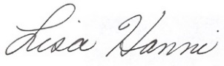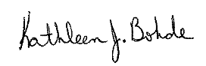

Lisa Hanni Kathleen J. Bohde
Program Assistant Extension Educator
Ag/Youth 4-H Youth Development

Animal Location Form

4-H members must turn in a 2024 Animal Location Form to the Extension Office by May 15.

KJB: meh
cc: Jerry Urbanus

