April 23, 2025

Dear 4-H Llama Members,

**In order to show at the 2025 Hamilton County 4-H Fair, all 4-H Llamas and Alpacas must have a completed 4-H Llama and Alpaca ID Enrollment in the 4honline system by May 15, 2025. Visit** [**in.4honline.com**](https://in.4honline.com/#/user/sign-in) **and log in to enroll your llamas. Animal ID instructions are enclosed.**

**Indiana State Fair 4-H Show**

If you own your llama or lease a llama and you are the only 4-H member showing this llama, you may participate in the Indiana State Fair 4-H Show per State Fair rules. You must complete llama animal identification by May 15 at [in.4honline.com](https://in.4honline.com/#/user/sign-in). Visit the Indiana State Fair website for state fair rules and entry deadline.

Please check your 2025 Hamilton County 4-H Handbook for a listing of the 2025 Livestock Rules. If you have any questions, please contact Lisa Hanni at the Extension Office at (317) 776-0854 or Project Superintendent Marilyn Nenni at 317-418-2258.

Sincerely,

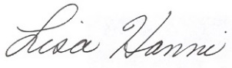 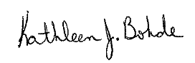

Lisa Hanni Kathleen J. Bohde

Program Assistant Extension Educator

Ag/Youth 4-H Youth Development

KJB:meh  
CC: Marilyn Nenni