April 23, 2025

Dear 4-H Rabbit Member,

**In order to show at the 2025 Hamilton County 4-H Fair, all 4-H Rabbits must have a completed 4-H Rabbit ID Enrollment in the 4honline system by May 15, 2025. Visit** [**in.4honline.com**](https://in.4honline.com/#/user/sign-in) **and log in to enroll your rabbits. Animal ID instructions are enclosed.**

Remember, you may show a maximum of 12 entries plus one meat pen. You may not show more than three (3) breeds of rabbits. A meat pen is not considered a breed class. The rabbits you plan to show at the Hamilton County 4-H Fair **MUST** be enrolled in 4honline.com. This is new for 2025.

All rabbits to be sold in the 4-H Livestock Auction must be shown in a meat class. ALL sale animals are slaughtered immediately following the auction.

**INDIANA 4-H QUALITY LIVESTOCK CARE:** 4-H’ers planning to exhibit beef cattle, dairy cattle, swine, sheep, meat goats, dairy goats, poultry or rabbits **MUST BE CERTIFIED** through Indiana 4-H Quality Livestock Care training (in-person option) **OR** Youth for the Quality Care of Animals Program (YQCA) (online option). 4-H’ers must be re-certified annually. See enclosed flyer for more information.

Please check your 2025 4-H Handbook for a listing of the 2025 Livestock Rules. Please do not hesitate to contact the Extension Office at 317-776-0854 or Project Superintendent Tom Koch at 317-439-4344 with any questions.

Sincerely,

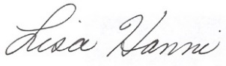 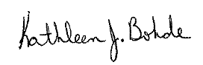

Lisa Hanni Kathleen J. Bohde

Program Assistant Extension Educator

Ag/Youth 4-H Youth Development

KJB: meh

cc: Tom Koch