4-H Online Event Registration Instructions for Chef U
- Visit v2.4honline.com. If you are a CURRENT 4-H MEMBER or have a 4-HOnline Account from a previous event, you will skip to Step # 3. If you are NOT a Current 4-H Member (and do not have a 4-HOnline account) or are a 4-H member participating from a different state, you will click the button “Don’t have an account?” at the bottom of the screen.

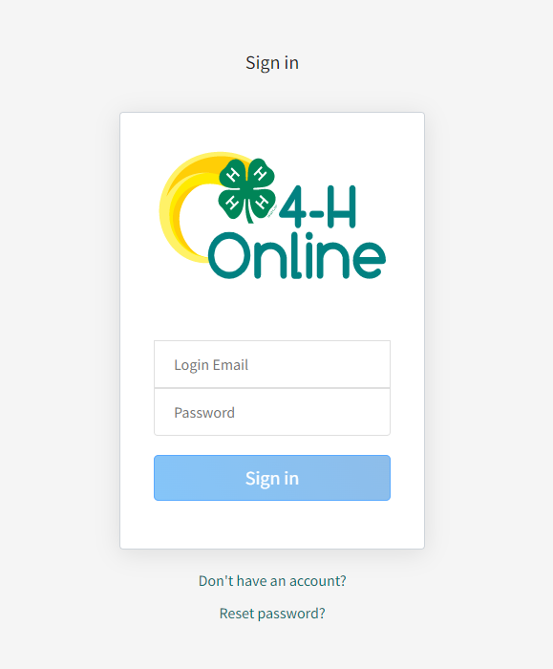
Current 4-H Members log in here
NOT CURRENT 4-H members click here

- Not Current 4-H Members/Outside of Indiana 4-H members will follow the steps to create a basic
4-HOnline Account. Once you have created an account, skip to step # 4.

- Current 4-H Members will complete the 4-HOnline login process to access your family profile and member list and continue to step #4.
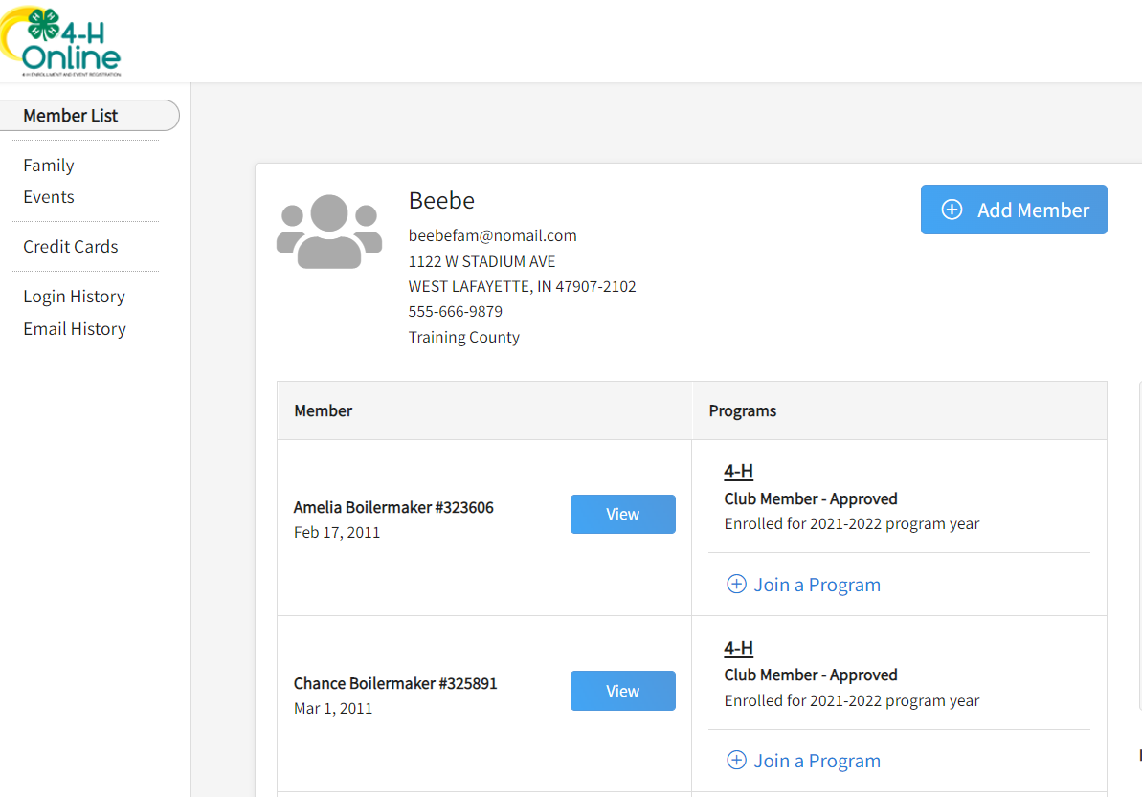
- Click “View” by the member you intend to register for Chef U

- Select the Events Tab once you are in their profile and click “Register for an event” to find the event titled “2026 Hendricks County Chef University” or “2026 Hendricks County Chef University 102”
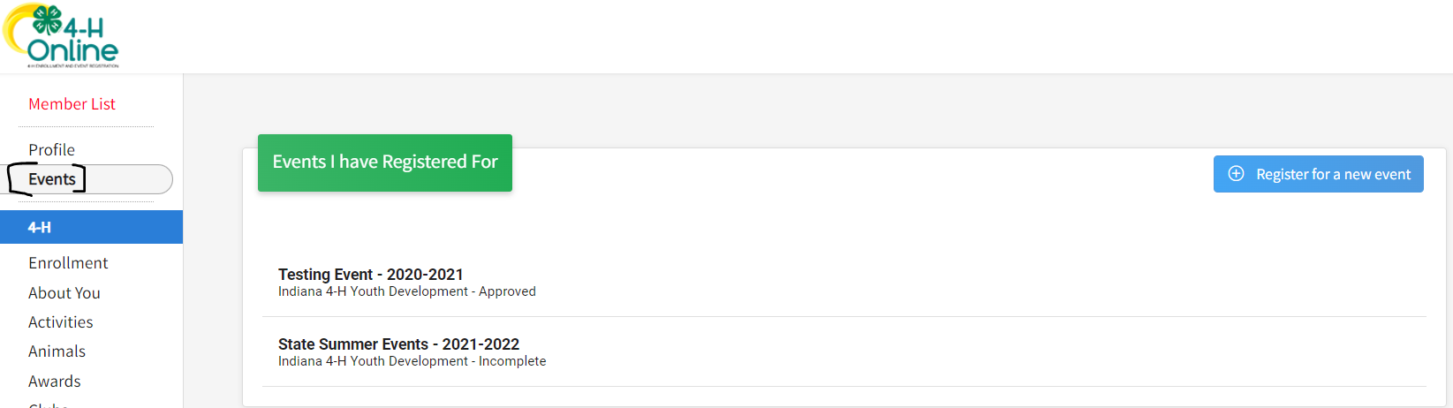

- There will be two options for registration on each of the Chef U Programs. Select the one that best fits your situation:
  - 4-H Member – Current 4-H Members that want to participate in the Chef U program will register here.
  - Youth Participant – Participants who are NOT 4-H Members and want to participate in the Chef U program will register here.

- Complete any required questions.
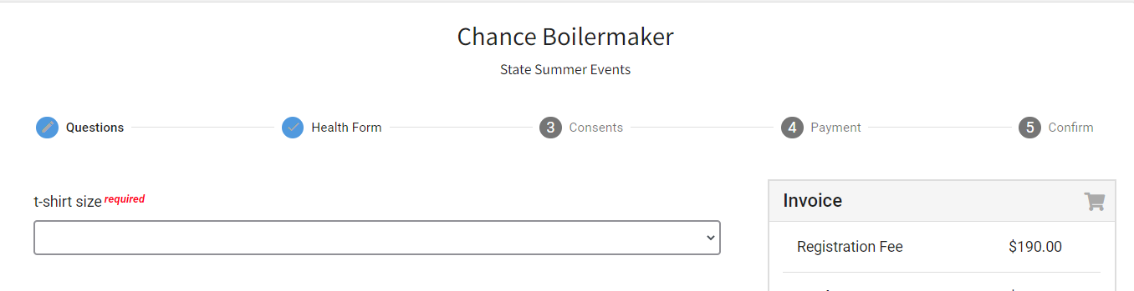
- Complete Consents (if any are listed).
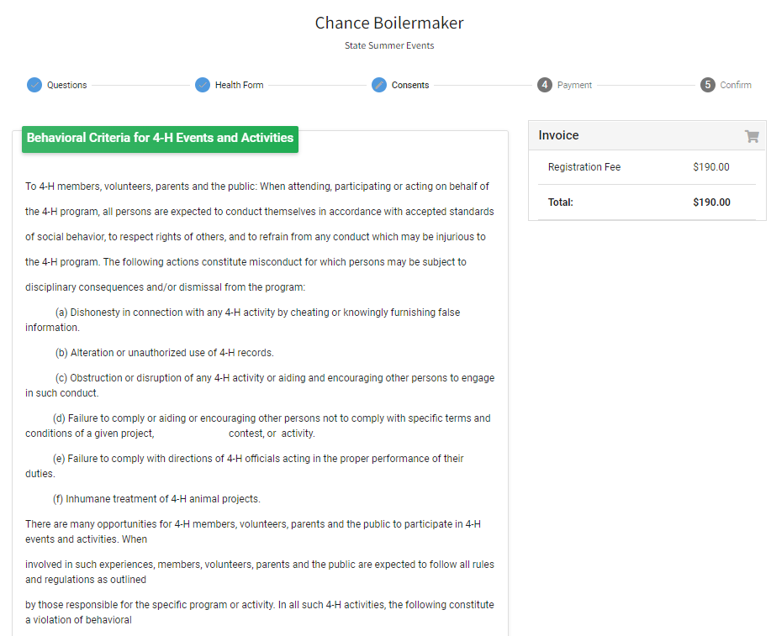

- You will be able to by card, cash, or check for this program.

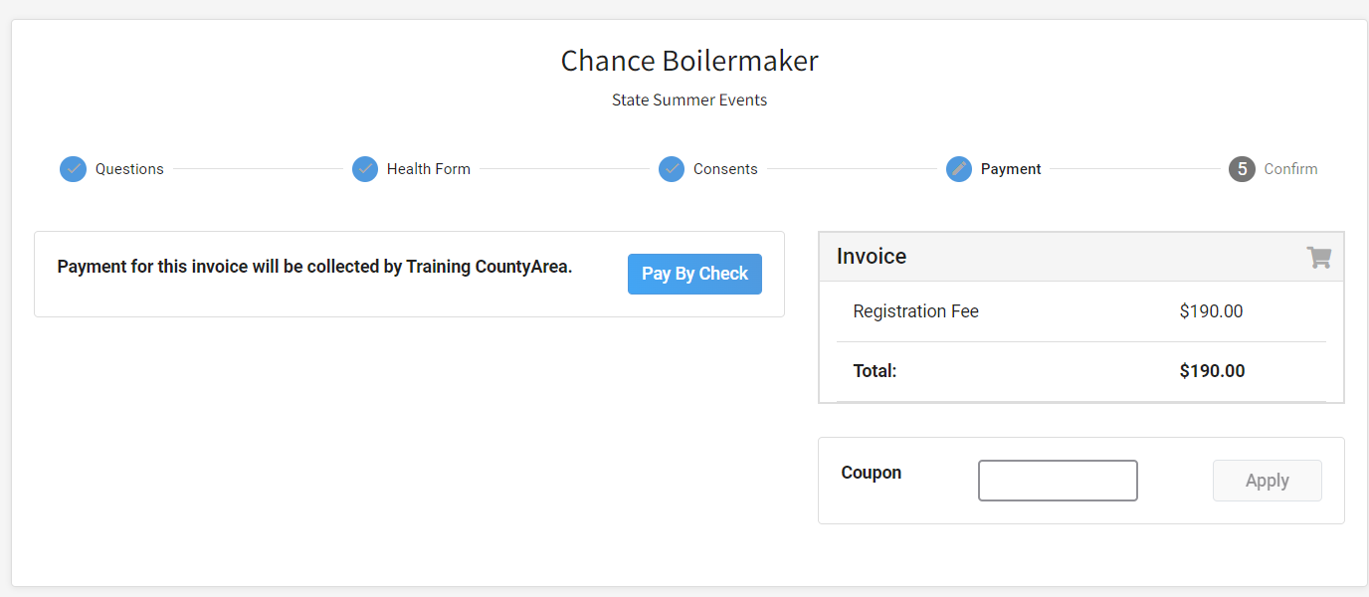

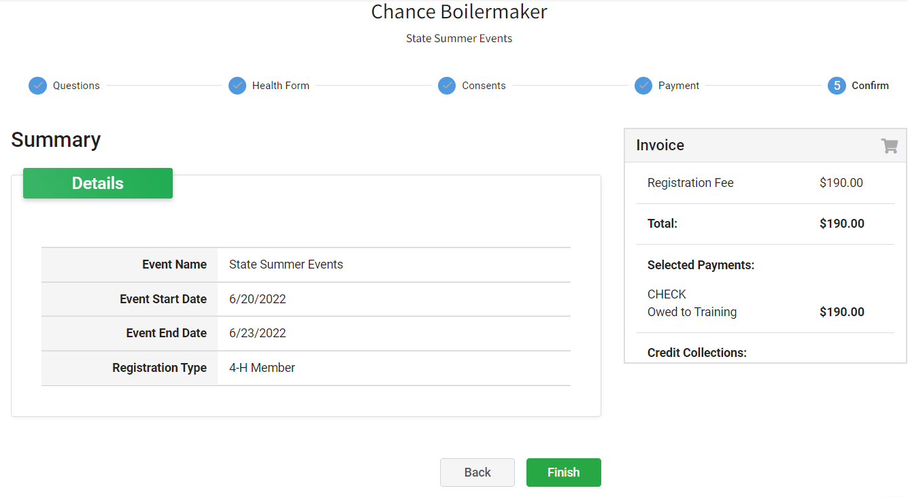
- Select Next once payment has been selected. And then Finish.

- A list of event registrations that have been submitted will appear and your county will accept your registration.
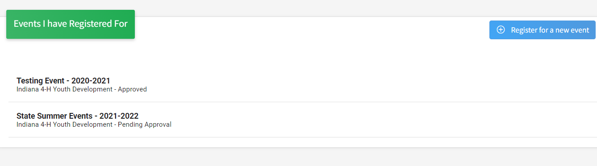

- If you selected to pay with cash or check, you have two options:
  - Pay by cash or check at your local Purdue Extension Office.
  - Pay by cash or check by making checks payable to Trustees of Purdue and sending to the address below:
Purdue Extension – Hendricks County
ATTN: Chef U
PO Box 7
Danville, IN 46122

If you have questions or need assistance, please contact Purdue Extension – Hendricks County at 317-745-9260 or email hendrces@purdue.edu.

