$1.00
Manual updated 2018

4-H Scrapbooking Project


EXHIBIT REQUIREMENTS

EXHIBIT:

- Scrapbooks must be displayed in a scrapbook. It will consist of photographs, embellishments, journaling, and memorabilia (in Level 3).
- Each year will have a title page. A title page will be at the beginning of each year’s exhibit and will not be judged or counted as part of the pages required for the year.
- Include previous year’s work with your scrapbook project but don’t have the album over filled. Once you get to Levels 2 and 3 you will need to start a new album. You do NOT need to bring prior year’s albums with you to judging.
- Scrapbooks must consist of the required number of completed pages for that level.
- ALL scrapbooks MUST be 12x12 in size.

SCRAPBOOK REQUIREMENTS:

- Exhibit a scrapbook that can have additional pages added. No spiral or magnetic albums allowed.
- You must use acid free products and photo safe supplies.
- All pages are to be displayed in plastic (acid free) covers/sleeves.
- ALL scrapbooks MUST be 12x12 in size.
- Each exhibited year must be separated by a title page (not counted or judged). The title page must have your name, grade in school, level and year.
- Pages will consist of photographs, memorabilia, and journaling depending on level requirements. Pages must have captions with dates, names, places, etc.
- Neatness and correct spelling counts.

ALL LEVELS:

- Display a scrapbook as described in Scrapbook requirements.
- Turn in a completed record sheet to your leader for them to sign.
- ALL scrapbooks MUST be 12x12 in size.

Level 1 (Grades 3-5)

- Complete 6 pages per year in your scrapbook.
- Crop straight cut only.
- Bullet journaling on each page. Bullet captions with names, dates, and places, etc. More details may be added depending on space.

Level 2 (Grades 6-8)

- Complete 8 pages per year.
- Crop photos in any shape.
- Journaling on each page or on one page of a two-page spread. Must be in complete sentences. Include names, dates, places, etc. More details may be added depending on space.

Level 3 (Grade 9-12)

- Complete 10 pages per year.
- Crop pictures in any shape.
- Journaling on each page or on one page of a two-page spread. Must be in complete sentences. Captions do not need to be in paragraph form. Include names, dates, places, etc.
- One page must contain memorabilia or documentation that goes with the photos (ticket stub, award, program, newspaper clipping, napkin, etc.).

Scrapbook Albums

Each album should have:
- A front and back cover with pages firmly attached between the covers. No spiral or magnetic albums.
- ALL scrapbooks MUST be 12”x12”.
- Use acid free, lignin-free, buffered scrapbook pages.
Acid-free – ph balanced chemistry, so pages will not accelerate the natural deterioration of your photos.
Lignin-free pages will maintain their durability and whiteness non-yellowing.
- Make sure the papers you use are acid and lignin free.
- Use polypropylene page protectors or covers.
Protectors are made of photo safe plastic to protect album pages and photos from fingerprints, abrasion and accidental spills. Protectors made of P.V.C. give off a chlorine gas that causes the plastic to bond with photos over time, making it impossible to separate the two!
- Use double-sided tape or mounting tape or corners to add photos and/or memorabilia. Rubber cement, white school glue or scotch tape contain chemicals that can adversely affect photos over time.

Title Page

A cover page will be at the beginning of each year’s exhibit and will not be counted or judged.
This page should include:
- Name
- Club and leader name
- Grade in school
- Level

Journaling
- Journaling or a caption is required on every page or on one page of a two-page spread (depending on level). With words, your photos and memorabilia are simply more complete, more meaningful, and more fun with detail, emotion and humor that only words can provide.
- Journaling is storytelling - writing your thoughts and feelings and telling a complete story or memory. It’s easiest to “storytell” if you pretend you are writing in your diary, or sharing some exciting news with your best friend.

Examples of journaling are:

Level 1: Journaling can be bullet format. Be sure to include who, what, when, and where. For example:

- Who: Page, Kelly and I
- What: 4-H camp
- When: June 4, 2004
- Where: Bradford Woods

Level 2: Use complete sentences and include names, dates, and places, etc. For example:

Kelly Jones, Tim Smith and I are outside Matthews Hall (Purdue University) at 4-H Round-Up on June 26, 2004.

Level 3: Your journaling should be in complete sentences include who, what, when and where. For example:

Ever since my older brother, Tim, began showing pigs in 4-H, I have been looking forward to getting old enough to show hogs, too. This has been a fun project because it is a family activity. My parents, brother and I went to some pig auctions in March and April. We finally brought Wilbur home.
I have been feeding him and keeping his pen clean with a little help from Dad. It’s a lot of work, but I really enjoy it. After school was out, I started walking him at least once a day. He’s really tame and knows exactly what I want him to do.
I have spent so much time with him, I know I will be sad to sell him. Tim told me that’s just part of the project and I can use that money to buy another pig next year. That is true, but I know I’ll never forget Wilbur and my first year of 4-H.

Photos

Photos are the focus of your album. Photos may be copied. Note: be sure to use acid-free paper.

Memorabilia

Memorabilia adds meaning, texture and variety to your albums. These items tell an important part of the story.

Cropping techniques

- Keep in mind that the main focus is preservation of your photos.
- Using a variety of cropping techniques and page layouts in your album will add interest and creativity to your album.
- Not everything has to be cropped. Too many shapes on a page can be distracting to the eye and take away from the meaning of photos.
- Do not crop Polaroid pictures. This will ruin them.

Decorations

- All decorations (including stickers and die cuts) should be acid-free and lignin-free to maintain the integrity of the page and photos.
- Neatness counts! Exhibit clean and neat pages. Your scrapbooks will be cherished for years to come.

- 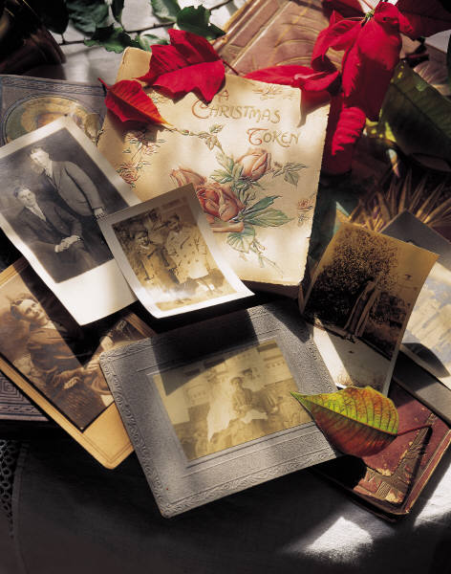

Keep in Mind

- Do not use scotch tape, school glue, or rubber cement! Use special photo tape, which is acid free.
- Check out your local scrapbook store.
- Don’t forget your title page.
- Photographs should be the focus of your album.
- Page/photo layout and design. A variety of page layouts will add creativity and interest to your album. Use a nice balance complementing your theme for the page and pictures. Keep in mind the placement of your photos - you are telling a story.
- Every item needs to be attached so it doesn’t float in the plastic cover.
- You may use matting to enhance the photo, but it is not necessary.

4-H SCRAPBOOK RECORD SHEET

YEAR 20____

NAME_______________________________________________________ GRADE______________________________________________________

LEVEL _________________ YEAR IN LEVEL ____________________
NAME OF CLUB______________________________________________

SIGNATURE OF LEADER______________________________________

I have reviewed this record

- What was your most enjoyable part about putting together your scrapbook?
______________________________________________________________________________________________________________________________________________________________________________________________________________________________________________________________________________________________________________________________________________________________________________

- What was your most challenging part about putting together your scrapbook?
______________________________________________________________________________________________________________________________________________________________________________________________________________________________________________________________________________________________________________________________________________________________________________

- What skills did you develop while you were participating in this project?
______________________________________________________________________________________________________________________________________________________________________________________________________________________________________________________________________________________________________________________________________________________________________________

