

Howard County Mini 4-H
Handbook

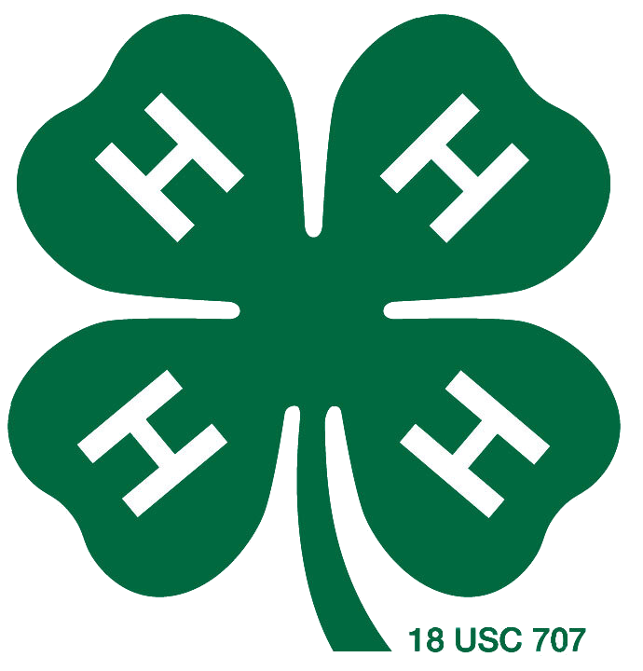

THE 4-H EMBLEM
A four-leaf clover with the letter "H"
on each leaflet, meaning the development of
HEAD, HEART, HANDS, and HEALTH are
the official 4-H Club emblem.
THE COLORS
Green (the clover) - nature's most common color is
emblematic of springtime, life, and youth.
White (the H’s) - symbolizes purity and high ide
THE PLEDGE
I pledge my HEAD to clearer thinking,
my HEART to greater loyalty,
my HANDS to larger service,
and my HEALTH to better living,
for my club, my community,
my country, and my world.
THE 4-H CLUB MOTTO
"TO MAKE THE BEST BETTER"
THE 4-H SLOGAN
"LEARN BY DOING"

It is the policy of the Purdue University Cooperative Extension Service that all persons have equal opportunity and access to its educational programs, services, activities, and facilities without regard to race, religion, color, sex, age, national origin or ancestry, marital status, parental status, sexual orientation, disability or status as a veteran. Purdue University is an Affirmative Action institution. This material may be available in alternative formats.
What is Mini 4-H?
The Mini 4-H Program in Howard County is designed specifically for youth in kindergarten through second grade of the current academic year. Mini 4-H members will be able to explore several project areas that interest them at a noncompetitive level. Projects may be displayed at the Howard County 4-H Fair and be awarded a special Mini 4-H ribbon.
Mini 4-H serves as an introduction to the 4-H program. Mini 4-H members can gain self-confidence and increase their self-esteem. Mini 4-H provides youth guidance while learning a variety of skills. Youth develop pride and skills in their ability to complete and display their projects. The intent is to allow the Mini 4-H members to have fun and enhance youth development and readiness for 4-H participation.
Mini 4-H Requirements:
1. Enrolled in kindergarten, first, or second grade of the current academic year
2. Register on v2.4honline.com
3. Attend Mini 4-H club meetings or camps, when possible
Poster Requirements:
1. Posters must be displayed horizontally and measure 22" x 28".
2. To provide support, you may use heavy cardboard, plywood, foam board, or
pegboard behind the poster. Foam board for backing can be purchased at the
Howard County Extension Office.
3. It is mandatory that all posters be covered with clear plastic, which can also
be purchased at the office in the form of clear plastic sleeves.
4. Please ensure that your poster is titled to include the project name.

Mini 4-H Policies
I. Mini 4-H Non-Competitive Policy
The Mini 4-H program is designed for children in kindergarten through second grade to explore friendships, learn how things work, and practice small and large muscle control. The non-competitive learning environment includes planned activities where children can explore without pressure, a low adult-to-child ratio for individual attention, simple and fun activities, encouraging participation in group activities, and rewards that are identical for everyone.
II. Safety Policy for Mini 4-H Members
The safety and well-being of 4-H youth is of the utmost importance. While kindergarten is the age at which children can begin participating in 4-H events and activities, parents are encouraged to consider their child’s physical and mental development before allowing them to show, work with, or care for animals.
The State 4-H Youth Program at Purdue University has allowed Mini 4-H members in grades K-2 to participate in animal projects, subject to certain conditions specified by each county.
Mini 4-H members in grades K-2 must have a liability release signed by their parent or legal guardian before being able to independently show, work with, or care for animals weighing 300 pounds or less. If the animal weighs over 300 pounds, the child must be assisted by a parent, legal guardian, or adult designated in writing by the parent or legal guardian. The adult must always have control of the animal.
Mini 4-H members exhibiting horses must wear ASTM or SEI standard-certified helmets whenever mounted. The parent/guardian must ensure that the specified headgear is properly fitted with the approved harness in place and fastened whenever the rider is mounted.
If the guidelines in this policy are not followed, any event or activity will not be considered to be a 4-H event or activity and will not be under the auspices of Extension 4-H educators or covered by Purdue University.

Mini 4-H Projects
Aerospace
- Make a rocket from a purchased kit. Learn how to glue, paint, and finish it.
Beef
- Make a poster or notebook showing:
  - Pictures of different beef cows (photos, magazine pictures, or drawings)
  - Your favorite beef cow breed with a picture, a brief description, and why it’s your favorite
  - A list of products we get from beef cows
  - Information on beef cow care and well-being
- OR participate in the Mini 4-H showmanship class by making arrangements with a 4-H beef member to show their animal (Mini 4-H members cannot bring their own animal)
- Mini 4-H Liability Release Form required before judging
Bicycle
- Make a poster or notebook showing either:
  - Bicycle safety information
  - Labeled bicycle parts (pictures or drawings)
- OR take part in the Bicycle Rodeo organized by the county (contact Extension Office for details)
Bugs
- Make a poster or notebook about one of the following:
  - Your favorite insect or spider (label body parts and describe characteristics)
  - Draw or find a picture of a butterfly with symmetrical wings
  - Explain different ways bugs protect themselves
  - Show several kinds of bugs/spiders using pictures or drawings
- OR make a bug-themed craft (like a mobile or diorama)
Cat
- Create a notebook based on your grade:
  - Kindergarten: Pictures of five cat breeds
  - 1st Grade: Add pictures of equipment used in raising cats
  - 2nd Grade: Add a short story about your cat
- OR participate in the Mini 4-H showmanship class by showing your cat or working with a 4-H cat member
- All cats must have required vaccinations before the 4-H Cat Show (contact Extension Office)
- Mini 4-H Liability Release Form required before judging
Collections
- Show a collection of five items or five pairs of items and complete the Mini 4-H Collections Log Sheet (update annually)
- OR create a chart about what your family and friends collect and why
- Do NOT bring valuable collections to exhibit—use a notebook of pictures instead

Cookie Decorating
- Make a poster or notebook showing your basic cookie decorating skills.
- OR make a poster or notebook that shows a variety of cookies you have decorated, with a description for each.
- OR decorate three cookies and display them on a covered 9-inch plate:
  - Division 1 or 2: Use frosting, sprinkles, and/or candy on top.
  - Division 2 or 3: Smooth frosting with a border of frosting/candy (recommended for 2nd graders).
Crafts
- Make and present one of the following:
  - A drawing or painting mounted on stiff backing (8½” x 11” or smaller)
  - A craft such as a collage, clothespin doll, scrapbook, puzzle, mobile, needlepoint, weaving, sun catcher, etc.
  - Any basic and simple craft
Dog
- Make a poster or notebook with:
  - Pictures of dogs (photos, magazine clippings, or drawings)
  - OR your favorite breed of dog, with a picture, short description, and why it’s your favorite
- OR participate in the Mini 4-H showmanship class at the fair by showing your dog or working with a 4-H dog member (dog must be at least 6 months old)
- All dogs must have required vaccinations (check with Extension Office)
- Mini 4-H Liability Release Form required before judging
Farm Toy Scene
- Create and display a farm scene diorama (no larger than 12” x 16” x 8”) on a sturdy base. Include animals, equipment, crops, trees, etc. Cases are allowed but not required.
Flowers
- Show one of the following:
  - Three cut flowers in a vase, labeled
  - A flowering plant in a pot, labeled
  - A house plant, labeled
  - A poster showing different parts of a plant or flower
  - A notebook with at least three different kinds of labeled flowers
Foods
- Make and exhibit one of the following:
  - A peanut butter sandwich (two slices of bread, peanut butter, and another ingredient of your choice), cut into two or four pieces
  - Your own popcorn snack (popped corn and one other ingredient), in a small plastic sandwich bag
  - Two no-bake cookies
  - Two marshmallow treat squares
  - A poster showing at least three kitchen safety rules
  - A poster showing the five food groups from MyPlate.org, with examples of a balanced meal

Forestry
- Choose one of the following to exhibit:
  - A visual display of your observations after visiting a lumberyard
  - An art collage using materials collected from a walk in the woods
  - An alphabet book using forest items for each letter
  - A display showing ways people can help trees or products that come from trees
  - A story or poem about your favorite tree
Garden
- Exhibit one of the following:
  - A plate with up to three types of vegetables
  - A scrapbook with pictures and labeled names of various vegetables
  - A potted plant (10 inches or less in diameter) that you have cared for at least two months before judging
Genealogy
- Choose one of the following:
  - My Family Tree chart from the Extension Office, colored/decorated
  - A poster of your family tree using pictures or information
Goats
- Make a poster or notebook showing:
  - Pictures of goats (photos, magazine pictures, or drawings)
  - Your favorite goat breed, with a picture, short description, and why it’s your favorite
  - Products we get from goats
  - Information about goat care and well-being
- OR participate in the Mini 4-H showmanship class by working with a 4-H goat member to show their goat (do not bring your own goat)
- Mini 4-H Liability Release Form required before judging
Horse & Pony
- Make a poster or notebook with:
  - Pictures or drawings of horses and ponies
  - Your favorite breed, with a picture and a brief description of why it’s your favorite
  - Equipment used with horses and ponies
  - Information about horse care, feeding, and grooming
- OR participate in the Mini 4-H Horse & Pony showmanship class by working with a 4-H member (Mini 4-H members may not bring their own animal)
- Mini 4-H Liability Release Form required before judging
Lego - Type Models
- Build your own Lego creation (no kits allowed) and display it on a sturdy base
- OR make a poster or notebook about your Lego project, explaining how you built it and what inspired you
Model Craft
- Build and exhibit a model (car, plane, train, ship, building, etc.) that you put together yourself (kits are allowed)
- OR make a poster or notebook about your model and what you learned to build it

Pets
- Make a poster or notebook about your pet, including:
  - Photos or drawings of your pet
  - A short story about your pet
  - Information about how you care for your pet (feeding, cleaning, exercise, etc.)
- OR participate in the Mini 4-H Pet showmanship class by working with a 4-H member (Mini 4-H members may not bring their own animal)
- All pets must have required vaccinations (check with Extension Office)
- Mini 4-H Liability Release Form required before judging
Photography
- Take and display one or more photos you have taken (can be printed at home or at a store)
- OR make a poster or notebook with information about taking photos, types of cameras, or your favorite subject to photograph
Plants, Flowers & Vegetables
- Show one of the following:
  - A potted plant or flower labeled with its name
  - A plate with up to three types of vegetables
  - A scrapbook or notebook with pictures of plants, flowers, or vegetables you have grown or cared for
Poultry
- Make a poster or notebook with:
  - Pictures or drawings of poultry (chickens, ducks, turkeys, etc.)
  - Your favorite breed, with a picture and a brief description of why it’s your favorite
  - Parts of a chicken, labeled
  - Products we get from poultry
  - Information about poultry care and well-being
- OR participate in the Mini 4-H Poultry showmanship class by working with a 4-H member (don’t bring your own animal)
- Mini 4-H Liability Release Form required before judging
Rabbit
- Make a poster or notebook with:
  - Pictures or drawings of rabbits
  - Your favorite breed, with a picture and a brief description of why it’s your favorite
  - Equipment used in raising rabbits
  - Information about rabbit care and well-being
- OR participate in the Mini 4-H Rabbit showmanship class by working with a 4-H member (don’t bring your own animal)
- Mini 4-H Liability Release Form required before judging
Sewing
- Make and exhibit a simple sewn item such as:
  - A pillow, drawstring bag, bookmark, stuffed animal, or similar beginner project
- OR make a poster or notebook showing sewing tools or explaining sewing safety

Sheep
- Make a poster or notebook with:
  - Pictures or drawings of sheep
  - Your favorite sheep breed, with a picture and a brief description of why it’s your favorite
  - Products we get from sheep
  - Information on sheep care and well-being
- OR participate in the Mini 4-H Sheep showmanship class by working with a 4-H member (don’t bring your own animal)
- Mini 4-H Liability Release Form required before judging
Shooting Sports
- Make a poster or notebook on one of the following topics:
  - Firearm or archery safety
  - Equipment identification and parts
  - Eye and ear protection
  - Safe storage of equipment
  - Shooting sports history
  - Personal experiences in shooting sports
Swine
- Make a poster or notebook with:
  - Pictures or drawings of pigs
  - Your favorite pig breed, with a picture and a brief description of why it’s your favorite
  - Products we get from pigs
  - Information on swine care and well-being
- OR participate in the Mini 4-H Swine showmanship class by working with a 4-H member (don’t bring your own animal)
- Mini 4-H Liability Release Form required before judging
Wildlife
- Make a poster or notebook on one of the following topics:
  - Types of wild animals found in your area
  - Tracks, homes, or food for wild animals
  - How to help wildlife in your community
  - Personal experience observing wildlife

