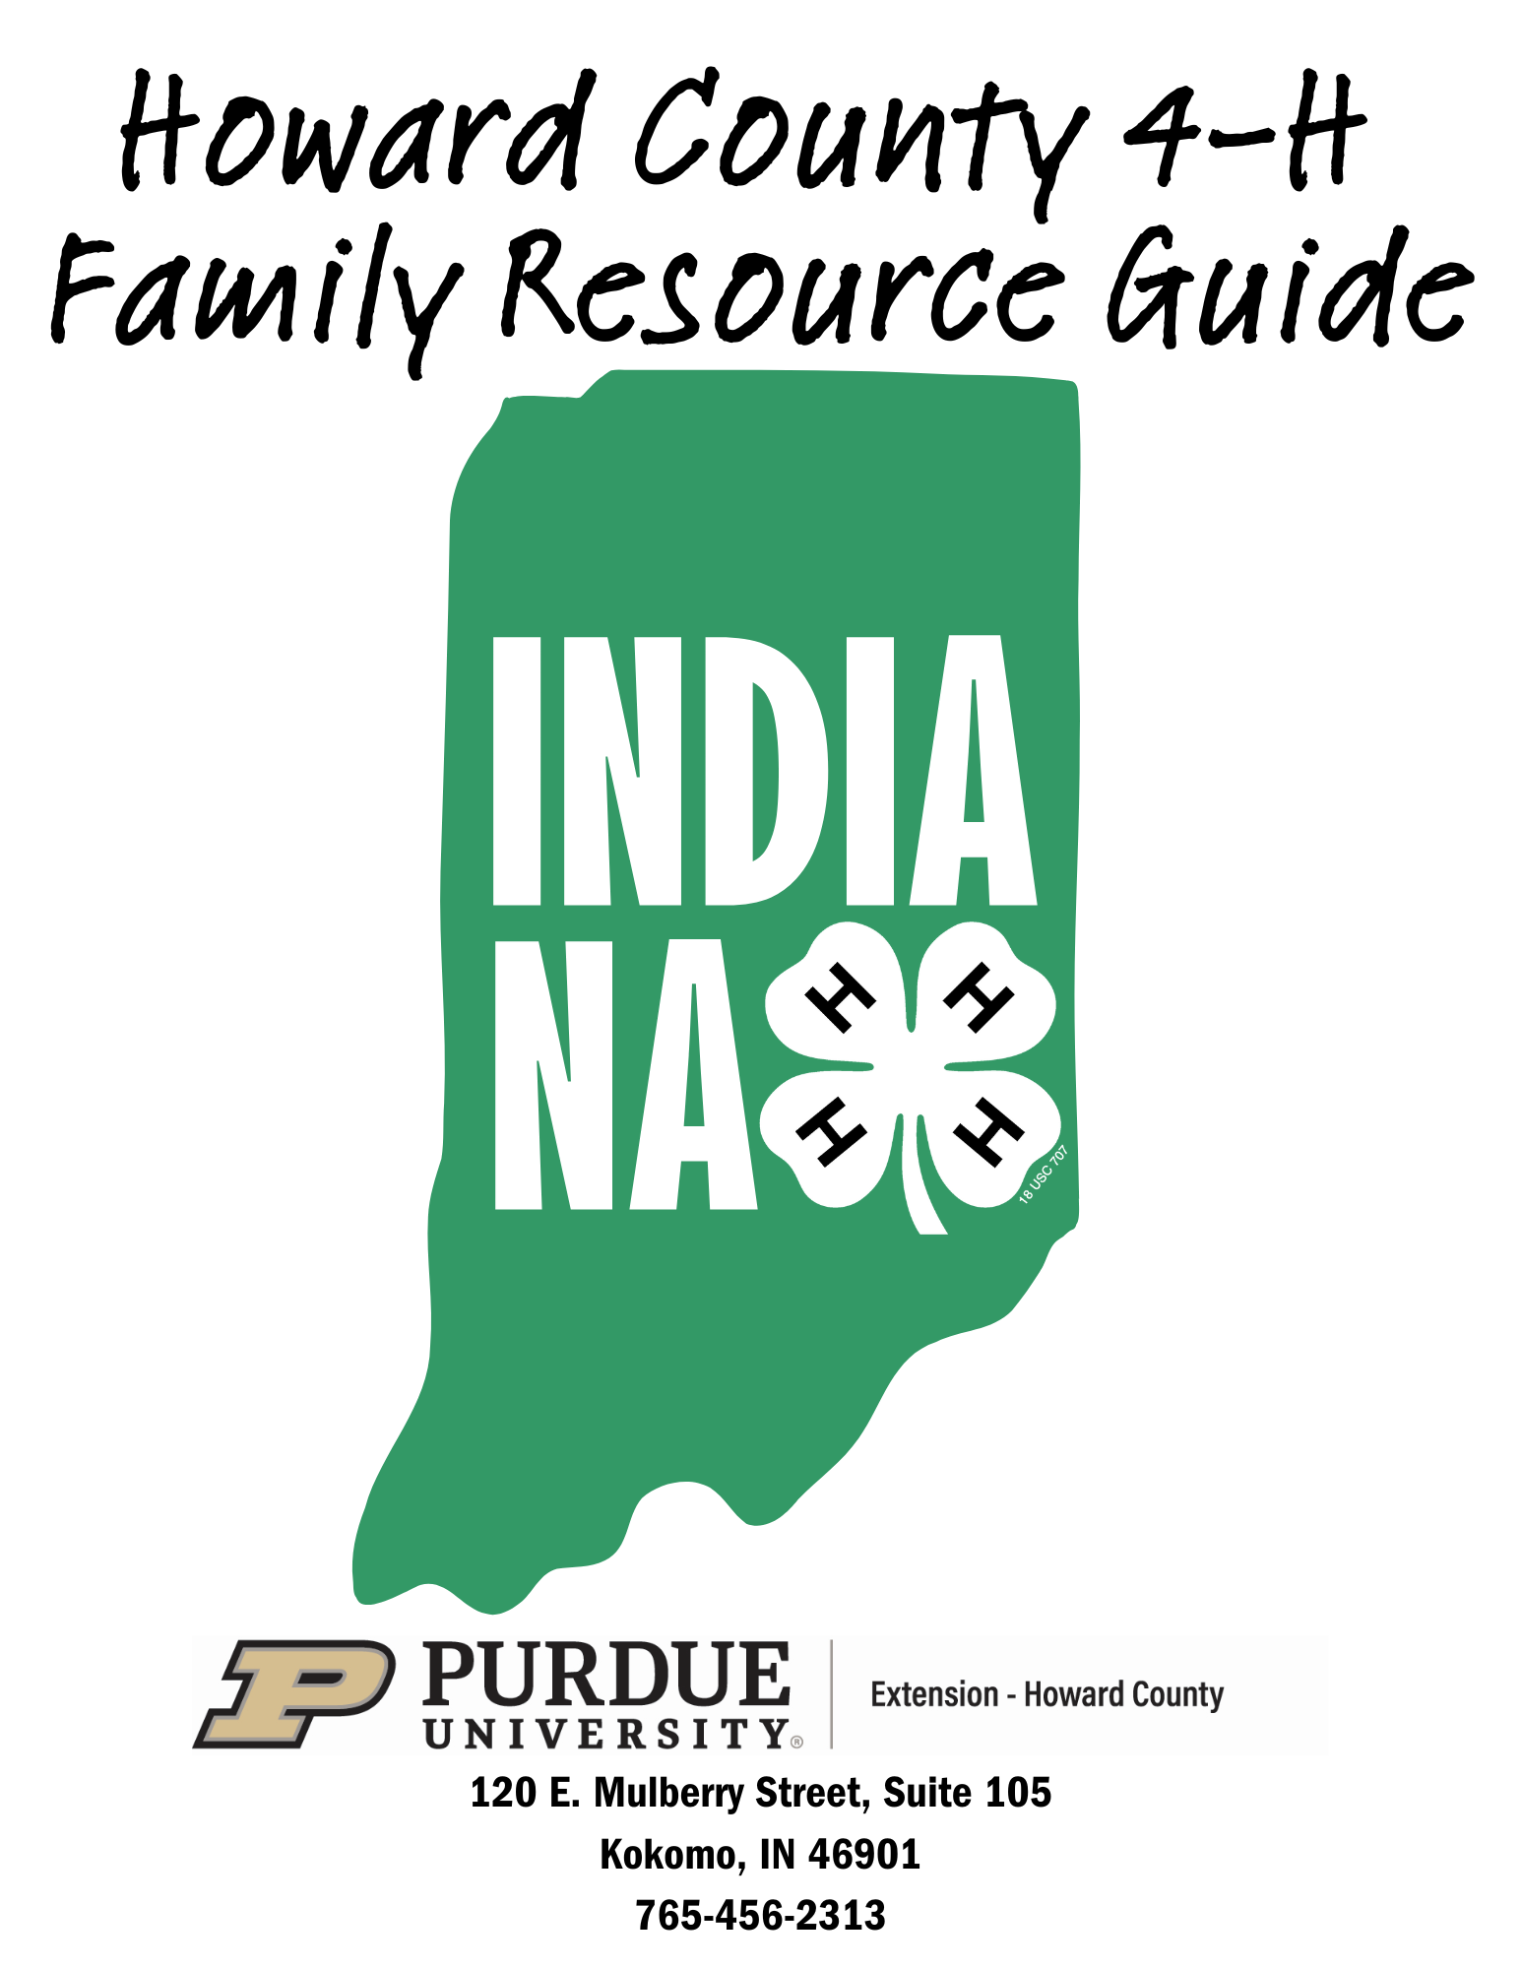

Welcome to Howard County 4-H!
This publication is provided to help you and your family to learn more about the Howard County 4-H Program. As you consider becoming a member of the 4-H program, you must be informed of the general terms and conditions governing the Indiana 4-H Program and our local program in Howard County. We encourage your questions and comments and look forward to receiving your 4-H member enrollment.

Office Hours and Location:
The Purdue Extension - Howard County Office is located at 120 E. Mulberry Street, Suite105, Kokomo, in the Jeff Stout Government Center across from the main branch of the Kokomo-Howard County Public Library.
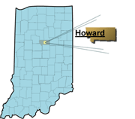
Office Hours are:
Monday – Friday, 8:00 am to 4:00 pm

Office: (765) 456-2313
Website: https://extension.purdue.edu/Howard/
Website: 4-H Enrollment https://v2.4honline.com/

What is 4-H?
4-H is an extracurricular, volunteer-led, family-oriented program
4-H is for boys and girls in kindergarten through grade 12
4-H is for urban as well as rural youth
4-H helps young people develop life skills like:

1. Building self-confidence
2. Developing an inquiring mind
3. Setting goals and making decisions
4. Relating to other people
5. Developing a concern for the community



It is the policy of the Purdue University Cooperative Extension Service that all persons have equal opportunity and access to its educational programs, services, activities, and facilities without regard to race, religion, color, sex, age, national origin or ancestry, marital status, parental status, sexual orientation, disability or status as a veteran. Purdue University is an Affirmative Action institution. This material may be available in alternative formats.

4-H Traditions:
EMBLEM: The national 4-H emblem is a four-leaf clover with the letter “H” on each leaf.

THE 4 H’S: The four H’s stand for head, heart, hands, and health. These represent the four-fold training and development in which members participate. This meaning of the four H’s is given in the pledge.
Head – learning to think, making decisions, understanding the whys, and gaining new and valuable knowledge.
Heart – being concerned with the welfare of others, accepting the responsibilities of citizenship, determining values and attitudes by which to live, and learning how to work with others.
Hands – learning new skills, perfecting skills already known, and developing pride in work and respect for it.
Health – practicing healthful living, protecting the well-being of self and others, and making constructive use of leisure time.

PLEDGE: “I pledge - my head to clearer thinking,
my heart to greater loyalty,
my hands to larger service, and
my health to better living, for
my club, my community, my country, and my world.”

COLORS: Green and white are the colors of 4-H. The white background of the flag symbolizes purity; the green 4-H emblem is nature’s most common color in the great outdoors and is the color of springtime, life, and youth.

MOTTO: “To Make the Best Better”
The motto was adopted at about the same time as the 4-H Club pledge. It intends to inspire young people to continue to learn and grow and to make their best efforts better through participating in educational experiences.

SLOGAN: “Learn by Doing”

4-H Membership:
4-H membership is open to all youth in Howard County who are in kindergarten through grade 12. All young persons in kindergarten, first, and second grades may participate in the Mini 4-H Program. This program allows younger children to participate in similar 4-H activities until they reach the traditional 4-H age. Traditional 4-H is open to all youth in grades 3 through grade 12. A member may continue membership in the traditional program for a maximum of ten years.

An individual’s 4-H grade is determined by the school grade in which he or she is classified regardless of the time of year he or she enrolls in 4-H. A member does not advance in 4-H grade until he or she enrolls in 4-H for the subsequent school year. Each member should enroll in the division of a project that would best suit his/her interest and potential for personal growth and would enhance their family involvement. Membership in 4-H is gained by annually enrolling in 4-H Online at https://v2.4honline.com/.

Howard County 4-H Projects:
(Please note that the descriptions listed below are general descriptions and are not intended to serve as an overall description of the entire project.)

AEROSPACE- This project provides youth with educational information about aerospace that develops project skills (i.e., principles of flight, model rocket construction, model rocket safety) and life skills (i.e., decision making, using science and technology, developing communication).

ATV SAFETY- Youth will familiarize themselves with an ATV, protective gear, riding techniques, safe strategies, and safe practices, and learn to respect the environment.

ANIMAL EDUCATION- Youth will learn about livestock and companion animals through a variety of experiences. (This includes cat, dog, llama/alpaca, poultry, and rabbit posters.)

ARTS & CRAFTS- This project allows the craft enthusiast to create any craft item that does not apply to one of the other craft-related projects offered in Howard County’s 4-H program. Ceramics including greenware and glass painting are accepted in this category.

BEEF- The educational 4-H beef program and related activities provide youth with a fun and hands-on learning experience that develops both beef subject skills such as nutrition, housing, and health care and life skills such as responsibility, decision-making, nurturing, and communications. Skills are learned under the direction of caring adults.

BEEKEEPING- This project is for youth interested in modern methods of beekeeping. Youth will study the fundamentals of beekeeping and management of honey and will also create an exhibit for the fair to display what was learned.

BICYCLE- The 4−H bicycle program provides youth with educational information about bicycles and biking that develops project skills (i.e., bicycle maintenance, operation, safety, and bicycle touring) and life skills (i.e., decision-making, using science and technology, developing communication skills).

CAKE DECORATING- Cake decorating can be a fun and exciting hands-on project. Learn how to express creative abilities through decorating cakes by adding frosting, trimmings, and fancy designs. Division of entry for this project is not determined by grade but by skill level.

CAT- This project provides youth with a fun experience that develops life skills, as well as teaches valuable information about properly caring for their animal. Subjects such as general care, nutrition, housing, training, and health care are presented in the curricular materials, through workshops, and in preparation for an exhibit.

CHILD DEVELOPMENT- Play goes on every day in the lives of young children. Through play, young children learn about their world. In this project, youth will learn about the development of babies, toddlers, and young children; how to care for them; and possible careers in early childhood.

COLLECTIONS- Do you like to collect objects as a hobby? Then this is the project for you! In this project,
4-H members develop and/or continue their collections (i.e., sports memorabilia, action figures, hats, stuffed animals, etc.) and exhibit them creatively at the fair.

COMPUTER- In this project, youth will become acquainted and educate the user with the terminology, functions, usage, capabilities, and structure of computers. The 4-H member will have an opportunity to program by being creative and designing programs to meet the needs of family and/or themselves.

CONSTRUCTION & ARCHITECTURAL REPLICA- Allows youth to learn life skills and grow in project knowledge while expressing creativity when designing replicas.
COMMUNICATIONS- Youth will learn about the process of communication, the different modes of communication, and strengthen their communication skills. As youth explore the world of communications, they will enjoy learning more about themselves and others.

CONSUMER CLOTHING- Clothing is one of our basic needs. All of us wear clothes and most of us invest a good deal of time and money in clothing. Youth in this project learn about clothing selection, wardrobe planning, care of clothing, and personal grooming. Included are activities to be completed at home and in stores.

CREATIVE WRITING- This project is designed to help youth explore writing talents. Examples include poetry, short stories, plays, essays, biographies, autobiographies, or novels. Whatever the topic, write it in your tone. Will it be serious, fictional, factual, or humorous? Have fun as you explore writing creativity.

CROPS- This project is designed to provide information, training, and experience to 4-H members on important aspects of agriculture related to various crops such as hybrids, soils, weather, insecticides, pesticides, fertilizer, etc. Suggestions on growing, improving the quality, and increasing the yields of various crops are provided. Crops to choose from include alfalfa, corn, oats, soybeans, and wheat.

CUPCAKE DECORATING - This project will provide information for making and using icing as decoration for cupcakes, cookies, etc. This activity, which can be enjoyed by families and friends, also is an introduction to a money-making skill and career.

DOG- The 4-H dog project provides youth with a fun and hands-on learning experience that develops life skills, as well as teaches valuable information about properly caring for their animal. Subjects such as general care, nutrition housing, training, and health care are presented in the curricular materials, through workshops, and in preparation for an exhibit.

ELECTRIC- What is electricity? Where does it come from? Learn the answers to these questions and more. This project provides 4-H members with educational information about electricity and how it is/can be used to benefit the human race. Learn how to make a circuit board, an extension cord, and lamps, and do minor household electrical repairs.

ENTOMOLOGY- There are more kinds of insects in the world than all other organisms combined. They live on the earth's surface, in the soil, and water. Insects live in deserts, rainforests, hot springs, snow fields, and dark caves. This project will help youth study insects and their relationship with people. Youth will also learn how to collect, preserve, and identify insects.

FARM TOY SCENE- This is a fun and creative project for youth to display their farm toys. Youth will create a farm scene for display at the fair which will be judged based on the artistic arrangement of the exhibit, detail of the exhibit, and realistic setting around toys.

FASHION REVUE- This project teaches youth skills to present themselves professionally by providing an opportunity for youth to model the outfit constructed in the 4-H sewing project.

FINE ARTS- In this project, youth will create a picture using one of the following mediums: oil, watercolor, charcoal, ink, pastels, acrylic, or pencil. This picture must be on canvas, paper, or canvas board. No glass painting is accepted. Only one picture may be displayed at the fair.

FLORICULTURE- This project will help youth learn how to grow, care for, arrange, and identify flowers and other houseplants. As youth advance in the project, they will learn about perennials and will expand prior knowledge about annuals, indoor plants, and floral arrangements.

FOODS, BAKED- Everyone likes to eat, so let's learn how to prepare those tasty foods. Youth will start with cookies and work their way up to yeast breads and other products. Youth will learn about the food pyramid and how to plan a well-balanced menu for a day. This is a fun project to help youth learn how to bake.

FOOD, PRESERVED- In this project, youth will learn the importance and appropriate steps of storing food properly using different techniques such as freezing and canning.

FORESTRY- This project provides youth with the opportunity to recognize the importance of trees and forests. They will learn how to identify different types of forests, trees, and forest products. They will develop the skills necessary to keep forests healthy.

GARDEN- Vegetables fresh from the garden taste delicious. Youth will learn to raise fresh vegetables and herbs in their garden. Planning a garden, garden safety, garden tips, garden pests, garden diseases, insect management, growing tips, and harvesting tips are areas covered in this project.

GENEALOGY- Have you ever wondered where your family came from originally? Tracing your family heritage can be fun and very interesting. This project is designed to help youth discover their roots and how to document the findings.

GEOLOGY- At some time or another, each of us has stopped to look at a rock because it was unusual in some way. It may be the shape, color, or size of the rock. This project will help youth learn more about the different types of rocks, how they are formed, what minerals and fossils are, and how to identify rocks.

GIFT WRAPPING- This project allows an abundance of creativity and imagination to create wrapped packages of all shapes, sizes, and designs using a variety of wrapping materials.

GOATS- The 4−H goat educational program and related activities provide youth with a fun and hands-on learning experience that develops both goat subject skills such as nutrition, housing, and health care, and life skills such as responsibility, decision-making, nurturing, and communications.

HEALTH- Are you healthy? Find out about good health and how to achieve it in this project. Emphasis is put on first-aid practices, maintaining personal health, and physical fitness.

HOME ENVIRONMENT- Your home is where you live. This project shows youth ways to care for parts of their home and how to make living areas more enjoyable. Learn about caring for furniture, design, storage, and so much more. Construct useful items that compliment a room's decor and the owner’s personality.

HORSE & PONY- This project aims to help 4-H members to develop leadership, initiative, self-reliance, and sportsmanship. An important objective of this project is for the 4-H member to experience the pride of owning a horse or pony and being responsible for its management. This project will also help youth develop an appreciation of horseback riding as a healthy and wholesome form of recreation.

JUNIOR LEADERS (GR. 7-12)- This is a great project for youth in grades 7-12 who want to develop their leadership skills. Youth will mentor younger 4-H members, assist local club leaders, assist with activities surrounding the 4-H Fair, participate in fundraising events, help younger 4-H members with projects as needed, and participate in community service activities.

LEGO®-TYPE MODEL- This project will encourage youth to use imagination and ingenuity in creating a LEGO-type exhibit. Overall design, construction techniques, soundness, sturdiness, and balance will be some of the criteria used to judge this project.

LLAMA/ALPACA- The 4-H llama/alpaca project provides youth with a fun and hands-on learning experience that develops life skills, as well as teaches valuable information about properly caring for their animal. An important objective of this project is for the 4-H member to experience the pride of owning/leasing a llama or alpaca, gaining its trust, and being responsible for its care.

MAKE WITH A MIX - This project is designed for youth to use their imagination and creativity to enhance the quality and taste of prepackaged food mixes such as cookies, brownies, cakes, bread mixes, and more.

MODEL CRAFT- In this project, youth will learn assembly, painting, design, and construction techniques and also become familiar with the technical terms and vocabulary associated with the representing model.

NEEDLE CRAFT- In this project, youth will learn different basic stitches, how to attach yarn, how to join edges, how to select a pattern and much more.

OTHER ANIMAL POSTERS- Youth will learn about livestock and companion animals through a variety of experiences. This only includes beef, goats, horses, sheep, and swine.
PHOTOGRAPHY- In this project, youth will learn about the basic elements of photography and practice those skills as an exhibit is developed. Youth will also learn all about cameras, photo composition, elements of a good picture, the differences between indoor and outdoor photography, and so much more.

PIGEONS- This project offers 4-H members the opportunity to participate in a program where they can care for, raise, and show their pigeons. Pigeons require a small amount of space, and there is very little expense in getting started in this hobby. Members in this project learn the proper way to keep their pigeons clean and healthy, along with keeping records, taming, training, and conditioning the birds for showing.

POULTRY- The commercial poultry project teaches production, marketing, and product utilization which includes meat and/or eggs. The exhibition poultry project concentrates on the “Standards of Perfection” of the individual breeds of poultry, teaching how to identify the qualities of the breed. Both projects teach how to properly prepare and show the birds to present them to the judge in the best possible light. All participants will gain knowledge of the methods of care and feeding of the flock for the intended purpose.

RABBIT- The purpose of the 4-H rabbit project is to familiarize the 4-H members with the principles of feeding, breeding, and management of rabbits. Youth will find some phase of rabbit raising which will stimulate and keep their interest. With good management, rabbits offer a pleasant 4-H project and an opportunity for modest financial profit.

READING- In this project, reading is encouraged in and out of the formal classroom as well as sharing the love of reading with others. Youth will choose from the list of display options and create a display for the fair about one of the books read.

RECYCLING- In this project, youth will help educate others about the importance of recycling and how to be creative in recycling rather than just taking items to a recycling center. Youth will learn to do this through the 5 R's – Reduce, Reuse, Reject, Repair, and Recycle.

REED BASKET- This project will teach youth all about constructing reed baskets including different reed materials and various weaving techniques. Youth will create a basket or similar woven item to be judged and displayed at the fair.

SCRAPBOOKING- Pictures - they're worth a thousand words; yet for all their importance, many pictures are not taken care of properly. Youth will learn how to turn boxes of photographs and memorabilia into keepsakes, and photo-safe albums.

SCRAPBOOKING, 4-H MEMORIES- The purpose of this project is to encourage 4-H members to keep accurate records of their projects, offices held, activities, and any other awards, trinkets, or potpourri related to
4-H. The object is not to collect the most scraps or the thickest scrapbook but to develop a neatly organized and meaningful collection of 4-H accomplishments and memories.

SEWING- The purpose of this project is to learn the use of a sewing machine, how to select fabrics, how to select and alter patterns and learn the fundamental techniques of good construction by completing the required sewing skills for each grade level. Youth will be able to apply these skills in making garments or non-wearable items for themselves and others.

SEW FOR FUN- The purpose of this project is to learn basic sewing techniques, how to select fabrics, and how to select and alter patterns while sewing useful items for oneself or the home.

SHEEP- The educational 4-H sheep program and related activities provide youth with a fun and hands-on learning experience that develops sheep subject skills such as nutrition, housing, and health care and life skills such as responsibility, decision-making, nurturing, and communications under the direction of caring adults.

SHOOTING SPORTS- The shooting sports program is designed to provide youth with the knowledge and hands-on practice needed to safely handle firearms and archery equipment. This program covers such subjects as safe handling and proper care of equipment, safety rules, learning to provide for your safety and the safety of others, and identifying the proper ammunition for your firearm.

SMALL ANIMALS- The 4-H small animal educational program and related activities provide youth with a fun and hands-on learning experience directly related to animal care, feeding, housing, and management. Youth develop important life skills such as decision-making, goal setting, record keeping, time management, and communication.

SMALL ENGINES- Do you enjoy messing around and repairing engines? This project will teach youth the difference between two-cycle and four-cycle engines, principles of operation, proper service maintenance, and simple engine repairs.

SOIL & WATER SCIENCE- This project emphasizes the reason for conservation practices and explores how soil and water are important to you and why we must take care of these valuable natural resources. In this project, youth may help bring this to the attention of others and help encourage them to take better care of our natural resources.
SPORTFISHING- Fishing can be a hobby and a source of study for an entire lifetime. The 4-H sportfishing project will introduce youth to fish, fishing, and aquatic habitats. Learn all about fishing from casting to baiting a hook. Youth will also have the opportunity to learn about water safety and how to properly care for our natural resources.

SPORTS- If you like sports, this project might be a good fit. Participate in your favorite sport and promote it to others by creating a poster display, video, or action demonstration.

STRAWBERRIES- In this project, youth learn how to prepare land, plant, fertilize, and maintain strawberry plants. Strawberry judging will take place at the member’s residence before the 4-H fair in early June of the current year. Plants will be judged on the care of the patch and completed record sheet at the time of judging.

SWINE- The educational 4-H swine program and related activities provide youth with a fun and hands-on learning experience that develops swine subject skills such as nutrition, housing, and health care and life skills such as responsibility, decision-making, nurturing, and communications under the direction of caring adults.

TRACTOR SAFETY & OPERATOR SKILLS- The purpose of safety and operator skills is to allow members to demonstrate their knowledge in engine operation, care and maintenance of various tractors, and skill in operation. Safety in work habits and equipment operation is stressed. Projects to choose from include lawn & garden, tractor, or zero-turn mower.

VETERINARY SCIENCE- Veterinary science is the branch of medicine that deals with the treatment and prevention of animal disease. This project will acquaint youth with the characteristics and care of healthy animals. Youth will also become familiar with the causes and prevention of animal diseases.

WEARABLE ARTS- In this project, youth will create wearable art that includes painted t-shirts, sweatshirts, jackets, tennis shoes, appliqué work, puff-painted articles, sequined and rhinestone articles, and tie-dye.

WEATHER AND CLIMATE SCIENCE- We all depend on the weather. Youth will learn what makes weather and do experiments with weather makers. Youth will have the opportunity to become a storm spotter, construct some of their own equipment, and study clouds and weather fronts/symbols.

WILDLIFE- This project offers an opportunity to learn about different kinds of fur-bearing animals, birds, reptiles, fish, and outdoor skills. Youth will learn how animals are important to us, where they live, and what they eat.

WOODCRAFT- This project is designed to help youth learn how to finish and decorate wood articles. In this project, youth refinish existing items versus constructing items.

WOODWORKING- This project provides youth with educational information about wood and how it can be used to construct items. The wood science project develops project skills (i.e., safe practices, using hand tools, using power tools, making specialized woodcuts) and life skills (i.e., decision-making, using science and technology, developing communication skills).



