
Jackson County
https://extension.purdue.edu/county/jackson/
4-H CLOVER CONNECTIONS


Dear 4-H Families,
Happy Holidays 4-H members, families, and volunteers!

Thank you to everyone who has taken the time to re-enroll in 4-H Online for the 2025-2026 Program year. You can re-enroll online at https://v2.4honline.com/ using the same email and password as previous years, or stop by our off ice anytime Monday—Friday from 8:00 a.m.- 4:30 p.m. for enrollment assistance and to pay your yearly program fees. Program fees are $20 for grades 3-12 and $5 for grades K-2.

If you need step by step instructions to complete this process visit:

https://bit.ly/4HEnrollmentInstructions

Don’t forget to re-enroll by January 15th!

Please make every effort to enroll online by January 15th. Doing so allows you to receive timely information, announcements, and updates.

Be sure to check out the newsletter for workshop information, 2026 ID Dates, as well as a lot of other announcements. There is something for everyone to get involved in with Jackson County 4-H!

Extension Educator
4-H Youth Development
Volume 26 Issue 1 – January and February
New Staff p. 2-4
Handbook News p. 5
Junior Leaders p. 6
Hanging Basket p. 7
Info
Brief Scholarship p. 7
Info
Juntos p. 8
New Future p. 9
Clubs
Tractor Meetings p. 10
& Updates
Mini 4-H Task p. 11
Mini 4-H Page p. 12
Coloring Sheet p. 13
Livestock Updates p. 15
Volunteers p. 16
Area & State p. 17-20
Happenings
Scholarships p. 21-25
4-H Spirit Week p. 26
Flower Order p. 27
Form
Calendar p. 29
Inside this Issue
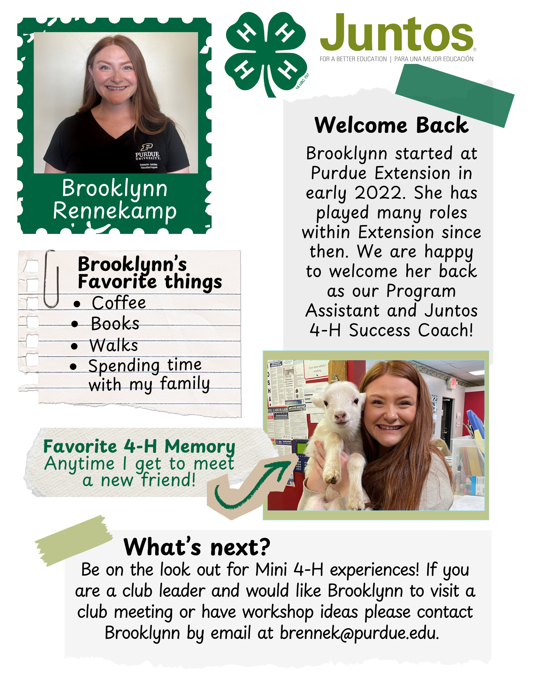
PAGE 2 VOLUME 26. ISSUE 1

I PLEDGE…FOR MY CLUB, MY COMMUNITY, MY COUNTY, AND MY WORLD
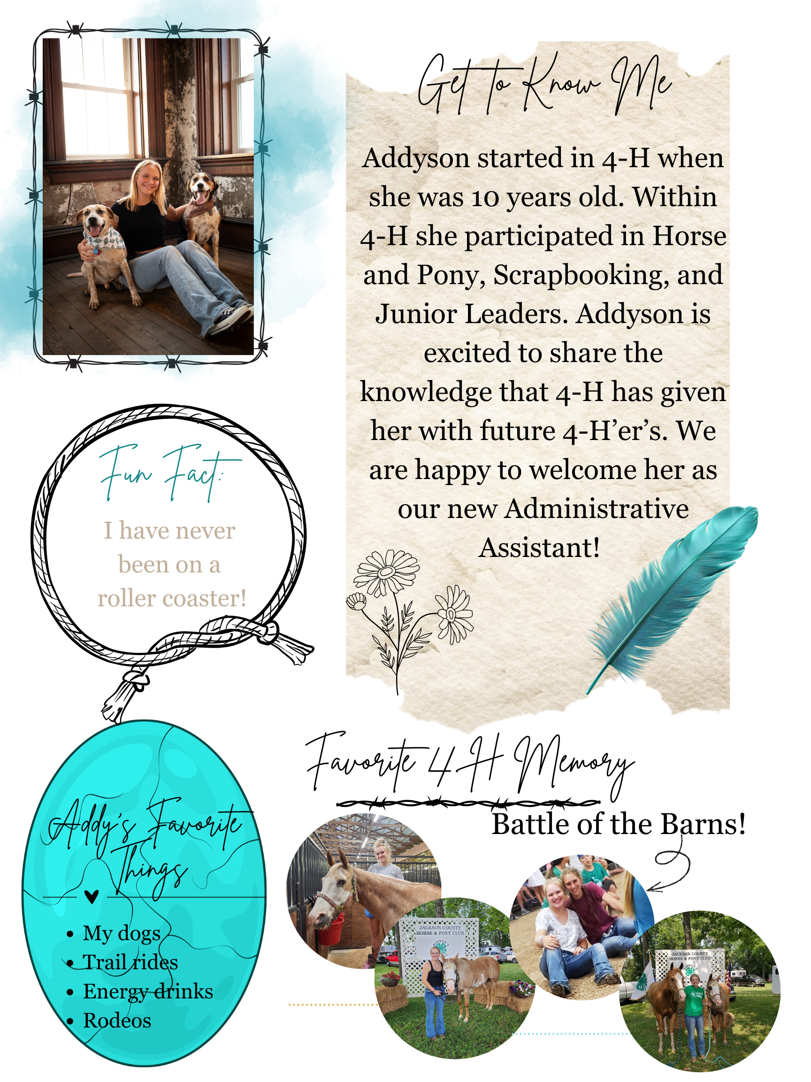
PAGE 3 VOLUME 26. ISSUE 1
I PLEDGE… FOR MY CLUB, MY COMMUNITY, MY COUNTRY, AND MY WORLD

PAGE 4 VOLUME 26. ISSUE 1
I PLEDGE…FOR MY CLUB, MY COMMUNITY, MY COUNTY, AND MY WORLD
4-H Handbook 2026: All youth will receive a link to our Jackson County 4-H Handbook when they receive their project books in late winter/early spring from club leaders. The link will also be emailed and published in future communications.
HANDBOOK NEWS
PAGE 5 VOLUME 26. ISSUE 1

ATTENTION:

The Hunger Elimination Leadership Program (H.E.L.P) has been removed from Jackson County this fair year.

If you have any questions call the Extension Office at 812-358-6101 or email our 4-H Educator, Brier, bryver@purdue.edu

Going into the 2026 Fair ALL Animal Education Poster Projects will be counted as State Fair Projects ONLY!

NEW UPDATE
I PLEDGE…FOR MY CLUB, MY COMMUNITY, MY COUNTY, AND MY WORLD
We need Junior Leader volunteers to sign up for the following events:
- Dairy Beef Tag Day on April 18th from 7:30 – 11:00 a.m. (arrive at 7:15 a.m.)
- Beef Tag Day on April 18th from 7:30 a.m. – 11:00 a.m. (arrive at 7:15 a.m.)
- Sheep/Goat Tag Day #1 on May 7th from 6:00 – 8:00 p.m. (arrive at 5:45 p.m.)
- Sheep/Goat Tag Day #2 on May 9th from 8:00 – 10:00 a.m. (arrive at 7:45 a.m.)
- Swine Tag Day on May 12th from 5:30 – 6:30 p.m. (arrive at 5:15 p.m.)
- Poultry Blood Testing Day on July 7th from 5:00 – 8:00 p.m. (arrive at 4:45 p.m.)
NO MAKEUP DATES FOR POULTRY!

Extension Office for Swine ONLY* All other species at fairgrounds*

Don’t forget that you are required to participate in at least two ID Days when enrolled in Junior Leaders! Call the office at 812-358-6101 or email Brier at bryver@purdue.edu to sign up.
- Thursday, January 15th
- 7:00 – 8:00 p.m.
- Chairperson: Zoe Wischmeier
- Citizenship: Becca Herbert
- Health & Safety: Adam Alberring
- Recreation: Chloe Jablonski
- Refreshments: Committee
Unpaid Dues: $2.50
- Tuesday, February 17th
- 7:00 – 8:00 p.m.
- Chairperson: Emma Doriot
- Citizenship: Micah Jablonski
- Health & Safety: Owen Snyder
- Recreation: Anna Jablonski
- Refreshments: Committee
Unpaid Dues: $2.75
- Thursday, March 10th
- 7:00 – 8:00 p.m.
- Chairperson: Emma Lucas
- Citizenship: Becca Herbert
- Health & Safety: Adam Alberring
- Recreation: Chloe Jablonski
- Refreshments: Committee
Unpaid Dues: $3.00
March Meeting
- Getting Fit
- Studio Health - Seymour
January Meeting
- Safety with Firefighters
- Seymour Fire Station 2
February Meeting
- Lawyer Up
- Montgomery Elsner & Pardieck, LLP
JUNIOR LEADERS
PAGE 6 VOLUME 26. ISSUE 1
I PLEDGE…FOR MY CLUB, MY COMMUNITY, MY COUNTY, AND MY WORLD
4-H Scholarship Applications
4-H Scholarship information was mailed to all eligible members. They are due by January 25, 2026 in the 4-H Online System. No late applications will be accepted. If you have questions or problems as you work through the application process, contact the Extension Office. In order for your application to be submitted, you must be enrolled in 4-H and active in the 4-H Online system.
DO NOT WAIT UNTIL THE LAST MINUTE TO UPLOAD YOUR APPLICATIONS!
Visit bit.ly/4hscholarship to learn more!
Hanging Flower Baskets

We are taking order for the hanging baskets with the proceeds being split between 4-H Clubs and the Jackson County 4-H Council to support educational programming. An email had been sent with the flyer attached in December.

Orders need to be returned to the Extension Office by January 30, 2026.
4-H Families (NOT individual costumers) will need to pick up all orders at Darlage Greenhouse on:
Wednesday, April 22nd from 5;00 – 7:00 p.m. – This will be done similar to last year; we will have a time assigned to members for pick-up. More details to come.

ATTENTION: Flowers not picked up and paid for will be cancelled.
Order form included in newsletter!
COUNTY HAPPENINGS
PAGE 7 VOLUME 26. ISSUE 1

A graduation cap and diploma tied with a red ribbon, with the word "Scholarship" below.
I PLEDGE…FOR MY CLUB, MY COMMUNITY, MY COUNTY, AND MY WORLD
COUNTY HAPPENINGS
PAGE 8 VOLUME 26. ISSUE 1

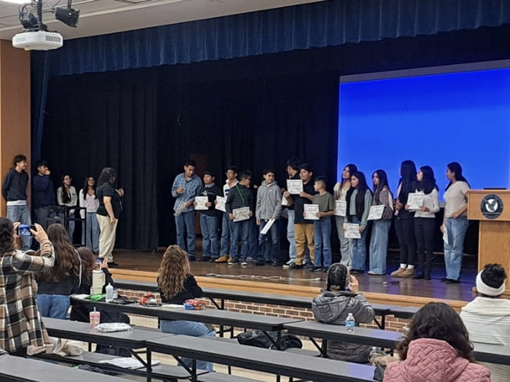
Our 5th cohort of Juntos 4-H Families graduated from the Family Connections Workshops on November 10th, 2025… CONGRADULATIONS & FELICIDADES!
I PLEDGE…FOR MY CLUB, MY COMMUNITY, MY COUNTY, AND MY WORLD
COUNTY HAPPENINGS
PAGE 9 VOLUME 26. ISSUE 1


812-358-6101

NOTE: These two clubs are NOT active yet. We are wanting to know how many/who is interested in these clubs before making them official.
If you are interested in any of these 2 new clubs call the Extension Office and let us know!
COMING
BACK

Shooting Sports
WELCOMING

Welding
WE ARE EXCITED TO ANNOUCE THE MAKINGS OF 2 NEW CLUBS!
I PLEDGE…FOR MY CLUB, MY COMMUNITY, MY COUNTY, AND MY WORLD
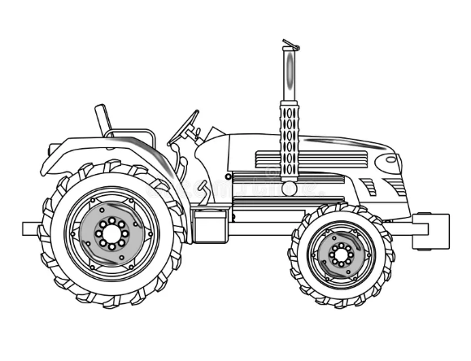
Tractor Meetings

- Will start meeting again in the Spring of 2026.
- Club Leader: Bill Baute
- Phone; 812-521-0898
PAGE 10 VOLUME 26. ISSUE 1
UPDATES
Updated 4-H Handbook
- Changes with Livestock
- Changes with State Projects

Updated 4-H Club Pamphlets
- New Club
- Removed Clubs
- New Clubs Leaders
COUNTY HAPPENINGS
I PLEDGE…FOR MY CLUB, MY COMMUNITY, MY COUNTY, AND MY WORLD
MINI 4-H PAGE
PAGE 11 VOLUME 26. ISSUE 1


Indiana 4-H Mini Goals & Priorities
Mini 4-H is a program designed to encourage positive development of children, Kindergarten through second grade. The goal of Mini 4-H is to help young children explore friendships outside the family; explore the way in which things work; practice both small and large muscle control; and think about the ways people work together on projects.
The NON-COMPETITIVE learning environment for Mini 4-H includes:​
1. Planned learning activities in which children are invited to be active and explore materials and ideas without the pressure of completing a specific product or exhibit.
2. Low adult/leader to child ratio that allows time for adults/leaders to provide individual, positive encouragement and assistance.
3. Simple, interesting activities that are fun.
4. Encouragement of children to participate in a group activity by sharing and/ or displaying their activity projects.
5. Rewards that are identical and/or ribbons of the same color for everyone.

I PLEDGE…FOR MY CLUB, MY COMMUNITY, MY COUNTY, AND MY WORLD
MINI 4-H TASK
PAGE 12 VOLUME 26. ISSUE 1

MINI
__ __ __ __ __ __ __ __
__ __ __ __ __ __ __ __
__ __ __ __ __ __ __ __
Attached on page 13.
You have until February3, 2026 to complete your spectacular masterpiece!
During the Junior Leaders February Meeting WINNERS will be chosen and given a prize!
*Please be sure to out your name and club name on the back.
*Winners will be announced the week of February 23rd.
Color the sheet and turn it back into the Extension Office when finished!
One of our very own Junior Leaders, Taylor Smith, has created a coloring sheet for you!
__ __ __ __ __ __ __ __ __ __
Mini 4-H’er’s we have a task for you!
I PLEDGE…FOR MY CLUB, MY COMMUNITY, MY COUNTY, AND MY WORLD
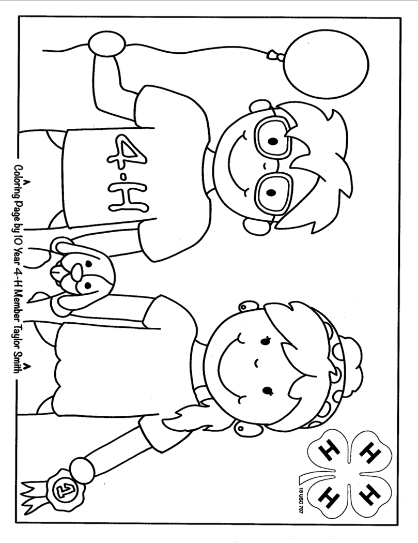
PAGE 13 VOLUME 26. ISSUE 1
I PLEDGE…FOR MY CLUB, MY COMMUNITY, MY COUNTY, AND MY WORLD

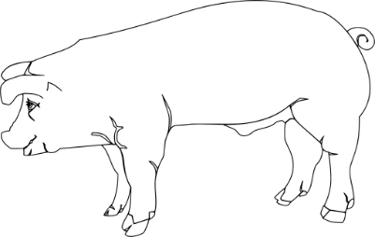
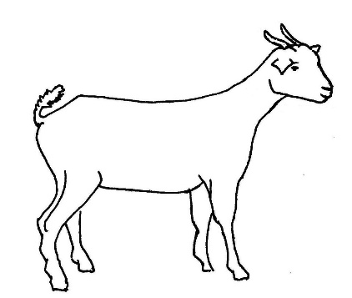


This Photo by Unknown Author is licensed under CC BY-NC-ND
Indiana 4-H Quality Livestock Care
The Indiana 4-H Quality Livestock Care Program is required for all Indiana 4-H members who participate and show the following species:
Beef Cattle, Dairy Cattle, Swine. Sheep, Meat Goats, Dairy Goats, Poultry, and Rabbits
Information on 2026 classes will be shared at a later date!
Animal ID Instructions
Once again, 4-Her’s will be responsible for entering required animal information in 4-H Online. ID Worksheets will be available at all ID Days to record information that will be used when entering animal identification online.
Please let us know if you need help!
2026 Tagging Days – SAVE THE DATES!

Beef/Dairy Beef ID Day:
Dairy Beef: Saturday, April 18th from 7:30 – 11:00 a.m.
Beef: Saturday, April 18th from 7:30 – 11:00 a.m.

Sheep/Goat ID Day:
Thursday, May 7th from 6:00 – 8:00 p.m.
Saturday, May 9th from 8:0-0 – 10:00 a.m.

Swine ID Day:
Tuesday, May 12th from 5:30 – 6:30 p.m.

Poultry Blood Testing Day:
Tuesday, July 7th from 5:00 – 8:00 p.m.
NO MAKEUP DATES

Extension Office for Swine ONLY* All other species at fairgrounds*
LIVESTOCK UPDATES
PAGE 15 VOLUME 26. ISSUE 1
Indiana 4-H Animal ID Requirements for 2026 MUST BE COMPLETED BY MAY 15TH
In Jackson County, we follow all State 4-H Requirements for Animal ID. See the chart on our website for required ID for each species.
I PLEDGE…FOR MY CLUB, MY COMMUNITY, MY COUNTY, AND MY WORLD

4-H Council
4-H Council will meet at 7:00 p.m. on Thursday, February 5th. Location is the Old Courtroom.
4-H Council Officers were elected at the December meeting.

Livestock & Auction Committee
The Livestock & Auction Committee will meet at 6:00 p.m. on Thursday, January 15th. Location is the Extension Office.
If you are on the Livestock Committee, make plans to attend the meeting!
Volunteers
- Volunteers must be approved!
- Volunteers NEED to finish their trainings
- REMINDER: You should be an approved volunteer BEFORE interacting with our 4-H Youth!
Volunteer Re-Enrollment
Volunteers are required to annually re-enroll in 4-H Online.

Visit https://v2.4honline.com/ to complete this process and take your required trainings. If you would prefer, you can take the trainings in-person at the Extension office. Contact us at 812-358-6101. Your volunteer re-enrollment needs to be completed ASAP to work with youth.
VOLUNTEER CORNER
I PLEDGE…FOR MY CLUB, MY COMMUNITY, MY COUNTY, AND MY WORLD
PAGE 16 VOLUME 26. ISSUE 1
AREA & STATE HAPPENINGS
PAGE 17 VOLUME 26. ISSUE 1
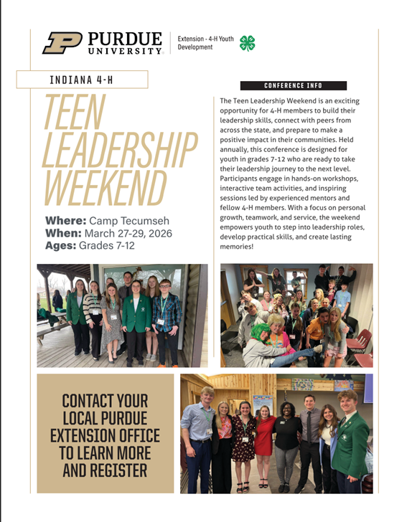
Call the Extension Office for more information!
I PLEDGE…FOR MY CLUB, MY COMMUNITY, MY COUNTY, AND MY WORLD
AREA & STATE HAPPENINGS
PAGE 18 VOLUME 26. ISSUE 1


https://2026SIndiana4HCamp.4honline.com
QR Code to Online Application
I PLEDGE…FOR MY CLUB, MY COMMUNITY, MY COUNTY, AND MY WORLD
AREA & STATE HAPPENINGS
PAGE 19 VOLUME 26. ISSUE 1


QR Code to Website with Counselor Details
https://bit.ly/4HCampCounselor26
I PLEDGE…FOR MY CLUB, MY COMMUNITY, MY COUNTY, AND MY WORLD
AREA & STATE HAPPENINGS
PAGE 20 VOLUME 26. ISSUE 1

I PLEDGE…FOR MY CLUB, MY COMMUNITY, MY COUNTY, AND MY WORLD

PAGE 21 VOLUME 26. ISSUE 1
I PLEDGE…FOR MY CLUB, MY COMMUNITY, MY COUNTY, AND MY WORLD

PAGE 22 VOLUME 26. ISSUE 1

I PLEDGE…FOR MY CLUB, MY COMMUNITY, MY COUNTY, AND MY WORLD

PAGE 23 VOLUME 26. ISSUE 1
I PLEDGE…FOR MY CLUB, MY COMMUNITY, MY COUNTY, AND MY WORLD

PAGE 24 VOLUME 26. ISSUE 1
I PLEDGE…FOR MY CLUB, MY COMMUNITY, MY COUNTY, AND MY WORLD

PAGE 25 VOLUME 26. ISSUE 1
I PLEDGE…FOR MY CLUB, MY COMMUNITY, MY COUNTY, AND MY WORLD
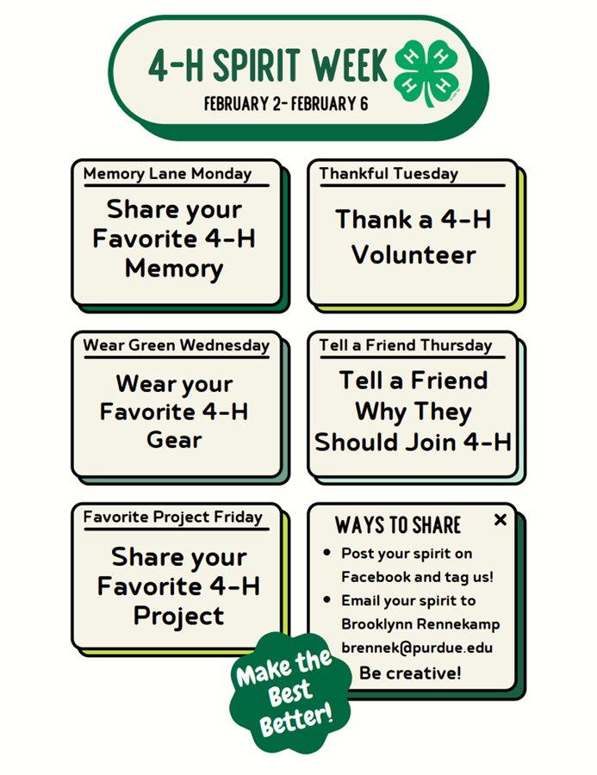
PAGE 26 VOLUME 26. ISSUE 1
I PLEDGE…FOR MY CLUB, MY COMMUNITY, MY COUNTY, AND MY WORLD
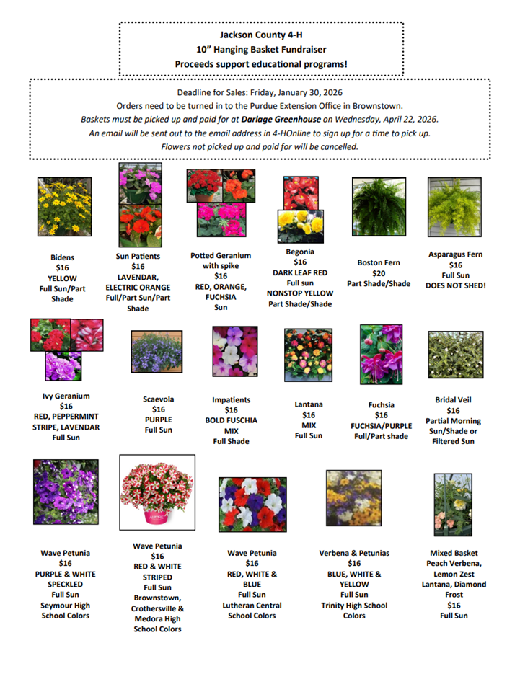
PAGE 27 VOLUME 26. ISSUE 1
I PLEDGE…FOR MY CLUB, MY COMMUNITY, MY COUNTY, AND MY WORLD
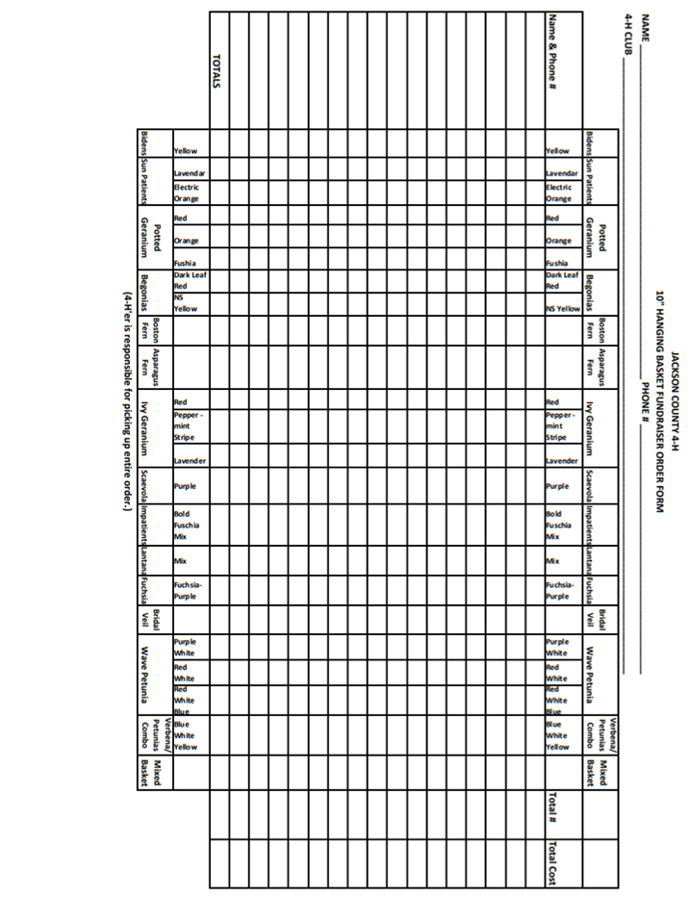
PAGE 28 VOLUME 26. ISSUE 1
I PLEDGE…FOR MY CLUB, MY COMMUNITY, MY COUNTY, AND MY WORLD
FIND US ON THE WEB FOR UP-TO-DATE INFORMATION ON THE GO!

Purdue Extension Jackson County Website:
https://extension.purdue.edu/county/jackson/index.html

Facebook:
Purdue Extension Jackson County

CALENDAR
PAGE 29 VOLUME 26. ISSUE 1


MARK
YOUR
CALENDARS
NOW!
CLICK ICON
February
5: 4-H Council at The Old Courtroom
15: Livestock & Auction Committee Meeting
16: President Day (Extension Office Closed)
17: Junior Leader Meeting at Montgomery Elsner & Pardieck, LLP
22: Dinner & Dessert Auction
January
1: New Years Day (Extension Office Closed)
15: Register for 4-H Deadline
15: Junior Leaders meeting at Seymour Fire Department
15: Livestock & Auction Committee Meeting
19: Martin Luther King Jr. Day (Extension Office Closed)
25: 4-H Scholarship Applications Due in 4-H Online
NO 4-H COUNCIL MEETING IN JANUARY
I PLEDGE…FOR MY CLUB, MY COMMUNITY, MY COUNTY, AND MY WORLD

PAGE 30 VOLUME 26. ISSUE 1
I PLEDGE…FOR MY CLUB, MY COMMUNITY, MY COUNTY, AND MY WORLD

