
Jackson County
https://extension.purdue.edu/county/jackson/
4-H CLOVER CONNECTIONS

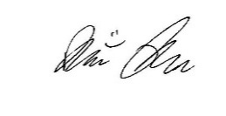
Dear 4-H Families,

Please be sure to read through the entire newsletter, as a lot of important reminders, events and dates are included. If you have questions about any of the opportunities, please let us know.
This year’s Area 2 4-H Camp is Under the Sea themed. Camp registration information was sent to all 3rd-8th grade 4-H members. It is a fun weekend spent with youth from 8 counties. Registration deadline is May 1, 2026.

We are excited for the upcoming Jackson County Fair! The dates for the fair are July 26– August 1, 2026, please see our updated schedule. Be sure to check out page 20, this includes links to both the 2026 4-H Jackson County Handbook and the State 4-H Project requirements.

Thank you to everyone for taking the time to re-enroll for this 4-H Program Year. Just a reminder that if you have not yet paid your program fees, please stop by the Extension Office as soon as
possible.

Animal identification information cannot be entered until your program fees have been paid and you are in “active” status. In addition, DNA samples for State Fair, including envelope and completed log-in sheet, are due by May 15th at end of business hours – 4:30 pm. ENVELOPLES TURNED IN AFTER 4:30 P.M. ON FRIDAY, MAY 15TH WILL NOT BE ACCEPTED!

Sincerely,

Brier Ryver
Extension Educator
4-H Youth Development
Junior Leaders p. 2
County p. 3-6 Happenings
Performing Arts p. 3
Important News p. 4
Tractor Meetings p. 5
Project Resources p. 5
25-26 Handbook p. 6
Mini 4-H Page p. 7
Mini 4-H Task p. 8-10
Save the Dates p. 11
Stock the Trailer p. 12
CANstruction p. 13
Livestock Updates p. 14-16
Quality Livestock p. 14 Care
ID Days p. 15
Volunteer Corner p. 17
2026 Fair p. 18-20 Schedule
Winner’s Circle p. 21-22
Letter & Form
Calendar p. 23
Inside this Issue
Volume 26 Issue 3 – May and June
- Tuesday, May 26
- 7:00 – 8:30 p.m.
- Chairperson: Chloe Jablonski
- Citizenship: Becca Herbert
- Health & Safety: Adam Alberring
- Recreation: Chloe Jablonski
- Refreshments: Committee
Unpaid Dues: $3.50
Nominate 4-H Royalty

JUNIOR LEADERS
PAGE 2 VOLUME 26. ISSUE 3
I PLEDGE…FOR MY CLUB, MY COMMUNITY, MY COUNTRY, AND MY WORLD
We need Junior Leader volunteers to sign up for the following events:
- Dairy Beef Tag Day on April 18th from 7:30 – 11:00 a.m. (arrive at 7:15 a.m.)
- Beef Tag Day on April 18th from 7:30 a.m. – 11:00 a.m. (arrive at 7:15 a.m.)
- Sheep/Goat Tag Day #1 on May 7th from 6:00 – 8:00 p.m. (arrive at 5:45 p.m.)
- Sheep/Goat Tag Day #2 on May 9th from 8:00 – 10:00 a.m. (arrive at 7:45 a.m.)
- Swine Tag Day on May 12th from 5:30 – 6:30 p.m. (arrive at 5:15 p.m.)
- Poultry Blood Testing Day on July 7th from 5:00 – 8:00 p.m. (arrive at 4:45 p.m.)
NO MAKEUP DATES FOR POULTRY!

Extension Office for Swine ONLY* All other species at fairgrounds*

Don’t forget that you are required to participate in at least two ID Days when enrolled in Junior Leaders! Call the office at 812-358-6101 or email Brier at bryver@purdue.edu to sign up.
May Meeting
- Wildlife at the Refuge
- Muscatatuck National Wildlife Refuge

June Meeting
- Helping Out the Community
- Anchor House or Provisions
- Date is TBD
- 7:00 – 8:30 p.m.
- Chairperson: Owen Snyder
- Citizenship: Micah Jablonski
- Health & Safety: Owen Snyder
- Recreation: Anna Jablonski
- Refreshments: Committee
Unpaid Dues: $3.75
Sign up to work in 4-H Building
- Thursday, July 16
- 7:00 – 8:30 p.m.
- Citizenship: Becca Herbert
- Health & Safety: Adam Alberring
- Recreation: Chloe Jablonski
- Refreshments: Committee
Unpaid Dues: $4.00
Lots of information coming at this meeting!
July Meeting
- Cleanin’ Up
- Jackson County Fairgrounds
Performing Arts Contest
COUNTY HAPPENINGS
PAGE 3 VOLUME 26. ISSUE 3

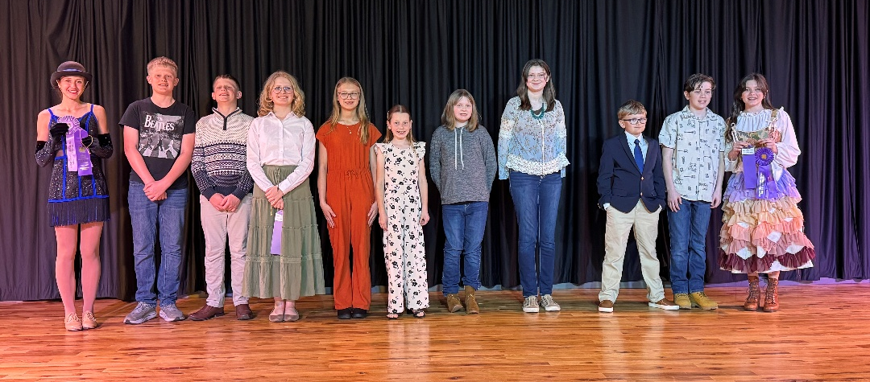
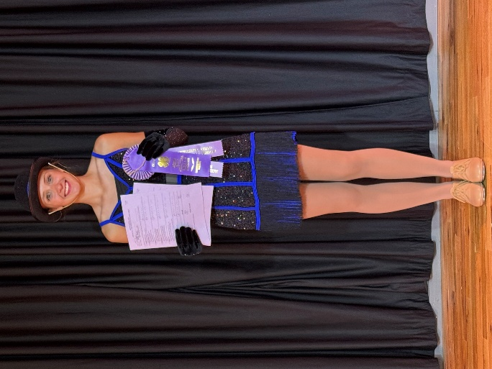
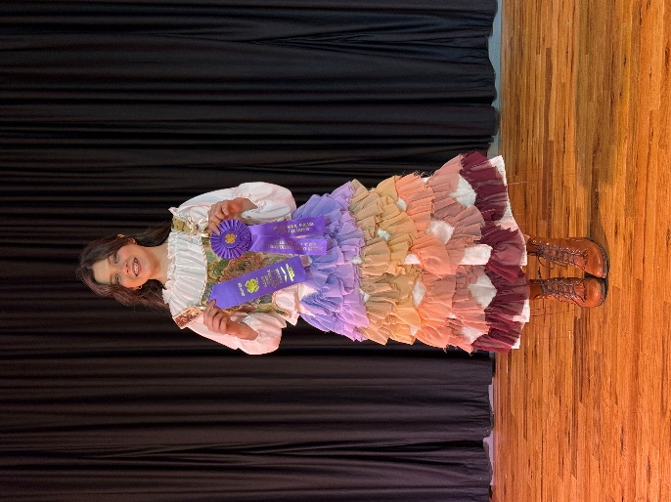



Congratulations to all youth who participated in the Performing Arts contest in March! Talented artists all around!
Ruby Blackenbeker
Musical
Grand Champion & Champion
Emma Doriot
Non-Musical
Reserve Grand Champion & Champion
I PLEDGE…FOR MY CLUB, MY COMMUNITY, MY COUNTRY, AND MY WORLD
FAIR ENTRY
Fair Entry will be open June 18th – July 3rd!
Mark your calendars and DO NOT miss your time to register for fair. If you need assistance, please call the office for help.
AREA 2 TRACTOR CONTEST
The Area 2 Tractor contest date, location, nor time have been released out. All 4-H tractor members be on the look for any emails related to the Tractor Contest!
EMAIL NOTICES
Information about 4-H events and important reminders will often be sent out via email. Please make sure what you have entered in 4-H Online is one you check often. You can go into 4-H Online and update your email, address, or phone number if they change.
COUNTY HAPPENINGS
I PLEDGE…FOR MY CLUB, MY COMMUNITY, MY COUNTRY, AND MY WORLD
PAGE 4 VOLUME 26. ISSUE 3

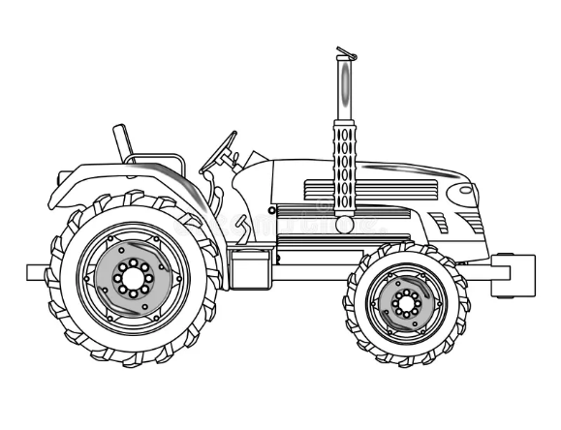
PAGE 5 VOLUME 26. ISSUE 3
Tractor Meetings
- May meetings are on the 5th and 12th
- During these meetings 4-H’ers will practice for the County Tractor Contest – July 14th at the Seymour High School Soccer parking lot on Lasher Dr.
- Location: Lawyer Excavation, Inc.
  - 7841 US-31, Seymour, IN 47274
- 7:00 – 8:00 p.m.
Foam Poster Board: $5.00
All Plastic Sleeves: $1.00
Entomology Pins: $6.00
Beginning Cake Decorating Kit: $13.00
Replacement Livestock Resource Book: $20.00
Electric Kits - Division III Cord: $20.00
Electric Kills – Division III Trouble Light Kit: $30.00

Project Resources for Sale in the Extension Office
We keep a variety of project resources in the Extension Office for your convenience. Stop by if you would like to purchase the following resources:

Prices are subject to change when current inventory runs out, due to pricing changes from our vendors. We will revise the pricing list when current inventory runs out.

Purchase your fair supplies as soon as possible to get these prices!
COUNTY HAPPENINGS
I PLEDGE…FOR MY CLUB, MY COMMUNITY, MY COUNTRY, AND MY WORLD
COUNTY HAPPENINGS
PAGE 6 VOLUME 26. ISSUE 3

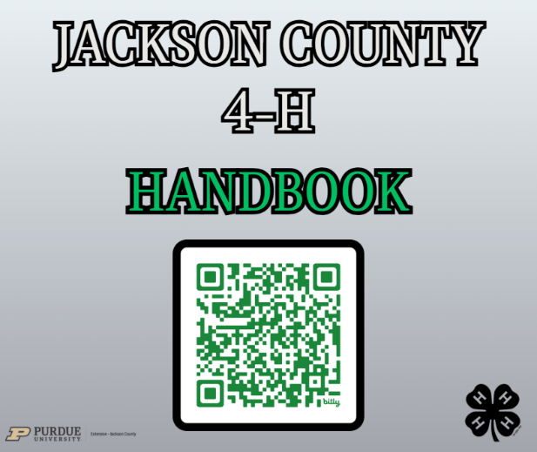
2026 4-H HANDBOOK PUBLISHED!
Visit https://bit.ly/2026handbook
View the 2026 Jackson County 4-H Handbook!

The Indiana State 4-H Office has updated projects for 2026. You can view all the State 4-H Project requirements on the State 4-H Website:
https://extension.purdue.edu/4-H/projects/index.html
Updates to Project Manuals and 4-H Requirements
· All 4-H Members need to pay close attention to new 4-H Manuals and Project Requirements in 2026. We can distribute the Handbook Link and resources to each member for every 4-H project. Several club leaders have already picked up 4-H project manuals and green folders from the Extension Office. Be sure to attend a club meeting or check in with your leader to get your project materials in a timely manner.
· Livestock manual activities are no longer required. The record sheets have been updated according to this change. Please notice there is a separate record sheet if you are just doing an animal poster.
· When doing research for projects, consider using websites that end with .edu and/or .gov for research-based information. Artificial Intelligence (AI) may be used, with parent permission, when creating exhibits and is to be documented as a reference with the sources it cited. See the 4-H Handbook for more information on AI use.

I PLEDGE…FOR MY CLUB, MY COMMUNITY, MY COUNTRY, AND MY WORLD
I PLEDGE…FOR MY CLUB, MY COMMUNITY, MY COUNTY, AND MY WORLD
PAGE 6 VOLUME 26. ISSUE 3

MINI
4-H PAGE
Indiana 4-H Mini Goals & Priorities
Mini 4-H is a program designed to encourage positive development of children, Kindergarten through second grade. The goal of Mini 4-H is to help young children explore friendships outside the family; explore the way in which things work; practice both small and large muscle control; and think about the ways people work together on projects.
The NON-COMPETITIVE learning environment for Mini 4-H includes:​
1. Planned learning activities in which children are invited to be active and explore materials and ideas without the pressure of completing a specific product or exhibit.
2. Low adult/leader to child ratio that allows time for adults/leaders to provide individual, positive encouragement and assistance.
3. Simple, interesting activities that are fun.
4. Encouragement of children to participate in a group activity by sharing and/ or displaying their activity projects.
5. Rewards that are identical and/or ribbons of the same color for everyone.

PAGE 7 VOLUME 26. ISSUE 3


I PLEDGE…FOR MY CLUB, MY COMMUNITY, MY COUNTRY, AND MY WORLD
MINI 4-H TASK
PAGE 8 VOLUME 26. ISSUE 3



MATCH
Look at the pictures.
Look at the words.
Draw a line to match them.
Have Fun!
COLOR
Look at the pictures.
Use crayons to color them.
Make May bright with Spring colors!
Make June sunny with summer colors.
Have Fun!
ATTACHED ON PAGES
MINI
__ __ __ __ __ __ __ __ __ __
Mini 4-H’er’s we have a task for you!
I PLEDGE…FOR MY CLUB, MY COMMUNITY, MY COUNTRY, AND MY WORLD
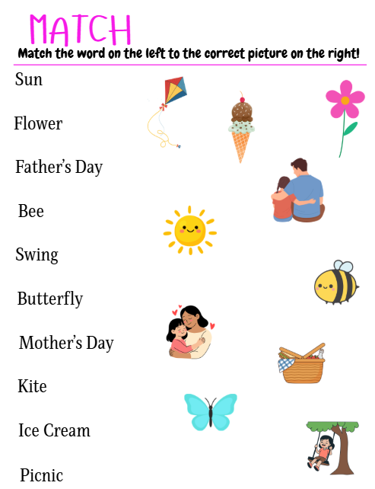

LATE OFFICE HOURS
Thursday, June 25th from 4:30 – 7:00 p.m.
Come see us for all your 4-H, Fair Entry, and Project needs! We’d be happy to help you!
SEWING WORKSHOPS
Every Tuesday and Thursday of June (except June 30th) from 9:00 a.m. – 3:00 p.m. at Seymour High School. Bring your own lunch.
A flyer will be sent out soon!
FAIR ENTRY
June 18th - July 3rd
Instructions will be mailed to families in June how to enter projects into Fair Entry.
SAVE THE DATES
PAGE 11 VOLUME 26. ISSUE 3
I PLEDGE…FOR MY CLUB, MY COMMUNITY, MY COUNTRY, AND MY WORLD
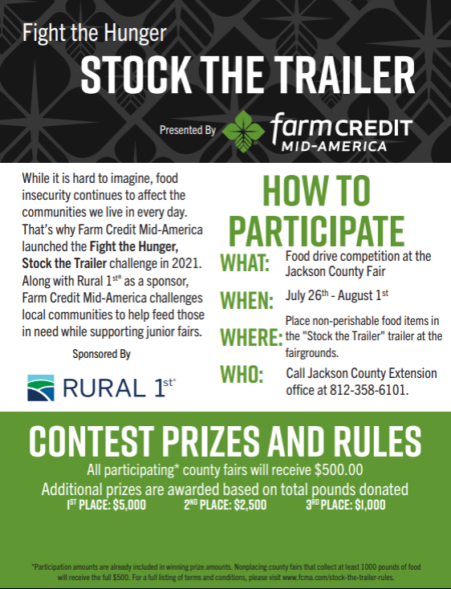


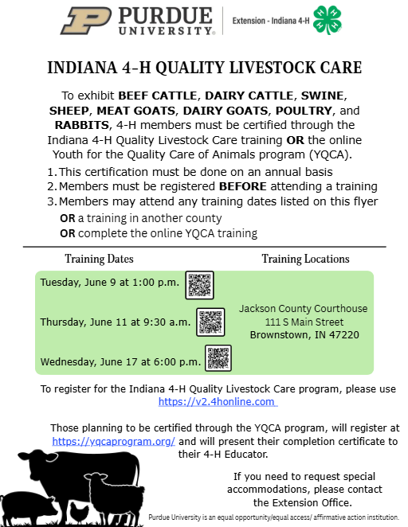
LIVESTOCK UPDATES
PAGE 14 VOLUME 26. ISSUE 3
I PLEDGE…FOR MY CLUB, MY COMMUNITY, MY COUNTRY, AND MY WORLD
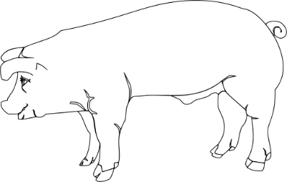
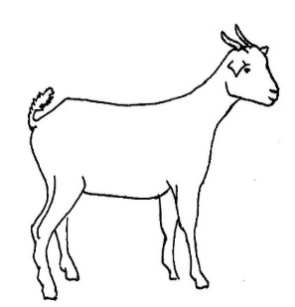
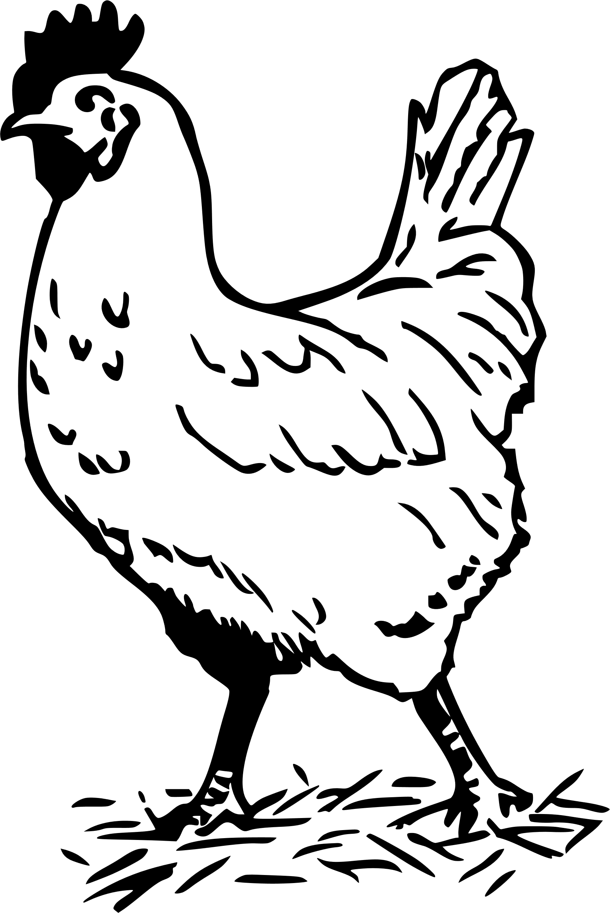
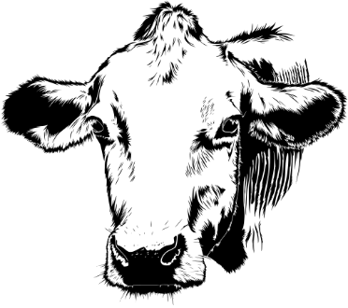
PAGE 15 VOLUME 26. ISSUE 3
Indiana 4-H Animal ID Requirements for 2026 MUST BE COMPLETED BY MAY 15TH
In Jackson County, we follow all State 4-H Requirements for Animal ID. See the chart on our website for required ID for each species.
Indiana 4-H Quality Livestock Care
The Indiana 4-H Quality Livestock Care Program is required for all Indiana 4-H members who participate and show the following species:
Beef Cattle, Dairy Cattle, Swine. Sheep, Meat Goats, Dairy Goats, Poultry, and Rabbits
See page 14!
Animal ID Instructions
Once again, 4-Her’s will be responsible for entering required animal information in 4-H Online. ID Worksheets will be available at all ID Days to record information that will be used when entering animal identification online.
Please let us know if you need help!
This Photo by Unknown Author is licensed under CC BY-NC-ND
2026 Tagging Days – SAVE THE DATES!

Beef/Dairy Beef ID Day:
Dairy Beef: Saturday, April 18th from 7:30 – 11:00 a.m.
Beef: Saturday, April 18th from 7:30 – 11:00 a.m.

Sheep/Goat ID Day:
Thursday, May 7th from 6:00 – 8:00 p.m.
Saturday, May 9th from 8:00 – 10:00 a.m.

Swine ID Day: *TAG PICKUP ONLY, NO ANIMALS*
Tuesday, May 12th from 5:30 – 6:30 p.m.

Poultry Blood Testing Day:
Tuesday, July 7th from 5:00 – 8:00 p.m.
NO MAKEUP DATES

Extension Office for Swine ONLY* All other species at fairgrounds*
LIVESTOCK UPDATES
I PLEDGE…FOR MY CLUB, MY COMMUNITY, MY COUNTRY, AND MY WORLD
Swine
Once again, swine members will not be bringing their swine to the fairgrounds for ID Day. You will be coming to pick up tags at the Extension Office on your designated ID Day and time. You will need to upload a CLEAR, readable picture of the tag in the pig’s ear when entering your information into 4-HOnline. You must have this information entered by the deadline of May 15th.

Dairy Cows
Once again, 4-H youth showing dairy will also need to identify the animals they are showing and working within 4-H Online by May 15th. Only those animals identified by May 15th will be eligible to participate in the 4-H Show. If you need RFID tags for Dairy animals, please contact the Extension Office. If you plan to show your Dairy Cattle at the Indiana State Fair, you will be required to provide DNA hair samples by May 15th. You can pick up DNA envelopes at the Extension Office.
Entry Deadlines
All beef and dairy beef steers, commercial heifers, registered heifers, and dairy & beef feeder steers must be identified by midnight, May 15th in the 4-H Online system.

All animals except cat, dog, and poultry will need to be identified in the 4-H Online system by May 15th. All rabbits must be entered in 4-H Online again this year by the May 15th deadline. Specific instructions will be mailed to all cat, dog, and poultry exhibitors to put their identification information in Fair Entry prior to the fair.

DNA Hair Samples
Market Steer DNA Hair Sample Collection:
Youth wishing to show their beef and dairy beef steers at the 4-H Show at the Indiana State Fair must collect DNA hair samples. Envelopes to collect the samples are available at the Extension Office. Samples must be turned in to the Extension Office by May 15th
NO EXCEPTIONS!
Registered Heifers, Commercial Heifers, Dairy Feeder Steers, Dairy Cattle DNA:
Youth wishing to show their registered heifers, commercial heifers, dairy feeder steers, and dairy cattle at the 4-H Show at the Indiana State Fair must collect DNA hair samples. Envelopes to collect the samples are available at the Extension Office. Samples must be turned in to the Extension Office by May 15th
NO EXCEPTIONS!
Goat, Sheep & Swine DNA Hair Collection:
Youth wishing to show their goats, sheep, or swine projects at the 4-H Goat, Sheep, or Swine Shows at the Indiana State Fair must collect DNA hair samples. Envelopes to collect the samples are available at the Extension Office. Samples must be turned in to the Extension Office by May 15th!
NO EXCEPTIONS!

LIVESTOCK IDENTIFICATION
Please read this and future notices very carefully, so your livestock animals are eligible for fair. You can find instructions on how to identify your animals online at https://bit.ly/2026AnimalID . Simply look for your livestock animal in the list to find important information related to exhibit and ID instructions. If you need RFID tags for registered livestock, contact the Extension Office.
Animals needing to come to ID Days will need to wait until after ID Day to identify their animals online. Youth not needing to come to ID Day may enter their animals starting now, but must complete the process by May 15th for most species. If you are unsure if your animal needs to come to ID Day, please consult your 4-H Handbook under your species for specific answers. Additional questions may be directed to the Extension Office. All beef, dairy beef, and sheep are to come to the designated ID Days at the fairgrounds. All meat goat wethers and percentage or commercial boers must attend ID Day. For all other goats, please consult your handbook for additional instructions. Some will be required and some will not. It all depends on if the animal has acceptable ID, if you plan to sell it in the auction, and/or if you are planning to go to the state fair.

4-H Auction Updates
As a reminder all 4-H members who sell an animal in the auction are required to stay with their animal until it is loaded on the trailer!

LIVESTOCK UPDATES
Fair Volunteers Needed
We will be in need of 4-H Volunteers to staff the 4-H Building during the Jackson County Fair. Be on the lookout soon for a sign-up for volunteer opportunities. We will also be making phone calls to confirm your volunteer participation in the next few months. Thanks for all you do to make the Jackson County Fair a success!
VOLUNTEER CORNER
PAGE 17 VOLUME 26. ISSUE 3
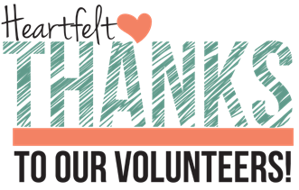
Jackson County will be participating in Stock the Trailer and Canstruction at the 2026 Jackson County Fair. As you may recall, all cans from Canstruction will go into the trailer for Stock the Trailer. If your 4-H Club would like to participate in Canstruction, please call the Extension Office.
Results from 2025:
Jackson County Fair won the 2025 Stock the Trailer contest, we collected 24,320 pounds of food during fair week, let’s beat that number in 2026!
Volunteers
- 112 Volunteers approved!
- Only 11 Volunteers need to do their trainings!
- REMINDER: You should be an approved volunteer BEFORE interacting with our 4-H Youth!
I PLEDGE…FOR MY CLUB, MY COMMUNITY, MY COUNTY, AND MY WORLD
PAGE 18 VOLUME 26. ISSUE 3

I PLEDGE…FOR MY CLUB, MY COMMUNITY, MY COUNTY, AND MY WORLD
I PLEDGE…FOR MY CLUB, MY COMMUNITY, MY COUNTRY, AND MY WORLD
PAGE 17 VOLUME 26. ISSUE 3

JACKSON COUNTY FAIR DAILY PROGRAM 2026
Daily Fair Schedule
PAGE 18 VOLUME 26. ISSUE 3
4-H Dates ONLY
*Changes for 2026 are highlighted*

Saturday, July 18
7:00 a.m. – Entry for 4-H Dog Show, Commercial Building Show Arena 2
8:00 a.m. – 4-H Dog Show & Poster Entry, Commercial Building, Show Arena 2
Monday July 20
8:30 a.m. – Public Speaking Prejudging, Brownstown High School
9:30 a.m.- Private Fashion Revue, Sewing and Consumer Clothing Judging, Brownstown High School
Wednesday, July 22
2:00-6:00 p.m. – 4-H project exhibits (other than Animals, Consumer Clothing, Crops, Floriculture, Garden,
Mini Garden, Potatoes, and Sewing) are due in the 4-H Building or at Brownstown High School
Saturday, July 25
8:00 a.m. – 4-H Horse & Pony Show Check-in, Horse Show Arena
8:30 a.m. – Entry of 4-H Cats
9:00 a.m. – 4-H Horse & Pony Show (Halter, Showmanship, and All Riding Classes), Horse Show Arena
9:00-11:00 a.m. – 4-H Corn, Garden, Mini Garden, Floriculture, Potatoes, Small Grains, and Soybeans
will be community-style judged at the 4-H Building
10:00 p.m. – 4-H Swine not in open class swine show may be brought to the fair
Sunday, July 26
4:00-6:00 p.m. – Register 4-H Rabbits, Rabbit Barn
5:00-6:00 p.m. – Register 4-H Poultry, Poultry Barn
5:00-7:00 p.m. – Entry/Weigh In of 4-H Goats
8:00 p.m. – 4-H Cattle and Sheep not entered in open class accepted
*Special Goat/Sheep Note: 4-H Goats not in open show may be brought to the fair before 8:00 a.m. on SUNDAY or after 5:00 p.m. on SUNDAY; 4-H Sheep not in open show may be brought to the fair after 5:00 p.m. on SUNDAY or before noon on MONDAY (for additional livestock drop information, see mailing in June)
I PLEDGE…FOR MY CLUB, MY COMMUNITY, MY COUNTRY, AND MY WORLD
8:00 p.m. – Battle of the Barns, Show Arena 1
PAGE 19 VOLUME 26. ISSUE 3
Monday, July 27
7:00 a.m. – All 4-H Swine exhibits must be penned
8:00 a.m. – Weigh -In of 4-H Swine Gilts, & Market Barrows, Show Arena 1
10:00 a.m. – 4-H Aerospace Rocket Launch, 4-H Building
12:00 p.m. – Closing for 4-H Livestock Entries (EXCEPT DAIRY)
12:00 p.m. – 4-H Poultry Judging, Show Arena 1
5:00 p.m. – 4-H Myotonic and Boer Goat Judging, Show Arena 2
Tuesday, July 28
7:30 a.m. – Dairy Beef Weigh-In to determine 4-H Classes
8:00 a.m. – 4-H Rabbit Judging, Show Arena 2
9:00 a.m. – 4-H Beef Workshop, Show Arena 1
11:00 a.m. – 4-H Fashion Revue, Pavilion
11:00 a.m. – Crowning of 4-H Royalty, Pavilion
12:00 p.m. – All Dairy Cattle entries must be on the fairgrounds
1:00 p.m. – 4-H Market Lambs Weighed
1:00 p.m. – 4-H Swine Gilt Show, Showmanship, Swine Barrow Show, Show Arena 1
6:00-7:00 p.m. – 4-H Horse & Pony Demonstration, Show Arena 2
Wednesday, July 29
7:30 a.m. – Weigh 4-H Steers & Heifers to determine 4-H Classes
9:00 a.m. 4-H Dairy Judging, Show Arena 1
1:00 p.m. – 4-H Dairy Beef Judging, Show Arena 1
4:00 p.m. – Judging of 4-H Sheep, Show Arena 2
6:00 p.m. – 4-H Goat Variety Show, Show Arena 1
7:30 p.m. – 4-H Waggin’ Pals Dog Club Demonstration, Show Arena 1
Thursday, July 30
9:00 a.m. – 4-H Dairy Goat Show, 4-H Dairy Goat Parent Showmanship, Show Arena 2
10:00 a.m. – 4-H Beef Heifer Judging, Show Arena 1
12:00 p.m. – 4-H Beef Steers Judging, Show Arena 1
2:30 p.m. – Check in for 4-H Performing Arts Performance, Pavilion
I PLEDGE…FOR MY CLUB, MY COMMUNITY, MY COUNTRY, AND MY WORLD
PAGE 20 VOLUME 26. ISSUE 3
3:00 p.m. – 4-H Performing Arts Performance, Pavilion
6:00 p.m. – Dairy Goat Milking Contest, Show Arena 2
6:00-7:00 p.m. – Register for 4-H Alumni Showmanship, Show Arena 1
7:00 p.m. – 4-H Alumni Showmanship, Show Arena 1
Friday, July 31
7:00 a.m. – Swine going home (locker, personal use) exhibits released
8:30 a.m. – 4-H Junior Supreme Showman Contest, Show Arena 1
9:30 a.m. – 4-H Supreme Showman Contest, Show Arena 1
1:00-2:00 p.m. – Quiet Barn Time for People with Disabilities and Sensory Needs, Show Arena 2
2:00 p.m. – Grand Parade of Livestock Registration Deadline, 4-H Building
3:00 p.m. – Presentation of 4-H Building Trophies, Building Winners Circle Awards, Ten Year Members, Mini T-Shirts, Achievement, Leadership and Outstanding Junior Leader Plaques and ‘I Dare You’ Awards, Pavilion
5:30 p.m. – Grand Parade of Open Class Grand Champions and Any 4-H Livestock, Show Arena 1
11:00 p.m. – 4-H Animals released from fairgrounds (non-auction animals)
Saturday, August 1
8:00 a.m. – All non-auction 4-H animals need to be removed from the fairgrounds by this time
9:30 a.m. – 4-H Livestock Auction – Beef, Dairy Beef, Sheep, Poultry, Rabbit, Goats, Swine, Show Arena 1
Sunday, August 2
1:00-3:00 p.m. – All exhibits must be claimed and removed, 4-H Building

I PLEDGE…FOR MY CLUB, MY COMMUNITY, MY COUNTRY, AND MY WORLD
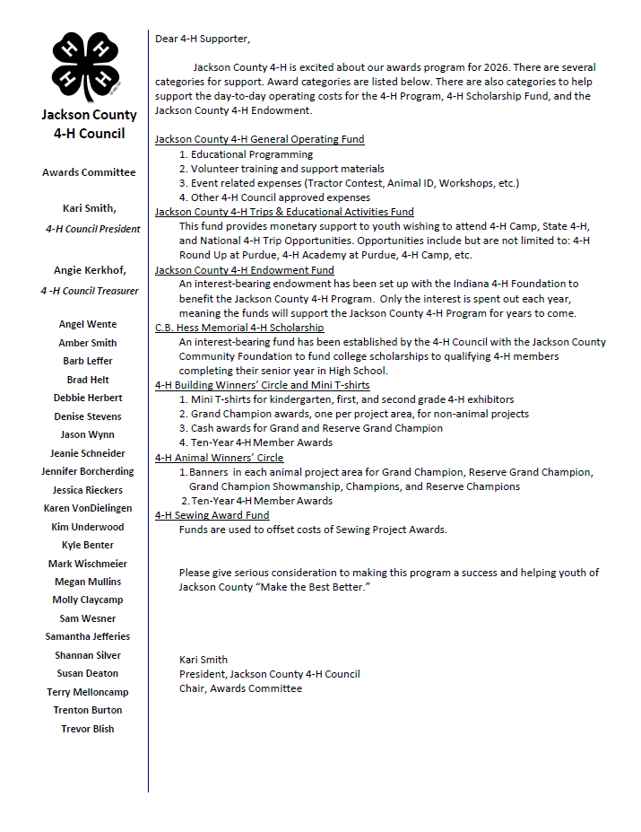
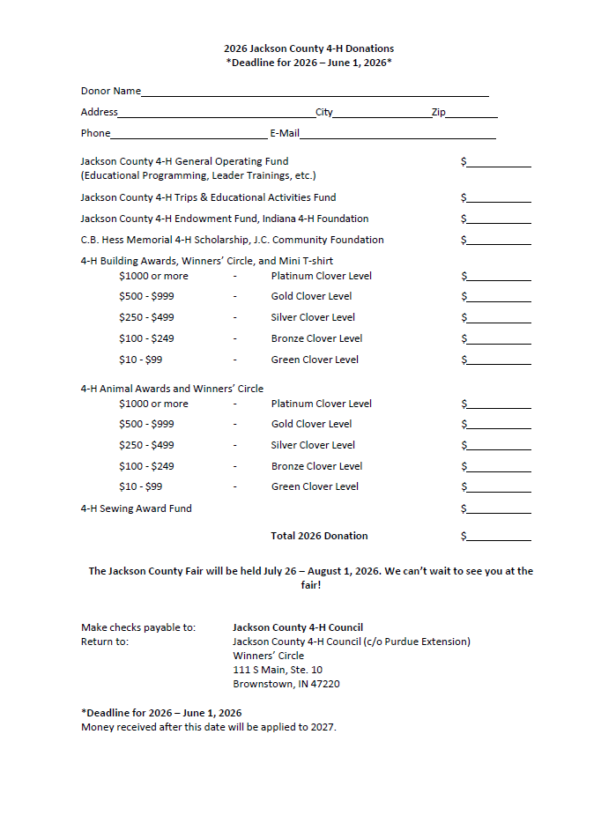

CALENDAR
FIND US ON THE WEB FOR UP-TO-DATE INFORMATION ON THE GO!

Purdue Extension Jackson County Website:
https://extension.purdue.edu/county/jackson/index.html

Facebook:
Purdue Extension Jackson County

June
1: Winners Circle donations due
9: YQCA course #1 at 1:00 p.m.
10-12: 4-H Round-Up & Academy
11: YQCA course #2 at 9:30 a.m.
17: YQCA course #3 at 6:00 p.m.
23: 4-H Livestock & Auction Committee meeting
TBD: Jr. Leading Meeting at Anchor House or Provisions
TBD: Fair Entry Opening & Closures Dates
May
1: 4-H Camp Register Deadline
5: Extension Office CLOSED (Election Day)
7: 4-H Council Meeting
7: Sheep/Goat ID Day
9: Sheep/Goat ID Day
12: Swine ID Day
15: ANIMAL IDENTICATION DEADLINE!
25: Extension Office CLOSED (Memorial Day)
26: Jr. Leader Meeting at Muscatatuck National Wildlife Refuge
29-31: 4-H Camp
PAGE 23 VOLUME 26. ISSUE 3

CLICK ICON



MARK
YOUR
CALENDARS
NOW!
I PLEDGE…FOR MY CLUB, MY COMMUNITY, MY COUNTRY, AND MY WORLD


NONPROFIT ORG.
U.S. POSTAGE
PAID
BROWNSTOWN, INDIANA
PERMIT NO. 44

Jackson County
Courthouse, 111 S Main St, Suite 10
Brownstown, IN 47220-2055
Cooperating with U.S. Department of Agriculture
Address SERVICE REQUESTED

Office Hours: 8:00 – 4:30 Weekdays, Closed County Holidays
Phone: 812.358.6101
Addyson Coomer
Administrative Assistant
coomer2@purdue.edu
Brier Ryver
Extension Educator,
4-H Youth Development
bryver@purdue.edu
Madge Warren
Office Manager
mewarren@purdue.edu
Molly Marshall
Co-Extension Director,
Extension Educator, HHS
marsh119@purdue.edu
Arturo Ballesteros
Extension Educator,
4-H Juntos
abelles@purdue.edu
Richard Beckort
Co-Extension Director,
Extension Educator, ANR
rbeckhort@purdue.edu
Jackson County Office Staff
It is the policy of the Purdue University Extension Service that all persons have equal opportunity and access to its educational programs, services, activities, and facilities without regard to race, religion, color, sex, age, national origin or ancestry, martial status, parental status, sexual orientation, disability or status as a veteran. Purdue University is an Affirmative Action institution. This material may be available in alternative formats.

