
Jackson County
https://extension.purdue.edu/county/jackson/
4-H CLOVER CONNECTIONS

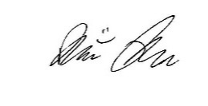
What’s New? p.3-5
Junior Leaders p. 6
County Happenings p. 7-10
10-Year Members p. 7
26 Flower p. 8
Fundraiser
26 Handbook p. 10
Volunteer Corner p. 11
Mini 4-H Page p. 12
Livestock Updates p. 13
Are You Ready? P. 14
Special Judging p. 15
Project Check-in p. 16-17
Check-in p. 18
Procedures
Check-in Map p. 19
State Fair Info p. 20
Did You Know? p. 21
CANstruction p. 22-23
Stock the Flyer p. 24
Battle of the Barns p. 25
Fair Schedule p. 26-28
Calendar p. 29

Dear 4-H Families,

We have had a great year full of many learning activities! There have been project workshops, Area 2 4-H Camp, 4-H trips, and 4-H Club Meetings. Everyone’s 4-H experience looks different and we are so thankful for our 4-H volunteers and members who make these opportunities possible for the youth.

As a reminder, all county and state fair project requirements can be found by visiting our 4-H Handbook online at: https://bit.ly/2025-2026-handbook

Be sure to read all instructions and guidelines carefully so you do not miss important information! Please note that you can always call the office at 812-358-6101 to find out important dates, times, and locations for various events.

Thank you for taking the time to enter your projects in Fair Entry. This helps us organize everything for the fair and prepare for project check-in.
Deadline to enter projects into Fair Entry is July 3rd!
NOTE: The office will be closed on July 3rd

We have once again included the 4-H fair schedule in the newsletter for your information on page 26-28. Please note, Public Speaking and Fashion Revue will take place on Monday, July 20th at Brownstown High School auditorium. Foods judging will be on Wednesday, July 22nd at the Brownstown High School cafeteria. Garden judging will be on Saturday, July 25th at the 4-H Building. Please be patient if judging and shows do not start at the exact times listed on the fair schedule. Check in with the livestock volunteers in the barns throughout the week to be sure you know what is happening with each species.
Sincerely,

Brier Ryver
Extension Educator
4-H Youth Development
Inside this Issue
Volume 26 Issue 4 – July and August


- What college are you currently attending?
  - I am going into my third year at Purdue University.
- What is your area of study/major?
  - I am majoring in Social Studies Education and hope to become a High School History teacher.
- Why are you excited to work in the Extension Office this summer?
  - I am excited to give back to the Jackson County 4-H program after being a dedicated 10-year member.
- What are three interesting facts you would like to share about yourself?
  - I am a huge history nerd.
  - My favorite color is orange.
  - This is my second summer serving as a summer assistant.
Meet Drew Kerkhof!
WHAT’S NEW!
We are very excited to welcome back our summer assistant to the Extension Office.
PAGE 3 VOLUME 26. ISSUE 4
I PLEDGE…FOR MY CLUB, MY COMMUNITY, MY COUNTRY, AND MY WORLD
WHAT’S NEW!
We are very excited to welcome our new summer assistant to the Extension Office! Check out some fun facts and be sure to say hello when you see her!
PAGE 4 VOLUME 26. ISSUE 4

- What college are you currently attending?
  - I am currently attending Marian University.
- What is your area of study/major?
  - I am double majoring in Logistics and Supply Chain Management with a minor in Industrial Organizational Psychology.
- Why are you excited to work in the Extension Office this summer?
  - I am excited to contribute to an organization that provided me with so many opportunities through my 4-H years.
- What are three interesting facts you would like to share about yourself?
  - I showed dogs, horses, and goats during my 4-H years.
  - I ran track and cross country in college.
  - I can never turn down a sweet treat.
Meet vivienne siefker!
I PLEDGE…FOR MY CLUB, MY COMMUNITY, MY COUNTRY, AND MY WORLD
WHAT’S NEW!
We are very excited to welcome our new summer assistant to the Extension Office! Check out some fun facts and be sure to say hello when you see her!

PAGE 5 VOLUME 26. ISSUE 4

- What college are you currently attending?
  - I am currently attending Purdue University.
- What is your area of study/major?
  - I am majoring in English Education with a minor in Theatre.
- Why are you excited to work in the Extension Office this summer?
  - I am excited to work at the office to grow my knowledge of 4-H and work at a place where I grew up participating in.
- What are three interesting facts you would like to share about yourself?
  - I love playing pickleball.
  - I am heavily involved in Purdue University’s Dance Marathon program.
  - I love Disney.
Meet katie cottrill!
I PLEDGE…FOR MY CLUB, MY COMMUNITY, MY COUNTRY, AND MY WORLD


Be on the lookout!
ELECTION OF OFFICERS FOR 2026-2027 COMING SOON!
If you would like to run for a Junior Leader office, please be sure to attend this meeting! If you cannot attend this meeting, but would like to run for an office, please contact the Extension Office.

- Thursday, July 16
- 7:00 – 8:30 p.m.
- Citizenship: Becca Herbert
- Health & Safety: Adam Alberring
- Recreation: Chloe Jablonski
- Refreshments: Committee
Unpaid Dues: $4.00
Lots of information coming at this meeting!
Sign Up to Work in the 4-H Building!
Junior Leaders are expected to work two shifts in the 4-H Building during the fair – don’t forget to sign up! Visit https://www.signupgenius.com/go/904054CAEA922A0FE3-64484071-2026 or scan the QR code to sign up TODAY!
July Meeting
- Cleanin’ Up
- Jackson County Fairgrounds
JUNIOR LEADERS
PAGE 6 VOLUME 26. ISSUE 4
I PLEDGE…FOR MY CLUB, MY COMMUNITY, MY COUNTRY, AND MY WORLD
Congratulations Ten Year Members!
COUNTY HAPPENINGS
PAGE 7 VOLUME 26. ISSUE 4



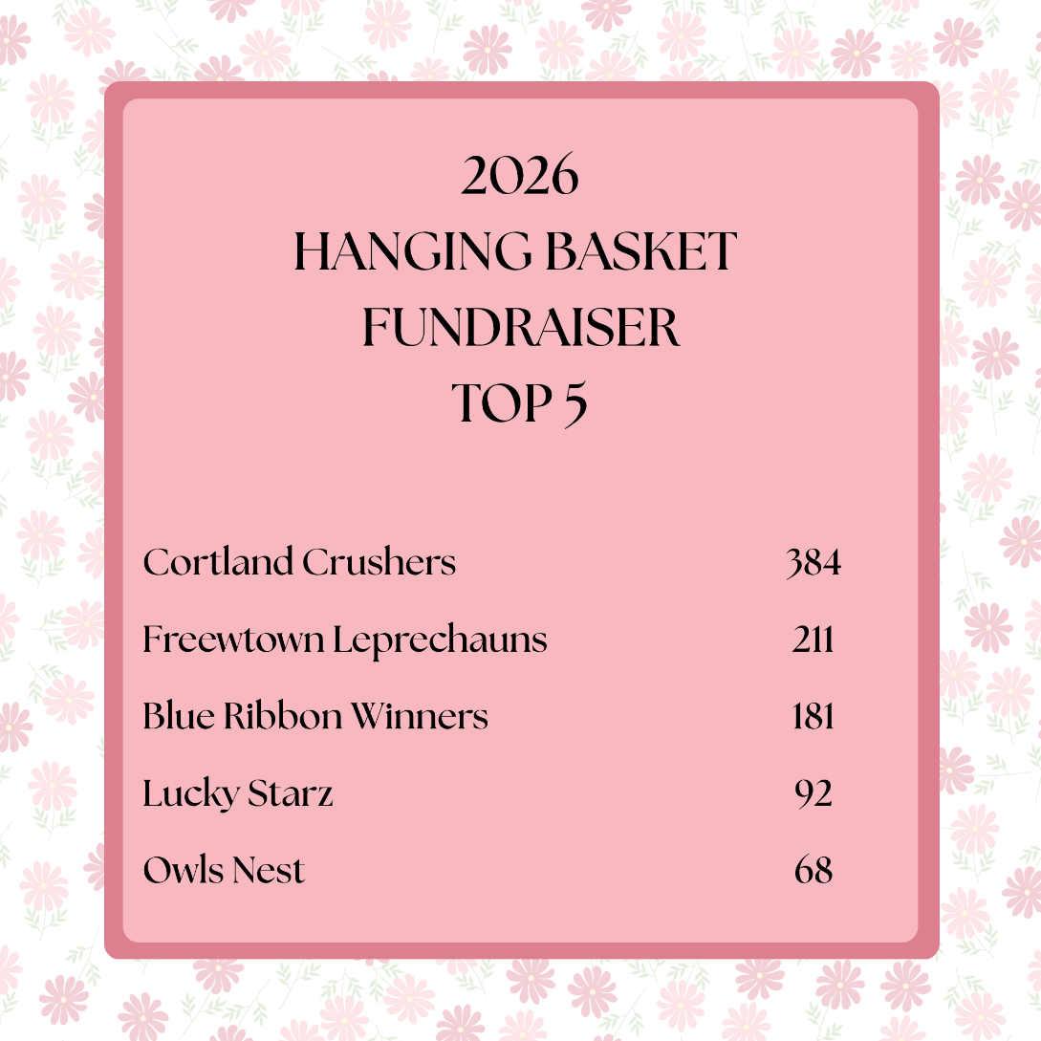
Farm Bureau, Inc.
4-H Tenure Award Winners
Taylor Smith
Kassidy Wischmeier
Indiana 4-H Foundation Scholarships – CONGRATULATIONS!
Sponsored by Jackson County 4-H Council: Collin Downing, Micah Jablonski, Kassidy Wischmeier
Sponsored by Jackson County 4-H Junior Leaders: Diego Aguilar-Tencle, Gillian Bumbleberg, Naythan Hernandez
C.B. Hess Memorial Scholarship: Collin Downing, Micah Jablonski, Anna Obermeyer, Kassidy Wischmeier
Evan Abbott
Madelyn Adams
Hannah Baker
Brody Brown
Gillian Bumbleburg
Stefani Christoper
Kelly Claycamp
Collin Downing
Hailey Hobson

Taylor Smith
Evan Stahl
Izabella Stanfield
Sloan Stuckwisch
Gavin Wessel
Kassidy Wischmeier
Owen Wischmeier
Sophie Wischmeier

Jennifer Jones
Dalton Lawyer
Gage Mull
Anna Obermeyer
Abigail Otte
Yaretzi Contreras-Ramirez
Caysen Robertson
Lillyan Schuerman
I PLEDGE…FOR MY CLUB, MY COMMUNITY, MY COUNTRY, AND MY WORLD
THANK YOU to Darlage Greenhouse for being a great partner for this annual fundraiser.
Congratulations to the Cortland Crushers for selling the most baskets!
COUNTY HAPPENINGS
I PLEDGE…FOR MY CLUB, MY COMMUNITY, MY COUNTRY, AND MY WORLD
PAGE 8 VOLUME 26. ISSUE 4
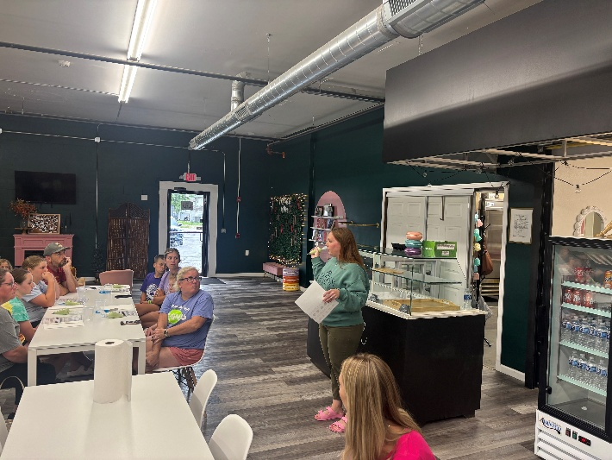
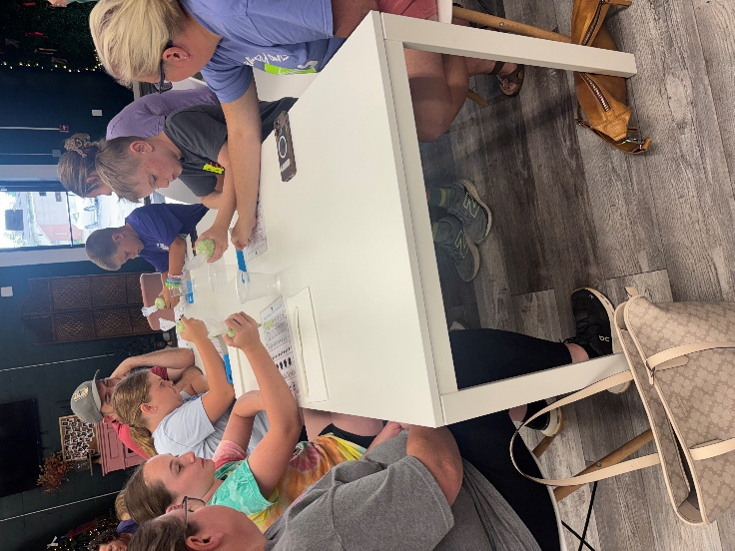

PAGE 9 VOLUME 26. ISSUE 4
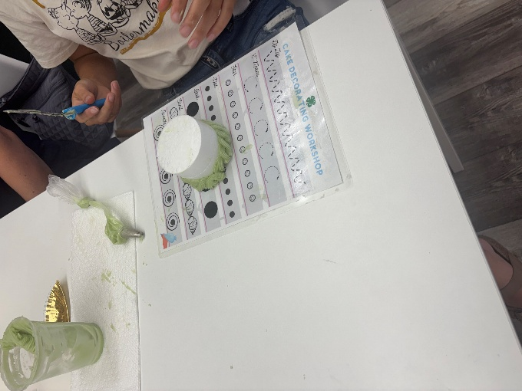
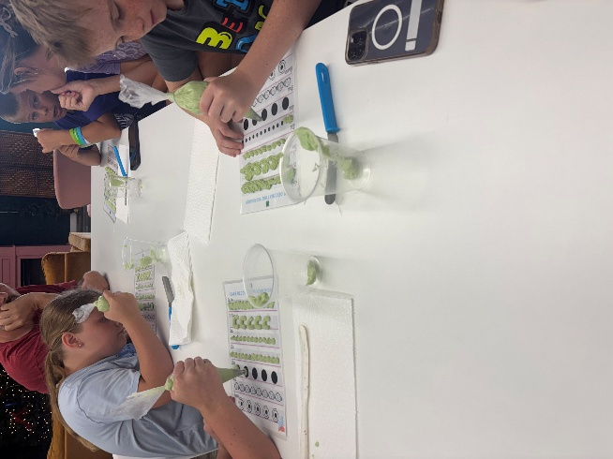
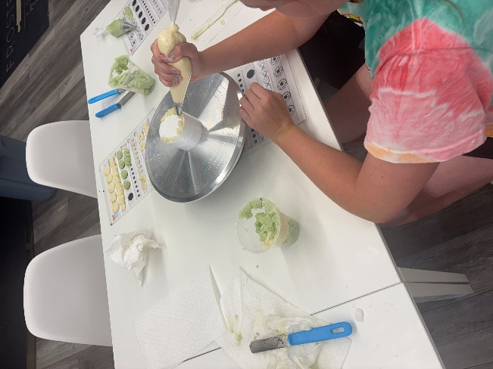
The Extension Office hosted a cake decorating workshop with help from Frosted by Macy!
COUNTY HAPPENINGS
I PLEDGE…FOR MY CLUB, MY COMMUNITY, MY COUNTRY, AND MY WORLD
COUNTY HAPPENINGS
PAGE 6 VOLUME 26. ISSUE 3

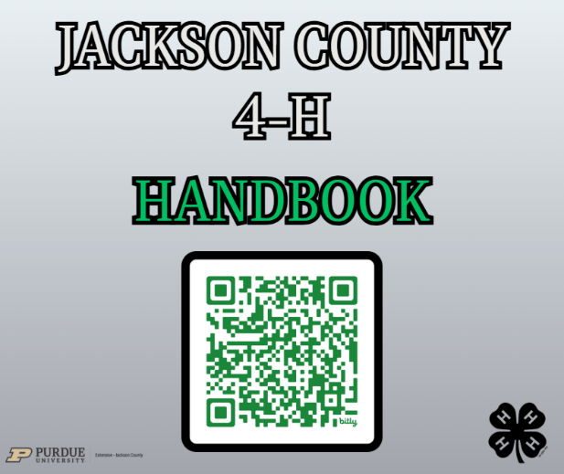
2026 4-H HANDBOOK PUBLISHED!
Visit https://bit.ly/2026handbook
View the 2026 Jackson County 4-H Handbook!

The Indiana State 4-H Office has updated projects for 2026. You can view all the State 4-H Project requirements on the State 4-H Website:
https://extension.purdue.edu/4-H/projects/index.html
Updates to Project Manuals and 4-H Requirements
· All 4-H Members need to pay close attention to new 4-H Manuals and Project Requirements in 2026. We can distribute the Handbook Link and resources to each member for every 4-H project. Several club leaders have already picked up 4-H project manuals and green folders from the Extension Office. Be sure to attend a club meeting or check in with your leader to get your project materials in a timely manner.
· Livestock manual activities are no longer required. The record sheets have been updated according to this change. Please notice there is a separate record sheet if you are just doing an animal poster.
· When doing research for projects, consider using websites that end with .edu and/or .gov for research-based information. Artificial Intelligence (AI) may be used, with parent permission, when creating exhibits and is to be documented as a reference with the sources it cited. See the 4-H Handbook for more information on AI use.

I PLEDGE…FOR MY CLUB, MY COMMUNITY, MY COUNTY, AND MY WORLD
PAGE 10 VOLUME 26. ISSUE 4

4-H Council
4-H Council will meet on July 14th to make final preparations for the 2026 Fair!
Interested in becoming a 4-H Volunteer?
Stop by the Extension Office and let us know how you would like to help the Jackson County 4-H Program. Potential volunteers complete an application process and then we work together to find a place for you to volunteer with the program. All 4-H Club Leaders and Volunteers are required to apply at the Extension Office.
VOLUNTEER CORNER
PAGE 17 VOLUME 26. ISSUE 3
I PLEDGE…FOR MY CLUB, MY COMMUNITY, MY COUNTY, AND MY WORLD
PAGE 18 VOLUME 26. ISSUE 3
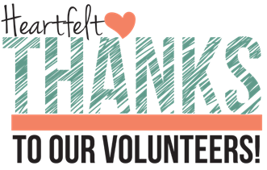
Dedicated Animal Volunteers
Our animal shows and projects would not be possible without our 4-H volunteers. Please be sure to thank a 4-H volunteer when you see them in the barns or show arena at the fair! We appreciate all you do!
Volunteers in the 4-H Building
We need screened and approved 4-H volunteers to help staff the 4-H Building during the fair week. Please call the office, or sign up here:
https://www.signupgenius.com/go/904054CAEA922A0FE3-64484071-2026
I PLEDGE…FOR MY CLUB, MY COMMUNITY, MY COUNTY, AND MY WORLD
I PLEDGE…FOR MY CLUB, MY COMMUNITY, MY COUNTRY, AND MY WORLD
PAGE 11 VOLUME 26. ISSUE 4

Indiana 4-H Mini Goals & Priorities
Mini 4-H is a program designed to encourage positive development of children, Kindergarten through second grade. The goal of Mini 4-H is to help young children explore friendships outside the family; explore the way in which things work; practice both small and large muscle control; and think about the ways people work together on projects.
The NON-COMPETITIVE learning environment for Mini 4-H includes:​
1. Planned learning activities in which children are invited to be active and explore materials and ideas without the pressure of completing a specific product or exhibit.
2. Low adult/leader to child ratio that allows time for adults/leaders to provide individual, positive encouragement and assistance.
3. Simple, interesting activities that are fun.
4. Encouragement of children to participate in a group activity by sharing and/ or displaying their activity projects.
5. Rewards that are identical and/or ribbons of the same color for everyone.
POSTER RULES
- All posters are to be 14”x22” poster board.
- All posters need to have a stiff backing.
- All posters need to be covered with a clear plastic sleeve.
- All posters should be horizontal.
- Put a title on your poster.
MINI 4-H PAGE
PAGE 12 VOLUME 26. ISSUE 4

I PLEDGE…FOR MY CLUB, MY COMMUNITY, MY COUNTRY, AND MY WORLD
Livestock Auction
Saturday, August 1st
9:30 a.m.
Auction Order for 2026:
Beef, Dairy Beef, Sheep, Poultry, Rabbits, Goats, Swine

Animal Show Information
For information on any animal show times or check-in times, please refer to the 2026 Fair Daily Program on page 18-20. You can also call the Extension Office at 812-358-6101.
Youth for the Quality Care of Livestock Classes
A big thank you to Richard Beckort for teaching our Youth for the Quality Care of Livestock Classes. If you did not participate in a class in person, you will need to take the YQCA training online.
Don’t forget to bring your online certificate to check-on!
Poultry Blood Testing
All Poultry no purchased from a NPIP certified flock needs to be blood tested before fair. Bring your bird(s) to be blood tested:
When? Tuesday, July 7th
Time? 5:00 – 8:00 p.m.
Where? Jackson County Fairgrounds
Livestock ID Tags
Animals tagged for ID purposes must have tags before they are entered at the fair. If a 4-H livestock tag falls out, please call the Extension Office at 812-358-6101.
As a reminder, it is unlawful to remove an RFID tag from an animal. We report animal ID information to the Indiana Board of Animal Health.
2026 Indiana State Fair Livestock Handbook – Check Website for Deadlines!
Requirements, dates, and entry information is all entered online. All State Fair Livestock information can be found online using the following link:
https://www.indianastatefair.com/p/livestock-new/livestock-information
If you plan to show at the State Fair, a signed Animal Affidavit is required for each species. You can pick up a paper copy from the office or download it from the Indiana State Fair Website.

LIVESTOCK UPDATES
PAGE 13 VOLUME 26. ISSUE 4
I PLEDGE…FOR MY CLUB, MY COMMUNITY, MY COUNTRY, AND MY WORLD

Volunteers Needed!
4-H Volunteers and Junior Leaders are needed to help supervise the 4-H Building during the fair. (July 26th – August 1st). To volunteer, call the Extension Office at 812-358-6101 or sign up online: https://bit.ly/4HOnlineSignIn-SignUp
Fair Books
Fair Books for the Jackson County fair will be available in the Extension Office. The Jackson County Fair Board publishes these books. All official 4-H information comes directly from the Purdue Extension Office.
PLEASE NOTE: Due to an error, please follow the daily program on pages 28-30 for the CORRECT 4-H Dates, the dates and times for the 4-H Program are INCORRECCT on pages 16-21.
4-H Green Folders
4-H Green Folders with a complete record sheet for each project (including Junior Leaders) are due in the 4-H Building at the Fairgrounds or at Brownstown Central High School on Wednesday, July 22nd from 2:00 - 6:00 p.m.
ARE YOU READY FOR THE FAIR?
PAGE 14 VOLUME 26. ISSUE 4
I PLEDGE…FOR MY CLUB, MY COMMUNITY, MY COUNTRY, AND MY WORLD

4-H Thank You Notes & Awards & Banners
4-H pins, banner, and monetary awards are only possible by the generosity of donors in the community who donate funds to the 4-H Program. Please be sure to a write a personalized thank you note to the donors if you receive an award at the fair during the award ceremony on Friday, July 31st. If you are a livestock member, make sure to sign the banner when you pick up your livestock packet on Wednesday, July 22nd. This is a new way we are thanking our donors – don’t miss out!
Banners: The 4-H Livestock & Auction Committee and Jackson County 4-H Council partnered with Owl Manufacturing to have banners printed for all the livestock & animal project winners.
Pins: Through donations 4-H Council is sponsoring commemorative pins for the Grand Champion winners in the 4-H Building.




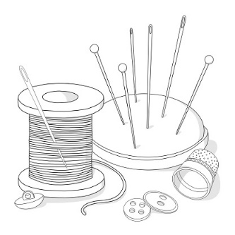
Check the Exhibit Requirements
Each 4-H family should have access to the 2026 Jackson County 4-H Handbook. This contains the county guidelines for everything that has to do with exhibits at the fair. Please check it carefully as you work on your projects! If 4-H manual requirements differ from the County 4-H Handbook, you should follow the County Handbook requirements. You can access the 2026 4-H Handbook: https://bit.ly/2025-2026-handbook
4-H Fashion Revue
4-H Sewing and Consumer Clothing judging will be held on Monday, July 20th, beginning at 9:30 a.m. at Brownstown Central High School. Detailed instructions with specific times have been mailed to sewing and consumer clothing 4-H members. The public 4-H fashion revue will be held Tuesday, July 28th at 11:00 a.m. at the Pavilion.
4-H Public Speaking and Communications Projects
4-H Public Speaking and Communications Projects (except Creative Writing) will be judged on Monday, July 20th at Brownstown Central High School. 4-H’ers should plan to arrive 15 minutes early to register. Be prepared to speak!
SCHEDULE:
8:30 a.m. – Junior
8:45 a.m. Senior
4-H Performing Arts Judging
The 4-H Performing Arts Contest took place in March!
Grand Champion: Ruby Blankenbaker
Reserve Grand Champion: Emma Doriot

4-H Members enrolled in the Performing Arts project are invited to participate in the public performance for the Performing Arts on Thursday, July 30th at the Pavilion on the fairgrounds. Check in will be at 2:30 p.m. with the event beginning at 3:00 p.m.
SPECIAL JUDGING ANNOUNCEMENTS
I PLEDGE…FOR MY CLUB, MY COMMUNITY, MY COUNTRY, AND MY WORLD
PAGE 15 VOLUME 26. ISSUE 4
Back of 4-H Building – Check in ONLY – will not be talking to a judge!
BROWNSTOWN CENTRAL HIGH SCHOOL
Foods: Mini
Foods: Baked
Foods: Preserved
FRONT OF HORTICULTURE BUIDLING
Photography
BACK DOOR OF 4-H BUILDING
Aerospace
Model Craft
Construction & Architectural Replica
BACK OF HORTICULTURE BUIDLING
Mini 4-H (expect Foods and Gardening)
FRONT OF 4-H BUILDING
Arts & Crafts, General
Cake Decorating
Ceramics
Gift Wrapping
Leather Craft
Needle Craft
Fine Arts
Accomplishment Resume
Animal Education Posters
ATV Safety Education
Beekeeping
Bicycle
Child Development
Collections
Computer Science
Creative Writing
Electric
Entomology
Forestry
Genealogy
Geocaching
Health
Home Environment
Lawn & Garden
Pocket Pets
Reading
Recycling
Scrapbook
Shooting Sports
Small Engine
Soil & Water Science
Sports
Sport Fishing
Tractor
Vet Science
Weather & Climate Science
Welding
Wildlife
Woodworking
Zero Turn
Projects judged this day – Wednesday, July 22nd – will be talking to a judge!
Every child will report directly to the back of the Farm Bureau Building to check-in and receive their Fair Entry cards for project judging. Once projects are scanned in, 4-H members will bring their card in card to the locations below to have their projects judged (open judging) or dropped off at the back of the 4-H Building (closed judging). Projects will not be judged without the Fair Entry check in card!
*Circle your projects on this page so you will know when and where to report*
Wednesday, July 22nd
2:00 – 6:00 p.m.
4-H PROJECT CHECK-IN
PAGE 16 VOLUME 26. ISSUE 4
I PLEDGE…FOR MY CLUB, MY COMMUNITY, MY COUNTRY, AND MY WORLD

If any 4-H Clubs would want to scoop ice cream, contact Janette Elliot (812) 569-2816
ICE CREAM
Farm bureau is giving FREE CREAM to 4-H Members all week at the farm Bureau Building! Pick up your certificate at project check-in on Wednesday, July 22nd. Certificates not picked up on the 22nd can be picked up at the 4-H Building beginning Sunday, July 26th.

Thank you Jackson County farm bureau!
PROJECT JUDGING ON SATURDAY, JULY 25TH FROM 9:00 – 11:00 A.M.
You will talk to the judge at the back and/or near of the 4-H Building.
Projects include:
- CORN, SMALL GRAINS, SOYBEANS
PROJECT JUDGING ON SATURDAY, JULY 25TH FROM 9:00 – 11:00 A.M.
You will talk to the judge at the front of the 4-H Building.
Projects include:
- GARDEN, MINI GARDEN, FLORICULTURE, POTATOES
Please remember to be patient. There might be long lines! THANK YOU!
4-H PROJECT CHECK-IN
I PLEDGE…FOR MY CLUB, MY COMMUNITY, MY COUNTRY, AND MY WORLD
PAGE 17 VOLUME 26. ISSUE 4
Project Check-in Process for 4-H Building
A map is included to help you find where you need to go for project check-in. we learned a lot the past few years with the full implementation of Fair Entry. We had made some changes last year to help with traffic flow and to better serve families on project check-in day. We will continue utilizing those changes for this year. Be sure to look for posted signs and instructions on project check-in day.
The Farm Bureau Building will serve as the main check in hub for 4-H Building Projects. All youth will need to first visit this station to get checked-in and receive your project cards. Once you have been checked in by staff members or 4-H Volunteers, then you can take your projects to the designated areas to be judged or drop off projects for closed judging. You will need to present the Fair Entry card you receive at the main check in hub at the judging station for each project for your projects to be judged or checked in for closed judging.
We will be using barcodes and scanners to get you and your projects checked in for the fair. We can do that from your Fair Entry.
Those not registered will need to register day-of in a separate line and the process will take more time. Please be patient with our volunteers and summer assistants as they help you!
Project Check-in for 4-H Animal/Livestock Projects:
Livestock Packers: Every child showing an animal at the Jackson County Fair will receive a packet of information that includes livestock packing passes (3), 4-H event schedule, back numbers, Battle of the Barns information, etc. These packets will be ready to be picked up on project check-in day – Wednesday, July 22nd when you drop off other 4-H Projects or your green folders. These will be in the Farm Bureau on project check-in day. If you do not pre-register your animal/livestock exhibits in Fair Entry, you will not be able to pick up your livestock packet on project check-in day or have your name listed in the show program.
We are working to some changes to our fair processes to make it more efficient for 4-H Volunteers, 4-H Families, and office staff. We know there are a lot of due dates, rules to abide by, and procedures to follow for 4-H Families. Thank you for the feedback you all have given over the past few years. It has helped us implement some changes to better serve you!
PAGE 18 VOLUME 26. ISSUE 4
I PLEDGE…FOR MY CLUB, MY COMMUNITY, MY COUNTRY, AND MY WORLD
CHECK-IN PROCEDURES
*MAP INCLUDED*
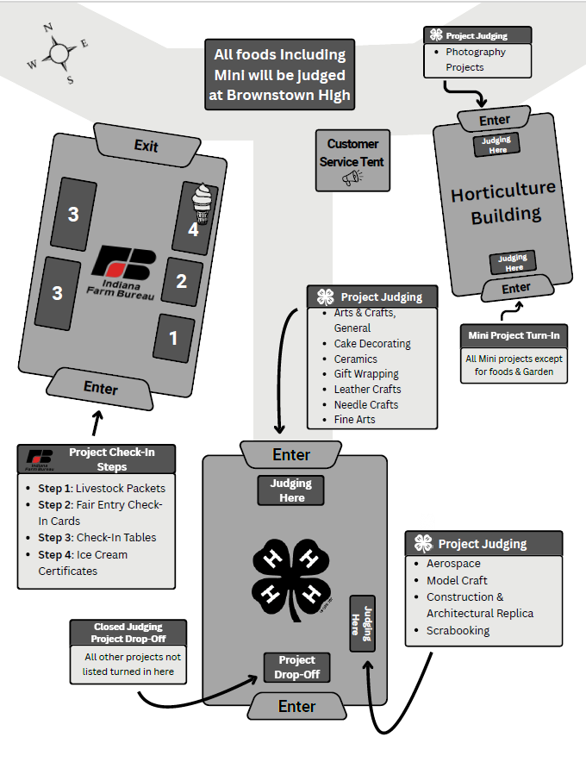
I PLEDGE…FOR MY CLUB, MY COMMUNITY, MY COUNTRY, AND MY WORLD
- ALL Indiana State Fair 4-H Exhibit Hall projects will be taken to the Indiana State Fair on Monday, August 3rd.
- If you project is selected for State Fair entry, please stop by the BACK of the 4-H Building during project check-out on Sunday, July 2nd from 1:00 - 3:00 p.m. Ribbons will need to be removed, and new State Fair tags will need to be placed on projects.
- Please bring packing material to safeguard the project during travel time. Some projects that usually need extra packing material include cake decorating, rockets, and other fragile projects that could break easily.
- Large or extremely fragile projects will need to be transported by the exhibitor’s family. You will be notified by the Extension Office if we cannot transport your State Fair Project. Check-in days/times will be provided if we are not able to transport your project for you.
- Any garden or food projects that are going to State Fair must be dropped off at the Extension Office on Monday, August 10th between 6:15 – 6:45 a.m. These projects are being checked in at the Indiana State Fair on Monday, August 10th, the same day. DO NOT leave these exhibits at the Fairgrounds. Take them home on August 2nd and bring them to the Extension Office on August 10th between 6:15 – 6:45 a.m. Foods projects will need to be remade for State Fair. Any project may be taken up to the State Fair by the 4-H/er if they would like to talk to a judge.
STATE FAIR PROJECT INFORMATION
Jackson County Purdue Extension Staff and 4-H Volunteers are NOT responsible for caring for or supervising children at the Jackson County Fair. If you child is left at the fair unattended and is causing issues, you will be contacted.
PAGE 20 VOLUME 26. ISSUE 4
COUNTY FAIR SUPERVISION

Are you looking for a community service project? Pease consider donating canned goods to the Jackson County Extension Office. These cans will be used to build a Canstruction structure for the 4-H Building at the fair. The cans will be donated to Stock the Trailer and then delivered by our Jackson County 4-H goat Club members to our local food pantries in Jackson County. 4-H is a great way to give back to the community and fight food insecurity. See the Canstruction and Stock the Trailer flyers for more information.
Action Demonstrations at the Fair
Call the Extension Office at 812-358-6101 if you would like to set up an action demonstration at the fair to showcase what you have learned. Most projects can be completed by doing an action demonstration in the 4-H Building. They should be approximately 30 minutes long. These are like the demonstrations you do at your 4-H Club Meetings. Action demonstrations can be done anytime the 4-H Building is open during the fair.

Project Resources for Sale in the Extension Office
We keep a variety of project resources in the Extension Office for your convenience. Stop by if you would like to purchase the following resources:

Prices are subject to change when current inventory runs out, due to pricing changes from our vendors. We will revise the pricing list when current inventory runs out.

Purchase your fair supplies as soon as possible to get these prices!
Foam Poster Board: $5.00
All Plastic Sleeve: $1.00
Entomology Pins: $6.00
Beginning Cake Decorating Kit: $13.00
Replacement Livestock Resource Book; $20.00
Electric Kits – Division III: $20.00
Electric Kits – Division III Trouble Light Kit: $30.00
DID YOU KNOW?
I PLEDGE…FOR MY CLUB, MY COMMUNITY, MY COUNTRY, AND MY WORLD
PAGE 21 VOLUME 26. ISSUE 4

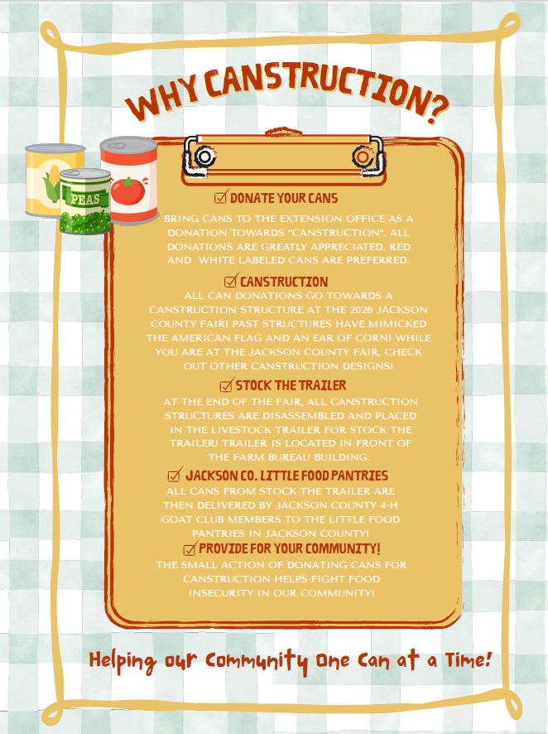

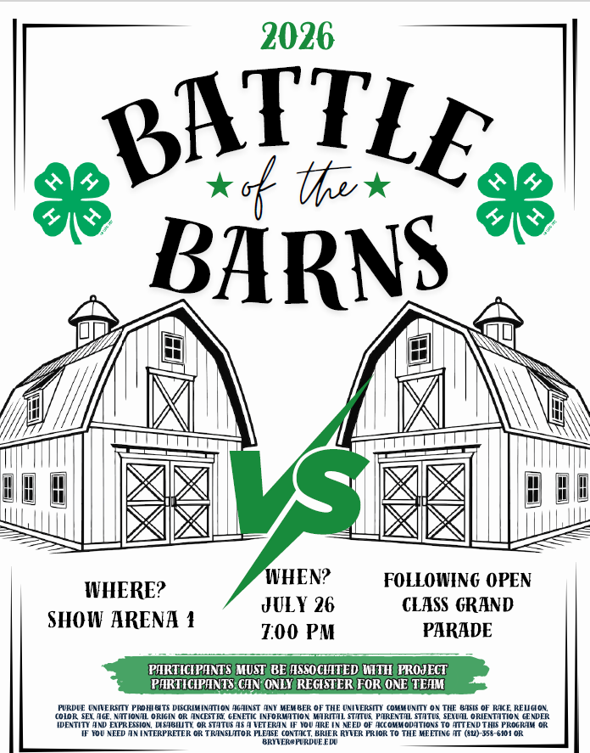
JACKSON COUNTY FAIR DAILY PROGRAM 2026
Daily Fair Schedule
PAGE 26 VOLUME 26. ISSUE 4
4-H Dates ONLY
*Changes for 2026 are highlighted*

Saturday, July 18
7:00 a.m. – Entry for 4-H Dog Show, Commercial Building Show Arena 2
8:00 a.m. – 4-H Dog Show & Poster Entry, Commercial Building, Show Arena 2
Monday July 20
8:30 a.m. – Public Speaking Prejudging, Brownstown High School
9:30 a.m.- Private Fashion Revue, Sewing and Consumer Clothing Judging, Brownstown High School
Wednesday, July 22
2:00-6:00 p.m. – 4-H project exhibits (other than Animals, Consumer Clothing, Crops, Floriculture, Garden,
Mini Garden, Potatoes, and Sewing) are due in the 4-H Building or at Brownstown High School
Saturday, July 25
8:00 a.m. – 4-H Horse & Pony Show Check-in, Horse Show Arena
8:30 a.m. – Entry of 4-H Cats
9:00 a.m. – 4-H Horse & Pony Show (Halter, Showmanship, and All Riding Classes), Horse Show Arena
9:00-11:00 a.m. – 4-H Corn, Garden, Mini Garden, Floriculture, Potatoes, Small Grains, and Soybeans
will be community-style judged at the 4-H Building
10:00 p.m. – 4-H Swine not in open class swine show may be brought to the fair
Sunday, July 26
4:00-6:00 p.m. – Register 4-H Rabbits, Rabbit Barn
5:00-6:00 p.m. – Register 4-H Poultry, Poultry Barn
5:00-7:00 p.m. – Entry/Weigh In of 4-H Goats
8:00 p.m. – 4-H Cattle and Sheep not entered in open class accepted
*Special Goat/Sheep Note: 4-H Goats not in open show may be brought to the fair before 8:00 a.m. on SUNDAY or after 5:00 p.m. on SUNDAY; 4-H Sheep not in open show may be brought to the fair after 5:00 p.m. on SUNDAY or before noon on MONDAY (for additional livestock drop information, see mailing in June)
8:00 p.m. – Battle of the Barns, Show Arena 1
I PLEDGE…FOR MY CLUB, MY COMMUNITY, MY COUNTRY, AND MY WORLD
PAGE 27 VOLUME 26. ISSUE 4
Monday, July 27
7:00 a.m. – All 4-H Swine exhibits must be penned
8:00 a.m. – Weigh -In of 4-H Swine Gilts, & Market Barrows, Show Arena 1
10:00 a.m. – 4-H Aerospace Rocket Launch, 4-H Building
12:00 p.m. – Closing for 4-H Livestock Entries (EXCEPT DAIRY)
12:00 p.m. – 4-H Poultry Judging, Show Arena 1
5:00 p.m. – 4-H Myotonic and Boer Goat Judging, Show Arena 2
Tuesday, July 28
7:30 a.m. – Dairy Beef Weigh-In to determine 4-H Classes
8:00 a.m. – 4-H Rabbit Judging, Show Arena 2
9:00 a.m. – 4-H Beef Workshop, Show Arena 1
11:00 a.m. – 4-H Fashion Revue, Pavilion
11:00 a.m. – Crowning of 4-H Royalty, Pavilion
12:00 p.m. – All Dairy Cattle entries must be on the fairgrounds
1:00 p.m. – 4-H Market Lambs Weighed
1:00 p.m. – 4-H Swine Gilt Show, Showmanship, Swine Barrow Show, Show Arena 1
6:00-7:00 p.m. – 4-H Horse & Pony Demonstration, Show Arena 2
Wednesday, July 29
7:30 a.m. – Weigh 4-H Steers & Heifers to determine 4-H Classes
9:00 a.m. 4-H Dairy Judging, Show Arena 1
1:00 p.m. – 4-H Dairy Beef Judging, Show Arena 1
4:00 p.m. – Judging of 4-H Sheep, Show Arena 2
6:00 p.m. – 4-H Goat Variety Show, Show Arena 1
7:30 p.m. – 4-H Waggin’ Pals Dog Club Demonstration, Show Arena 1
Thursday, July 30
9:00 a.m. – 4-H Dairy Goat Show, 4-H Dairy Goat Parent Showmanship, Show Arena 2
10:00 a.m. – 4-H Beef Heifer Judging, Show Arena 1
12:00 p.m. – 4-H Beef Steers Judging, Show Arena 1
2:30 p.m. – Check in for 4-H Performing Arts Performance, Pavilion
I PLEDGE…FOR MY CLUB, MY COMMUNITY, MY COUNTRY, AND MY WORLD
I PLEDGE…FOR MY CLUB, MY COMMUNITY, MY COUNTRY, AND MY WORLD
PAGE 28 VOLUME 26. ISSUE 4
3:00 p.m. – 4-H Performing Arts Performance, Pavilion
6:00 p.m. – Dairy Goat Milking Contest, Show Arena 2
6:00-7:00 p.m. – Register for 4-H Alumni Showmanship, Show Arena 1
7:00 p.m. – 4-H Alumni Showmanship, Show Arena 1
Friday, July 31
7:00 a.m. – Swine going home (locker, personal use) exhibits released
8:30 a.m. – 4-H Junior Supreme Showman Contest, Show Arena 1
9:30 a.m. – 4-H Supreme Showman Contest, Show Arena 1
1:00-2:00 p.m. – Quiet Barn Time for People with Disabilities and Sensory Needs, Show Arena 2
2:00 p.m. – Grand Parade of Livestock Registration Deadline, 4-H Building
3:00 p.m. – Presentation of 4-H Building Trophies, Building Winners Circle Awards, Ten Year Members, Mini T-Shirts, Achievement, Leadership and Outstanding Junior Leader Plaques and ‘I Dare You’ Awards, Pavilion
5:30 p.m. – Grand Parade of Open Class Grand Champions and Any 4-H Livestock, Show Arena 1
11:00 p.m. – 4-H Animals released from fairgrounds (non-auction animals)
Saturday, August 1
8:00 a.m. – All non-auction 4-H animals need to be removed from the fairgrounds by this time
9:30 a.m. – 4-H Livestock Auction – Beef, Dairy Beef, Sheep, Poultry, Rabbit, Goats, Swine, Show Arena 1
Sunday, August 2
1:00-3:00 p.m. – All exhibits must be claimed and removed, 4-H Building
I PLEDGE…FOR MY CLUB, MY COMMUNITY, MY COUNTRY, AND MY WORLD
CALENDAR

August
1: Last day of fair
2: All projects must be checked out
3: All State Fair projects being taken to State Fair
10: Garden & Food projects being taken to State Fair
7-23: Indiana State Fair
July
3: Office Closed
14: County Tractor Contest
18: 4-H Dog Show
20: Public Speaking and Private Fashion Revue
22: Project Check-in Day
25: 4-H Horse & Pony Show, Corn, Garden, Floriculture, Potatoes, Small Grains and Soybeans judging
26-1: FAIR WEEK

MARK
YOUR
CALENDARS
NOW!



FIND US ON THE WEB FOR UP-TO-DATE INFORMATION ON THE GO!

Purdue Extension Jackson County Website:
https://extension.purdue.edu/county/jackson/index.html

Facebook:
Purdue Extension Jackson County

PAGE 29 VOLUME 26. ISSUE 4
I PLEDGE…FOR MY CLUB, MY COMMUNITY, MY COUNTRY, AND MY WORLD
CLICK ICON
NONPROFIT ORG.
U.S. POSTAGE
PAID
BROWNSTOWN, INDIANA
PERMIT NO. 44

Jackson County
Courthouse, 111 S Main St, Suite 10
Brownstown, IN 47220-2055
Cooperating with U.S. Department of Agriculture
Address SERVICE REQUESTED



Jackson County Office Staff
Addyson Coomer
Administrative Assistant
coomer2@purdue.edu
Madge Warren
Office Manager
mewarren@purdue.edu
Arturo Ballesteros
Extension Educator,
4-H Juntos
abelles@purdue.edu
Brier Ryver
Extension Educator,
4-H Youth Development
bryver@purdue.edu
Richard Beckort
Co-Extension Director,
Extension Educator, ANR
rbeckhort@purdue.edu
Office Hours: 8:00 – 4:30 Weekdays, Closed County Holidays
Phone: 812.358.6101
It is the policy of the Purdue University Extension Service that all persons have equal opportunity and access to its educational programs, services, activities, and facilities without regard to race, religion, color, sex, age, national origin or ancestry, marital status, parental status, sexual orientation, disability or status as a veteran. Purdue University is an Affirmative Action institution. This material may be available in alternative formats.

