FairEntry Step-by-step Instructions for Johnson County 4-H Families

Register all 4-H & Mini 4-H projects/events for the Johnson County 4-H Fair by July 1, 2026!
FairEntry registration is available June 1 to July 1, 2026.
Check the Johnson County 4-H Handbook for exhibition descriptions, guidelines and rules.
Tips for making Online Entries:
- Recommended browsers: Google Chrome or Mozilla Firefox. Older versions of Internet Explorer may cause unexpected results.
- Register all entries for each exhibitor in the family before proceeding to the Review and Approval section.
- Be sure to click “submit” when you have completed your entries. Entries are not final until they have been submitted.
- Check your email (used with 4-H Online account) inbox for a confirmation email with a list of your entries.
- You will receive a second email when your entries have been approved by your fair.

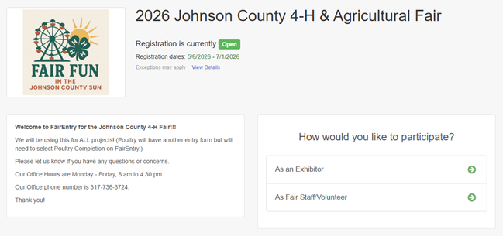
Go to http://johnsoncountyindiana.fairentry.com/
Select “As an Exhibitor” button. A separate box will pop up where you can enter the login email address and password from 4HOnline.
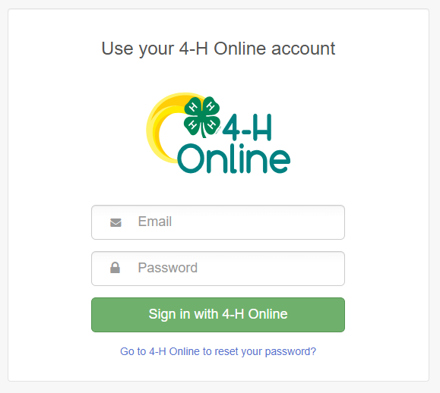
NOTE: If you forgot your password for your 4-H Online account, you need to go to 4-H Online to set a new password. Then use the new password (not the temporary password) to log in to FairEntry.
Click the green “Sign in with 4-H Online” box.
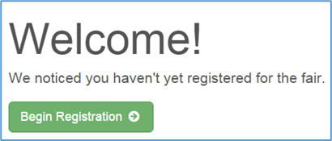
This will take you to the Welcome screen, where you will need to select the green box to “Begin Registration.”

Section 1 – EXHIBITORS TAB
Choose the register an exhibitor button and click the green “Individual” box. There is no payment necessary during this process.
Choose the dot next to the name of the 4-H’er you would like to register and then click the green “continue” box.
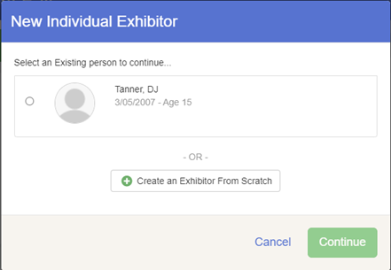
Please do not create any exhibitors from scratch, as you will not be able to add exhibits for the projects you are enrolled in.
Review the exhibitor registration information.
Make any necessary corrections (using the green edit boxes). Remember that any corrections made here DO NOT transfer back to your 4-H Online Account. Please contact the Extension Office to update your 4-H Online Family profile.
Complete the required questions (for livestock: all the questions) and then select the green “Continue” box.
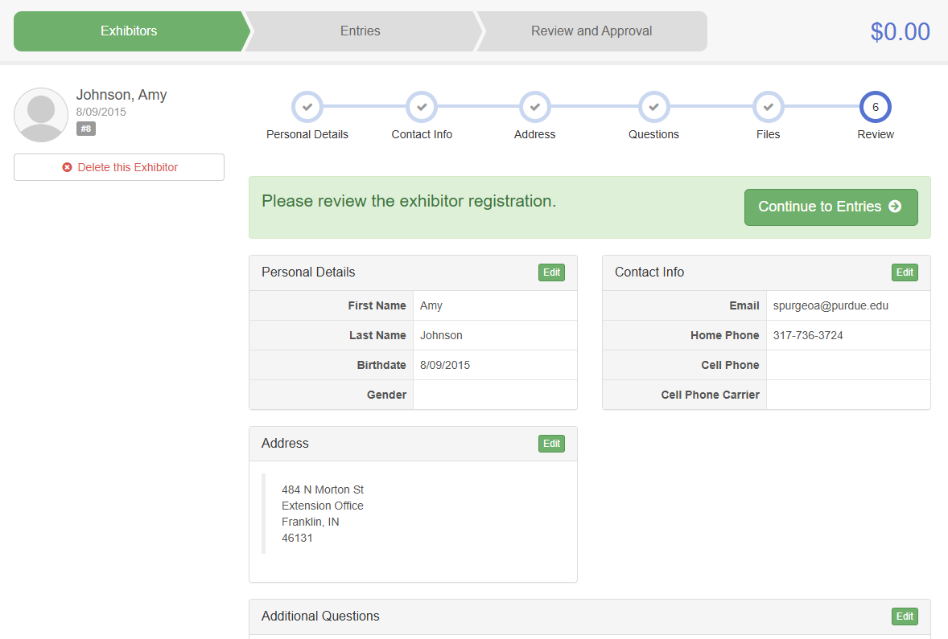
When you are taken back to the Exhibitor information page, click the green “Continue to Entries” button

Section 2 – ENTRIES TAB
Each exhibitor can have multiple entries. One entry must be made for each item, animal, class, etc. For example, if an exhibitor is bringing 2 photographs, two entries into the photography class must be created. If an exhibitor is showing one horse in 5 events, five class entries must be created. Once all entries have been created for the first exhibitor, you have the choice of registering another exhibitor or proceeding to check-out (submitting the entries, whether or not fees are charged).

Click the green “Add an Entry” box to the right of the exhibitor’s name.
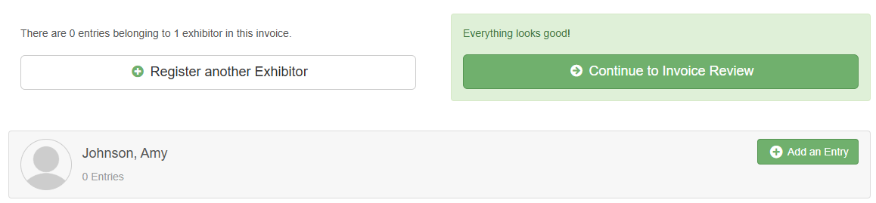
Click the green “Select” box next to the Department you would like to enter. Any departments that are not available for entry will be noted as “Not Available” with a short explanation.
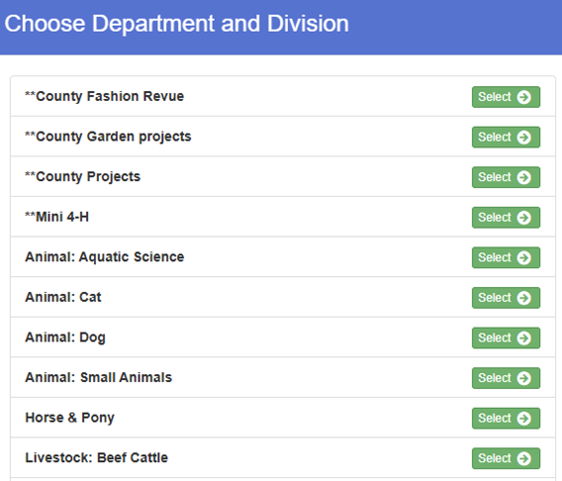

Click the green “Select” box next to the Division you would like to enter. (Check the list of FairEntry department and FairEntry division.)
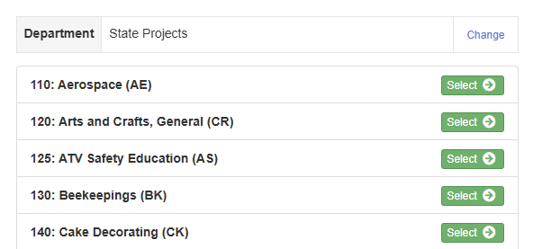
Click the green “Choose” box.
Next it moves to the class selection.
Most Departments and Divisions are set up for single entries. Select the appropriate class and then click continue.
Some Departments and Divisions (Mini 4-H, Horse, Photography, Animal Education, Garden) allow you to make multiple class entries at one time. Click the small boxes next to the Classes you would like to enter. Then click continue.
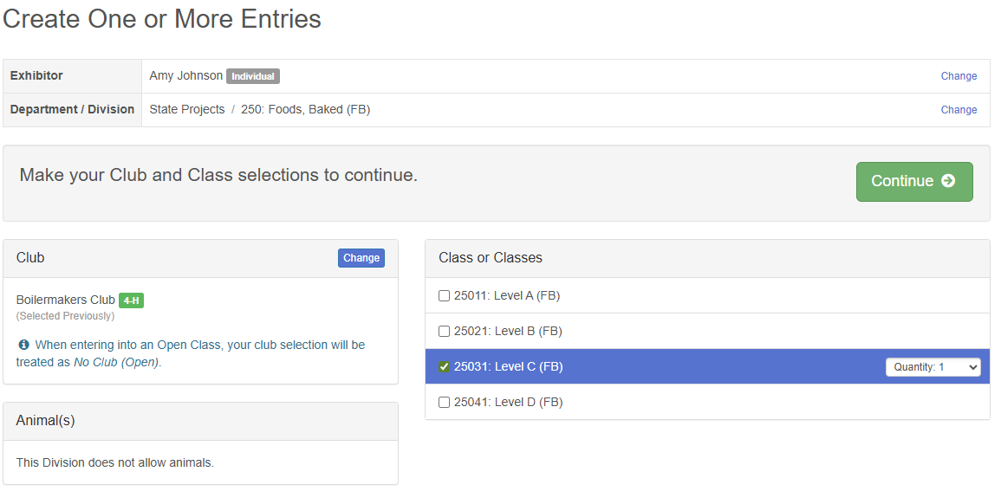
Then you choose your club.
Select the dot next to the 4-H Club that you belong to and then select the green “Continue” box.
Review the selection of the Department, Division and Class. To correct errors in the Department or Division, click the corresponding blue ‘Change’ button in case you mistakenly select an incorrect department or division.
Click the green ‘Create Entries’ button to move to the next step.
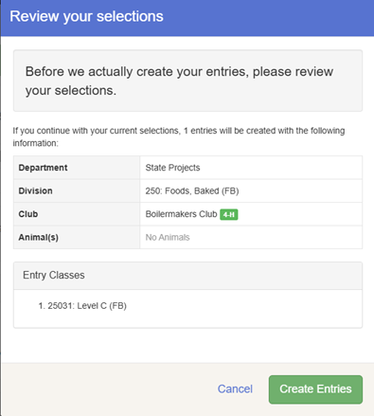
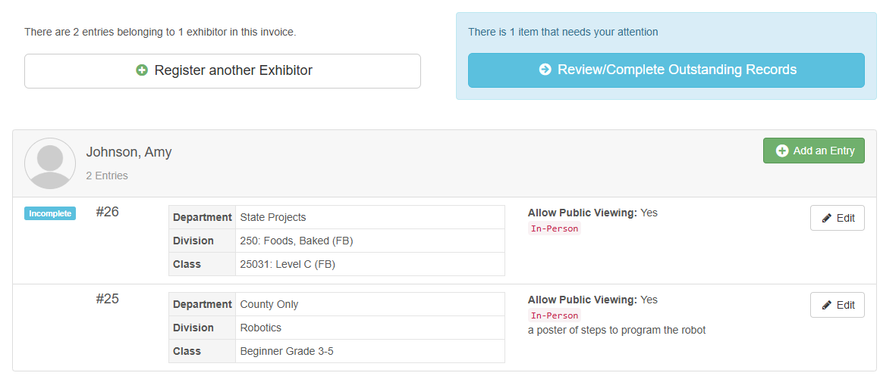
Answer any Additional Questions required for that entry.
Next, enter in a description of your exhibit (if required, some are not required and can be left blank) and click blue “Continue”.
(Short Description - please be specific as this description for non-animal exhibits will be used to distinguish between exhibits, example – don’t just type in “photo”, type in something descriptive, such as “Butterfly on leaf photo” or “Blue shorts”. We only need to be able to identify the item, this is not seen by the project judges.)

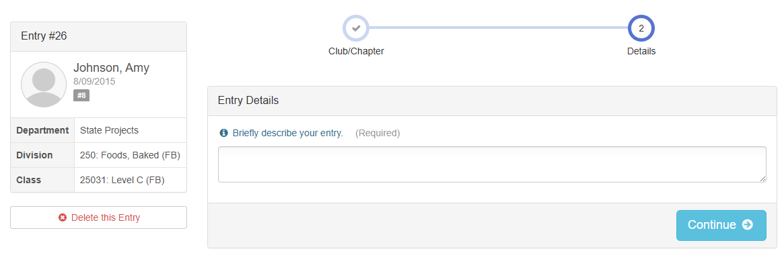

When each class entry is complete, you have three choices for what to do next:
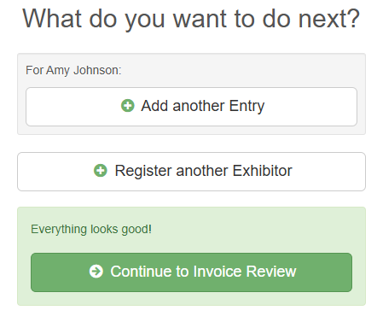
- If this exhibitor has more class entries to make, you can Add another Entry
- If all class entries have been completed for one exhibitor, you can Register another Exhibitor in this family.
- If all entries for all exhibitors in the family have been completed, Continue to Invoice Review (or Payment) to finalize and submit your entries.
**The payment section is a formality of the system. No payment is needed, but you must go through the steps to submit your entries.

Section 3 – ANIMAL ENTRIES
The first two steps of selecting a department and division are similar. Once those elections are made, the exhibitor will be asked to first select a class.
Most livestock and horse classes will require you to “Add an animal”. Click the button and a new screen Adding an Animal will appear. “Choose an Existing Animal Record” option will import and allow you to select from animals enrolled in 4-H Online that match the animal type for that class.
Review, Department, Division Class and Animal. Then click on green “Create Entries” box.
**To enter a Cat or Dog – you will put in a description in the entry, do not add an animal.
**Poultry/Pigeons/Waterfowl will complete a Google Form through the poultry project leaders but be sure to enter a Poultry Completion entry. Look for a separate email.
All of the information about that animal will be pulled over from 4-H Online, so that you can check to make sure that is the correct animal. If you want to switch to a different animal, click on the “remove from entry” box. If it is correct, click the green “Continue” box.

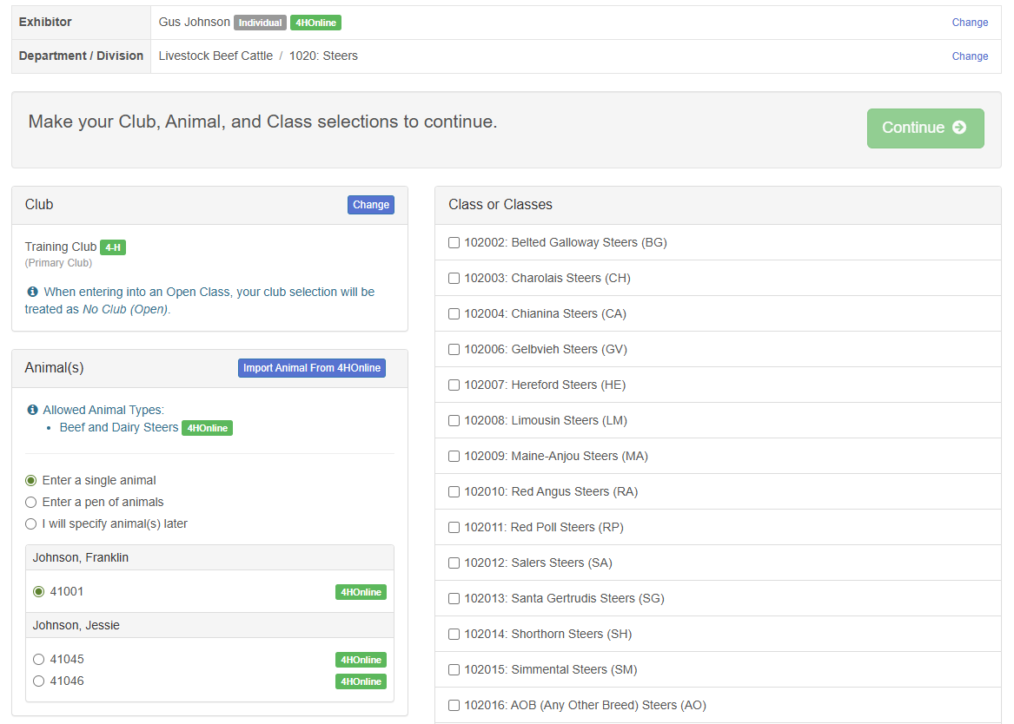
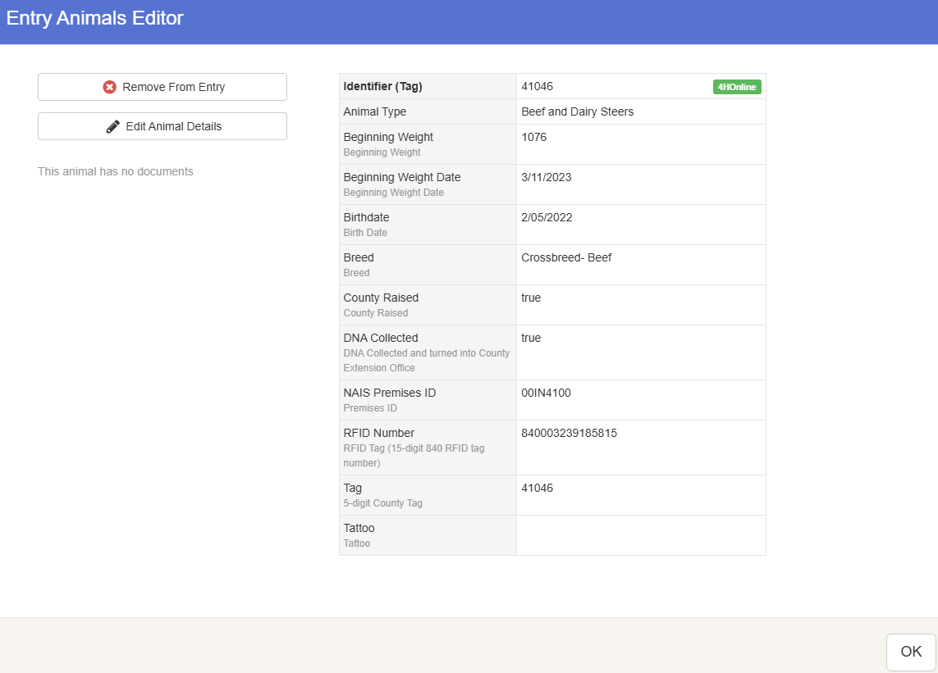

This then takes you to answer any Additional Questions required for that entry.

Section 4 – PAYMENT TAB
***The payment section is a formality of the system. No payment is needed, but you must go through the steps to submit your entries. It is best to enter all entries for all exhibitors in your family before completing the Payment and submission steps.
Review your invoice, in either summary format or detail format. If it looks correct, click the green “Continue” box. If not, go back to the entries tab and fix what you need to.
Select the green “Continue box.
Continue to confirm and submit your entries.
- NOTE: Once you hit submit, you cannot edit your entries. (Also, if you hit submit it will not allow you to enter another exhibitor until our office approves the submitted entries.)
Click the Submit button to submit your entries.
You will receive a “Thanks!” message. You can choose the button to “Visit Dashboard” to see your entry.
Check your email inbox for a confirmation email with a list of your entries.
You will receive a second email from FairEntry letting you know if your entry was approved or rejected by the County Extension Staff. If part of your entry was rejected, a reason will be listed and you will be able to log in and fix the problem before submitting that entry again.
Please contact the Johnson County Extension Office if you have any problems with this process at 317-736-3724 or email spurgeoa@purdue.edu to contact Amy Spurgeon, 4-H Secretary. Office Hours are 8 am to 4:30 pm, Monday through Friday.
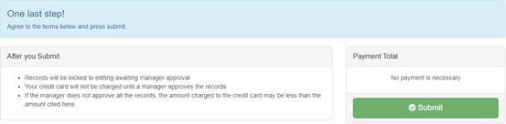

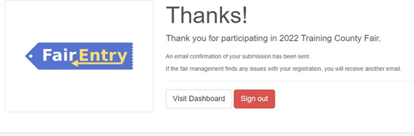

Reviewed 5/27/26 for ADA 508 A. Spurgeon

