Name: 4-H Club

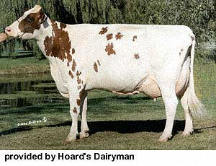
Identification: Please write the breed name (Ayrshire, Brown Swiss, Jersey, Guernsey, Holstein, Shorthorn) on the line below the picture.

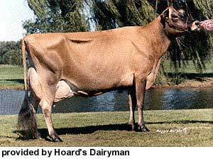
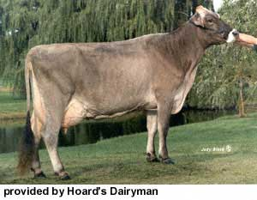

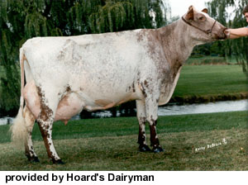
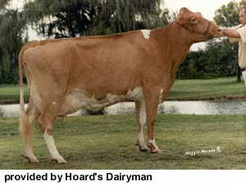
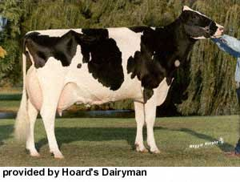

Part Identification: Please write the correct part name (back, hock, hoof, muzzle, pin bones, poll, switch, tailhead, teats) on the line provided with the correct letter.
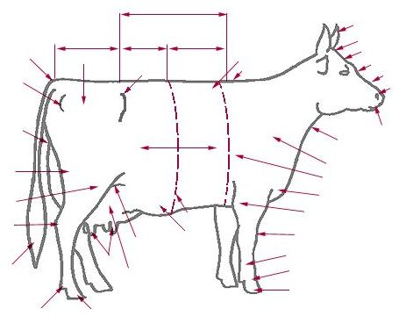
B
C
D
A.

B.
E
C.
D.
E.
A
F.
G.
H.
F
I.
I
J.
G
J
H
Care, Housing & Safety - Fill in the blanks: Please write the correct answer on the line provided to correctly complete the statement.

1. New animals entering your herd should be isolated from the rest of the herd for days to stop the spread of .
2. To safely handle an animal, you must be aware of the animal’s zone or zone. This zone is known as the space around them.
3. Cattle, sheep and hogs have panoramic vision causing a
for the animal. Swine and cattle are -blind.
4. If housing your calf in a hutch, what size should the hutch be? feet X feet
5. If your calf is in a pen by itself, what size should the pen be? feet X feet
6. Loose housed animals should have to square feet of bedded area per . There should be and available at times.

Basic Show Equipment Word Search: Please use the word bank below to find the show equipment in the puzzle below, circle or draw a line through the words in the puzzle.

C M R O F I N U E T I H W O X H V I
S L U D Y F S E V R H Y I O F U H B
D H E F T S G W Y V A E F P Q Y Q Q
E Y O A B H R K E P E I Z M N V P A
Word Bank:
CLEANING EQUIPMENT
CLIPPERS
ROPEHALTER
SHAMPOO
SHOWBOX
SHOWHALTER
WHITEUNIFORM

K H U W N M V U J W Q S W A B N B A
G D Z D H I F K T L U H O H A M O C
O K A A A A N R W V S P J S W S J O
R R D Y Y R L G H Z X P T L R Z U W
R F T U K D M T E I S Q Z E W Z I P
H O D U M Z R Y E Q E Y P W D M P I
Z Q P G N H J X G R U P W B U J Z W
Y Y Z E T D O D F T I I C P J J O T
L Q F M H B L D P L W V P O Q A T A
C O Y K W A I Y C L Y Q L M E I F Z
W M C O M J L I S I Z F C F E G V G
C X H J P M Y T Y V X I F E T N K F
L S G D P V S B E Z P D X M G V T E
W V N G J K R L J R C V M V Z O J H

