Name: 4-H Club

Matching Identification: Please write the letter of the correct breed name with the matching color descriptions of the breed.

1. Shorthorn A. range from a light brown to gray; nose, hooves
and switch are all black
2. Ayrshire B. red, red and white or roan
3. Jersey C. shade of fawn, being either solid or with white
markings; skin has a yellow pigmentation
4. Holstein D. red and white coloring; the markings on the
animal can vary being almost all red or almost all white
5. Brown Swiss E. vary greatly from being mousy gray to a dark
fawn color to being almost black
6. Guernsey F. black and white or red and white

Part Identification: Please write the correct part name on the line provided with the correct letter.
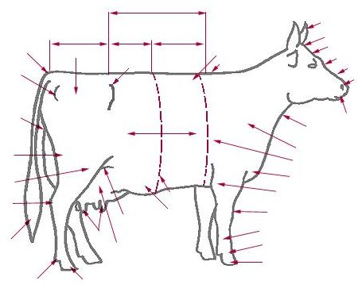
A.
A

C
D
B.
B
C.

D.
E.
F.
G.

H.
J
I.
E
J.

G
I

F
H
Care, Housing & Safety - Fill in the blanks: Please write the correct answer
on the line provided to correctly complete the statement.

1. If you have a registered Jersey cow, what breed association would you get your registration paper from?
More information can be found about this breed association by visiting what world wide website address?

2. The a person enters the comfort zone of an animal without allowing the animal time to the severe the reaction may become.
3. Swine and cattle are color-blind and have poor perception.
4. Most animals are creatures of . Most animals have a strong territorial instinct and develop a sense of .
5. Generally calves are housed individually from to to prevent transfer from -to- contact.
6. Hutch fronts should face or in the winter, especially in cold climates, to provide calves with exposure to the and protection from the winds.
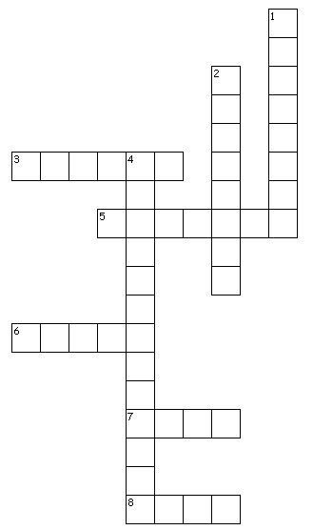
7. There should be at least waterer for every to cows and it should be easy accessible.

Basic Show - Cross Word Puzzle:
Please use clues below complete the puzzle to the right.

Across:
3. used to lead and control your animal
5. develops self-confidence
6. color you wear in the show arena
7. the first thing you need to teach the animal for the fair
8. best place to start clipping animals

Down:
1. regularly will make the hair coat soft and shiny
2. is the key to showing dairy
4. should be completed before the fair

