Name: 4-H Club

Matching Identification: Please write the letter of the correct breed name with the matching mature cow weight.

1. Holstein A. 800 – 1, 200 pounds
2. Jersey B. 1,100 – 1, 200 pounds
3. Guernsey C. 1,200 – 1,300 pounds
4. Shorthorn D. 1,300 – 1,400 pounds
5. Ayrshire E. greater than 1,500 pounds
6. Brown Swiss

Part Identification: Please write the correct part name on the line provided with the correct letter.
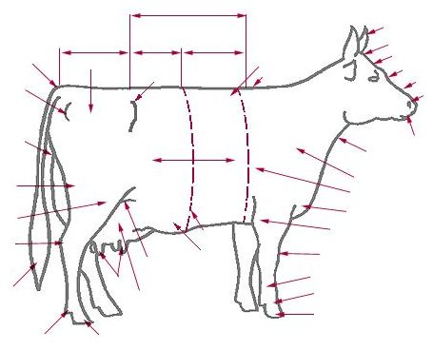
A.
B.
C
D
C.
E
D.
E.
F
F.
B
G.
A
H.
G
J
I.
J.
I
H
Care, Housing & Safety - Fill in the blanks: Please write the correct answer
on the line provided to correctly complete the statement.

1. DHIA provides computerized dairy production records for cows and herds to help dairy producers manage their and the best breeding stock. What does DHIA stand for?

2. The point of balance of an animal is the .
3. This instinct in dairy cattle causes animals to want to stay together.
4. can be transmitted between humans and animals.
5. Dirty wet stalls contribute to higher instances of , which is an or of the mammary gland; this is the most dairy cattle disease.
6. The recommended number of pens for maternity or sick cows is pens per animals. Maternity and sick pens should be
feet x feet or feet x feet.
7. Hutch fronts should face or in the winter, especially in cold climates, to provide calves with exposure to the and protection from the .
8. There are main types of milking parlors. What are the names of the milking parlors and how are the cows situated in each?
a) -

b) -

c) -

9. What are the basic needs for showing dairy cattle?

