Name: 4-H Club

Part Identification: Please write the correct names of the udder parts near the arrow identifying the part.
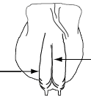

Careers, Milk Pricing, Production, Mammary Health & Reproduction - Fill in the blanks: Please write the correct answer on the line provided to correctly complete the statement.

1. When was the FMMO authorized by congress? .
2. How many FMMO’s are there?
3. Indiana is in the same FMMO as Ohio, which order is Indiana in?
4. The front quarter are smaller that the rear quarters and secrete approximately percent of the milk.
5. Approximately to pounds of blood must pass through the udder and around the alveoli for each of milk produced.
6. How much does an empty udder range in weight? to pounds.
7. What are the two major roles of the female reproductive system?
8. The female reproductive system has how many major organs?
9. The male reproductive system has how many major organs?
10. What is the major function of the male reproductive system?
11. What are the 4 major areas of career groups in animal sciences?
A. B.
C. D.
12. Your experience in 4-H has given you many that employers are seeking.
13. What are the four of the six characteristics learned in 4-H?
A. B.
C. D.
Dairy Products Cross Word Puzzle: Write the correct answer in the spaces provided for each phrase.

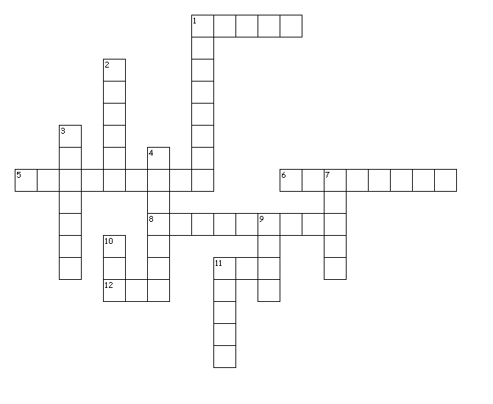
Across
1. Mild cheddar cheese is aged for how many days
5. 1% and 2% milk is made by mixing what with skim milk
6. Milk is stored between 32-40 degrees to prevent what from growing
8. Pounds of milk needed to make a pound of butter
11. Federal organization which highly regulates the dairy industry
12. Pounds of milk needed to produce one pound of cheese
Down
1. What product is an end result of separation
2. The most milk product consumed in the United States
3. Your body needs this from milk to grow strong muscles
4. Pounds of milk needed to make one gallon of ice cream
7. What product is an end result of separation
9. Sharp cheddar cheese is aged for how long
10. Is commonly used for making juice and coffee creamers
11. The type of pasteurization most modern processors are using

