Name: 4-H Club

Part Identification: Please write the correct part from the anatomy of the mammary gland on the line provided.
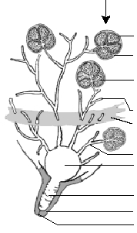
A.
B.
C.
D.
E.
F.

Careers, Processing and Production - Fill in the blanks: Please write the correct answer on the line provided to correctly complete the statement.
1. What is a career area for an individual who enjoys working with animals?
2. A career in agribusiness is where many people are needed to the and needed in producing livestock.
3. People who assist and provide services to producers and consumers have a career in
and agencies.
4. When preparing for a career, what is normally considered a basic requirement?
5. The characteristic of is acquired through judging contests.
6. What is the FDA?
7. When milk is picked up at the farm a sample is pulled from the bulk tank to test for
8. What is Artificial Insemination (AI)?
9. Heating up of milk to kill any disease causing organisms is known as .
10. What is whey?

Milk Production Cross Word Puzzle: Write the correct answer in the spaces provided for each phrase.
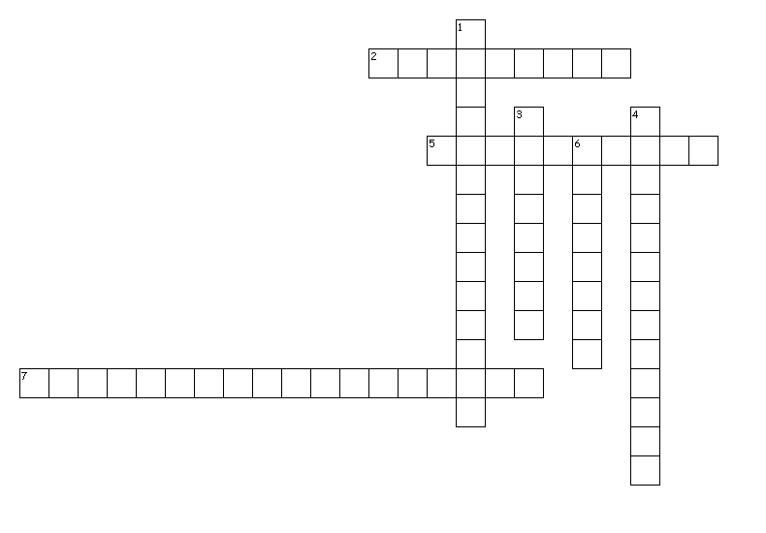
Across
2. Maintain a constant stable vacuum in the line
5. Mechanical device that extracts and exhausts air from a system to create vacuum
7. Two systems consist of the manual system of the CIP system

Down
1. Proportion of the cycle that is in the milk phase versus the rest phase
3. Automatic air-vacuum valve that directs atmospheric air into hoses and chambers between the teat cup liner and the shell
4. Number of times the teat goes through the rest and milk phase
6. Part of the machine that is suspended from the cow and performs the milking operation and receives the milk

