Name: 4-H Club

Careers, Pricing - Fill in the blanks: Please write the correct answer on the line provided to correctly complete the statement.

1. If you were interested in a career in the health and care of animals, then what would be a logical choice?
2. If someone is interested in being around livestock but not interested in the production should become involved in .
3. If you were to take a career in agribusiness, what would it be and why?
4. and offers opportunities for those with inquiring minds who want to help other people.
5. When preparing for a career in the livestock industry one should take what science courses? Plus their mathematics courses should include
6. What are three characteristics milk has that create challenges in marketing.
A.
B.
C.
7. What components in milk determine milk prices?
A.
B.
C.
8. The suspensory ligaments are and
, they start high above the udder and come down the sides of the udder and across the bottom to join the .

Matching Mammary Health: Please write the letter of the definition with the matching word related to mammary health.

1. Clinical A. inflammation or infection of the mammary gland
2. Mastitis B. no visible changes in the milk, udder or cow, but SCC
are above normal
3. WMT C. quick and easy mastitis test done in the parlor
4. SCC D. visible changes in the milk
5. Subclinical E. somatic cells in the milk, greater than 150,000 indicates
mastitis problems
6. CMT F. bulk samples to test for mastitis

Reproduction Basics Cross Word Puzzle: Write the correct answer in the spaces provided for each phrase.
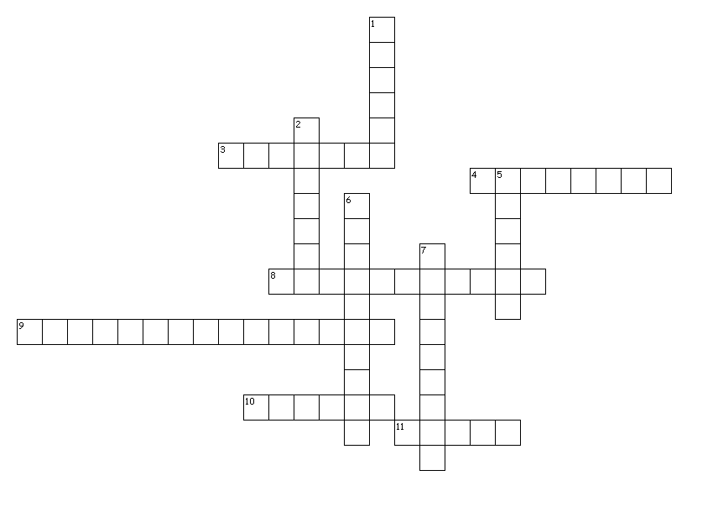
Across
3. Produce eggs, estrogen and progesterone
4. Site of fertilization
8. Tubes that transport sperm during mating
9. Add fluid to transport sperm to the female
10. Protects the uterus and part of the birth canal
11. Delivers sperm into the female during mating

Down
1. Site of growth and development of the calf
2. Tube that transports sperm and urine
5. During natural mating sperm are deposited
6. Temporary storage and maturation of sperm
7. Secrete testosterone and site where sperm are produced

