Name: 4-H Club

Nutrition - Fill in the blanks: Please write the correct answer on the line provided to correctly complete the statement.

1. How many compartments does a cows’ stomach have?
2. A cows’ rumen can hold gallons of material.
3. Cows are ruminants, give 3 other examples of animals which are ruminants.

4. What are the six essential nutrients for dairy cattle?

5. What is called a honeycomb and why?
6. What does the abomasums do in the digestive process?
7. What is the esophageal groove?
8. What is the function of zinc to a dairy cow?
9. What is the purpose of vitamins in a dairy cow?
10. What is colostrum and why is it some important to calves at birth?
11. What are the three main feeding systems?

12. What are the nutrient requirement stages of lactating dairy cows?

13. At what age should you start feeding your calf small amounts of hay?

Feed Tag Cross Word Puzzle: Write the correct answer in the spaces provided for each phrase.
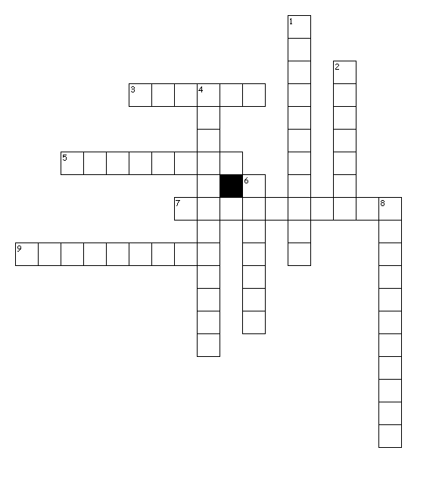

Across
3. antibodies manufactured from the animals immune system
5. feeds containing all nutrients required for animals
7. information on the various ingredients in the feed
9. statement tells the purchaser the weight of the feed

Down
1. products added or mixed into the feed
2. antibodies transferred from the mother to the calf
4. information on how the product should be fed
6. name that is always present on a feed label
8. company responsible for making the feed

