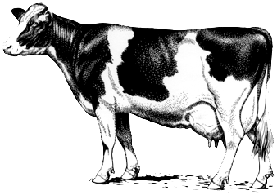

LaGrange County 4-H
Dairy Leasing Agreement

I, , agree to the items cited below relating to leasing a dairy animal for the LaGrange County 4-H Dairy project. I realize that I may be removed from this program at any time, or not allowed to participate in future years, if I do not abide by these guidelines.
I agree to:

- Treat all animals in a kind and humane manner.
- Show good sportsmanship and behave in a respectful manner to others.
- Have the same rules apply for leased animals versus enrolled animals.
- Fill out the State 4-H Dairy Enrollment and Ownership Form and return it to the Extension Office by May 15.
- Attend to the animals a minimum of three (3) times a week, if not housed at residence.
- Bathe and trim all the animal(s).
- Help with 4-H Fair set-up and clean-up.
- Provide daily care of the animal(s) at the county 4-H Fair, which includes feeding, as well as, continuous watering and clean-up.
- Dairy heifers and cows are to arrive at and remain on the 4-H Fairgrounds during the week of the 4-H Fair as defined in the county or fair rules.

We, the undersigned, do agree to all the terms listed above.
4-Hers name: Date:
Parent or Guardian: Date:
Animal Leaser: Date:
4-H Dairy Superintendent: Date:

