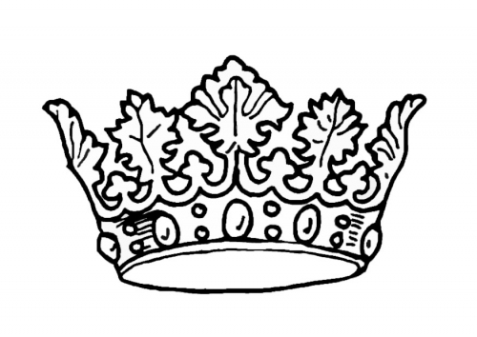

2024 Miss Montgomery County 4-H Queen/Princess Entry Form
Name:________________________________________________________________________________
Age:___________________________________ Birthdate:_____________________________________
Address:______________________________________________________________________________
Home Phone Number:_________________________ Cell Phone Number:________________________
Email:________________________________________________________________________________
Parent(s) or Guardian(s) Name(s):_________________________________________________________
Parent(s) or Guardian(s) Phone Number(s):__________________________________________________
4-H Club:_____________________________________________________________________________
Number of Years in 4-H:_______________________
Contestant Signature:___________________________________________________________________
Parent Signature:_______________________________________________________________________

This form must be emailed to nikkigalloway80@gmail.com by Friday, May 17th, 2023.
**LATE ENTRIES WILL NOT BE ACCEPTED**
**There will be a Call-Out Meeting for the contest on Sunday, May 19th at 6:00pm in the Exhibit Hall**

