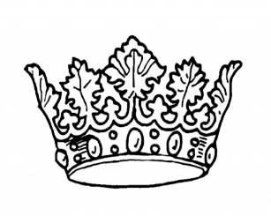

2024 Montgomery County Pork Queen Entry Form
Name:________________________________________________________________________________
Age:___________________________________ Birthdate:_____________________________________
Address:______________________________________________________________________________
Home Phone Number:_________________________ Cell Phone Number:________________________
Email:________________________________________________________________________________
Parent(s) or Guardian(s) Name(s):_________________________________________________________
Parent(s) or Guardian(s) Phone Number(s):__________________________________________________
4-H Club:_____________________________________________________________________________
Number of Years in 4-H:_______________________ Number of Years in Swine Project:_____________
High School:__________________________________________________________________________
Contestant Signature:___________________________________________________________________
Parent Signature:_______________________________________________________________________
Why do you want to be the Montgomery County Pork Queen:___________________________________
_____________________________________________________________________________________
_____________________________________________________________________________________
_____________________________________________________________________________________
_____________________________________________________________________________________
This form must be emailed to Morgan Bible at morganmeadows02@gmail.com no later than Monday, June 3rd, 2024.
Interviews will take place on Wednesday, June 26th, 2024. Queens will be announced at a reception for all contestants immediately following the interviews, and Queens will receive their crown and sash on Saturday, July 6th during the intermission of the Miss Montgomery County 4-H Queen Contest. More info to follow.

