Historian Officer Guide

The historian keeps a record of the club’s activities. This may involve taking photos as well as organizing news clippings, mementos of events and programs, etc. These items may be kept in a scrapbook, on a web page, etc.

Here is an example of a 4-H Historian’s record:

Rough Riders 4-H Historian Page
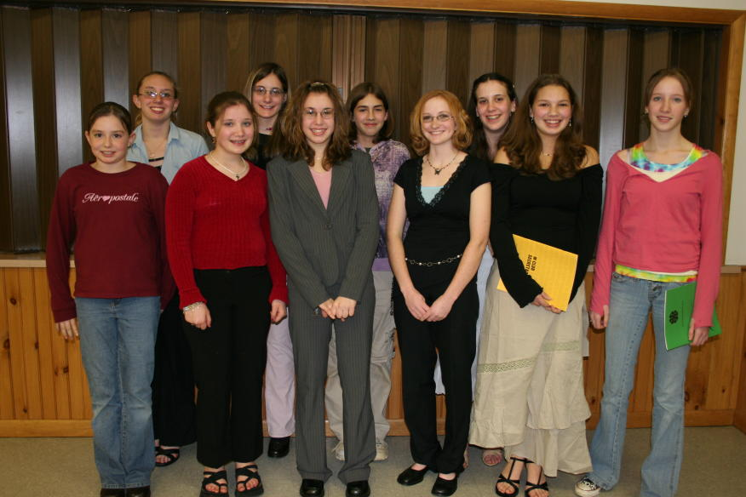 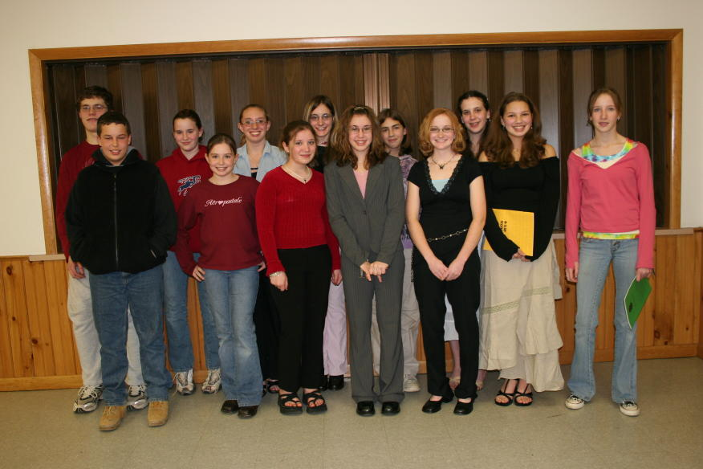
2018 Officers 2018 Members
click on pics to enlarge
October Show Costume Class
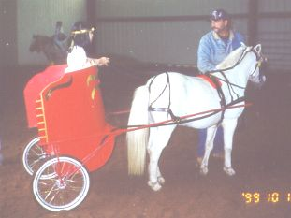. .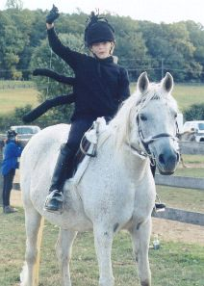. ..
CONGRATS to TARYN PJA Pony Jumper Champion and PJA Hopeful Jumper Champion
Way to go!! We are VERY proud of Taryn and Flash!!

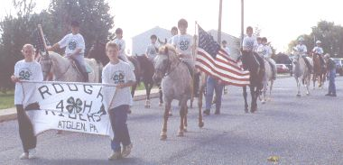 ..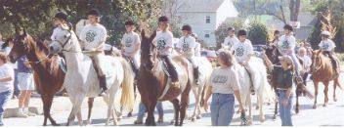
Rough Riders participated in the Atglen Parade in October 2017
4-H State Horse Show
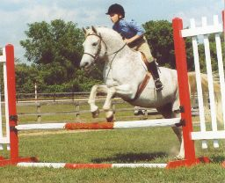................................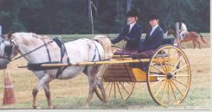
WON Pony Hunter Hack 2017 3rd place Pony Driving 2017

Here’s another example of a 4-H Club web page…
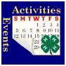 |   History  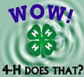  Prairie 4-H Club is one of the oldest clubs in Crawford County. It was formed in 1949 with Leonard Blackwell as the Community Leader and Eva Stewart as the Assistant Club Leader. Howard Breuer holds the honor of being the first Club President. Since that time hundreds of members have benefited from their affiliation with the club.  In the years before her death, Eva Stewart would often comment that the club had initially been formed to give the children in the community something to do, but in more recent years our youth are so involved with other activities that we sometimes have to “work in 4-H.”  When the club was first formed projects were more farm and home-life related (i.e. cattle, hogs, crops, cooking and sewing) while today our members are involved in many different projects (i.e. computers, photography, shooting sports, leadership, arts and crafts) as well as those original projects.  We also find time every year to do community service projects, such as trash pick-up along a portion of Highway F and decorating the Catholic Cemetery fence with an evergreen swag at Christmas.  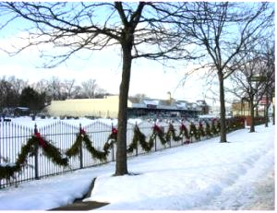  One of our main focuses during the year has always been the Crawford County Fair. This is where our members have always learned to become the “Prairie Family,” rather than just a Club of disjointed participants. The comraderie, teamwork, and true friendships formed are attributes and memories our members carry with them for a lifetime. It is heartwarming to watch the older members guide and help the younger members---and we all revel in any accomplishment by one of our members.  Page last updated September 2, 2018
  2018-2019 Officers
  President:
  Vice-President:
  Secretary:
  Treasurer:
  Reporter:
  Game & Song Leader:
  Historian:
  Parliamentarian:

