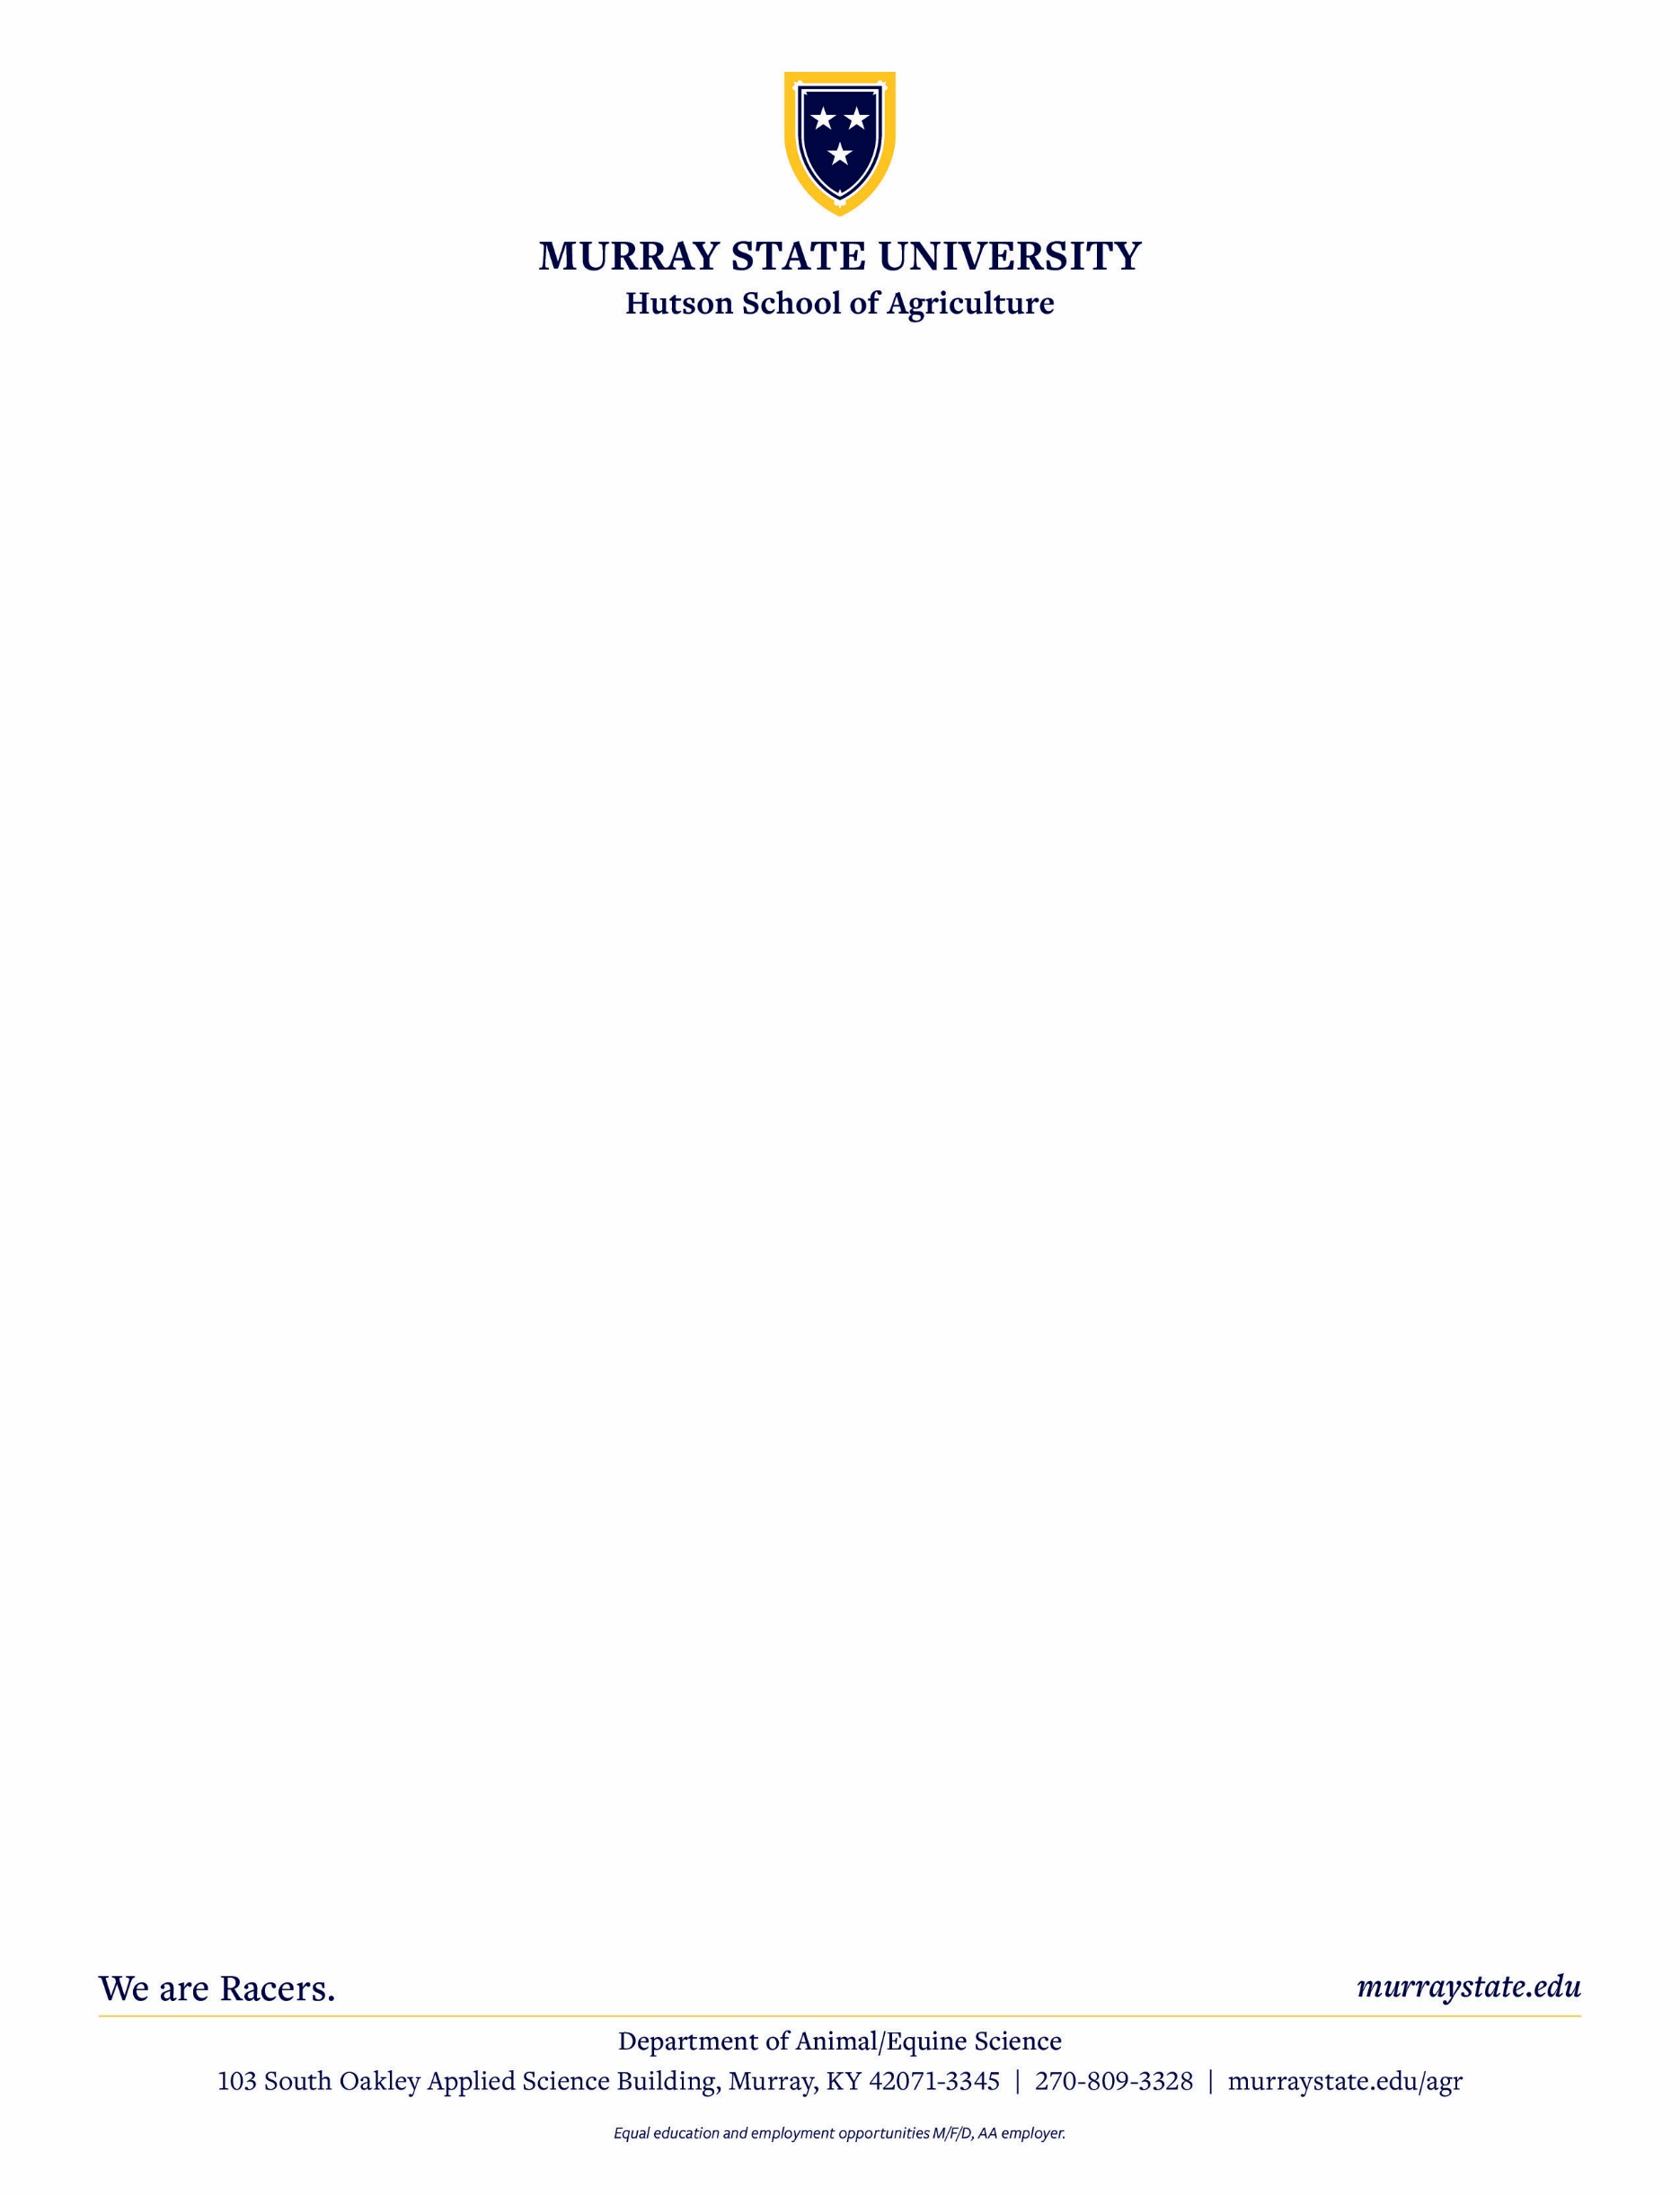

**Murray State University**

**Block & Bridle**

**“Shoes Up” Classic**

   



**2nd Annual 4-H/FFA Livestock Judging Contest**

**Saturday, April 26th 2025**

**TURN OVER  
 (More info on back)**

#### GENERAL RULES

1.) ELIGIBILITY:

Competition is open to 4-H and FFA Members. There is no limit on the number of teams that may come from a State, 4-H Club, or FFA Chapter.

**Junior 4-H/FFA Division:** 4-H and FFA members that are between 9 and 13 years old on January 1, 2025

**Senior 4-H/FFA Division:** 4-H and FFA members that are between 14 and 19 years old on January 1, 2025

2.) **Entry Fee: $25 per person**, **Make check payable to: MSU Block & Bridle. If you pay the day of the Contest it will be $30**

###### Entry Forms MUST be completed and Checks MUST be received by FRIDAY, APRIL 18th. Address to mail checks is BELOW.

###### Entry form is available at: [https://sites.google.com/murraystate.edu/shoesupjudging/home](https://protect.checkpoint.com/v2/___https://sites.google.com/murraystate.edu/shoesupjudging/home___.YzJ1OnN0YXRlb2ZpbmRpYW5hOmM6bzoyYmU3Y2RlMDkzNzZmMjkyZjhjY2M3YWRlYzlhMGY0Yjo2OjMyYzQ6MTMyNzE1MzExYjAwODQ3YmJhNzJjOTc3MmY5OGI1ZWJmOTFkYjE5ZGM4MTE5ZGNhYWFjZjYyMDg4ZGZmZjBiYTpwOlQ6Tg)

3.) **There will not be a Novice Division, BUT those under 4-H age (less than 9 years old as of   
 January 1st 2025) wishing to participate will be eligible to “move up” and compete in the Junior 4-H/FFA Division.**

4.) The Junior 4-H/FFA Division and the Senior 4-H/FFA Division will consist of a maximum of ten (10) members per team and a minimum of three (3) members per team with the top three (3) scores constituting the team score. Coaches may choose how you wish to enter your team members in regards to the number of members that you have. States, 4-H Clubs, and FFA Chapters may have multiple teams**.**

**If JUNIOR AGE 4-H/FFA MEMBERS wish to “move up” and enter the SENIOR 4-H/FFA Division that WILL BE ALLOWED.**

5.) CLASSES:

**Junior 4-H/FFA Division:** Will consist of 12 placing classes and 2 sets of 10 questions and 1 set of oral reasons

**Senior 4-H/FFA Division:** Will consist of 12 placing classes and 4 sets of oral reasons

6.) Teams are to report to the William “Bill” Cherry Ag Expo Center Lobby (2101 College Farm Road, Murray, Kentucky 42071)

Team check-in/final instructions will take place from 8:00am – 8:30am, with the Contest to start promptly at 8:45am.

7.) You **WILL** be able to add Contestants the day of the Contest, for **$35** per contestant and you may substitute contestants for no additional

charge as long as your check was received by APRIL 18th.

8.) All contestants must have a #2 lead pencils. All contestants must bring their own notebooks or paper for taking notes for oral reasons and questions. Participants will be provided a contestant number that will identify them throughout the duration of the Contest.

9.) Since members from a county may be in the same group, please instruct your members about not talking to anyone but a group leader. Talking or conferring during the contest is prohibited. The contestant cannot wear any markings, clothing items or jewelry that reveals identity or area of residency. **Personal communication devices are prohibited**. **Contestants talking to anyone but a group leader may be disqualified.**

10.) Contestants will be allowed twelve (12) minutes to evaluate all classes. Signals will be given to start the class and at various intervals

to indicate time remaining. When the final signal is given, contestants will turn their back to the class.

11.) Lunch will be provided for all contestants during a break period in the contest.

12.) The Executive Committee of the Murray State University Block & Bridle Club will interpret and enforce all rules contained here within and

will rule on any other matters that may occur, of which, their decision will be final.

###### MAIL CHECKS TO (made payable to Murray State Block & Bridle) FOR QUESTIONS on REGISTRATION: FOR MORE INFORMATION: Dr. Thomas Powell Jason P'Pool Murray State University Murray State University Phone: 270-809-3867 208 South Oakley Applied Science Building Email: [tpowell23@murraystate.edu](mailto:tpowell23@murraystate.edu) Murray, Kentucky 42071

###### Cell: 334-703-1047

###### Email: [jppool2@murraystate.edu](mailto:jppool2@murraystate.edu)