MINI
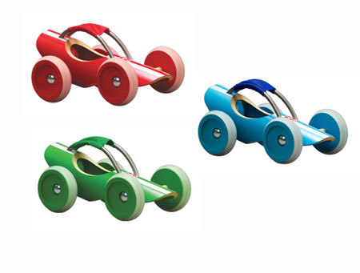

4-H
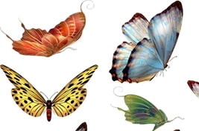
COLLECTIONS

MINI 4-H COLLECTIONS

Building a 4-H collection is fun! Sometimes when you see something that you think is different or interesting, you save it. When you find another one like it, and add it to the one you’ve already saved, you have the start of a collection!

As you are building your collection, you may wish to keep your special collection in a box, or book or display it on a shelf at home. Your mother or father, older brother or sister will help you select your materials and ideas for your collection project. They will also help you decide the safest place to keep your special treasures.

Collecting things like stamps or unusual rocks, is not only fun, but it is a great learning experience. Collecting teaches us to be more alert. You have to keep your eyes open for more treasures. Building a collection can help us to be neater. A good collector keeps his collection neat and well cared for. Collecting will help you to become more aware of the world around you. A visit to the library in search of a book about your collection will help you learn more about your specialty. Hopefully, you will learn where the best places are to find your treasures, and how to identify a special variety.

All around the house and yard are many things that make great collections. Most of these cost very little or nothing at all to collect. Once your family and friends know you are a collector, they will want to help you find and save items for your collection.

REMEMBER: Never take something for your collection without permission!

- Choose an item to collect that you like.
- Purchase or gather all materials you need for the project before you begin working.
- Find a place where you can do your work.
- Once you have started your project, finish it.
- Put your collection in a place where it can be displayed.

Here is a list of ideas to help you get started on your new hobby of collecting. Your collection doesn’t need to be limited to these ideas. This is what makes collecting so much fun. A good collection should be at least 5 to 10 things.
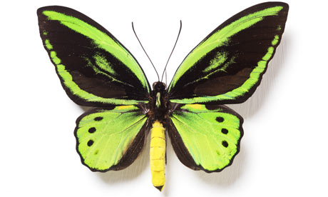
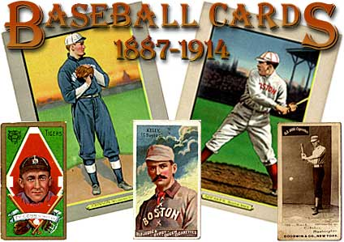
- Butterflies 8. Shells
- Rocks 9. Marbles
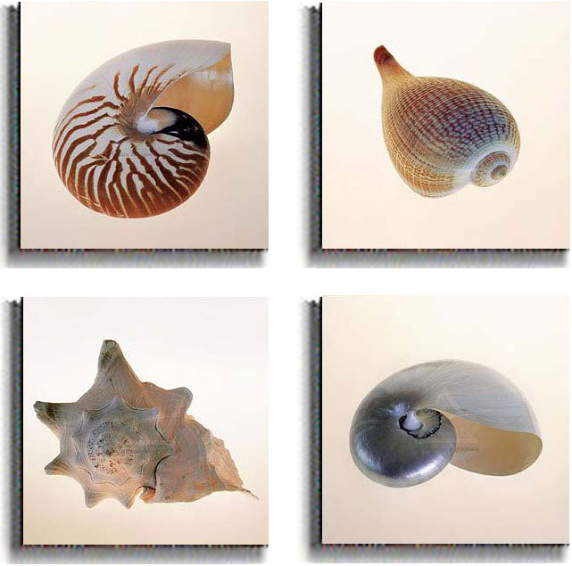
- Bugs 10. Baseball Cards
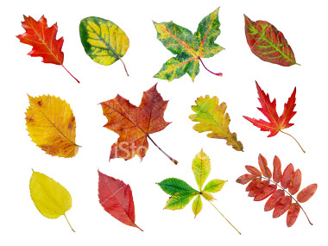
- Stamps 11. Feathers
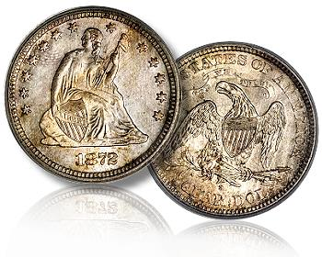
- Coins 12. Dolls
- Leaves 13. Stuffed Animals
- Books 14. Campaign Buttons

These are just a few ideas!!! Have Fun!!!

You will learn:

- To start a collection
- The value of your collection.
- To care for your treasures.
- Where to find items to add to your collection.
- To show your collection.

Mini 4-H Collections requirements

- You must be between grades kindergarten and second grade.
- Exhibit 5 to 10 items for your collections project in a box or on a poster. Identify or label each item in your collection.
- You must exhibit your project at the Warrick County 4-H Fair, held at the Warrick County 4-H Fairgrounds in Boonville, Indiana.
- Your collections project will be displayed in a special Mini 4-H section at the 4-H County Fair.
- There will be suggestions from a judge on your project. You will receive a Mini 4-H Ribbon for exhibiting at the County Fair.
- You must exhibit a different Collections project each year.

You will exhibit:

You must exhibit one of the following. The Warrick County 4-H Extension Educator will tell you when and where your exhibit is to be turned in. A participation ribbon will be awarded to each project exhibited at the fair.

- Take a shoe box or an egg carton and arrange 2 to 5 of your treasures to exhibit. The size of your treasures will decide how many you will use. Decorate the box as you wish. Standard size shoe box must be used.

Or

Perhaps your collection is too valuable to display. (Mini 4-H collections will not be locked up). If so, you may elect to make a poster exhibit as described next.

- Display your poster horizontally. Title the poster “My Collection”. Fill in the label with your name, age, etc., and place it in the lower right hand corner of your poster. Attach 5 to 10 items from your collection to the poster and label each item on the board.

My Collection

Exhibit Tag

When your poster is complete, cover it with clear plastic and tape the wrap to the back of the poster to protect your exhibit.

Name Age Grade
Mini 4-H

