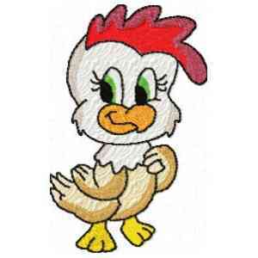
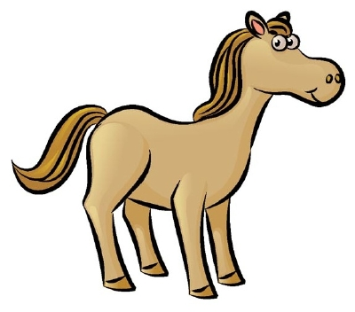
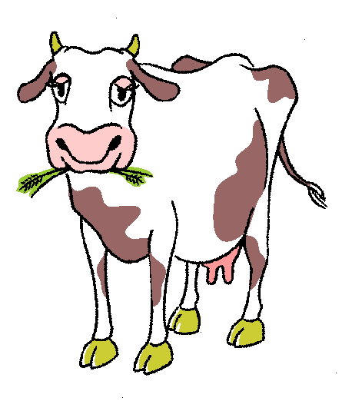
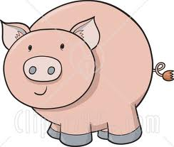
MINI
4-H
FARM
ANIMALS
Welcome to your Mini 4-H Farm Animals Project. I'm sure most of you chose Farm Animals because they are so cute. But did you know that they are a lot of hard work, also? We hope you learn a lot from this project and have lots of fun too.

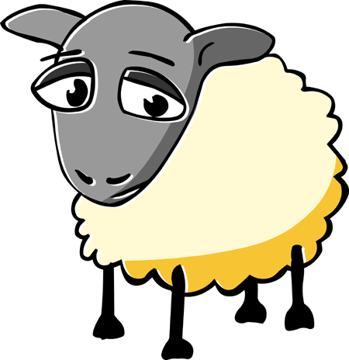
Some of you may live on a farm and already know how farm animals are taken care of. But some of you might live in town or somewhere that doesn't have space for large animals. But that is O.K. If everyone were a farmer, who would deliver the mail or take you to school?

Animals take a lot of work and care. You have to make sure they have plenty of food and water. You need to make sure they have proper housing and that their homes are clean. They need daily exercise and grooming. But most of all they need plenty of attention.

Not only are farm animals very cute, but they are also a very important part of our economy. We need the farm animals for meat, milk, eggs, and all different kinds of food. The farm animals help keep us from going hungry.

But the most important thing you should learn is safety. Yes, farm animals are cute and I know you want to pet all of them. But you should never go near an animal without an adult. Most of the farm animals are very big and could hurt you by accident.

You will exhibit a poster for fair. You could cut out pictures from magazines or you could take your own pictures and paste them on a poster board or draw your own pictures of farm animals. You need to decide what you want to do. For example: Pet Care, Playing with your Pet, Food For Your Pet, Different Breeds of Dogs, etc. Use your imagination and get creative. NO LIVE ANIMALS ARE TO BE EXHIBITED AT THE FAIR FOR MINI 4-H.

REMEMBER THESE THINGS:

- CHOOSE WHAT YOU WANT TO DO FOR YOUR PROJECT.
- PURCHASE OR GATHER ALL MATERIALS YOU MAY NEED FOR THE PROJECT BEFORE YOU BEGIN WORKING.
- FIND A PLACE WHERE YOU CAN DO YOUR WORK.
- ONCE YOU HAVE STARTED YOUR PROJECT, FINISH IT!
- PUT YOUR PROJECT IN A PLACE WHERE IT CAN BE DISPLAYED AND KEPT CLEAN.
- REMEMBER - NO LIVE ANIMALS -- ONLY POSTERS CAN BE EXHIBITED.
The most important thing is for you to have fun and learn something while you are preparing your project.

PREPARING YOUR EXHIBIT

Be sure your Farm Animals Exhibit is clean and neat. Attach the Mini 4-H Exhibit Tag to your exhibit.

MINI 4-H FARM ANIMALS REQUIREMENTS

- YOU MUST BE IN KINDERGARTEN, FIRST, OR SECOND GRADE.
- YOU MUST EXHIBIT YOUR POSTER PROJECT AT THE WARRICK COUNTY 4-H FAIR, HELD AT THE WARRICK COUNTY 4-H CENTER IN BOONVILLE.

Remember, the best place to have a work station for your project is at a table. If you put down paper before you begin to work you will be able to clean-up quickly. And don't we all like quick clean-ups?
