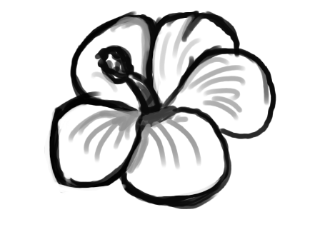
MINI
4-H
FLOWERS

FUN WITH FLOWERS


WELCOME TO THE MINI 4-H FLOWER PROJECT. WE THINK IT'S FUN TO GROW FLOWERS. SO, LETS START BY READING CAREFULLY THE FOLLOWING INFORMATION ABOUT THE FLOWERS YOU WILL BE GROWING.

FIRST, YOU MUST PURCHASE YOUR FLOWER SEEDS. WE RECOMMEND EITHER MARIGOLD OR ZINNIA SEEDS. THEY ARE BEAUTIFUL AND EASY TO GROW. ONE PACKAGE WILL BE PLENTY, AND THEY CAN BE PURCHASED AT ALMOST ANY GROCERY, HARDWARE, GARDEN OR DEPARTMENT STORE.

YOU AND YOUR PARENTS MUST DECIDE WHERE TO PLANT YOUR FLOWER SEEDS. OUTSIDE IN THE GARDEN OR AROUND THE HOUSE WILL BE BEST. REMEMBER, ALL GROWING THINGS NEED LIGHT, WATER, AND FOOD. SO PICK A SPOT WHERE THE SOIL IS RICH AND WELL DRAINED, AND THERE 'S LOTS OF SUNLIGHT.

AFTER PICKING THE LOCATION, YOU ARE READY TO PREPARE THE SOIL. FIRST PICK UP ALL TRASH (STICKS, STONES, PAPER, ETC.) THAT MAY BE LYING ON THE GROUND. IF TOOLS ARE TOO HEAVY FOR YOU, ASK FOR SOME HELP. IF YOU USE A TILLER, HAVE DAD RUN IT. SPADE, TILL, OR PLOW
UNTIL YOU HAVE A FINE LEVEL SEED BED.

READ THE INFORMATION ON THE SEED PACKAGE. IT WILL TELL YOU HOW DEEP AND HOW FAR APART TO PLANT THE SEEDS. BE VERY CAREFUL AND DO NOT COVER MARIGOLD OR ZINNIA SEEDS WITH MORE THAN 1/4" OF SOIL. JUST BARELY COVER THE SEEDS. CAREFULLY WEED YOUR FLOWER BED AT LEAST ONCE A WEEK. WEEDS COMPETE WITH YOUR FLOWERS FOR FOOD, MOISTURE, AND LIGHT, SO IT IS VERY IMPORTANT TO PULL OUT ALL WEEDS. JUST BE SURE TO PULL OUT ONLY THE WEEDS AND NOT YOUR FLOWERS.


ALL GROWING PLANTS NEED WATER. IF THERE IS A LOT OF RAIN, THERE WILL BE PLENTY OF WATER FOR MARIGOLDS OR ZINNIAS TO GROW, BUT IF IT'S DRY FOR SEVERAL DAYS, YOU SHOULD WATER YOUR FLOWERS. IT IS MUCH EASIER TO USE A LOT OF WATER ONCE A WEEK THAN IT IS TO WATER EVERY DAY. DO NOT WATER PLANTS EVERY DAY AS TOO MUCH WATER IS JUST AS HARMFUL TO YOUR PLANTS AS TOO LITTLE WATER.
ZINNIA BLOSSOMS USUALLY APPEAR BETWEEN 65 TO 90 DAYS AFTER PLANTING. MARIGOLD BLOSSOMS USUALLY APPEAR 30 TO 45 DAYS AFTER PLANTING. THIS MEANS THAT ZINNIAS WOULD NEED TO BE PLANTED IN MAY AND MARIGOLDS IN JUNE TO BE READY FOR EXHIBIT AT THE 4-H FAIR IN JULY. YOU MAY WISH TO PLANT SEEDS TWO OR THREE TIMES, ABOUT TEN DAYS APART TO INSURE HAVING FLOWERS TO SELECT FROM OVER A LONGER PERIOD OF TIME.

USE YOUR FLOWERS TO BRING JOY TO OTHERS AS WELL AS YOURSELF. BE SURE THE FLOWERS ARE PLANTED WHERE NEIGHBORS AND FRIENDS CAN SEE AND ENJOY THEIR BEAUTY. CUT SOME OF YOUR FLOWERS FOR THE DINNER TABLE OR TO SET AROUND THE HOUSE. IT WOULD BE VERY NICE TO TAKE SOME FLOWERS TO A FRIEND, RELATIVE, OR NEIGHBOR, ESPECIALLY SOMEONE WHO IS ILL.

MINI 4-H FLOWER REQUIREMENTS

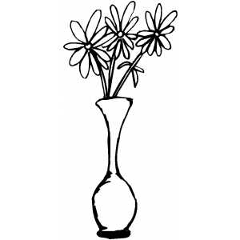
- YOU MUST BE BETWEEN KINDERGARTEN AND SECOND GRADE.

- YOUR EXHIBIT WILL BE YOUR CUT FLOWERS.

- YOU MUST EXHIBIT YOUR PROJECT AT THE WARRICK COUNTY 4-H FAIR, HELD AT THE WARRICK COUNTY 4-H CENTER IN BOONVILLE, IN.

- YOUR FLOWER PROJECT WILL BE DISPLAYED IN A SPECIAL MINI 4-H SECTION AT THE 4-H FAIR.

- THERE WILL BE SUGGESTIONS FROM A JUDGE ON YOUR PROJECT. YOU WILL RECEIVE A MINI 4-H RIBBON FOR EXHIBITING AT THE COUNTY FAIR.

- YOU MUST EXHIBIT A DIFFERENT PROJECT EACH YEAR.

PREPARING YOUR EXHIBIT

THE FLOWERS SHOULD BE CUT RIGHT BEFORE BRINGING THEM TO EXHIBIT. CUT THE STEMS LONG, LEAVING LEAVES ON THE STEMS. PLACE THREE BLOOMS IN A TALL CONTAINER FILLED WITH WATER. PLACE A MINI 4-H EXHIBIT TAG ON THE CONTAINER.





