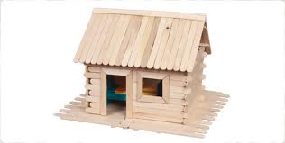
MINI 4-H
WOODCRAFT

MINI 4-H WOODCRAFT REQUIREMENTS

- YOU MUST BE BETWEEN KINDERGARTEN AND SECOND GRADE.
- YOUR EXHIBIT WILL BE ONE SIMPLE ARTICLE YOU HAVE MADE.
- YOU MUST EXHIBIT YOUR PROJECT AT THE WARRICK COUNTY 4-H FAIR HELD AT THE WARRICK COUNTY 4-H CENTER IN BOONVILLE, IN.
- YOUR WOODCRAFT PROJECT WILL BE DISPLAYED IN A SPECIAL MINI 4-H SECTION AT THE 4-H FAIR.
- THERE WILL BE SUGGESTIONS FROM A JUDGE ON YOUR PROJECT. YOU WILL RECEIVE A MINI 4-H RIBBON FOR EXHIBITING AT THE COUNTY FAIR.
- YOU MUST EXHIBIT A DIFFERENT WOODCRAFT PROJECT EACH YEAR.

***** ***** ***** ***** ***** *****

WHAT TO EXHIBIT AT THE FAIR

1. YOUR OWN CREATION.

A. YOU MAY USE ANY ONE OF THE FOLLOWING ITEMS, OR ALL OF
THEM, TO CREATE AN ARTICLE.

TOOTHPICKS MATCHSTICKS
TONGUE DEPRESSORS POPSICLE STICKS
CLOTHESPINS

B. SOME SUGGESTIONS TO TRY TO BUILD ARE:

BIRDHOUSE BIRD FEEDER
WISHING WELL FLOWERPOT
HOUSE OR BARN ANYTHING YOU CAN CREATE

C. ATTACH YOUR EXHIBIT TAG TO YOUR PROJECT.

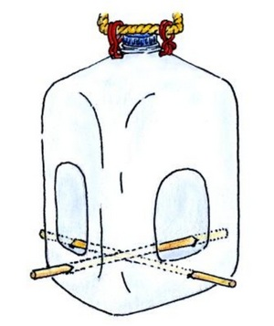
MILK CARTON BIRD FEEDER

MATERIALS YOU WILL NEED:

- ONE EMPTY HALF GALLON MILK CARTON

- WIRE OR STRING TO ATTACH CARTON TO TREE

- A SMALL BLOCK OF WOOD APPROXIMATELY 1" BY 2" BY 1/2" CONSTRUCTION

INSTRUCTIONS:

- CUT TWO OPPOSITE SIDES OUT OF THE CARTON, LEAVING APPROXIMATELY 1" ALL THE WAY AROUND THE CUT-OUT (see illustration). THE TOP SHOULD BE STAPLED, GLUED, OR TAPED SHUT.

- PUNCH 3 OR 4 HOLES IN THE BOTTOM OF THE CARTON WITH A NEEDLE.

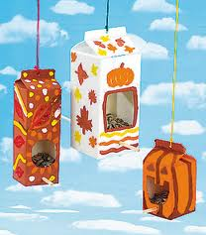
- PUNCH A HOLE IN THE CENTER BOTTOM AND CENTER TOP. (Do not open top!!)

- LOOP STRING OR WIRE AROUND WOOD AND DRAW STRING OR WIRE UP THROUGH THE HOLES. TWIST WIRE OR TIE STRING IN KNOT ENOUGH TO HOOK AROUND A TREE LIMB OR POST.

E. COVER WITH LEAVES (dried, green, or artificial).
THESE CAN BE GLUED ON WITH).
WEATHERPROOF GLUE.

F.HOOK TO LIMB OR POST. HANG FROM A LOW).
BRANCH OF A TREE FOR EASY FILLING.

VILLAGE OR FORT

  - YOU WILL BE CREATING A VILLAGE OR FORT USING TWIGS FROM A LOCAL WOODS OR FROM TREES IN THE YARD.

  - FIND A STIFF PIECE OF CARDBOARD THAT IS 25" BY 20" TO USE AS YOUR BASE OF YOUR PROJECT.

  - FIND AS MANY TWIGS AS YOU WILL NEED TO CREATE YOUR VILLAGE OR FORT.

  - PUT YOUR BUILDINGS TOGETHER BY USING GLUE.

  - DECORATE YOUR VILLAGE OR FORT ANY WAY YOU WISH BY USING GLUED DOWN SAND, ROCKS, FLOWERS OR FIGURES.

  - MAKE SURE YOUR DISPLAY IS SECURED TO THE PIECE OF CARDBOARD.

  - ATTACH YOUR MINI 4-H EXHIBIT TAG TO YOUR PROJECT.

********** *************** ********** *************** **********

BIRD FEEDER OR BIRD HOUSE

- CHOOSE BETWEEN A BIRD HOUSE OR A BIRD FEEDER.

- ATTACH YOUR MINI 4-H EXHIBIT TAG TO YOUR EXHIBIT

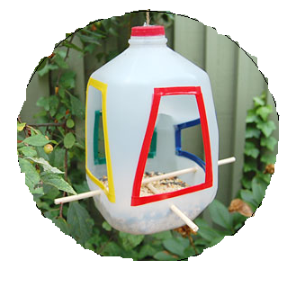
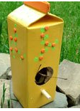

TOOTHPICK SCULPTURE
ICE-CREAM STICK ART

DID YOU KNOW THAT YOU COULD CONSTRUCT A PROFESSIONAL LOOKING ABSTRACT SCULPTURE FROM ICE-CREAM STICKS? ....OR MAKE A MINIATURE TREE OR HOUSE FROM COMMON WOODEN TOOTHPICKS? TO BEGIN MAKING THESE AND MANY OTHER PROJECTS -- ALL YOU NEED IS A SMALL BOTTLE OF WHITE GLUE AND TOOTHPICKS OR ICE-CREAM STICKS.

AMONG THE LEAST EXPENSIVE AND EASIEST OF HOBBIES, FASCINATING TO BOTH YOUNG AND OLD, THIS CRAFT WILL FIRE YOUR IMAGINATION. MAKE MODELS, MINIATURE ANIMALS, TRIVETS, JEWELRY BOXES, PUPPETS, PENCIL HOLDERS, PLACE MATS, EVEN CHRISTMAS DECORATIONS – THE POSSIBILITIES ARE ENDLESS.

WHETHER YOU PAINT OR STAIN YOUR CREATIONS, EMBELLISH THEM WITH COLORED TISSUE AND METALLIC PAPER, OR SIMPLY LEAVE THEM IN THEIR NATURAL WOOD STATE -- YOU WILL FIND TOOTHPICK ART AND ICE-CREAM STICK SCULPTURE SO ENJOYABLE THAT YOU WON'T BE ABLE TO WAIT TO BEGIN YOUR NEXT PROJECT.

ICE CREAM STICK WEAVING

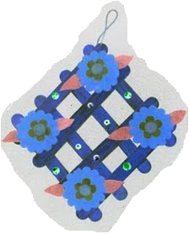
YOU CAN WEAVE ICE-CREAM STICKS TO CREATE MANY UNUSUAL AND USEFUL OBJECTS. IT IS ALWAYS WISE TO FIRST SOAK THE STICKS SUFFICIENTLY, TO MAKE THEM MORE FLEXIBLE AND EASIER TO MANIPULATE.

THE BASIC WEAVING PATTERN CONSISTS OF THREE VERTICAL STICKS, WITH OTHER STICKS WOVEN HORIZONTALLY OVER AND UNDER THESE THREE. YOU CAN CREATE A NUMBER OF THINGS BY EXPANDING ON THE THEME OF THE BASIC WOVEN RECTANGLE OR SQUARE: A CHILD'S FAN IS A GOOD EXAMPLE. (See picture)

THE BASIC SQUARE FORMS THE PATTERN FOR A PLACE MAT YOU CAN MAKE. THIS PLACE MAT IS MADE UP OF TWELVE INTERWOVEN SQUARES.

LARGE BASKETS, PICNIC BASKETS, BOXES AND MODEL HOUSES MAY BE CONSTRUCTED FROM WOVEN ICE-CREAM STICK SQUARES. BEND AND CURVE THE SQUARES WHILE THEY ARE DRYING AND STILL WET TO OBTAIN THE SURFACES NEEDED FOR THESE PROJECTS.
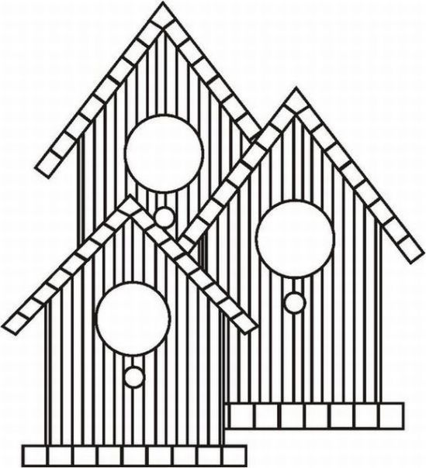
FOR ANY OF THESE PROJECTS INVOLVING WOVEN SQUARES, YOU CAN ENSURE THE PERMANENCE OF YOUR CREATIONS BY APPLYING GLUE TO THEIR OVERLAPPING PARTS, ONCE THE WOOD HAS STARTED DRYING.

A LAST WORD



NOW THAT YOU HAVE SAMPLED A FEW OF THE ENORMOUS RANGE OF OBJECTS THAT CAN BE MADE FROM BOTH TOOTHPICKS AND ICE-CREAM STICKS, YOU ARE READY TO START OUT ON YOUR OWN. IF YOU WISH TO MAKE SOMETHING NOT ILLUSTRATED IN THIS BOOKLET, SO MUCH THE BETTER. YOU KNOW THE BASIC CONSTRUCTION TECHNIQUES AND CAN NOW APPLY THEM TO MAKE ANY FORM THAT YOU MAY DESIRE. BEFORE STARTING, SIMPLY GIVE A LITTLE THOUGHT TO YOUR OBJECT'S BASIC STRUCTURE AND HOW YOU WILL GO ABOUT DUPLICATING IT. THEN START IN AND HAVE FUN!



