Register for the 2026 Wayne County 4-H Fair
Dates of Registration for Fair Entry: May 18 – June 2, 2026
Link for Registration: https://waynecountyindiana.fairentry.com/

If you don’t use the link, you can visit www.fairentry.com and click “Find Your Fair” to find the 2026 Wayne County 4-H Fair. |  | 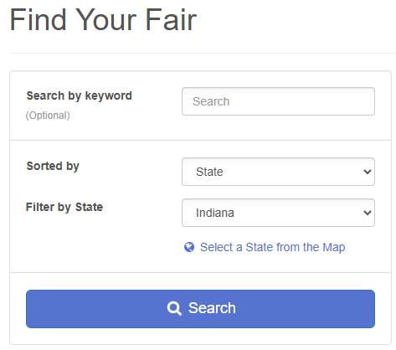
- When asked how you would like to participate, select “As an Exhibitor”  - Use the same login email address and password from 4-HOnline.  - Choose the register an exhibitor button and click the green “Individual” box. There is no payment necessary during this process |  | 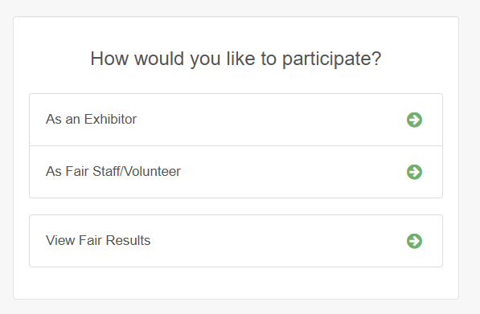
Begin Registration! |  | 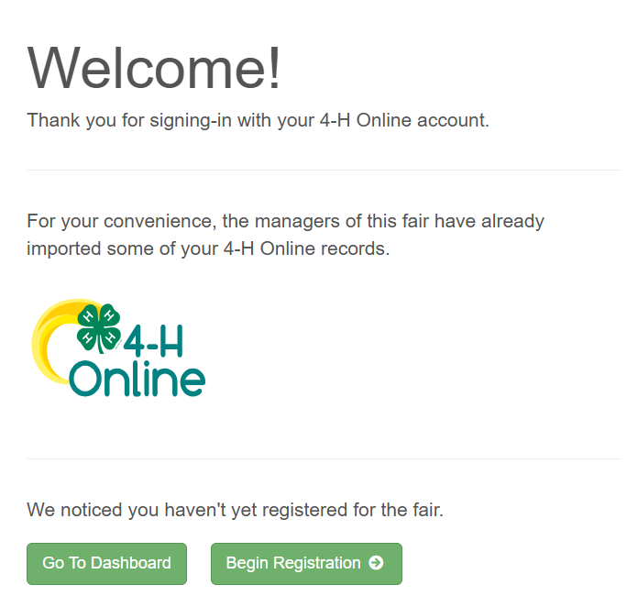
- Click “Individual”  - Select the box next to the Exhibitor’s name you’d like to register and click “Continue” |  | 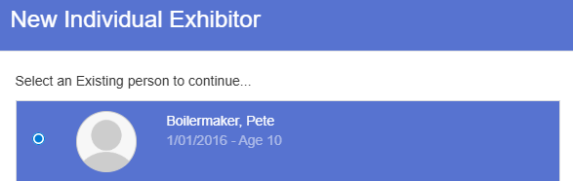  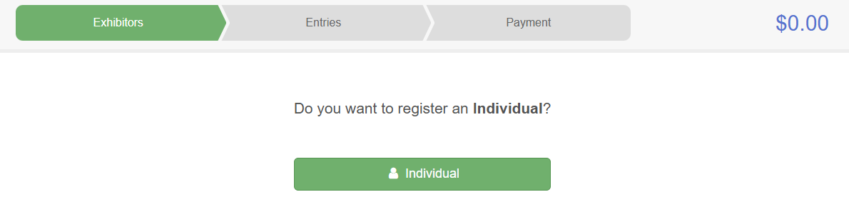
This will take you to register your exhibitor.  - Click “Continue” under Questions  - Review the exhibitor’s detail and then click “Continue to Entries”  - Then select “Add an Entry” – if you select “Continue to Payment” you will be taken to the final page without registering your Exhibitor’s entries |  | 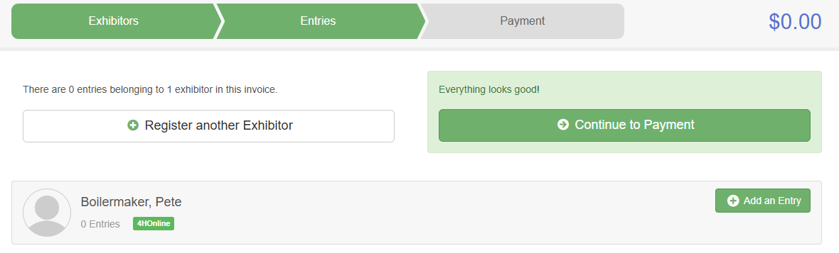
ENTERING AN ANIMAL PROJECT
Now you will choose your Department and Division.  - Click “Select” next to the project (Department) you would like to enter.  - Then select the Division  - Once those are selected, click “Choose” |  | 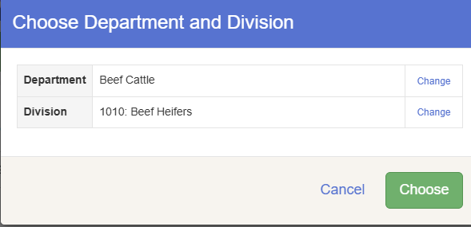
Now you will choose your Class.  - Click “Select” next to class your animal will be exhibiting in |  | 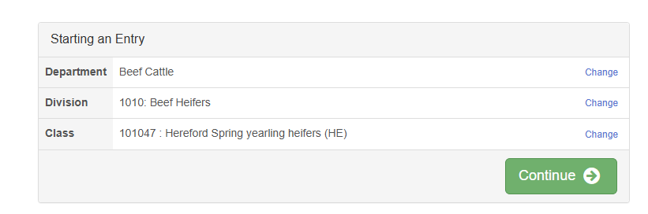
Now you will choose your Club.  - Check the box next to your club and click “Continue” |  | 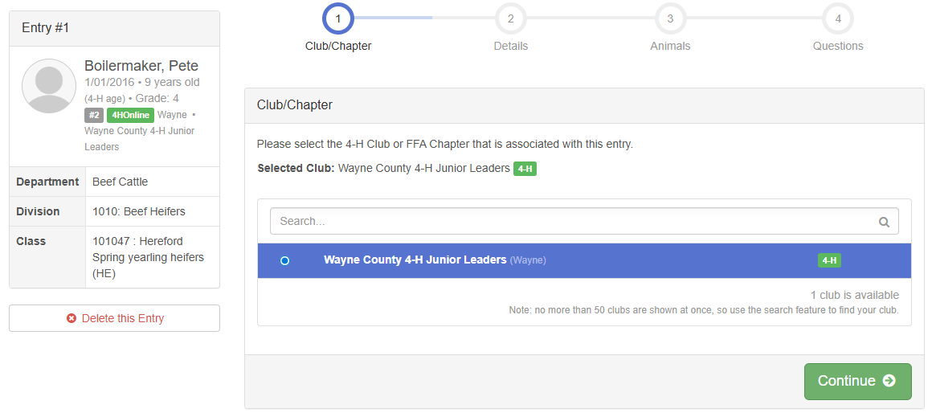
Entry Detail  - You do not have to fill out anything in this section  - Click “Continue” |  | 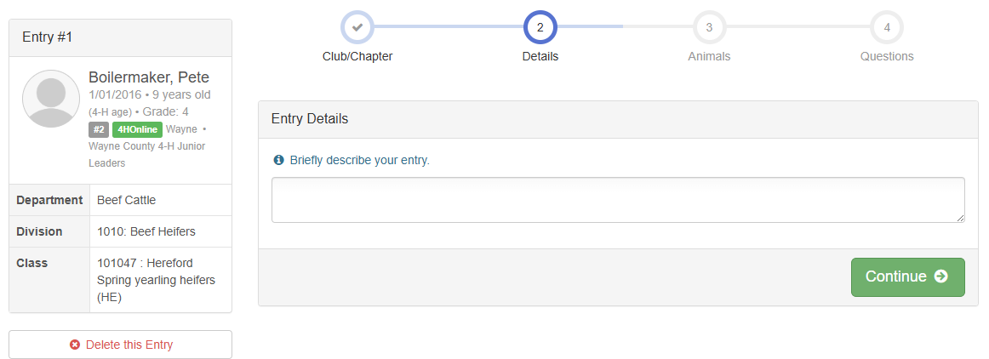
Now you will need to add your animal. These animals are synched from 4-HOnline.  - Click “Add an Animal”  - The eligible animals for this class will populate under the Exhibitor’s name  - Check the box next to the animal you’d like to enter and click “Select Animal” |  | 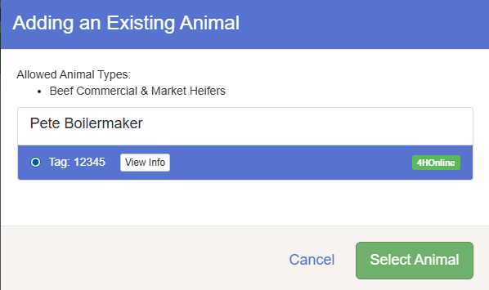
Now you will verify your animal.  - Look over the identification information on the animal you selected to verify you have the correct one for that class  - Then, click “Continue” |  | 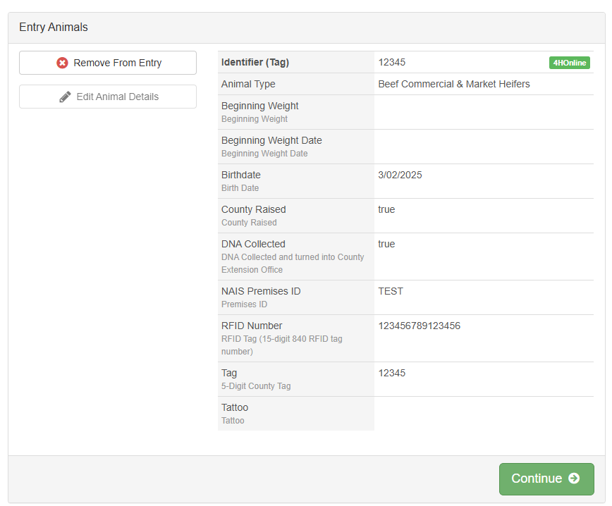
Questions  - Fill this out if you have special requests.  - Click “Continue” |  | 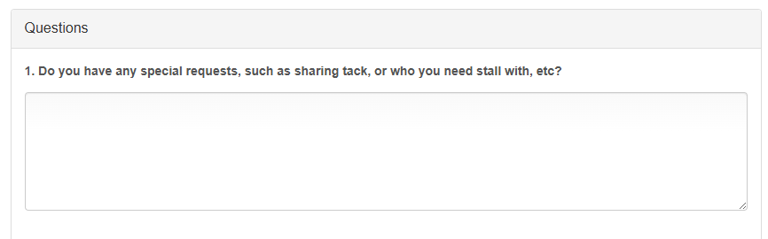
What do you do next?  - Add another Entry  - Select this if your Exhibitor will be showing in other classes, species, and/or building projects  - Register another Exhibitor  - Select this if you are finished adding all classes for the current Exhibitor and have another Exhibitor in the family that you need to register  - Continue to Payment  - Select this if you are done entering projects for your current Exhibitor and don’t have another Exhibitor to register |  | 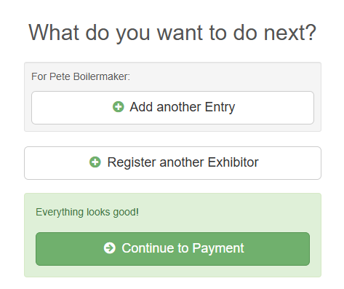
ENTERING A BUILDING PROJECT
Now you will choose your Department and Division.  - Click “Select” next to the State Projects department.  - Then select the Division (Project)  - Once those are selected, click “Choose” | 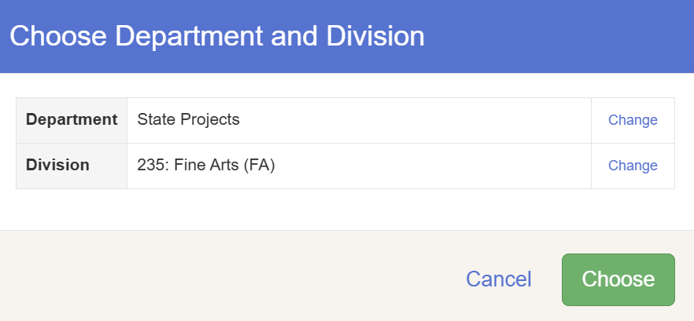
Now you will choose your Class.  For most projects, the classes are:  - Beginner – grades 3-5  - Intermediate – grades 6-8  - Advanced – grades 9-12  Please refer to the Handbook to ensure you are selecting the correct Class. | 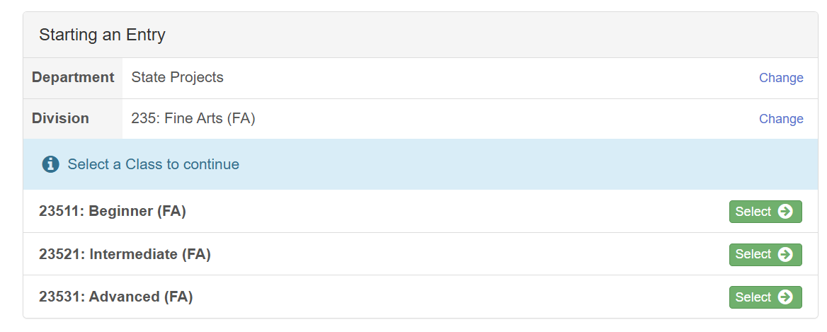
Click “Continue” after you select the appropriate Class. | 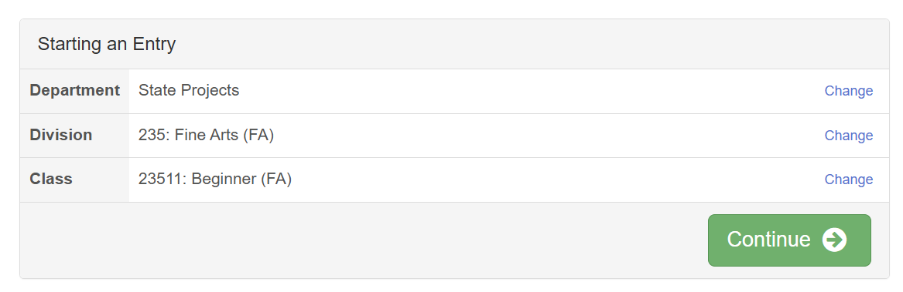
Now you will choose your Club.  - Check the box next to your club and click “Continue” | 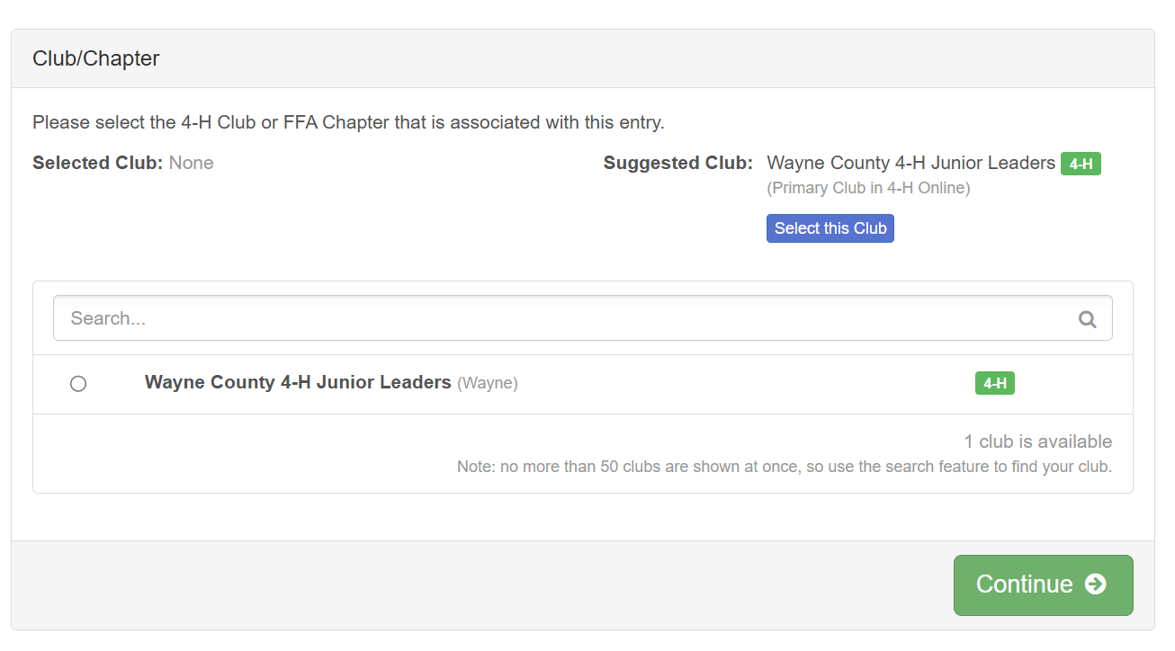
What do you do next?

- Add another Entry
  - Select this if your Exhibitor will be showing in other classes, species, and/or building projects
- Register another Exhibitor
  - Select this if you are finished adding all classes for the current Exhibitor and have another Exhibitor in the family that you need to register
- Continue to Payment
  - Select this if you are done entering projects for your current Exhibitor and don’t have another Exhibitor to register
SUBMITTING YOUR ENTRIES
Payment is not required in Fair Entry, but the system brings you to a payment screen.  - Click “Continue” and then “Continue” again | 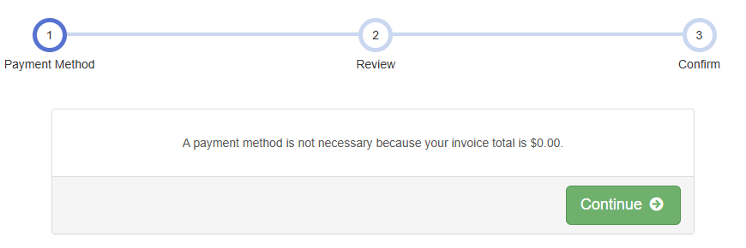
Please verify you have all exhibitors listed on this “invoice”  - Click “Continue” | 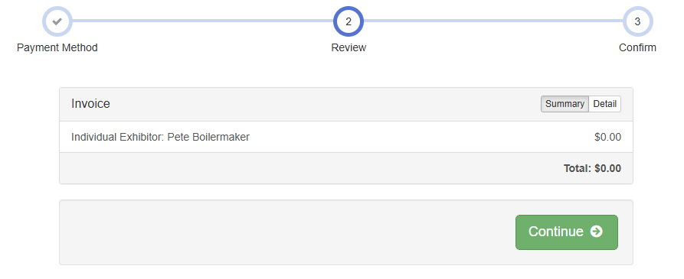
ONE LAST STEP!  - Check the box next to “I agree to the above statement” before submitting  - Click “Submit” | 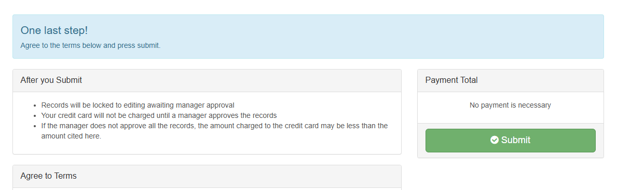
Your entries are submitted!  - You should receive an email confirmation that your submission has been sent for review.  - If we notices changes that will be made, you will receive another email with notes on those changes | 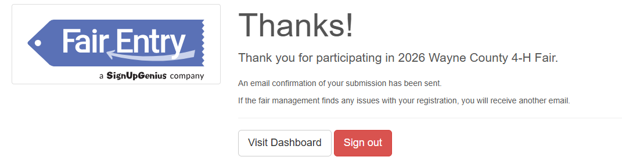

All entries – Mini & Regular Members + Building & Animal Projects – must be entered by Tuesday, June 2nd.

Have questions? Contact us! (765) 973-9281

