WHITE COUNTY GOAT PROJECT

EDUCATIONAL ACTIVITIES
SERIES #3
LEVEL 1: GRADES 3 - 5

Name______________________________________ Grade___________

Why is quality assurance so important to the livestock industry? (Goat Resource Handbook, pages 162-163).

______________________________________________________________________

______________________________________________________________________

______________________________________________________________________

______________________________________________________________________

Identify and describe 4 topics important to quality assurance. (Goat Resource Handbook, page 162).

1.____________________________________________________________________

______________________________________________________________________

2.____________________________________________________________________

______________________________________________________________________

______________________________________________________________________

______________________________________________________________________

3.____________________________________________________________________

______________________________________________________________________

______________________________________________________________________

4.____________________________________________________________________

______________________________________________________________________

______________________________________________________________________
WHITE COUNTY GOAT PROJECT
EDUCATIONAL ACTIVITIES
SERIES #3
LEVEL 1: GRADES 3 - 5

Name______________________________________ Grade___________

Answer the following questions about Pygmy goats. (Goat Resource Handbook, pages 20-21.)

- What is the average height of a full-grown Pygmy goat at the withers?

______________________________________________________________________

- What are the average mature weights for Pygmy does and bucks?

______________________________________________________________________

- What was the Pygmy goat orginally called?

______________________________________________________________________

- Where were Pygmy goats originally developed?

______________________________________________________________________

- What is the most common coat color of Pygmy goats, and what does it look like?

______________________________________________________________________

- When were Pygmy goats first imported into the United States?

______________________________________________________________________

- From where were Pygmy goats originally imported to the United States?

______________________________________________________________________

- How much can a Pygmy doe in milk be expected to give each day?

______________________________________________________________________

WHITE COUNTY GOAT PROJECT
EDUCATIONAL ACTIVITIES
SERIES #3
LEVEL 1: GRADES 3 - 5

Name______________________________________ Grade___________

Label the following 5 goat topline structures on the diagrams below. (Goat Resource Handbook, page 26. Diagram reprinted courtesy of the Ohio State University Extension.)

- SWAY BACK
- ROACHED BACK
- IDEAL BACK
- WEAK IN THE CHINE
- WAVY BACK

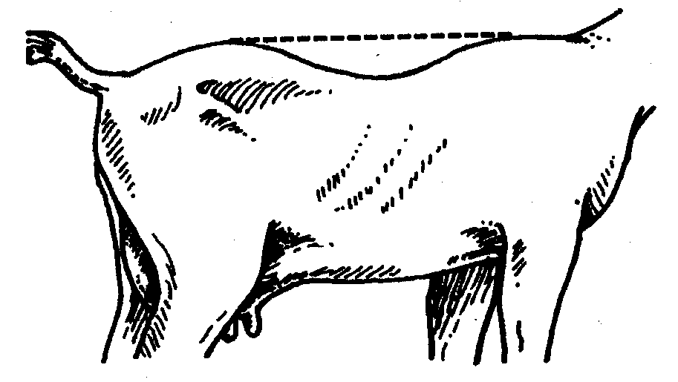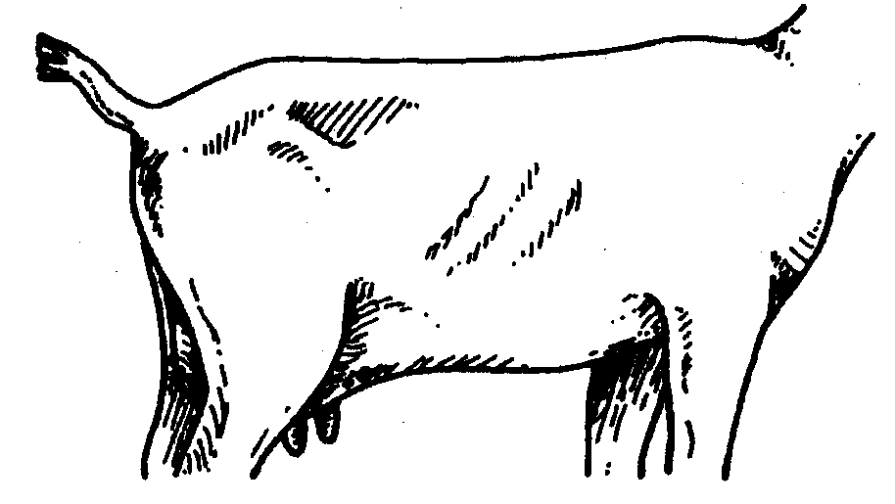
1.____________________ 2.____________________

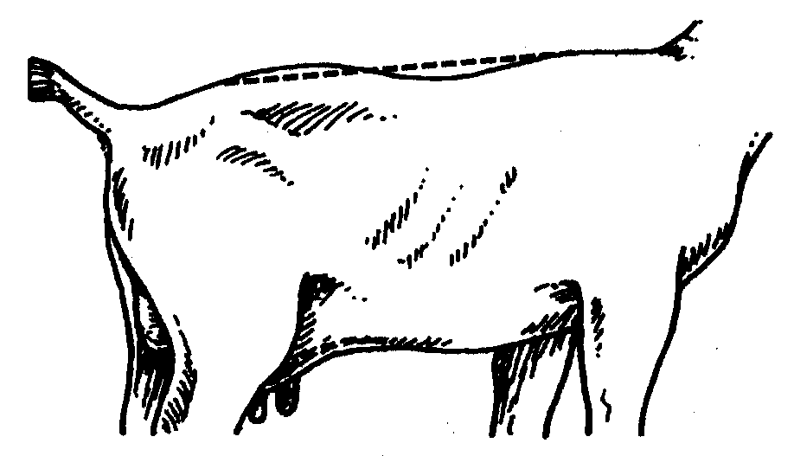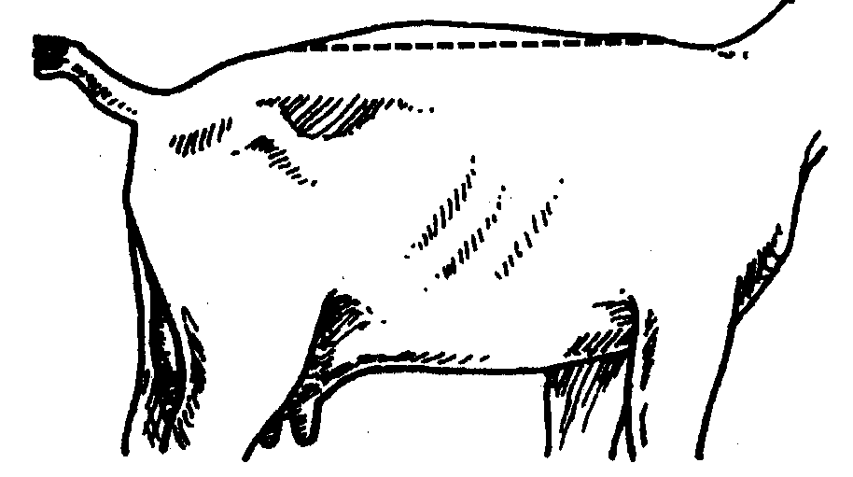
3.____________________ 4.____________________

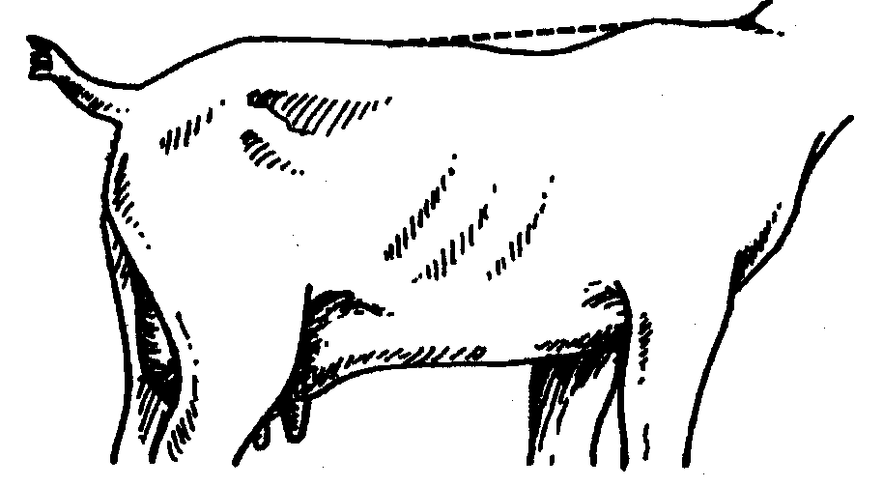
5.____________________

