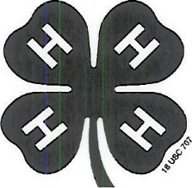
Page 1 of 3
WHITE COUNTY GOAT PROJECT
EDUCATIONAL ACTIVITIES
SERIES #2
LEVEL 1: GRADES 3-5

Name______________________________________________Grade___________

Identify 2 roles of the female reproductive system and list 5 major organs. (Goat Resource Handbook, page 35).

Roles
- _______________________________________________________________________________
- _______________________________________________________________________________

Organs
- _______________________________________________________________________________

- _______________________________________________________________________________
- _______________________________________________________________________________
- _______________________________________________________________________________
- _______________________________________________________________________________
Identify the role of the male reproductive system and list 6 major organs. (Goat Resource Handbook, pages 38-39).
Role: _______________________________________________________________
Organs:
- ______________________________________________________________
- ___________________________________________________________________
- ___________________________________________________________________
- ___________________________________________________________________
- ___________________________________________________________________
- ___________________________________________________________________

Signature of 4-H Member_______________________________________________
*Leader signature not required.
(Committee Use Only: ______ & ______ Grade ______)

Page 2 of 3
WHITE COUNTY GOAT PROJECT
EDUCATIONAL ACTIVITIES
SERIES #2
LEVEL 1: GRADES 3-5

Name _______________________________________ Grade___________

List 10 tips for showing your animal. (Goat Resource Handbook, page 176.)
- ____________________________________________________________________________________________________________________________________________________
- __________________________________________________________________________
- ____________________________________________________________________________________________________________________________________________________
- __________________________________________________________________________
- ____________________________________________________________________________________________________________________________________________________
- ____________________________________________________________________________________________________________________________________________________
- ____________________________________________________________________________________________________________________________________________________
- ____________________________________________________________________________________________________________________________________________________
- ____________________________________________________________________________________________________________________________________________________
- ____________________________________________________________________________________________________________________________________________________
______________________________________________________________________________________________________________________________

Signature of 4-H Member_______________________________________________
*Leader signature not required.
(Committee Use Only: ______ & ______ Grade ______)
Page 3 of 3
WHITE COUNTY GOAT PROJECT
EDUCATIONAL ACTIVITIES
SERIES #2
LEVEL 1: GRADES 3-5

Name_________________________________________________Grade_________
Define the following types of injections. (Goat Resource Handbook, page 165.)
Subcutaneous(SQ):____________________________________________________________________________________________________________________________________________________________________________________________
Intramuscular(IM):_____________________________________________________
____________________________________________________________________
____________________________________________________________________
Intravenous (IV): ______________________________________________________
____________________________________________________________________
____________________________________________________________________
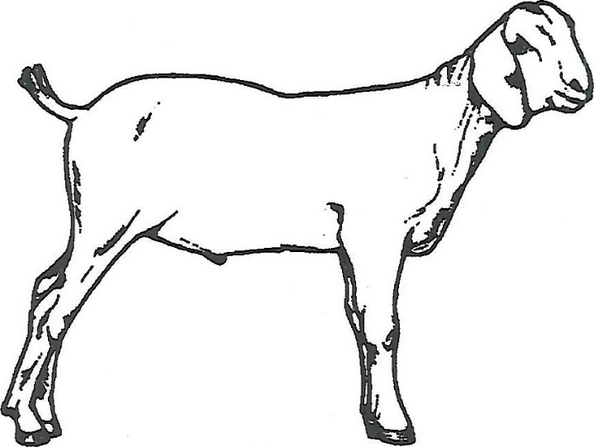
Identify the correct subcutaneous and intramuscular injection sites on the diagram below using arrows and the abbreviations SQ and IM. (Goat Resource Handbook, page 166. Diagram reprinted courtesy of the Ohio State University Extension.)

Signature of 4-H Member________________________________________________________
*Leader signature not required.
(Committee Use Only: ______ & ______ Grade ______)

