
WHITE COUNTY GOAT PROJECT Page 1 of 3
EDUCATIONAL ACTIVITIES
SERIES #2
LEVEL 3: GRADES 9-11

Name ___________________________________________________ Grade _________

Identify 4 hormones of the female goat and 4 hormones of the male goat with their sites of production, and functions. (Goat Resource Handbook, pages 36, 39).

- Female Hormone: _________________________________________________________________
Site: ____________________________________________________________________________
Function: _______________________________________________________________________
_________________________________________________________________________________
- Female Hormone: __________________________________________________________________
Site: _____________________________________________________________________________
Function: ________________________________________________________________________
_________________________________________________________________________________
- Female Hormone: __________________________________________________________________
Site: _____________________________________________________________________________
Function: ________________________________________________________________________
_________________________________________________________________________________
- Female Hormone: _________________________________________________________________
Site: ____________________________________________________________________________
Function: ________________________________________________________________________
________________________________________________________________________________
- Male Hormone: ___________________________________________________________________
Site: ____________________________________________________________________________
Function: _______________________________________________________________________
_________________________________________________________________________________
- Male Hormone: ____________________________________________________________________
Site: _____________________________________________________________________________
Function: ________________________________________________________________________
_________________________________________________________________________________
- Male Hormone: ____________________________________________________________________
Site: _____________________________________________________________________________
Function: ________________________________________________________________________
_________________________________________________________________________________
- Male Hormone: ___________________________________________________________________
Site: ____________________________________________________________________________
Function: ________________________________________________________________________
________________________________________________________________________________

Signature of 4-H Member___________________________________________________
*Leader signature not required.
(Committee Use Only: ______ & ______ Grade ______)
WHITE COUNTY GOAT PROJECT Page 2 of 3
EDUCATIONAL ACTIVITIES
SERIES #2
LEVEL 3: GRADES 9-11

Name ____________________________________________________ Grade ________

Identify and describe 4 major areas of animal science careers and list 2 careers within each category. (Goat Resource Handbook, pages 173-174).

1.______________________________________________________________________
______________________________________________________________________
- __________________________________________________________________
- __________________________________________________________________
2.______________________________________________________________________
______________________________________________________________________
- __________________________________________________________________
- __________________________________________________________________
3.______________________________________________________________________
______________________________________________________________________
- __________________________________________________________________
- __________________________________________________________________
4.______________________________________________________________________
______________________________________________________________________
- __________________________________________________________________
- __________________________________________________________________
If you were going to pursue a career in animal science, which would it be and why?
________________________________________________________________________________________________________________________________________________

Signature of 4-H Member___________________________________________________
*Leader signature not required.
(Committee Use Only: ______ & ______ Grade ______)
WHITE COUNTY GOAT PROJECT Page 3 of 3
EDUCATIONAL ACTIVITIES
SERIES #2
LEVEL 3: GRADES 9-11

Name ____________________________________________________ Grade ________

Identify the following 6 birthing positions and describe any possible conditions or circumstances of each. For example, is it normal, should delivery be attempted, etc.? (Goat Resource Handbook, page 43. Diagrams reprinted courtesy of the Ohio State University Extension).
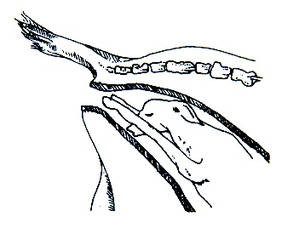
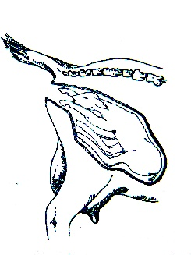

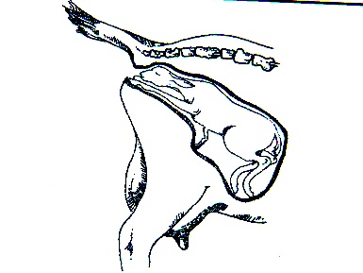
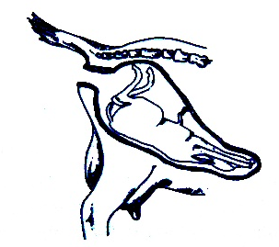

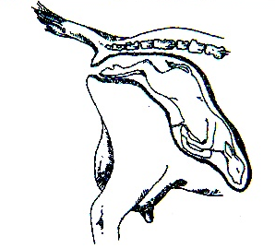
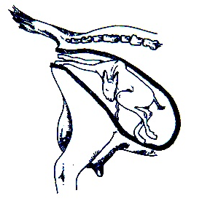

Signature of 4-H Member___________________________________________________
*Leader signature not required. (Committee Use Only: ______ & ______ Grade ______)

